INDS 1319 technical drawing – CRN 21623
2 Lecture / 4 Lab / 80 Hrs / 3 Credit
Instructor: Don Tullier
Class Location: Central Campus JBW 124B
Class Times: Monday and Wednesday, 8:30 AM to 11:35 AM
Office Location: J.B. Whiteley Building, Suite #124D, HCC Central Campus (adjunct = no office)
Phone#: 713.718.6038 (Program Coordinator’s office)
Email Address: donald.tullier@hccs.edu

COURSE DESCRIPTION
The course is an introduction to reading and preparing technical construction drawings for interior design, including plans, elevations, details, schedules, dimensions, and lettering.

COURSE GOALS
- Employ architectural drawing symbols
- Use appropriate drawing equipment
- Demonstrates understanding of architectural blueprints in order to translate dimensions and building features accurately
- Create complete interior design drawings
- Demonstrate understanding of the building envelope including types of foundations, framing, roofing, windows and other materials on the impact of design solutions.

SCAN SKILL OBJECTIVES (Secretary’s Commission Addressing Necessary Skills)
Houston Community College System is determined to prepare you with the knowledge and skill you need to succeed in today’s dynamic work environment. Towards this end, the following workplace competencies and foundation skills have been designed into the curriculum for each program of study:
1. Personal: The student will follow the Program, Student Handbook, code of ethics, and the AST scope of practice as they participate as part of the class in study and practical situations. They will have to develop their time-management skills by reviewing the class agenda and test schedule to prepare a study schedule that allows them to prepare effectively for each test. The student will be expected to develop their integrity/honesty by choosing not to cheat on written exams and/or falsely claiming ownership of any assigned projects.
2. Interpersonal: The student will participate as a member of a team: form study groups and show up at appointed times to study with the group. The student will study with fellow students regardless of sexual orientation, race, religion, or gender.
3. Information: The student will use computers to process information: create assignments and take lecture notes from computer generated class presentations.
4. Basic Skills: The student will have to listen to receive the lecture, presentation material and record this information in a proper note taking format. They will also have to speak properly phrased questions and responses during class. The student will have to read the assigned text in accordance to the syllabus and class schedule. And finally, the student will have to complete all written assignments.
5. Thinking Skills: The student will have to develop their critical thinking skills as they acquire the knowledge presented in class and in the text. The student will then have to develop their creative skills through assignments that ask them to apply what they have learned on a variety of design-oriented projects.

Academic Honesty
Plagiarism, cheating, and other forms of academic dishonesty are prohibited by college policy and the rules of this class. Plagiarism involves using the ideas or words of another person (either in whole or in part) without crediting the source. Cheating involves fraud and deception for the purpose of violating testing rules. Students who improperly assist other students are just as guilty as students who receive the assistance. If two or more students submit work that is identical or nearly identical, in whole or in part, they are equally guilty of violating the academic honesty policy. The Interior Design Department has a zero-tolerance stance towards this policy. Any student found guilty by a professor through tangible evidence or testimony may be dismissed from the course and/or given a failing grade.

PREREQUISITE
None

COURSE TEXT
Construction Drawings and Details for Interiors
by W. Otie Kilmer and Rosemary Kilmer
Copyright 2003xc (edition 1) or Copyright 2009 (edition 2)
ISBN 0-471-10953-3 (paperback) ISBN 978-0-470-19041-8 (paperback)

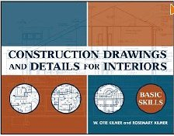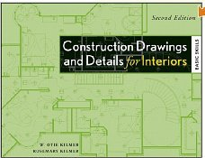

EVALUATION
Student Participation/Attendance 10%
Average of All Five Preliminary Projects 70%
Final Project 20%

COURSE CALENDAR WITH READING ASSIGNMENTS
See Instructor’s periodic handouts. Reading assignments are associated with textbook chapters covered on each project or exam. It is the student’s responsibility to review the course schedule, insuring correct chapters are read and studied prior to each class lecture and each test.

STUDENTS WITH DISABILITIES
Any student with a documented disability (e.g. physical learning, psychiatric, Vision, hearing, etc.) who needs to arrange reasonable accommodations must contact the Disability Services Office at Central College at the beginning of each semester. Faculty members are authorized to provide only the accommodations requested by the Disability Support Services Office. If you have any questions, please contact a disability counselor.

Interior Design Departmental Policies Also Apply
See separate handout

Course: INDS 1319 Technical Drawing
Instructor: Don Tullier (TBAE License Arch. #7123 and I.D. #6055, TDLR RAS #1105)
Course Location: CE/JBW 124B
Scheduled Times: (established each semester)
Office: J. B. Whiteley Building, Suite 124, HCC Central Campus
Phone: 713/718-6038 (Department Chair’s office)
Email: donald.tullier@HCCS.edu

The following materials are required for this class. You may have already purchased many of them for other classes and you will most surely be using them in subsequent classes and, indeed, within your professional career, as well. Put your name on items in a neat manner that can not be removed.

- Architect’s Scale – This is a three sided measuring instrument. DO NOT purchase an Engineer’s Scale.

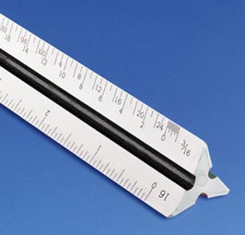

- 45 degree Triangle – 12 inch works best for now but 10 inch can be used. You may have additional sizes. No bevel edges. Beveled edges are for ink drawing.

- 30/60 degree Triangle – 12 inch works best for now. Clear or Orange will be fine. You may have additional sizes. No bevel edges.
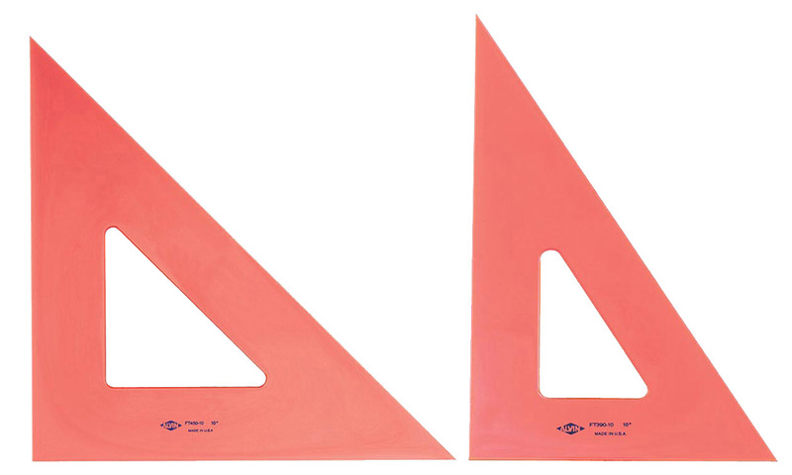

- One wooden Drafting Pencil in H or F lead for drawing boarder line ONLY.

- Mechanical Drafting Pencils – 3 Pencils, one each that hold .3mm lead, .5mm lead, and .7mm lead. Pentel is one common brand that is affordable and good quality.

- Pencil Leads – DO NOT purchase HB leads because they are easy to SMEAR!

  - Size .3mm – 4F or 4H Lead (Medium) Good for drawing fine layout and guidelines (4F and 4H may be hard to find, if so, get .3mm 2F or 2H)
  - Size .5mm – 2F and 2H Leads (Medium) Excellent general purpose lead for most intermediate drawing lines.
  - Size .7mm – F or H Lead (Medium) Good for drawing thicker object lines and lettering

- Eraser – White Eraser (such as Staedtler Mars Plastic or Sanford Magic Rub). Additionally, though not required, you may wish to purchase a battery powered mechanical eraser with refills (refills use up quickly). Careful, though, they can quickly and easily rub holes in your paper. Use electric unit delicately and with care.

- Metal Erasing Shield – Keep the paper sleeve it comes in as this is how you store and keep it clean.



- Drafting Brush – Removes erasure debris from your drawings without smearing paper. When you sweep drawing with your hand you transfers body oils to paper.
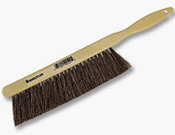

- Drafting Tape or Dots – To anchor drawing to drawing surface. DO NOT PURCHASE masking tape as it leaves residue on drawing surface and drawing. Dots are neat but pricey. Drafting tape is cheaper but care must be taken in how you put it down so that it will not curl away from paper.

- Vellum Paper – Tablets of Vellum, 16 lb. Traditional 8 ½” x 11” and 11” x 17”. Both without a grid. Two of you may share the tablets as not all sheets will be used.

- Templates – This item can get very expensive. By purchasing quality now, you will have these for a lifetime.
  - Furniture Templates – a good variety residential furniture template or templates.

Two options for detailed, premium furniture template sets are listed below. These are not the only furniture templates that will work for this class. You can manage this course with a simpler, less expensive template.

Available at www.asidga.org/hand.html is a set of three templates with product code TMP001. They are priced at approximately $50.00 per set. The set include the following ¼” scale templates:
    - Template A: Seating, Bedding, and Case Goods
    - Template B: Tables and Booth/Banquette Seating
    - Template C: Contract Seating and Case Goods
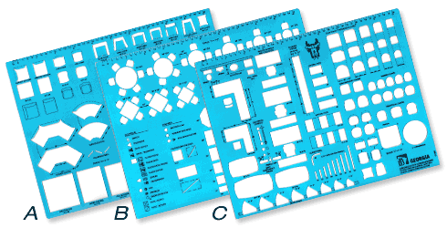
Another option for high quality furniture templates can be resourced at http://www.vrtemplates.com for approximately $69.
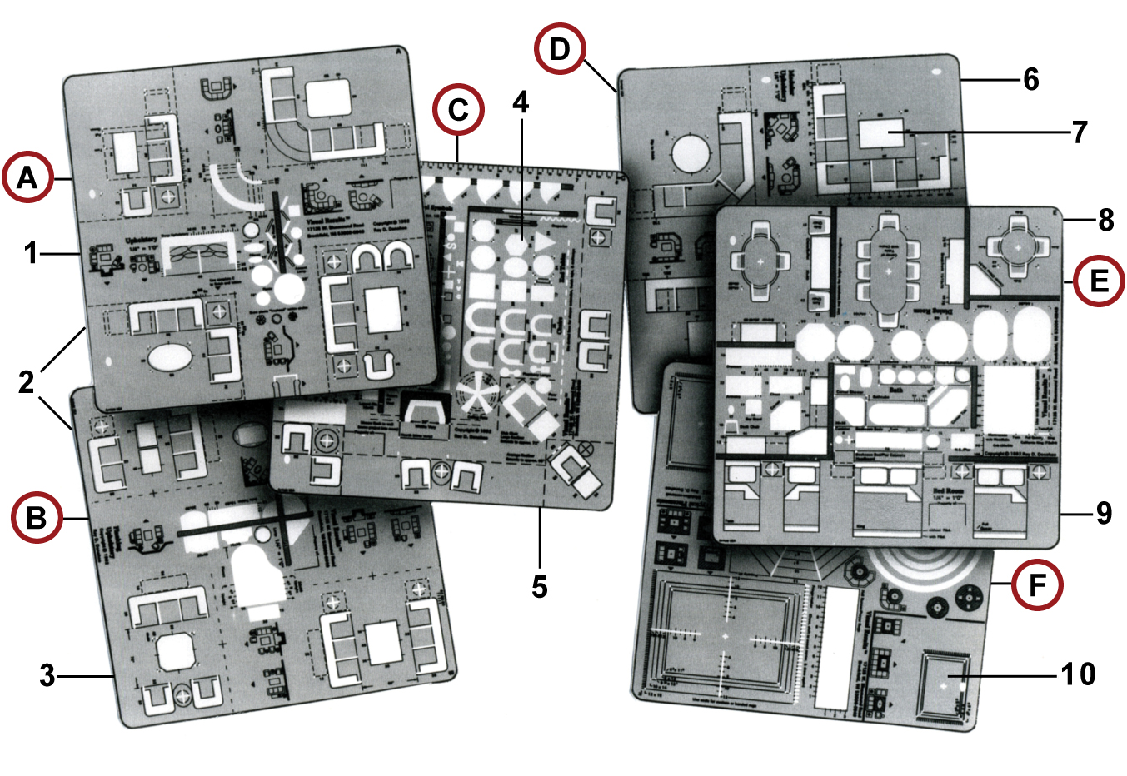
  - Kitchen and Bath Templates – While this is not the only Kitchen and Bath template that will work for this class, available at www.asidga.org/hand.html is a ¼” scale template with product code TMP003. It is priced at about $22.50.
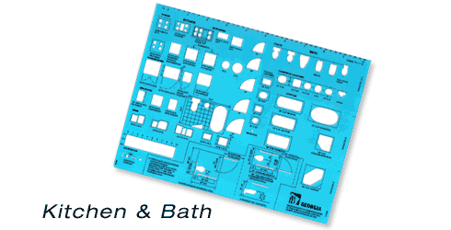

  - Circle Template – Template with a variety of circle sizes. Be cautious of thin, inexpensive templates. They warp and that corrupts the “roundness” of the circles.

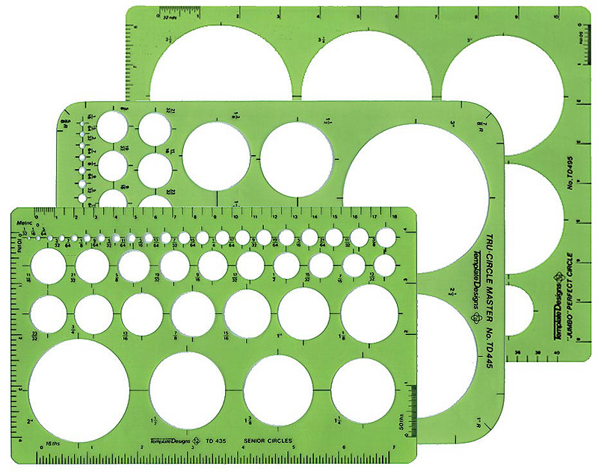

  - Generic Geometric Template – A small template that is a series of progressively smaller sized circles, squares, triangles, and hexagonal shapes.

- French Curve – This is an oddly shaped, usually clear template-like tool made up of many joined segments of a variety of sized curves.

- T Square – This instrument provides you with a movable consistently horizontal guide for your drawings. 30 to 36 inch long will work best. Clear edges are a must.

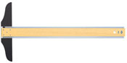

- Portable Table Top Drafting Board or Drawing Box – This is a drawing surface that may or may not have a parallel bar integral to its construction. Size is up to you but it should be big enough to accommodate a variety of drawing sizes but small enough to not kill you to carry it. An alternative to a portable drafting board would be a portable drafting box that both can contain and carry your other tools but opens and converts to a drafting board with integral parallel bar.

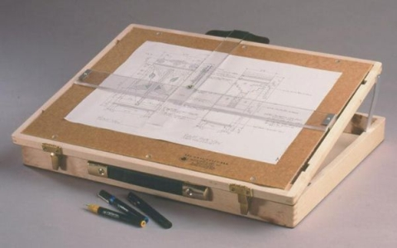

NOTE: if you should chose to order any of the items listed, do plan to have interim materials as your assignments will not wait. Furniture and Kitchen and Bath templates will not be used for the first few classes but all others will need to be available for use.

