Fred P. Gaines
Email: ROLAND.GAINES@gmail.com

Objective: Seeking new opportunities in teaching in higher education, which will maximize effective classroom instruction, i.e., pedagogy and andragogy.

Education
University of St. Thomas – Houston, Texas - Post Bach. - Education
Cornell [SUNY] University – Ithaca, New York -B.S. in Animal Science / Communication Arts
Cornell [SUNY] University – Ithaca, New York -M.S. Animal Breeding / Statistics
Certification: Texas: Generic Special Education (Grades PK-12)
License: Texas Real Estate Commission – broker #228297 – since 1973

Educational Experience

2006 to Present - Adjunct Math Instructor with Houston Community College
Teach Developmental Math (0306, 0308 and 0312,) promote active learning including individualized
instruction, problem-solving assignments, and small group work. Plan & teach essential elements of
math. Create a classroom environment that is conductive to learning. Employ appropriate instructional
methods and materials.

08/2004 to 02/2010 - Teacher with Sharpstown H.S.
Teacher, Resource, Vocational Adjustment Coordinator, co-teach Mathematics
Employ diverse techniques, i.e., best practices to promote active learning including individualized
instruction, problem-solving assignments, and small peer-tutor-group work.
Develop, implement and provide data driven instruction in vocational curricular to increase student
performance and love of learning.

Plan, facilitate and in-service administration, teaching professionals, parents and students on transition
supports and services available both during and after high school.
Build and maintain business and school partnerships to provide work-based and supported employment
opportunities for students.

Collaborate with teaching professionals and administration weekly in the selection and adaptation of
best teaching practices and best teaching materials for classroom use to help students be attentive and
life-long learners.

11/2003 to 07/2004 - Teacher Family Technology Center
Planned and taught basic computer classes and integrated Microsoft’s state of the art Text-to-Speech
(TTS) and Voice Recognition (VR) to students’ ages 7 to 70. Designed browsers, web pages, lesson plans
and computer based activities using Yahoo’s Geocities software while using various forms of multimedia
including the digital camera. Collaborated and co-taught with peers to develop small business plans,
marketing plans, flyers, and business cards.

01/1990 to 06/2004 - Project Manager with Inner-city Management Works
Established a Community Housing Development Organization (CHDO) 501(c)(3) through the City of
Houston to build affordable housing. Elected to the City of Houston’s Imagine Houston Steering
Committee “Where to Work” during Mayor Bob Lanier’s term.

08/1999 to 08/2001 - Support Specialist with University of Texas
Implemented milieu treatment for residents exhibiting chronic psychiatric disorders. Worked directly
with doctors and registered nurses in triage with admission, orientation, patient escort, record keeping,
reports, scheduling of team meetings, and coordination of transfers. Notarized court documents.

09/1999 to 12/1999 - Salesman with Dell Computer Corporation
Provided prompt courteous service to customers while assisting with product selection, pricing, and
delivery information. Monitored sales programs, planned new marketing strategies, devised creative
product applications, and prepared monthly activity and forecast reports.

Professional Achievements
Texas Real Estate Broker ~ 9950 Westpark , #638 Houston TX 77063
Dba capital gaines affordable investments
Technological Skills : Microsoft Word and Excel, Adobe Muse, Premiere Pro CC, Digital Camera, Scanner, iPhone
Soon to learn the following CMS systems, e.g., Sketch, InVision, Figma, Asana, Jira, etc.

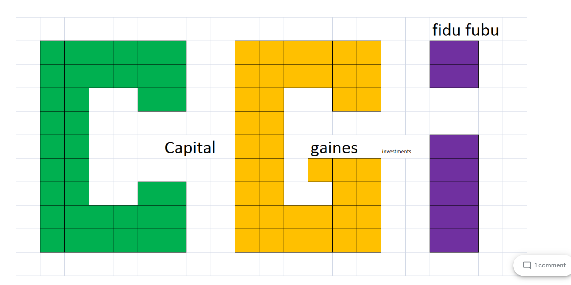

Senior Product Designer
SAVE
The Obama Foundation
Anywhere
Apply on Glassdoor
17 days ago Work from home full-time
About the Obama Foundation

At the Obama Foundation, we are guided by a core belief: that ordinary people working together can change history. Our mission is to inspire those people to take action, empower them to change their world for the better, and connect them so they can achieve more together than they can alone.

We were founded by community organizers, so when we seek to change, we do it by bringing people together.

That approach begins at home, on the South Side of Chicago, where we are building the Obama Presidential Center. The Center represents a historic opportunity for Chicago: a chance to build a world-class museum and public gathering space that celebrates our nation's first African American President and First Lady, steps away from where he began his career, where she was raised, and where together they made their home.

But that approach extends to all our work, whether it's holding leadership training sessions in communities throughout the U.S., bringing local leaders together in countries around the world, working to support the global education of girls, or ensuring young men of color have pathways to opportunity.

As President Obama has said, "we cannot solve the challenges of our time unless we solve them together." So join us.

For more information, please visit www.obama.org .

About the Role

In this role, you will design and research user-centric, data-driven, and inspiring user experiences for the Foundation's growing portfolio of new products aimed at scaling the Foundation's mission of inspiring, connecting, and empowering people to change their world.

As Senior Product Designer, you will work closely with the larger Technology and Product team and alongside colleagues from around the organization, to craft foundational design processes, kickstart execution on our product development roadmap, and support existing Foundation products.

As a founding member of our growing product and technology organization, you will provide an innovative design perspective, help define and drive the future of the Foundation's product and design strategy, and contribute to envisioning complex user experience ecosystems -- not just limited to the UX of digital products but also including that of place-based experiences, like those at the future Obama Presidential Center or at the Foundation's convenings and events.

The Product Designer will report to the Product Management Lead and be a member of our wider Digital team.

Outcomes

The Senior Product Designer will be responsible for achieving the following outcomes within the first year:
• In collaboration with product, engineering and organizational leadership, finalize a product and user experience strategy and vision for the Foundation's core families of products, along with a plan for evolutionary, iterative updates that actualize the larger vision over time.
• Establish foundational design systems and processes to guide product development
• Advance the tech and product team's short-term OKRs by leading the design of both current user experiences and a number of high-priority new product areas -- ranging from products for general audiences to tools for niche groups of global changemakers
• Execute UX design, research, and product copywriting for the Foundation as a whole

Responsibilities

The ultimate aim of the Senior Product Designer is to achieve the outcomes listed above. In order to achieve those outcomes, we imagine that the Senior Product Designer will spend their time in the following ways:
• Collaborating with the Product Lead to develop a product roadmap focused on transforming ideas, product requirements, research, data, and creative vision into tangible features, products, and services that provide clear, usable, useful and desirable outcomes for the Foundation's diverse sets of users
• Develop all product design assets and deliverables and ensure that they are timely, thorough, thought-through, intuitive, delightful, and easy to use
• In partnership with Product and Engineering, establish best practices in design thinking, process, and user-centric product development across the organization -- driving the creation of and iteration on new, best-in-class product experiences
• In partnership with product develop and execute upon continuous user research and testing
• Contribute to all phases of product development from documentation to release in an agile, fast moving environment
• Contribute to creative and holistic thinking across diverse product families, platforms, and releases
• Building and maintaining strong relationships and operating rhythms with stakeholders within and beyond the core tech and product team to efficiently implement user experiences that are cohesive, inclusive, and well-informed
• In collaboration with the Product Lead advocating for product design skills across the organization, finding ways to involve non-designers in the design process through design sprints and other creative means
• Ensuring adherence to design best practices, standards, and brand consistency
• Nourishing a collaborative environment by encouraging the sharing of ideas and openness to feedback, learning, and iteration

Qualifications
• 5+ years of experience in user-centered experience and or user interface design
• A demonstrated track record of shipping successful and scalable products as well as creating and implementing consistent and scalable product design frameworks
• Exceptional problem-solving skills and high-velocity UX thinking and execution
• Top-tier ideation, sketching, prototyping, testing, and qualitative and quantitative user research skills
• Ability to turn complex interactions into intuitive user experiences
• Familiarity with agile software development and lean UX processes
• Solid technical understanding of current web and app development technologies -- Specifically experience working across web, iOS, Android and an understanding of HTML/CSS
• Fluency with design, project management, and development tools and CMS systems, e.g., Sketch, InVision, Figma, Asana, Jira, etc.
• Proven ability to build effective partnerships at all levels of the organization and cross-functionally; builds trust quickly
• Clear and confident communicator with an affinity for visual storytelling
• Tendency to be creative and solution-oriented when problem-solving; thrives in a culture of open feedback and critique
• High degree of comfort working in a scrappy, fast-paced, mission-oriented environment
• Ability to manage and work with individuals across geographic locations and with a variety of backgrounds
• Passion and commitment to inclusive and accessible design and familiarity with designing products that meet digital accessibility standards
• Committed to our mission of inspiring, empowering, and connecting people to change their world

Portfolio Review

All candidates should be prepared to provide a portfolio/samples of work upon request.
- Certified FUUSA families under urban and social attack
- Five oh one c 3 innercity management works inc.
- Community garden urban harvest
- Braiding and dog grooming school
- Horse breeding
- Feral hog hunts
- Swim lessons at the ymca
- Tutors for the science of getting rich
- Book club cadets for the war on normal people
- Usa puerto rico and cuba games
- Junior achievement by zip code
- Bringing a mountain of soul to sunnyside texas
- Kort and flow also known as the knights of the round table and first ladies of worthing, wheatley and kashmere gardens , high schools : barbara jordan and booker t washington and jack yates
- Poise means product , own , invest , save , entrepreneurs
- To be named after the survey census done monthly
- To be named

Equal Opportunity Employer

The Foundation is committed to creating a diverse work environment and is proud to be an equal opportunity employer. The Foundation does not discriminate on the basis of race, color, national origin, sex, gender identity, religion, sexual orientation, age, disability, parental status, veteran status, or any other protected status under applicable laws. We encourage individuals of all backgrounds to apply. If you are a qualified candidate with a disability, please e-mail us at careers@obama.org if you require a reasonable accommodation to complete this application

Roland Gaines1 week ago
renee , i am leaning in . bring it (the bread) to texas and will give you ted cruz for free . let us build bridges not walls , let's put kid-dreamers in government not cages . call tex as 832.543.3587

https://youtu.be/U9H9FS9NI9E

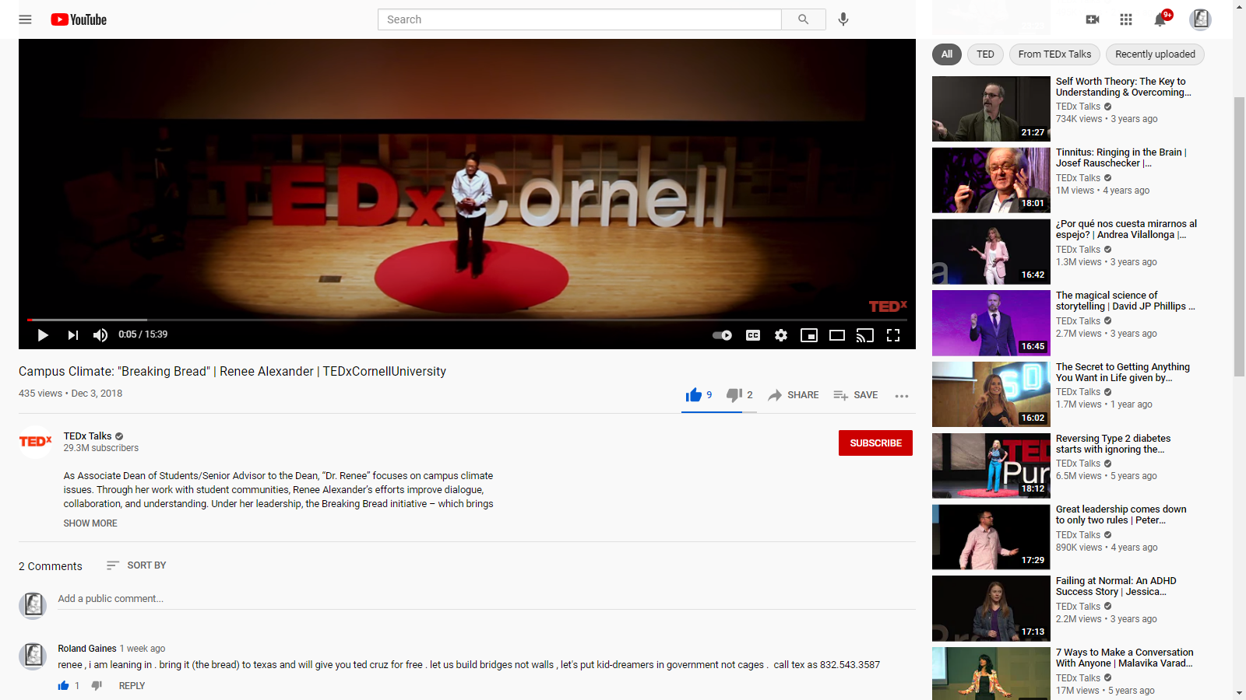

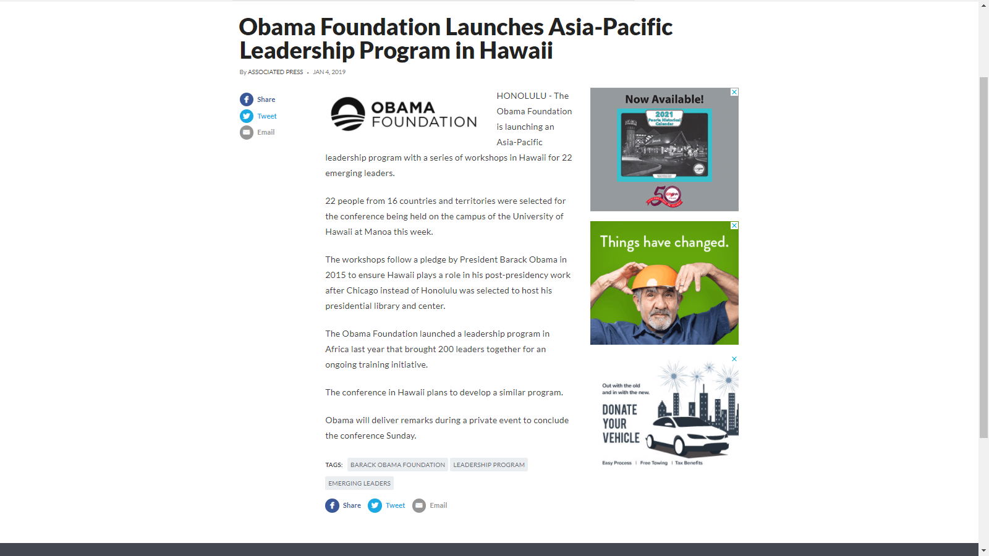

Project one raise thy neighbor’s barn
Home improvement one oh one
Breaking bread with renee alexander at cornell university SUNY ithaca is gorges
Foundations
Roofs
Bridges
Ponds and lakes
Zip line from the astrodome
Solar panel the astrodome
Re imagine astro world

Re Hi-ymca-tri-ywmc civic club and lobby texans

Cover memo
Saturday January 31, 2021

From the desktop of Fred Patrick Gaines
8425 Hearth Drive #4
Houston TX 77054-2709
832.347.7596
Messages at 832.347.7596

Dear President Obama,

Please consider me for the position of Senior Project Manager with your foundation.

I Believe big dreams will require ample investment of our treasure , our time and our talent . i think we colts (grads of my high school , Worthing Sr.Hi.) are the ones . I ask are you ready to join the fight ? i declare war on lo-wealth (poverty), ignorance and missed opportunities . Not knowing the answers begins with knowing to ask the right questions . Does this sounds like a plan ? When we colts left middle school in 1966 Barbara Jordan spoke at our graduation -- Dream BIG were two words that stuck with me these plus fifth years . I see we worthing colts have a problem but we can fix it . how ? go back to when we were the last class to be segregated from kindergarten 1955 to 1969 . we had Skipper Lee broadcast daily from radio AM KCOH that he would bring a mountain of soul to us . Now, it is our turn .

Perry Weston left Worthing to found the high school of health professions . We had giants like Arthur Gaines , Lawrence Marshall , Floyd Stringfellow , do not forget Juanita Gillon , Daisy Mccoy , and Freddie Gaines' guidance . We had programs like the science fair , Rice University summer school for high school students , knights of the round table KORT and first ladies of worthing FLOW . Our bill we wrote in the capitol at Austin at the annual hi-YMCA-tri-hi-YWCA in 1969 to change the voting age from 21 to 18 . It just made sense to all Texans that if we were old enough go to war at 18 then we were old enough to vote at 18 not 21 .

Within you will find my application and resume for the following entry-level position. I look forward to scheduling an interview and discussing the benefits of working with the Obama Foundation as project director. Live Long and Prosper ,

Sincerely,

Fred P. Gaines
