HOMEWORK PROBLEMS Chapter 5: ENERGY

PART-A: Hand in your answers in class on scantron on Monday 04 October-2010

1. A worker pushes a wheelbarrow 5.0 m along a level surface, exerting a constant horizontal force of 50.0 N. If a frictional force of 43 N acts on the wheelbarrow in a direction opposite to that of the worker, what net work is done on the wheelbarrow? (a) 250 J (b) 215 J (c) 35 J (d) 15 J (e) 45 J

2. A skier leaves a ski jump at 15.0 m/s at some angle θ. At what speed is he traveling at his maximum height of 4.50 m above the level of the end of the ski jump? (Neglect air friction.) (a) 11.7 m/s (b) 16.3 m/s (c) 12.2 m/s (d) 8.55 m/s (e) 17.4 m/s

In the absence of any air resistance, the work done by nonconservative forces is zero. The work–energy theorem then states that ,which becomes
or
Choosing the initial point to be where the skier leaves end of the jump and the final point where he reaches maximum height, this yields
making (a) the correct answer.

3. A 40.0-N crate starting at rest slides down a rough 6.00-m-long ramp, inclined at 30.0° with the horizontal. The magnitude of the force of friction between the crate and the ramp is 6.0 N. What is the speed of the crate at the bottom of the incline? (a) 1.60 m/s (b) 3.32 m/s (c) 4.5 m/s (d) 6.42 m/s (e) 7.75 m/s
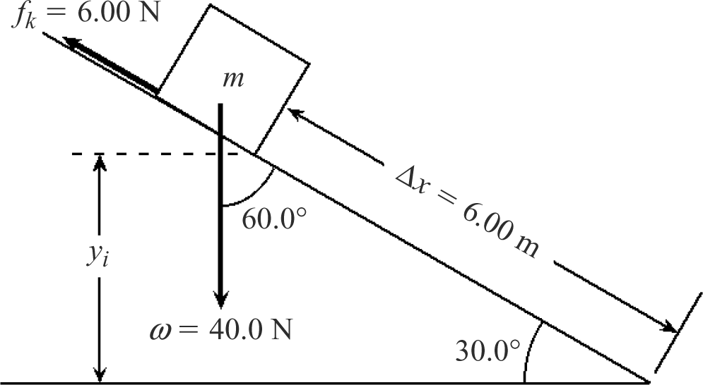
The mass of the crate is
and we may write the work–energy theorem as
Since the crate starts from rest,
and we are left with
so
and
making choice (d) the correct response.

4. What average mechanical power must be delivered by the muscles of a 70.0-kg mountain climber who climbs a summit of height 325 m in 95.0 min? Note: Due to inefficiencies in converting chemical energy to mechanical energy, the amount calculated here is only a fraction of the power that must be produced by the climber’s body. See Chapter 12. (a) 39.1 W (b) 54.6 W (c) 25.5 W (d) 67.0 W (e) 88.4 W
We assume the climber has negligible speed at both the beginning and the end of the climb. Then , and the work done by the muscles is
The average power delivered is
and the correct answer is choice (a).

5. The work required to accelerate an object on a frictionless surface from a speed v to a speed 2v is (a) equal to the work required to accelerate the object from v = 0 to v, (b) twice the work required to accelerate the object from v = 0 to v, (c) three times the work required to accelerate the object from v = 0 to v, (d) four times the work required to accelerate the object from 2v to 3v, or (e) not known without knowledge of the acceleration.
The net work needed to accelerate the object from υ = 0 to υ is
The work required to accelerate the object from speed υ to speed 2υ is
Thus, the correct choice is (c).

6. Alex and John are loading identical cabinets onto a truck. Alex lifts his cabinet straight up from the ground to the bed of the truck, whereas John slides his cabinet up a rough ramp to the truck. Which statement is correct? (a) Alex and John do the same amount of work. (b) Alex does more work than John. (c) John does more work than Alex. (d) None of these statements is necessarily true because the force of friction is unknown. (e) None of these statements is necessarily true because the angle of the incline is unknown.
Assuming that the cabinet has negligible speed during the operation, all of the work Alex does is used increasing the gravitational potential energy of the cabinet. However, in addition to increasing the gravitational potential energy of the cabinet by the same amount as Alex did, John must do work overcoming the friction between the cabinet and ramp. This means that the total work done by John is greater than that done by Alex and the correct answer is (c).
7. Mark and David are loading identical cement blocks onto David’s pickup truck. Mark lifts his block straight up from the ground to the truck, whereas David slides his block up a ramp on massless, frictionless rollers. Which statement is true? (a) Mark does more work than David. (b) Mark and David do the same amount of work. (c) David does more work than Mark. (d) None of these statements is necessarily true because the angle of the incline is unknown. (e) None of these statements is necessarily true because the mass of one block is not given.
Since the rollers on the ramp used by David were frictionless, he did not do any work overcoming nonconservative forces as he slid the block up the ramp. Neglecting any change in kinetic energy of the block (either because the speed was constant or was essentially zero during the lifting process), the work done by either Mark and David equals the increase in the gravitational potential energy of the block as it is lifted from the ground to the truck bed. Because they lift identical blocks through the same vertical distance, they do equal amounts of work and the correct choice is (b).

8. An athlete jumping vertically on a trampoline leaves the surface with a velocity of 8.5 m/s upward. What maximum height does she reach? (a) 13 m (b) 2.3 m (c) 3.7 m (d) 0.27 m (e) The answer can’t be determined because the mass of the athlete isn’t given.

Once the athlete leaves the surface of the trampoline, only a conservative force (her weight) acts on her. Therefore, her total mechanical energy is constant during her flight, or . Taking the y = 0 at the surface of the trampoline, . Also, her speed when she reaches maximum height is zero, or . This leaves us with , or , which gives the maximum height as
making (c) the correct choice.

9. A certain truck has twice the mass of a car. Both are moving at the same speed. If the kinetic energy of the truck is K, what is the kinetic energy of the car? (a) K/4 (b) K/2 (c) 0.71K (d) K (e) 2K

, so (b) is the correct answer.

10. If the speed of a particle is doubled, what happens to its kinetic energy? (a) It becomes four times larger. (b) It becomes two times larger. (c) It becomes √2 times larger. (d) It is unchanged. (e) It becomes half as large.

11. If the net work done on a particle is zero, which of the following statements must be true? (a) The velocity is zero. (b) The velocity is decreased. (c) The velocity is unchanged. (d) The speed is unchanged. (e) More information is needed.

The work–energy theorem states that . Thus, if , then or , which leads to the conclusion that the speed is unchanged . The velocity of the particle involves both magnitude (speed) and direction. The work–energy theorem shows that the magnitude or speed is unchanged when , but makes no statement about the direction of the velocity. Therefore, choice (d) is correct but choice (c) is not necessarily true.

12. A block of mass m is dropped from the fourth floor of an office building, subsequently hitting the sidewalk at speed v. From what floor should the mass be dropped to double that impact speed? (a) the sixth floor (b) the eighth floor (c) the tenth floor (d) the twelfth floor (e) the sixteenth floor

As the block falls freely, only the conservative gravitational force acts on it. Therefore, mechanical energy is conserved, or. Assuming that the block is released from rest , and taking y = 0 at ground level , we have that
or and
Thus, to double the final speed, it is necessary to increase the initial height by a factor of four, or the correct choice for this question is (e).

13. A car accelerates uniformly from rest. When does the car require the greatest power? (a) when the car first accelerates from rest (b) just as the car reaches its maximum speed (c) when the car reaches half its maximum speed (d) The question is misleading because the power required is constant. (e) More information is needed.

If the car is to have uniform acceleration, a constant net force F must act on it. Since the instantaneous power delivered to the car is, we see that maximum power is required just as the car reaches its maximum speed. The correct answer is (b).

14. A sledge loaded with bricks has a total mass of 18.0 kg and is pulled at constant speed by a rope inclined at 20.0° above the horizontal. The sledge moves a distance of 20.0 m on a horizontal surface. The coefficient of kinetic friction between the sledge and surface is 0.500. What is the tension in the rope?
a) 59.4 N b) 69.4 N c) 79.4 N d) 89.4 N

(a)

15. A mechanic pushes a 2.50 X 10³-kg car from rest to a speed of v, doing 5 000 J of work in the process. During this time, the car moves 25.0 m. Neglecting friction between car and road, find the horizontal force exerted on the car.
a) 100 N
b) 150 N
c) 200 N
d) 250 N

(a) The work–energy theorem, , gives
, or
(b) , so

16. A 7.00-kg bowling ball moves at 3.00 m/s. How fast must a 2.45-g Ping-Pong ball move so that the two balls have the same kinetic energy?
a) 80 m/s
b) 100 m/s
c) 120 m/s
d) 140 m/s
e) 160 m/s

Requiring that with , we have
giving .
17. A child and a sled with a combined mass of 50.0 kg slide down a frictionless slope. If the sled starts from rest and has a speed of 3.00 m/s at the bottom, what is the height of the hill?
a) 0.459 m
b) 0.487 m
c) 0.919 m
d) 0.989 m
Since no nonconservative forces do work, we use conservation of mechanical energy, with the zero of potential energy selected at the level of the base of the hill. Then, with yields
18. A 2.1 X 10³-kg car starts from rest at the top of a 5.0-m long driveway that is inclined at 20° with the horizontal. If an average friction force of 4.0 X 10³ N impedes the motion, find the speed of the car at the bottom of the driveway.
a) 2.8 m/s
b) 3.2 m/s
c) 3.5 m/s
d) 3.8 m/s

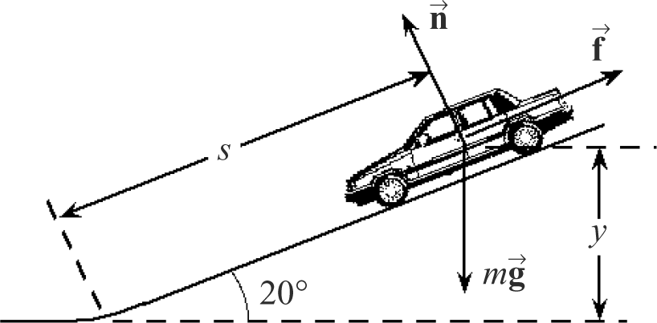
  - Choose PE_{g} = 0 at the level of the bottom of the driveway.
Then becomes
Solving for the final speed gives
or

PART-B: Hand in your solutions to the following questions in class, on Monday 04 October-2010. Show the detailed calculations. Write your final answers in the box.

23. A 2 300-kg pile driver is used to drive a steel beam into the ground. The pile driver falls 7.50 m before coming into contact with the top of the beam, and it drives the beam 18.0 cm farther into the ground as it comes to rest. Using energy considerations, calculate the average force the beam exerts on the pile driver while the pile driver is brought to rest.

The work the beam does on the pile driver is given by
Here, the factor is included because the force F exerted on the driver by the beam is directed upward, but the displacement undergone by the driver while in contact with the beam is directed downward.
From the work–energy theorem, this work can also be expressed as
Choosing y = 0 at the level where the pile driver first contacts the top of the beam, the driver starts from rest at and comes to rest again at at . Therefore, we have
yielding

60. An object of mass 3.00 kg is subject to a force F_{x} that varies with position as in Figure P5.60. Find the work done by the force on the object as it moves (a) from x = 0 to x = 5.00 m, (b) from x = 5.00 m to x = 10.0 m, and (c) from x = 10.0 m to x = 15.0 m. (d) If the object has a speed of 0.500 m/s at x = 0, find its speed at x = 5.00 m and its speed at x = 15.0 m.

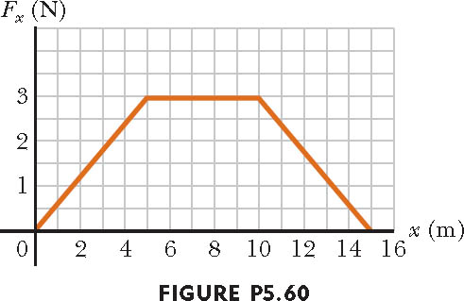
The work done by a force equals the area under
the force versus displacement curve.
(a) For the region ,
(b) For the region ,
- For the region ,
- _{, or}
giving
For :
For :
or

89. Three objects with masses m₁ = 5.0 kg, m₂ = 10 kg, and m₃ = 15 kg, respectively, are attached by strings over frictionless pulleys as indicated in Figure P5.89. The horizontal surface exerts a force of friction of 30 N on m₂. If the system is released from rest, use energy concepts to find the speed of m₃ after it moves down 4.0 m.

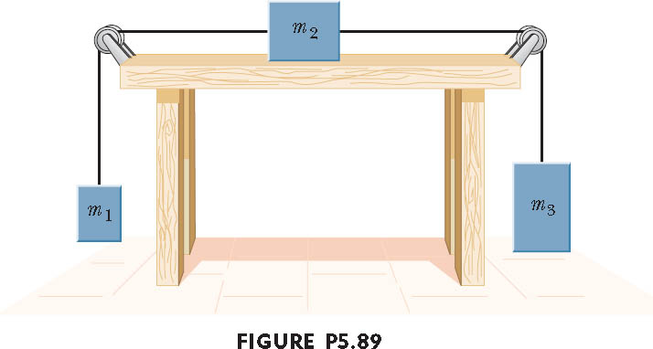

(K_{f} – K_{i}) + ( P_{f} – P_{i}) = -fd
[ 0.5(m₁+m₂+m₃)V_{f}² – 0 ] + [m₁g4 +m₂x0 –m₃g4] = -30x4

….

V = 4.26 m/s

