17th and 18th Century Stage Makeup
Article by Madame Isis

Stage makeup in the 17th and 18th century
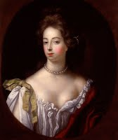
Stage makeup was quite similar to ordinary makeup, especially for young characters. Nowadays stage lighting is much brighter than ordinary lighting, but up until the kerosene lamp was invented in 1783, the stage made use of the same kind of light as everywhere else [natural or candle]. However, the distance between actors and audience made heavy makeup necessary. In England, the Restoration brought a new dawn to the theatre, and for the first time women took to the stage. It might be argued that the increasing popularity for heavy makeup in England was due to ordinary women taking their cues from popular actresses, but that would not explain the same trend in the rest of Europe where actresses had been around for much longer. Samuel Pepys did make note of the heavy makeup used by Nell Gwynne and her co-worker Mrs. Knepp on stage, and how frightful he found it, so it is likely that even if makeup in general had an artificial look, stage makeup went a few steps further.
Red cheeks connoted youthfulness and health, yellow cheeks age and illness. India ink could be used to draw lines on the face to age it and as it was normally the actor or actress who applied their own makeup, personal skill dictated the success of the illusion. Eye makeup, rarely if ever used by the general public, was used on the stage. The eyes were outlined with black and shaded with colored pigment, blue being quite popular. Hair powder was used on the stage as well, and the color of it could be used either to compliment the actor or actress's look, or be chosen to suit the character they played. False facial hair was another means to change an actor’s look.

Makeup tutorial, for men or women

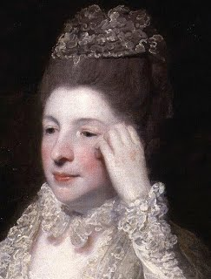
Makeup in the 17th and 18th century was quite simple, but with a very artificial look. The ideal, for both men and women, was a pale face, enhanced with cosmetics aimed to lighten the complexion or with white makeup. Most popular because it was easy to obtain and provided the most opaque coverage was Ceruse, a white pigment derived from lead. Mercury Sublimate was another white pigment, as well as Bismuth, which gives a very shiny, almost metallic whiteness. It was sometimes called "pearl powder," though pearl powder made from real pearls was also available for those who had the means to afford it. It only gives a slight coverage, but the light reflecting particles in it evens out the skin tone and makes it appear flawless. [Ed: see the difference in the pictures above. The woman at left is wearing a lead-based powder. The man at right is wearing a bismuth or pearl powder.] Talc could also be used, and there are makeup recipes that call for a mix of different kinds of white pigment. Both Ceruse and Mercury sublimate are highly toxic substances and can cause several very serious health symptoms and even death -- something that was known, but largely ignored.Â To do a period makeup, most people now turn to white theatreÂ paint. It contains Titanium dioxide which came in use in the 19th century and replaced Lead white. However, Titanium dioxide is 50% more opaque than Lead white and it also has a cold blue undertone, when Lead white has a warmer tone. If one wants to recreate the coverage of Lead white, the best suggestion is to do a 50/50 mix of Titanium dioxide and rice powder. One can either pat the powder onto the face after applying a heavy face cream, like cold cream, which chemically is quite close to the pomatums people used in the 17th and 18th century. One can also add water to the pigment. A period correct way is to cover the pigment with the liquid, stir and let the pigment settle, and then gently pour away the excess liquid. The remaining â€œcreamâ€ can then be applied with a brush.Â Both these methods do demand a bit of work to cover evenly and it is undoubtedly much easier to use a modern white makeup base.

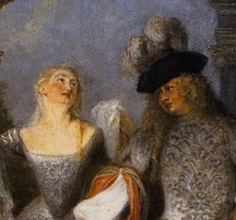
Rouge was used to bring color to the face and could be made from a number of red pigments, both safe and unsafe. Vermillion, Mercury based pigment and red lead are poisonous, but there were also Carmine, derived from a scale insect, and Alkanet root which comes from a plant as well as Red Ochre that all are quite safe to use. In general rouge played a less significant role during the 17th century than in the 18th. Even if there are recipes specifically for red lip paint; rouge was used both on lips as well as cheeks. Rouge was available as liquid, as cream, and dry -- and in several shades like bright red, pink, and more brownish reds.Â For rouge, choose a shade that is red, either in a cool or a warm tone, or a cool pink one. Stay away from brown or apricot shades. Apply generously over the whole cheek, either in a round or an upside down triangular shape. If the rouge is lip safe, one can use that on your lips; otherwise, choose a lipstick in a similar tone. A small mouth was the ideal, but there are no indications that lips were ever painted smaller than they actually were.Â
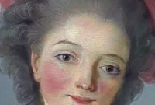

Eyebrows could be darkened --Â Use a black eye pencil to fill in the brows. As with the lips, there is no real evidence that brows were blotted out and repainted higher up on the brow, though that may have happened in the theatre for effect.Â If the makeup is meant for the stage, then use the same black pencil to outline the eyes and paint the eyelids with green or blue matte eye shadow.Â

The crowning glory of the makeup is of course one or several black patches.Â Patches were very popular throughout both the 17th and 18th century, most commonly round and black made out of taffeta, velvet or paper, but larger and more elaborate shapes were also in use.Â Though they were never painted on in the 17th and 18th century, it is perfectly possible to opt for that today, though it is possible to find readymade patches. Personally, I have had good luck with that on Etsy. Glue them on with false-eyelash glue or be period correct and use Mastic or Gum Arabic. In the 17th century the upper classes wore many patches in their face and lower just one or two; in the 18th century it switched and it was seen as a sign of quality to wear a few on well chosen spots, while the lower classes wore multiple patches.Â

At the end of the 17th century hair powder became popular and it kept its popularity for the next 100 years. [Ed: the "white wig" look associated with this period was usually obtained with powders dusted over normal-colored hair, either natural or a wig, rather than from wearing white or grey wigs.] White powder was most common, but it could be mixed with grey, brown and yellow for a more flattering shade. To make the powder stick, as well as keeping the hairstyle in check, pomatums made of such things as lard, suet and bees wax were applied. For the most daring, hair powders in bright colors like blue and pink could be used.Â Hair powder in the 18th century was mainly made from starch and today the easiest way to obtain that is the local food store. Back then the starch mainly came from wheat; today it is easier to find corn starch, but the difference is very small. Do your hairstyle with a soft wax as styling help, and then brush on the powder with a large makeup brush and the powder will stick to the wax. If one wants to use more modern products, white hairspray is available and there is also possible to buy hair powder in spray cans.

18th century cosmetic recipes
Here are a few period makeup recipes which have been updated and modified to make it possible to safely make 18th century style.
- Spanish white, white makeup made with Bismuth
- Nunâ€™s cream, white makeup made Bismuth or real pearl powder and a cream rouge made with carmine.
- French rouge, dry rouge made with starch and carmine.
- Liquid rouge pigmented with Brazil wood and red wine.
- Red lip salve pigmented with Iron oxide (originally red lead).
- Red lip salve pigmented with Alkanet root
- White hair powder
- Brown hair powder
- Pink, yellow and blue hair powder

