Authentic 1920s Makeup Tutorial
Shares548
- 125
- 115
- 23
- 56
- 132
- 97
Most 1920s makeup tutorials online show how to apply 1920’s inspired makeup or looks based off of black and white film movie stars. Both are inaccurate to the real 1920’s. Makeup for the everyday woman was much softer and more natural. This tutorial is about creating the natural 1920s look for both the day and evening. Remember that the more authentic colors and application techniques you use the more authentic the results! The guide included here is based on the 1927 booklet Etiquette of Beauty by Dorothy Cocks.
If you haven’t already, read about the history of 1920s makeup first.
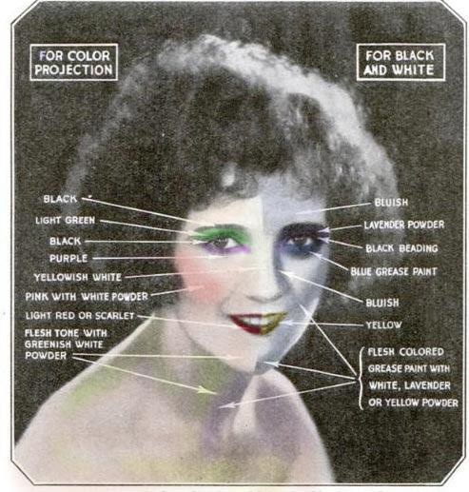
Theater and movie makeup is heavier than real life women’s makeup.

What you need:
- Loose face powder- in your skin tone or one shade lighter for early 20’s looks.
- Liquid Rouge- Red, not pink or orange. Matte, not glitter.
- Black or Brown pencil for eyes and brows
- Matte red lipstick and matching lip pencil
- Black or brown mascara
- Dark matte eye shadow- black, green, or blue.

Step 1. Powder
Choose you day time powder to match your skin exactly. It should be loose in a jar and applied with a fluffy powder puff. Cream based powders or powder compacts are often too thick for the light 20s look. Apply powder in small sections brushing downward following the contours of your face. Powder is not meant to mask your skin but to fill in and even out color and texture.
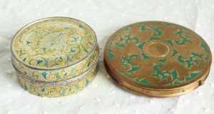
1920s Powder Compacts

Step 2. Rouge (blush)
A day look- Light on powder, heavy on blush and natural red lips.
Apply liquid rouge (rosy red) on a wet cotton ball and blend into a half circle on the center of your check just under the cheekbone. Blend the rouge no further down than the tip of your nose. The wet cotton keeps the edges soft preventing harsh blush lines. Keeping the rouge high on the checks keeps a youthful appearance. If you ears are exposed add a hint of powder rouge to them. Pale ears are considered unsightly. Don’t forget to rouge your knees too!
“Rouge should be applied in the form of a thin crescent moon on each cheek. The center of the crescent comes about on the cheek bone. The cusps fade off as they follow the curve of the cheek, parallel to the eye, back toward the temple and for-ward toward the nose. Put the merest bit of rouge on first, and blend it, blurring the edges till the color is as natural as a blush. Add more rouge, a little at a time, to increase the depth of the tint, if necessary, and keep on adding and blending and blurring, to build up the perfect semblance of youthful color.”
Tip: Round or broad faces should apply the rouge slightly closer to the nose. For thin or oval faces apply rouge further away from the nose. For very long faces ad a dab of rouge to your chin.
Tip: Liquid blush is not easy to find. A theater makeup supply store usually has them. Otherwise a blush creme is your next best choice although still hard to find.
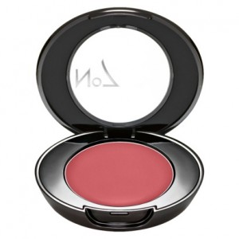
Blush cream is better than powdered blush

Step 3. Lipstick
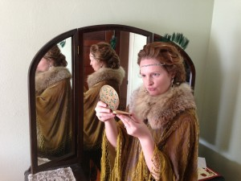
The cupid’s bow lips should look like a kissable pout without pursing your lips.
Lips should be matte red.There are a million shades of red out there. Most can be eliminated because they have some sparkle and to them. Going with a matte red will make all the difference in creating an authentic vintage look. I personally like L’Oreal Infallible Le Rouge Lipstick in “Target Red” that I found at … you guessed it at Target. You may have to try a few shades before you find the right red for your skin tone. Any matte red with a hint of orange or yellow will be the most authentic to the 1920’s. For a daytime look the red should be a bit more natural and for evening a lot more red.
It is very useful to start with a lip pencil first to outline your lip shape and then blend the line downward onto your lip. Top with the lipstick. If you have full lips, line your lips just on the inside edge and if you have thin lips line them just a hair on the outside. Always smudge the lines in towards the lips otherwise the lip pencil line will be too harsh.
Overdrawing the top lip points will makes a “cupids bow.” The effect is to make you look young and child like as possible. You can also play a little trick with your lipstick to enhance the cupid bow lip even more. “If you leave your upper lip free of red in the very center, and arch the color on the curve of the lip on both sides of the center, you make your mouth look most temptingly soft and child-like. There is no means of counting the myriads of women who have practiced that trick since the world began.” The bottom lip if naturally thin can also be overdrawn for more plumpness.
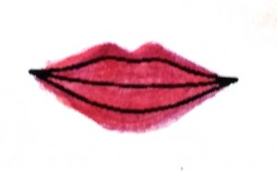
Overdraw lips to form the cupid’s bow on top and fuller lip bottom

Step 4. Eye Makeup
Makeup around the eyes was considered too much for day wear. The following tips should only be applied for formal afternoon parties and evening wear.

Eyebrows
Although arched eyebrows were the style of the 1920’s plucking was discouraged. Instead brows could be shaped with a brow brush. Brush the hairs up from the bottom then down from the top to create the arched line. A small dab of petroleum jelly on the brows will keep them in line and add a bit of shine acceptable for evening wear. Only if you have very thin eyebrows will a pencil be necessary. Keep the color natural. Only black or dark grey hair ladies should use a black pencil.
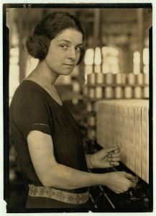
Natural arched eyebrows look best

Eye Lashes
Use a pencil in a shade that matches your natural hair to draw a line along your upper eye lid only continuing past the edge just a hair, no more than 1/4 of an inch. Smudge the line into your lashes. This aids in making your lashes look fuller.
Mascara was used in the late 1920’s. It came in a cake form that had to be applied with a wet brush (similar to the one you shape your eyebrows with.) If you didn’t have the latest makeup fad you could use some brown liquid/cream makeup and apply it first to your fingers then to your lashes by batting your lashes onto your finger. I had to do this the other day when I couldn’t find my mascara and it works quite well. The look is softer and more natural. It makes the middle and tips of the lashes fuller and the inner lashes clear.
Tip: Go ahead and use your normal mascara in a tube. It is a lot easier than brushing on powder.
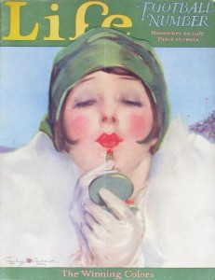
Just a smudge of eye shadow on the lash line and bright red lips goes a long way

Eye Shadow
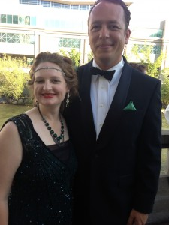
Evening Makeup is Bold with Very Red Lips and Darker Eyes
A touch of black or other dark color eye shadow right against the upper lash line with bring out the brightness of your eyes. Don’t apply the shadow all over you lids or on your lower lid at all. In fact to lighten the harshness of eye shadow it is a good idea to apply face powder over the eyelids including the shadow you just applied. It softens the look. Only movie and film stars applied heavy eye shadow which was necessary for filming in black and white.
Color eye shadows were chosen to match eye colors: *
Blue eyes: green or blue eye shadow, brown mascara and eyeliners
Green eyes: grey or green eye shadow, brown mascara and eyeliners
Brown eyes- brown or plum eye shadow, black mascara and eyeliner
Black eyes- a very faint red could be applied.
* In the very late 20’s eye pencils started to come in the colors of eye shadow which was an option for evening looks. For day time looks, stick to brown or black.
Here is a handy makeup chart I put together.
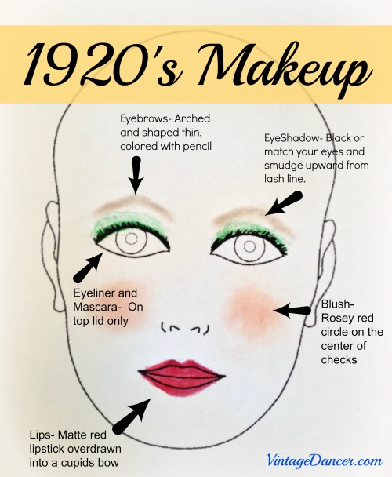
Print, Pin or Save for your next 1920s makeup look
Additional resources:
Retro Makeup: Techniques for Applying the Vintage Look by Lauren Rennells is a great book to have on hand. The looks are a bit more movie star than day wear but the modern techniques are helpful. I love her Retro Hair book too.
Besame Cosmetics- Vintage makeup colors in beautiful cases. I really need to try these someday. Read their guide to 1920s makeup.
Vintage Makeup Guide – 1920s – The best way to learn to apply 1920s makeup is from a direct source (such as what I did for this article.) This downloadable eBook is a copy of a very popular 1920s vintage makeup and beauty routine book. It does into more detail on contouring your face, choosing colors, and basic skin care. Highly recommended.

