Division of Earth, Life & Natural Sciences Biology Department
https://www.hccs.edu/programs/areas-of-study/science-technology-engineering-- math/biology/

BIOL 1407: General Biology II Lecture/Lab **CRN #22674

Fall 2020, 16 weeks

Flex Schedule, Northline Campus, Rm 312
Tue Thurs 7:00am – 8:30am

4 Credit Hours, 96 hours per semester
**All courses will begin in the virtual classroom per HCC administration and return to campus for in person labs (Tuesday or Thursday schedule will be provided) on Monday Oct. 5th
Subject to change per HCC administration**

Instructor Contact Information

Instructor: | Aaron Palmer, M.S.
HCC Email: | aaron.palmer@hccs.edu
Please feel free to contact me concerning any problems that you are experiencing in this course. Your performance in my class is very important to me. I am available to hear the concerns and just to discuss course topics.

Instructor’s Preferred Method of Contact

Please use the "Inbox" feature in Canvas to send emails. You may also email me directly at my HCC email address listed above using your HCC student email account (the one that starts with W followed by your student number). I do not respond to emails from personal accounts such as gmail, hotmail, AOL, etc. I will attempt to respond to emails within 24-48 hours Monday through Friday. I will reply to weekend messages during the following week.

Course Modality
Flex Schedule (FC). The class will be taught online now during the specified class time, BUT the students WILL come back to the campus in October. At that time, all students will be required to show up one of the two class days. The institution will determine who shows up when.

What’s Exciting About This Course

Biology is an endless adventure as there are constantly new developments in this area. This course is fascinating as it is the study of endless forms of life on earth, how organisms evolve, and the interaction between living organisms and how human activities affect this interaction. Learning about the human body’s complex systems enables you to make better decisions for your health and the health of others.

My Personal Welcome

Welcome to General Biology II (BIOL 1407). I am glad you are here!
This course will build on the principles of biology covered in the General Biology I (1406 or 1306). Topics include classification of organisms, organ systems of animals and plants, animal behavior and ecological relationships.

The course is an integration of 2 parts: a standard textbook, and an online course shell. Students are responsible for obtaining and reading the correct textbook and lab manual. The online course shell contains information designed to be an overview of the material covered in the text with added insights provided by the instructor to help you better understand the concepts.

I am excited about teaching this course and delighted that you are going to be part of it. I trust that you will leave at the end of the term with a greater understanding of how to apply principles of Biology to your professional and personal life. In this course, you will have various activities, videos, lecture notes and quizzes to review course material, and interact with your classmates and professor.

Prerequisites and/or Co-Requisites
Recommended prerequisite: MATH 1314 or 1414, successful completion of college algebra or concurrent enrollment in higher-level mathematics is recommended.
Recommended pre or co-requisite: BIOL 1306 1106 Biology for Science Majors I (lecture/ lab) Please carefully read the repeater policy in the HCCS Student Handbook.

Canvas Learning Management System and Computer System Requirements
HCC uses the Canvas learning management system (LMS), which we call Eagle Online. To access Eagle Online, you will need a PC (Windows 7 sp1 or better), or Mac (OS X 10.8 or better) with a broadband connection to the Internet. Use FIREFOX or CHROME as the internet browser.

All biology sections utilize Canvas (https://eagleonline.hccs.edu) to supplement in class assignments, exams, and activities. The biology department requires a computer or iPad with the ability to download the Respondus Lockdown Browser (LDB) software and a webcam for online assessments.
Chromebooks and smartphones cannot be used for graded assessments for which the instructor requires LDB and webcam monitoring. If you do not have the capabilities for LDB with webcam monitoring, live proctoring will be used for graded examinations. Students will use the device to take the exam, but will login to the conference canvas feature using the canvas app on a phone and the phone camera will be used for monitoring. Schedule will be at the discretion of the instructor.
Type Minimum Recommended
PC Users Windows Vista Windows 10 (10 S mode is not supported) Mac Users OS X 10.5 or higher OS X 10.13 High Sierra
Webcam 640×480 resolution 1280×720 resolution Internet Download Speed .768 Mbps 1.5 Mbps

Canvas Browser Requirements:

- Canvas recommends the use of the latest version of any web browser. It’s important to update
your web browser regularly.
- Pop-ups must be enabled. Disable your pop-up blockers.

- Javascript must be enabled
- Cookies must be enabled
- Install the most commonly used internet plugins and keep them updated

Canvas help and information will be found in the “Start Here” module of your canvas course.

Open Lab Locations
HCCS Open Computer Lab locations may be used to access the Internet and Canvas.
USE FIREFOX OR CHROME AS THE INTERNET BROWSER.

HCC Online Information and Policies

For online/hybrid students. As an online /hybrid student, you are responsible for all information/requirements provided by the online college. Here is the link to information about HCC Online classes http://www.hccs.edu/online/. This includes the mandatory online course prior to start of class.

Scoring Rubrics, Sample Assignments, etc.

When applicable, look in Canvas for the scoring rubrics for assignments, samples of class assignments, and other information to assist you in the course. https://eagleonline.hccs.edu/login/ldap

Instructional Materials Instructional Materials Required for the Course

Required Resources

Inclusive Access
Do not purchase a book or access code for this course. You have already paid for your course materials through the registration process. The cost of digital course materials for this class were included in your student bill and are guaranteed to be the lowest cost available to purchase your required materials. Your course materials for this class will be accessed digitally through this Canvas site. NO other purchase is necessary. For students who wish to have a printed copy of the text, an optional low-cost print copy is available for purchase at the Houston Community College Bookstore. You have the right to opt-out and purchase your own course materials if you desire, prior to the official day of record, which is for Fall 2020. It is NOT recommended that you Opt-Out, as these materials are required to complete the course. You can choose to Opt-Out on the first day of class, but you will be responsible for purchasing your course materials at the full retail price and access to your materials may be suspended.

Student Video: How to access eBook Course Materials in Canvas 1111
https://vimeo.com/304674236

The textbook listed below is required for this course and the e-text comes with your course registration. If you choose to Opt-out (not recommend as explained above), you are required to purchase the text.
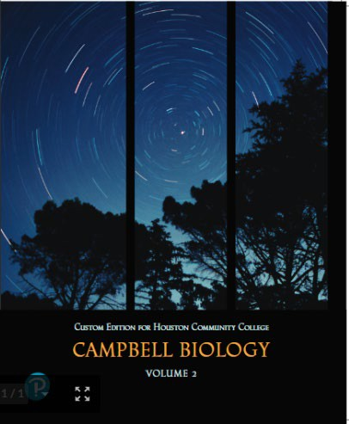
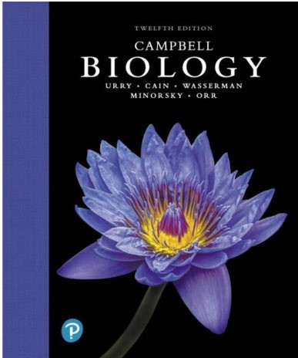
Campbell Biology 12th edition with mastering: Full volume or split volume
Author Edition ISBN
Campbell Biology w/ Mastering (full volume test with chapters for BIOL 1306 and BIOL 1407) | Urry | 12 | 9780135855836

• 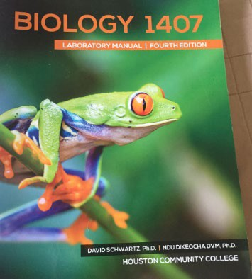

Biology 1407 Lab Manual: Used at Southwest, Northwest and Northeast
- “Biology 1407 Laboratory Manual”, 4th Edition, Blue Door Publishing. ISBN: 978-1- 68135-062-2
For Fall 2020, we will be using the custom-built interactive for this class.

You can visit the Top Hat Overview (https://success.tophat.com/s/article/Student-Top-Hat- Overview-and-Getting-Started-Guide) within the Top Hat Success Center which outlines how you will register for a Top Hat account, as well as providing a brief overview to get you up and running on the system.

An email invitation will be sent to you by email, but if don’t receive this email, you can register by simply visiting our course website in the canvas course shell.

You will enter payment information at the checkout page . Alternatively, if you purchased an access code at the bookstore, you will enter it at checkout. Don’t worry if you don’t see any content in the course right away, I will make it available to you as we progress through the semester.

Should you require assistance with Top Hat at any time, due to the fact that they require specific user information to troubleshoot these issues, please contact their Support Team directly by way of email (support@tophat.com), the in-app support button, or by calling 1- 888-663-5491.
Please watch the following video on how to access your lab manual in Top Hat https://www.loom.com/share/6fb6f96ca1ae49d8a174c5c1f02573b8

Suggested Resources

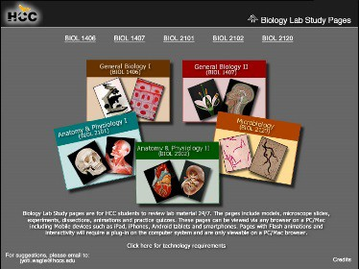
HCCS Biology Lab Study Pages
Click here to access Biology lab study pages online.

Other Instructional Resources

Tutoring
HCC provides free, confidential, and convenient academic support, including writing critiques, to HCC students in an online environment and on campus. Tutoring is provided by HCC personnel in order to ensure that it is contextual and appropriate. Visit the HCC Tutoring Services website for services provided.

Libraries
The HCC Library System consists of 9 libraries and 6 Electronic Resource Centers (ERCs) that are inviting places to study and collaborate on projects. Librarians are available both at the libraries and online to show you how to locate and use the resources you need. The libraries maintain a large selection of electronic resources as well as collections of books, magazines, newspapers, and audiovisual materials. The portal to all libraries’ resources and services is the HCCS library web page at http://library.hccs.edu.

Supplementary Instruction
Supplemental Instruction is an academic enrichment and support program that uses peer- assisted study sessions to improve student retention and success in historically difficult courses. Peer Support is provided by students who have already succeeded in completion of the specified course, and who earned a grade of A or B. Find details at http://www.hccs.edu/resources-for/current-students/supplemental-instruction/.

Course Overview
In BIOL 1407, the diversity and classification of life will be studied, including animals, plants, protists, fungi, and prokaryotes. Special emphasis will be given to anatomy, physiology, ecology, and evolution of plants and animals. Laboratory activities will reinforce study of the diversity and classification of life, including animals, plants, protists, fungi, and prokaryotes. Special emphasis will be given to anatomy, physiology, ecology, and evolution of plants and animals.

Core Curriculum Objectives (CCOs)

BIOL 1407 is a course covers evolutionary theory, including organization, function, evolutionary adaptation, macro and micro evolution, speciation and classification. Animal physiology and homeostasis is also included.

- Critical Thinking: Students will demonstrate the ability to engage in inquiry and analysis, evaluation and synthesis of information, and creative thinking by completing a written assignment such as a book report, research paper, or essay.
- Communication Skills: Students will demonstrate effective development, interpretation and expression of ideas through written, oral, and visual communication by completing a written assignment such as a book report, research paper, or essay.
- Quantitative and Empirical Literacy: Students will explore the scientific research methods that are used in the study of biology. They will be able to interpret numerical data in charts, graphs, and tables that are in their textbooks and other resources. Students should be able to carry out basic mathematical operations: be able to use Hardy and Weinberg equations, calculate percentages, frequencies, complete textbook reading assignments and answer questions on quizzes and exams that pertain to Course Student Learning Outcome # 7
- Social Responsibility: Students will demonstrate the ability to engage effectively in class activities and discussion, complete textbook reading assignments, and answer questions on quizzes and exams that pertain to Course Student Learning Outcome #9 below.

Program Student Learning Outcomes (PSLOs)

Can be found at: https://www.hccs.edu/programs/areas-of-study/science-technology- engineering--math/biology/

Course Student Learning Outcomes (CSLOs)

Upon successful completion of BIOL 1407, students will:
- Describe modern evolutionary synthesis, natural selection, population genetics, micro and macro evolution, and
speciation.
- Describe phylogenetic relationships and classification schemes.
- Identify the major phyla of life with an emphasis on plants and animals including the basis for classification,
structural and physiological adaptations, evolutionary history, and ecological significance.
- Describe basic animal physiology and homeostasis, as maintained by organ systems.
- Compare different sexual and asexual life cycles noting their adaptive advantages.
- Illustrate the relationship between major geologic change, extinctions, and evolutionary trends.
- Apply scientific reasoning to investigate questions and utilize scientific tools such as microscopes and
laboratory equipment to collect and analyze data.
- Use critical thinking and scientific problem-solving to make informed decisions in the laboratory.
- Communicate effectively the results of scientific investigations.

Student Success
Academic standards require a minimum of 3 study hours for every contact hour; meaning for a class that meets 3 hours per week, you need to budget and set aside a minimum of 9 hours each week to study and prep for your course success. Expect to spend at least twice as many hours per week outside of class as you do in class studying the course content. Additional time will be required for written assignments. The assignments provided will help you use your study hours wisely. Successful completion of this course requires a combination of the following:
  - Reading the textbook
  - Attending class in person and/or online
  - Timely completion of assignments
  - Participating in class activities
  - Successful exam performance, including the mandatory final

There is no short cut for success in this course; it requires reading and studying the material using the course objectives as a guide.

Instructor and Student Responsibilities

As your Instructor, it is my responsibility to:
  - Provide the grading scale and detailed grading formula explaining how student grades are to be derived
  - Facilitate an effective learning environment through learner-centered instructional techniques
  - Provide a description of any special projects or assignments
  - Inform students of policies such as attendance, withdrawal, tardiness, and making up assignments
  - Provide the course outline and class calendar that will include a description of any special projects or assignments
  - Arrange to meet with individual students before and after class as required

As a student, it is your responsibility to:
  - Attend class in person and/or online
  - Participate actively by reviewing course material, interacting with classmates, and responding promptly in your communication with me
  - Read and comprehend the textbook
  - Complete the required assignments and exams
  - Ask for help when there is a question or problem
  - Keep copies of all paperwork, including this syllabus, handouts, and all assignments
  - Be aware of and comply with academic honesty policies in the HCCS Student Handbook

Assignments, Exams, and Activities

Assessment: Final grades will be based on the results of:
4 Combined Lecture/ Laboratory examinations/projects (15% each) | 60%
Pearson Mastering Online Homework Laboratory Reports & Laboratory Assignments (15%) | 15%  15%
Cumulative District Final Exam (10%) | 10%
 | 100%

All graded assessments (quizzes and exams) will be taken in the virtual classroom (T/R 7am-8:20am or in person when campus re-opens)

All extra credit points will be available to all students. No extra credit assignments will be given on an individual student basis.

Rounding policy: Mathematical rules of rounding will apply. 0.5 or greater rounds up, less than 0.5 rounds down. Ex: 79.5 rounds up to 80=B, 79.4 rounds down to 79=C.

The grading scale will be the HCCS standard:

90-100% A: 4 points per semester hour
80-89% B: 3 points per semester hour
70-79% C: 2 points per semester hour
60-69% D: 1 points per semester hour
0-59% F: 0 points per semester hour
Withdrawals and incompletes earn 0 points per semester hour

Grading Formula
Grades will be posted in canvas. Final course grades will be posted exclusively in People Soft

Incomplete Policy:
In this course, the purposes of the “I” (incomplete) grade is for students who are caught up and passing at the student withdrawal deadline, and then have a medical or other problem that prevents them from completing the course. If you are not passing at the student withdrawal deadline, you should drop yourself from the course, or you will likely earn an “F.” An incomplete “I” grade will be given only if all of the following conditions are met:
- You have earned at least 85% of the available points by the date that the “I” grade is requested.
- You can provide documentation showing why you should earn an incomplete, such as a doctor's note, etc.
- You must be passing with a grade of “C” or better.
- You must request the incomplete in writing
- In all cases, the instructor reserves the right to decline a student’s request to receive a grade of Incomplete.

HCC Grading Scale can be found on this site under Academic Information: http://www.hccs.edu/resources-for/current-students/student-handbook/

 | Course Calendar
Week 1 | *subject to change *
8-25 | Syllabus/Course Orientation
8-27 | Descent with Modification | Ch 19
Week 2  9-1 | Phylogeny & The Evolution of Populations | Chs 20, 21
9-3 | Phylogeny & The Evolution of Populations (cont)
Week 3 9-8 | Quiz #1 (Darwin and HW Equilibrium)  The Origin of Species | Ch. 22
9-10 | Human Genetics | Lab Ex. #1
Week 4  9-15 | Exam #1 | Ch 19-23 Labs #1 & 2
9-17 | Early Life and the Diversification of Prokaryotes  Prokaryotes | Ch 24  Lab Ex. #3
Week 5  9-22 | The Origin and Diversification of Eukaryotes | Ch 25
 | The Protists | Lab Ex. #4
9-24 | Quiz #3 (Prokaryotes)  The Colonization of Land | Ch 26
 | Fungi | Lab Ex #5
Week 6  9-29 | Plant Structure and Growth | Ch 28
10-1 | Quiz #4 (Eukaryotes/ moving to land)  Plant Responses to Internal and External Signals | Ch 31
 | Kingdom Plantae | Lab Ex #6

Week 7 (expected return to campus for labs n=9 students per day)

10-6 Resource Acquisition, Nutrition, and Transport in Vascular Plants

10-8 Quiz #5 (Plants)

Ch 29

Reproduction and Domestication of Flowering Plants Ch 30
Kingdom Plantae Lab Ex #6

Week 8  10-13 | Reproduction and Domestication of Flowering Plants
10-15 | Exam #2: Early Life/Plant Form and Function
Week 9  10-20 | The Rise of Animal Diversity | Ch 27
10-22 | Quiz #6 (Animal Diversity)  The Internal Environment of Animals: Organization and Regulation | Ch 32
 | Animal Tissues | Lab Ex #8
Week 10  10-27 | Animal Nutrition | Ch 33
10-29 | Quiz #7 (Tissues/ Digestive)  Circulation and Gas Exchange | Ch 34
 | The Circulatory and Respiratory Systems | Lab Ex 9& 10
Oct 30: Last day for Student Withdrawal (after this date a grade WILL be assigned)
Week 11  11-2 | The Immune System | Ch 35
11-4 | Quiz #8 (Anatomy of the heart)  Reproduction and Development | Ch 36
Week 12  11-9 | Neurons, Synapses and Signaling | Ch 37
 | The Nervous System | Lab Ex. #11
11-11 | Exam #3: Animal Form and Function
Week 13  11-16 | Population Ecology and the Distribution of Organisms | Ch 40
11-18  Week 14 | Quiz #9 (Ecology)  Species Interactions | Ch 41
11-23 | Ecosystems and Energy | Ch 42
11-25 | Thanksgiving Holiday
Week 15  11-30 | Global Ecology and Conservation Biology | Ch 43
12-2 | Ecology Project Due (Counts as Exam #4)

Week 16 District final exam (per HCC schedule)

Syllabus Modifications
The instructor reserves the right to modify the syllabus at any time during the semester and will promptly notify students in writing, typically by e-mail, of any such changes.

Instructor’s Practices and Procedures

Missed Assignments
Students are expected to participate in all scheduled examinations. No make-up exams will be given for unexcused absences, excused absences must be accompanied by appropriate paperwork (hospital invoice, doctor’s note, court order, etc). Make-up exams for excused absences will differ in format (essay only) from the scheduled exam and will be arranged on an individual basis within one week of the scheduled exam date. Appointments must be made at the Testing Center 24 hours in advance. No make-up tests will be given greater than one week after the regularly scheduled exam, and the student will receive a ‘zero’ for the exam. If a student arrives late for a scheduled exam, they will receive the time remaining from the official start of the exam. Lecture exams will begin at 2:00
p.m. and will be turned in at 4 p.m. No one may enter and begin the exam after the first person has completed the exam and exited the room. No make-up exams will be administered for quizzes or the final exam(s).

Academic Integrity
Academic dishonesty: Academic dishonesty will result in disciplinary action, including dismissal. If cheating is discovered during assessments an “F” with zero points will be administered for the exam/quiz/homework/lab grade. If this should become a persistent problem, the student will receive an “F” for the course. Please be aware that it is VERY difficult to pass the course with a zero-point exam score.
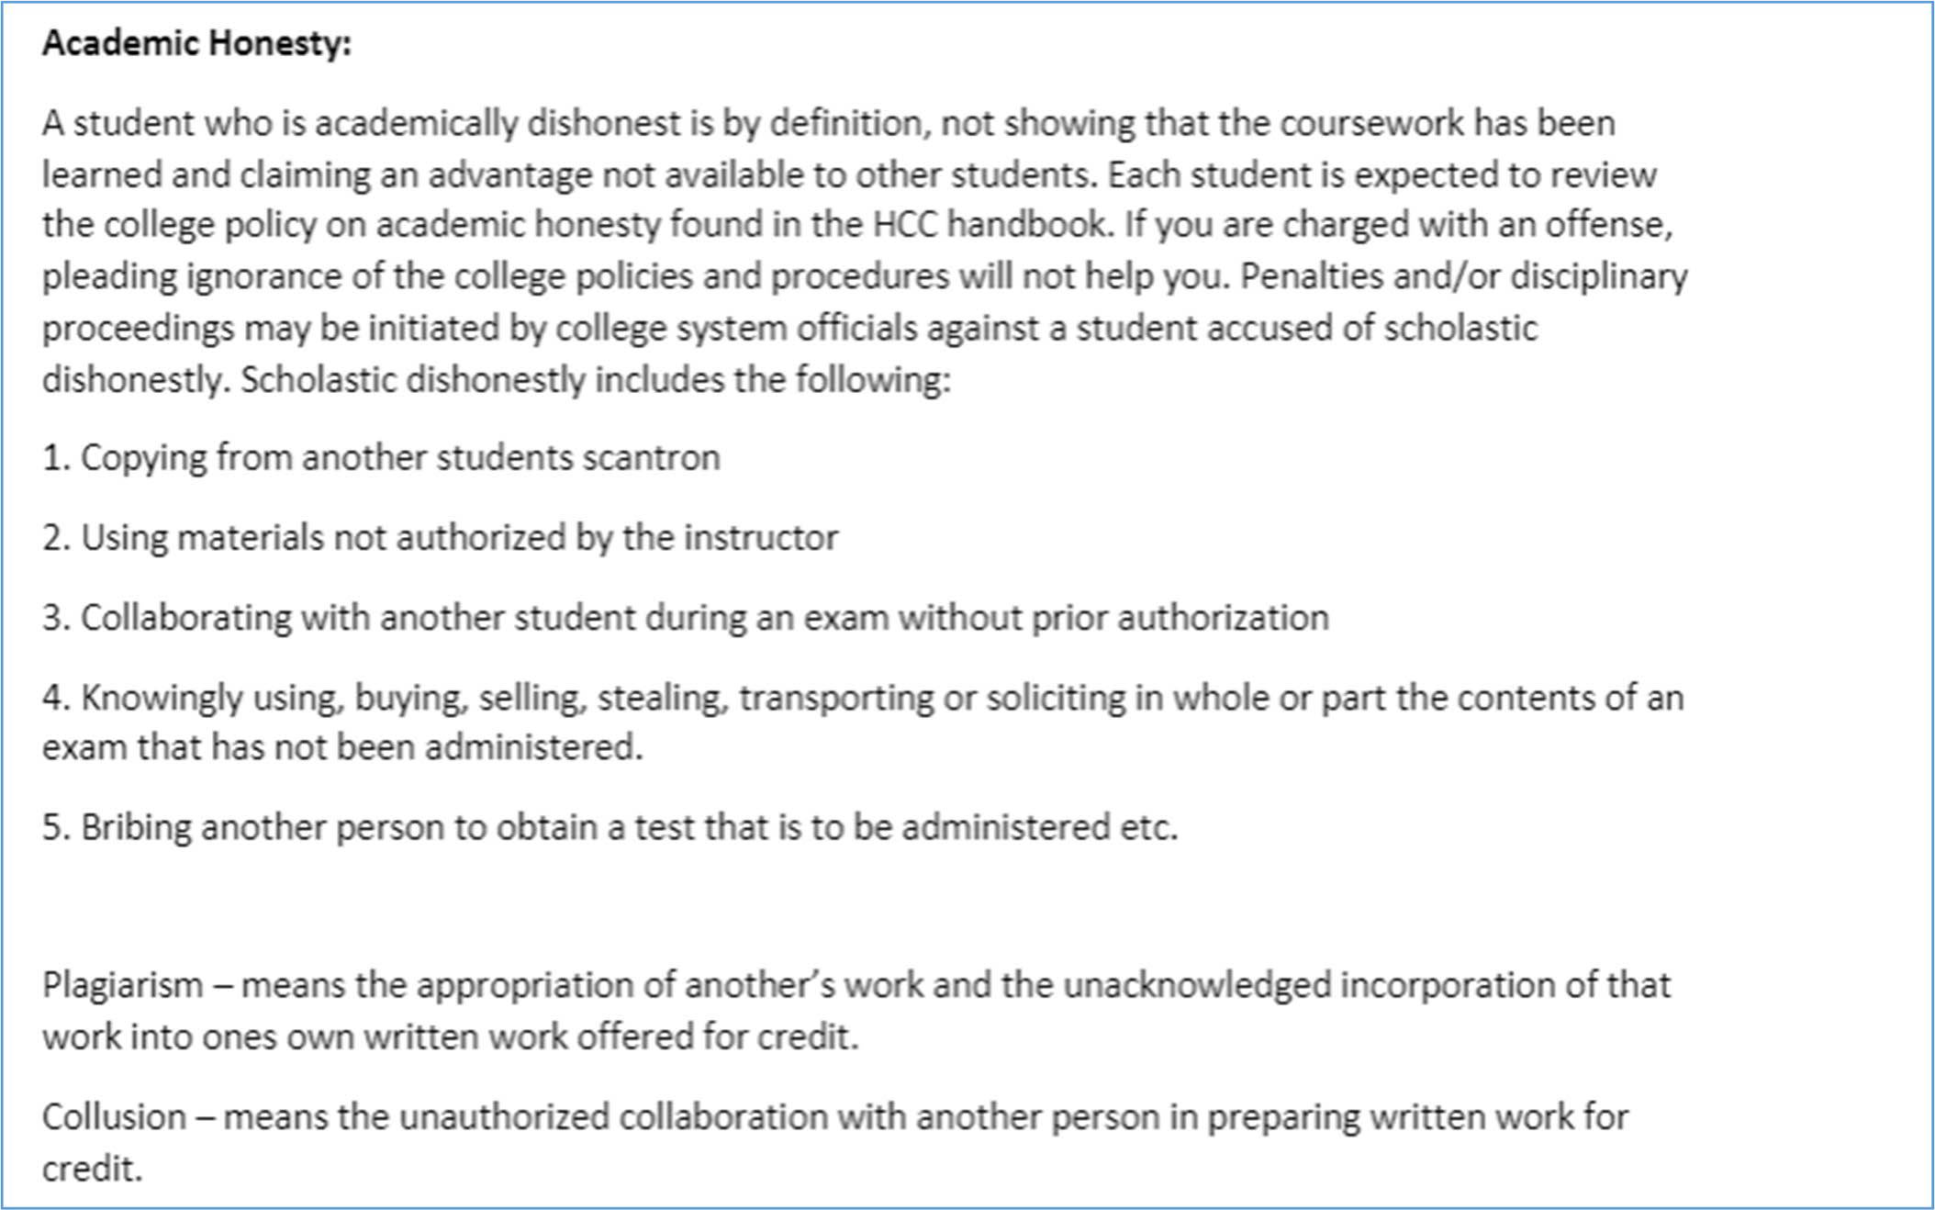

Here’s the link to the HCC information about academic integrity (Scholastic Dishonesty and Violation of Academic Scholastic Dishonesty and Grievance):
http://www.hccs.edu/about-hcc/procedures/student-rights-policies--procedures/student- procedures/

Attendance Procedures
Attendance will be recorded at the beginning of each class period. Students are responsible for information missed due to absence, including information gathered from laboratory exercises. Absence from lab is strongly discouraged. Absence from class does not excuse a student from class work or exams missed. A student who misses four or more classes is subject to administrative withdrawal. Absences are excused in cases of illness verified by a physician, the death of an immediate family member or a problem verified by a police report or court order. Make-up labs are not available. Students who miss lab exercises may consult with other students regarding information missed but will NOT receive credit for lab reports.

Student Conduct
Appropriate student conduct is expected at all times. Disruptive behavior will result in Security.

Instructor’s Course-Specific Information
As a courtesy, please silence cell phones; cell phones must be put away during examinations. Pictures of notes are NOT allowed.

NO EXAM GRADES WILL BE DROPPED; the students will have the option to replace ONE graded lecture examination with the grade earned on the instructor written cumulative final exam (NOT district final exam).

The last day for student/administrative withdrawal is Oct 30th, 2020. Students will not be assigned a “W” after this date. A grade WILL be assigned.

Quizzes will be administered at the BEGINNING of class on the dates indicated on the course schedule. No make up quizzes will be given. Only ONE quiz grade will be dropped.

Biology Program Information
The Biology area of study here at HCC covers the smallest and simplest organisms (microbiology) to the largest and most complex organisms (human anatomy and physiology, zoology, botany).

AWARD TYPES: Associate in Science
AREA OF STUDY: Science, Technology, Engineering & Math

Please visit link: https://www.hccs.edu/programs/areas-of-study/science-technology- engineering--math/biology/

HCC Policies
Here’s the link to the HCC Student Handbook http://www.hccs.edu/resources-for/current- students/student-handbook/. In it you will find information about the following:

- Academic Information
- Academic Support
- Attendance, Repeating Courses, and Withdrawal
- Career Planning and Job Search
- Childcare
- Disability Support Services
- Electronic Devices
- Equal Educational Opportunity
- Financial Aid TV (FATV)
- General Student Complaints
- Grade of FX
- Incomplete Grades
- International Student Services
- Health Awareness
- Libraries/Bookstore
- Police Services & Campus Safety
- Student Life at HCC
- Student Rights and Responsibilities
- Student Services
- Testing
- Transfer Planning
- Veteran Services

EGLS3
The EGLS3 (Evaluation for Greater Learning Student Survey System) will be available for most courses near the end of the term until finals start. This brief survey will give invaluable information to your faculty about their teaching. Results are anonymous and will be available to faculty and division chairs after the end of the term. EGLS3 surveys are only available for the Fall and Spring semesters. EGLS3 surveys are not offered during the Summer semester due to logistical constraints.
http://www.hccs.edu/resources-for/current-students/egls3-evaluate-your-professors/

Campus Carry Link
Here’s the link to the HCC information about Campus Carry: http://www.hccs.edu/departments/police/campus-carry/

HCC Email Policy
When communicating via email, HCC requires students to communicate only through the HCC email system to protect your privacy. If you have not activated your HCC student email account, you can go to HCC Eagle ID and activate it now. You may also use Canvas Inbox to communicate.

Housing and Food Assistance for Students
Any student who faces challenges securing their foods or housing and believes this may affect their performance in the course is urged to contact the Dean of Students at their college for support. Furthermore, please notify the professor if you are comfortable in doing so.

This will enable HCC to provide any resources that HCC may possess.

Office of Institutional Equity
Use the link below to access the HCC Office of Institutional Equity, Inclusion, and Engagement (http://www.hccs.edu/departments/institutional-equity/)

Disability Services
HCC strives to make all learning experiences as accessible as possible. If you anticipate or experience academic barriers based on your disability (including long and short term conditions, mental health, chronic or temporary medical conditions), please meet with a campus Abilities Counselor as soon as possible in order to establish reasonable accommodations. Reasonable accommodations are established through an interactive process between you, your instructor(s) and Ability Services. It is the policy and practice of HCC to create inclusive and accessible learning environments consistent with federal and state law. For more information, please go to http://www.hccs.edu/support- services/disability-services/

Title IX
Houston Community College is committed to cultivating an environment free from inappropriate conduct of a sexual or gender-based nature including sex discrimination, sexual assault, sexual harassment, and sexual violence. Sex discrimination includes all forms of sexual and gender-based misconduct and violates an individual’s fundamental rights and personal dignity. Title IX prohibits discrimination on the basis of sex-including pregnancy and parental status in educational programs and activities. If you require an accommodation due to pregnancy please contact an Abilities Services Counselor. The Director of EEO/Compliance is designated as the Title IX Coordinator and Section 504 Coordinator. All inquiries concerning HCC policies, compliance with applicable laws, statutes, and regulations (such as Title VI, Title IX, and Section 504), and complaints may be directed to:

David Cross
Director EEO/Compliance
Office of Institutional Equity & Diversity 3100 Main
(713) 718-8271
Houston, TX 77266-7517 or Institutional.Equity@hccs.edu http://www.hccs.edu/departments/institutional-equity/title-ix-know-your-rights/

Office of the Dean of Students
Contact the office of the Dean of Students to seek assistance in determining the correct complaint procedure to follow or to identify the appropriate academic dean or supervisor for informal resolution of complaints.

https://www.hccs.edu/about-hcc/procedures/student-rights-policies--procedures/student- complaints/speak-with-the-dean-of-students/

Department Chair Contact Information
Dr. DaeJan Grigsby
Email: daejan.grigsby@hccs.edu Phone: 713-718-7775

