Using Qualifiers to Compose Statements of Cause or Effect
For each event or phenomenon, assess the cause or effect and write a better statement. Use qualifiers in your statement when necessary. The box below lists common qualifiers.
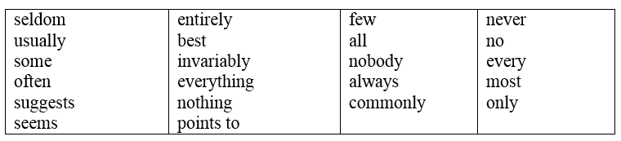

1. Event or Phenomenon: The Braves lost the game.
A statement that oversimplifies: The Braves lost because their key player was off his game.
A better statement: ____________________________________________________________

2. Event or Phenomenon: Marcus failed his Spanish class.
A statement that oversimplifies: Marcus failed his Spanish class because he never studied.
A better statement: _____________________________________________________________

3. Event or Phenomenon: Demetria worked an extra shift.
A statement that oversimplifies: Demetria must have worked the extra shift because she needed more money.
A better statement: ____________________________________________________________

4. Event or Phenomenon: There aren’t many customers at Marco’s restaurant.
A statement that oversimplifies: There aren’t many customers at Marco’s restaurant because nobody likes the new menu.
A better statement:________________________________________________________________

