**9.1 Intro to Algebra**

**Vocab:**

Expression Evaluate Product Quotient less/more than

Equation Substitute Sum Difference of

Variable Coefficient Constant Equivalent is

1. Define Expression, Equation, variable, coefficient, constant, evaluate, substitute.



2. Define the main translation terms needed for algebra.

4. Meredith pays her babysitter $10 per hour. What does it cost her to hire the sitter for m hours?

List on p 616

Examples on p 617

e) The sum of two numbers is 23.

f) 59% of some number is 10.



Additional Examples:

1. The area of a rectangle is the product of it’s length and width. If a rectangle has the length of 24.5 and a width of 8, find the area.

**9.2 The Real Numbers**

**Vocabulary:**

Set Rational Numbers Inequalities

Natural Numbers Irrational Numbers Absolute Value

[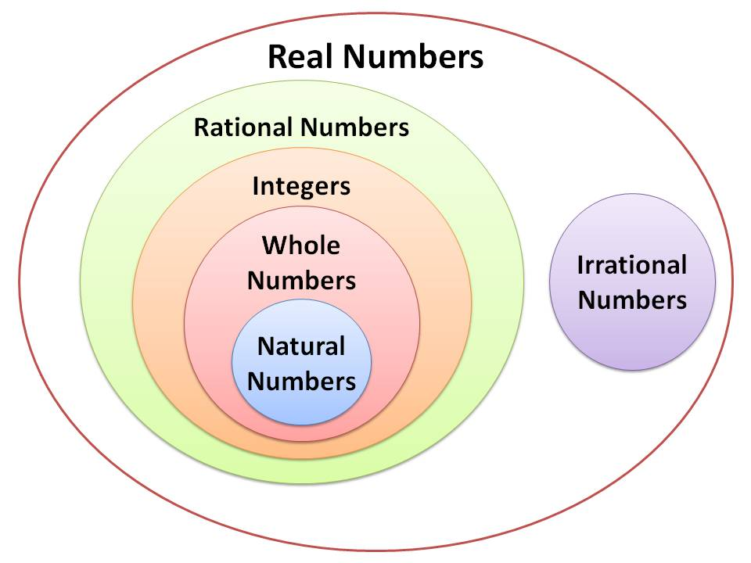](http://rds.yahoo.com/_ylt=A0PDoS4UYBNP6DkAeWCjzbkF;_ylu=X3oDMTBpcGszamw0BHNlYwNmcC1pbWcEc2xrA2ltZw--/SIG=12ffsaldc/EXP=1326698644/**http:/nowiunderstandmath.com/nium_distance_edu_course.html)Whole Numbers Real Number System

Integers Opposites

1. Show the real number system w/ examples.

Natural or counting: 1,2,3,4

Whole: 0,1,2,3,4

Integers: -2,-1,0,1,2,3

Rational: Numbers that can be represented by fractions: can be repeating

Irrational: Numbers that can’t be represented by fractions: non-repeating/

Terminating decimals, square roots of non-perfect squares…



Review…Divide top by bottom.

Define Absolute Value. Also should be review.



**Math 0308 9.3 – 9.4 Adding and Subtracting Integers**

* You can use a number line...start by facing the positive values and move the number that is given to you.

Remember every negative means to **change direction**.

[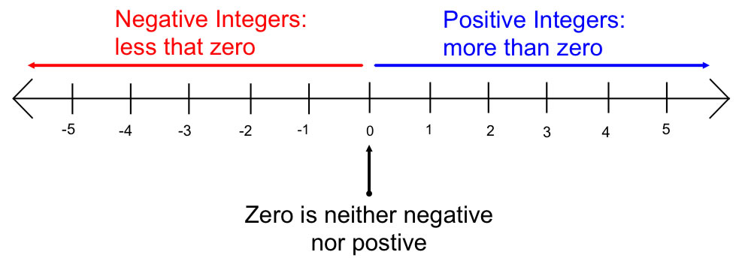](http://rds.yahoo.com/_ylt=A2KJkexujxRPIUEALwajzbkF;_ylu=X3oDMTBpcGszamw0BHNlYwNmcC1pbWcEc2xrA2ltZw--/SIG=13kvr0oqr/EXP=1326776302/**http%3a/mset.rst2.edu/portfolios/a/andriulli_m/instructional_design/midterm/support/integers.html)

**Rule Review:**

* **When signs are the same, add the absolute values and keep the sign.**
* **When signs are different, subtract the absolute values and keep the sign of the larger absolute value.**

1. 8 + (-5) = 11. -5 + (-4) = 21. 14 + 7 + (-4) =

2. -6 – 8 = 12. 13 + (-25) = 22. -9 + (- 4) + (-3) =

3. 15 + (-3) = 13. -4 + 4 = 23. -6 + 10 + (-8) =

4. 7 + (- 8) = 14. -10 + (-10) = 24. 23 + (-6) + 2 =

5. 14 – 17 = 15. 9*x* + (-4*x*) + 3*x* = 25. 4 + (-7) + (-8)=

6. 3*x* + 12*x* = 16. -11*x* + (-9*x*) = 26. -12*x* + (-4*x*) +(*-*5*x*) =

7. (-3) + (-3) = 17. 5*x* + 8*x* + (-5*x*) = 27. -8 – 7 – 12 =

8. 11 + (-14) = 18. 4*a* + 9*a* + (-13*a*) = 28. 5 – 12 + 7 =

9. -12 + (-18) = 19. 20*x* + (- 9*x*) + 3*x* = 29. 6 + (-4) + (-9) + 7 =

10. 1 + (-5) = 20. 6*x* + 12*x* + (-7*x*) = 30. -9 + (-5) + 14 + (-6) =

**Evaluate each expression.**

**Remember that - (-) = +. There must not be a number between the two negatives to use this rule.**

31. 14 – (-5) = 33. –15 – (-7) = 35. 3*x* + 9*x* – (-4*x*) =

32. –(-7) + 18 = 34. 12*x* – (-4*x*) = 36. -8*x* – (-3*x*) –(-2*x*) =

**Substitute the given value for the variable and evaluate. *x = -* 4*, y* = -7, *m =* 3**

37. *x + y*  + 5 = 38. *m* – ( *x*) *=* 39. – (-*y*) + *x* =

**Math 0308 9.5– 9.6 Multiplying and Dividing Integers**

**Rule Review:**

First, Multiply or Divide.

Then count the number of ***negative*** signs....Are there an ***EVEN*** number of ***negative*** signs?

|  |  |  |
| --- | --- | --- |
| **YES** | There are an ***EVEN*** number of ***negative*** signs | the answer is **POSITIVE** |
| **NO** | There is an ODD number of ***negative*** signs | the answer is **NEGATIVE** |

1. 8 (-5) = 11. -5 (-4) = 21. 7 (-4) =

2. -6 (– 8) = 12. 15 /(-5) = 22. -9 (- 4) (-3) =

3. 15 ÷ (-3) = 13. -4 ÷ -4 = 23. -40 ÷ 8 =

4. 7 (- 8) = 14. -10 ÷ (-10) = 24. 2(-6)(2) =

5. -1.4 x 1.7 = 15. 9 (-4) = 25. =

6. 3 *÷ -* 12= 16. -11 (-9) = 26. -12 */* -4 =

7. = 17. 5  *x* 8 x -5 = 27. -8 (– 7)( – 1) =

8. 11 (-14) = 18. 4 / -16 = 28. 5 (– 12)(2) =

9. -12 (-18) = 19. (-2)(- 9)(3) = 29. 6 (-4) (-2)(7) =

10. 1 / -5 = 20. = 30. -3(-5)( 4)(-2) =

**Evaluate each expression.**

**Remember that when you divide you have watch for the zero…**

31. 32.

Watch for the double negative also… Example: -(-3). It is like multiplying -1(-3).

33. -(-4) = 34. -(6)= 35. -(-6)(– 8) = 36. -(2)(-6)(2) =

**Substitute the given value for the variable and evaluate. *x = -* 4*, y* = -7, *m =* 2**

37. (*x)( y)(5)* = 38. *m* / *x =* 39. – (-*y*)( *x)* =

**9.7 Properties of Real Numbers**



**Let a, b, and c be real numbers, variables, or algebraic expressions.**

|  |  |  |
| --- | --- | --- |
| **Property** | | **Example** |
| Commutative Property of Addition | a + b = b + a | 3x + x2 = x2 + 3x |
| Commutative Property of Multiplication | ab = ba | (3 - x)x2 = x2(3 - x) |
| Associative Property of Addition | (a + b) + c = a + (b + c) | (x + 3) + x2 = x + (3 + x2) |
| Associative Property of Multiplication | (ab)c = a(bc) | (3x • 2)(5) = (3x)(2 • 5) |
| Additive Identity Property | a + 0 = a | 7x2 + 0 = 7x2 |
| Multiplicative Identity Property | a • 1 = a | 8y • 1 = 8y |
| Additive Inverse Property | a + (-a) = 0 | 5x2 + (-5x2) = 0 |
| Multiplicative Inverse Property | |  |  |  | | --- | --- | --- | | a • | 1 | = 1 | | a | | |  |  |  | | --- | --- | --- | | (x2 + 3) • | 1 | = 1 | | (x2 + 3) | |
| Distributive Property | a(b + c) = ab + ac  (a + b)c = ac + bc | 3x(5 + 2x) = (3x• 5) + (3x • 2x)  (y + 5)4 = (y • 4) + (5 • 4) |



Basic Factoring can be thought of as “backwards distributive Property”



Review CLT



**9.8 Simplify Expressions and Order of Operations.**

Remember equations are solved and expressions are simplified…



Review Order of Operations

|  |  |
| --- | --- |
| **P** | **P**arentheses first |
| **E** | **E**xponents (ie Powers and Square Roots, etc.) |
| **MD** | **M**ultiplication and **D**ivision (left-to-right) |
| **AS** | **A**ddition and **S**ubtraction (left-to-right) |

PEMDAS





|  |
| --- |
| **Order of Operations** |

|  |
| --- |
| Please complete the problems below. |

|  |  |  |
| --- | --- | --- |
| 1. (73 − 82) − 4 | 2. (3 ÷ 3) + (1 − 6) − 6 | 3. (3 − 3 − 3) |
| 4. (6 × 72) + (7 × 1) − 6 | 5. (5 × 2 − 4) | 6. 92 − 5 × (42 − 52 × 7) |
| 7. (52 × 2) ÷ (4 − 22) + 2 | 8. (6 − 4) × 1 | 9. (1 × 5 + 6) |
| 10. (6 × 62 + 62) + 4 ÷ 2 | 11. (83 ÷ 23) ÷ 1 | 12. (8 − 12 × 3) |
| 13. 6 ÷ (8 − 9) + 7 − 6 | 14. 1 + 92 − (3 × 23) − 7 | 15. (52 − 2) + 5 |
|  |  |  |
|  | | | | |

|  |
| --- |
| **Order of Operations Key** |

|  |
| --- |
|  |

|  |  |  |
| --- | --- | --- |
| 1. (73 − 82) − 4 = 275 | 2. (3 ÷ 3) + (1 − 6) − 6 = -10 | 3. (3 − 3 − 3) = -3 |
| 4. (6 × 72) + (7 × 1) − 6 = 295 | 5. (5 × 2 − 4) = 6 | 6. 92 − 5 × (42 − 52 × 7) = 876 |
| 7. (52 × 2) ÷ (4 − 22) + 2 = 2 | 8. (6 − 4) × 1 = 2 | 9. (1 × 5 + 6) = 11 |
| 10. (6 × 62 + 62) + 4 ÷ 2 = 254 | 11. (83 ÷ 23) ÷ 1 = 64 | 12. (8 − 12 × 3) = 5 |
| 13. 6 ÷ (8 − 9) + 7 − 6 = -5 | 14. 1 + 92 − (3 × 23) − 7 = 51 | 15. (52 − 2) + 5 = 28 |