3.1 The Rectangular coordinate system
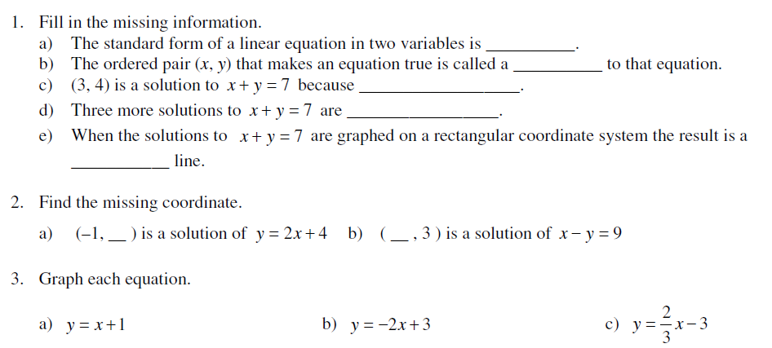
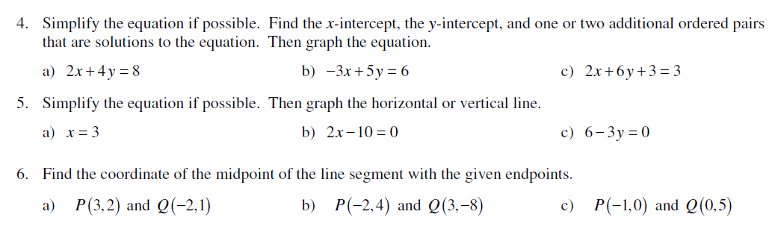

3.2 The Slope of the Line
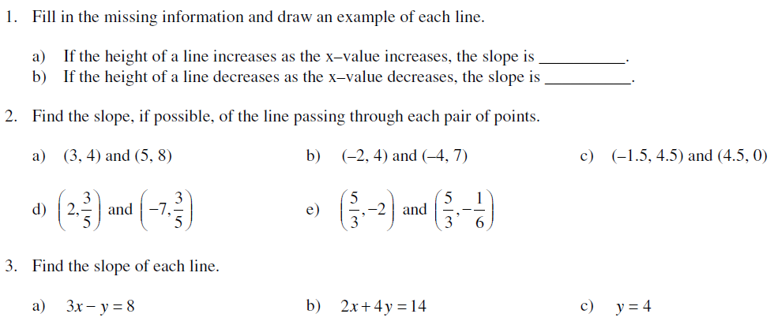

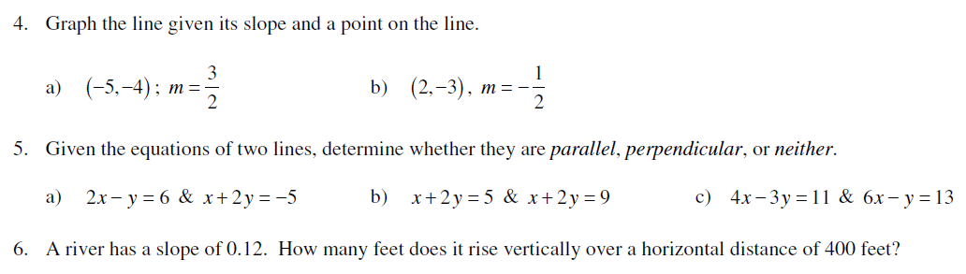

3.3 Linear Equations in two variables
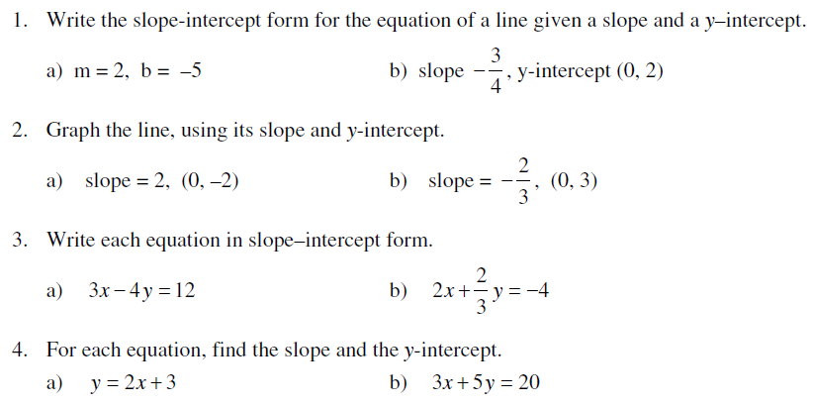
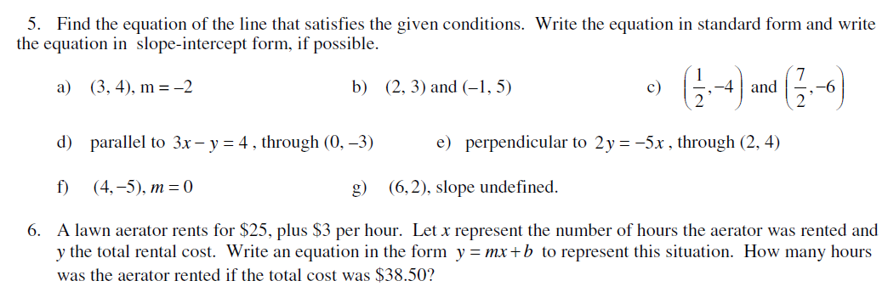

3.4 Linear Inequalities in two Variables
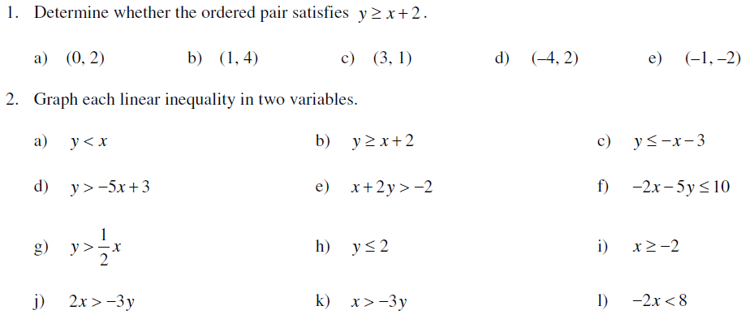
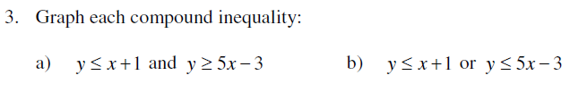
  - 3.5 Intro to relations and functions
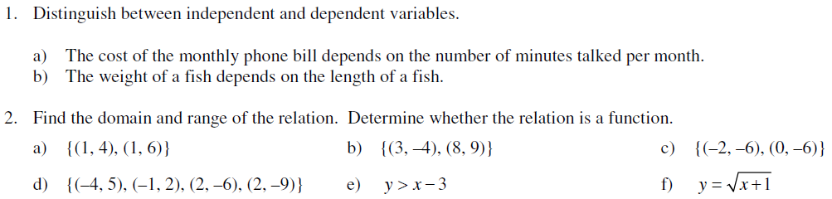
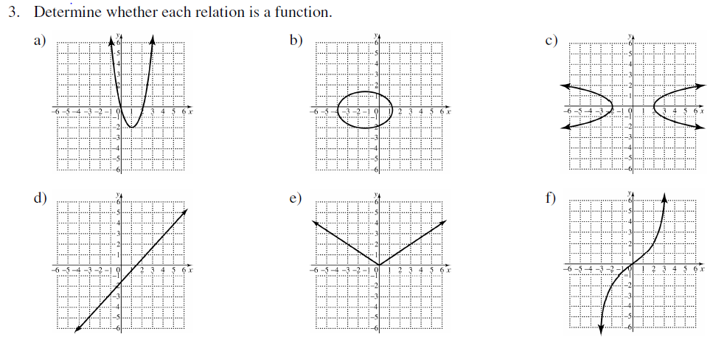
3.6 Function Notation and Linear Functions
