**What is Johari Window?**

**The Johari Window model** is a simple and useful tool for illustrating and improving self-awareness, and mutual understanding between individuals within a group. The Johari Window model can also be used to assess and improve a group's relationship with other groups. The Johari Window model was devised by American psychologists Joseph Luft and Harry Ingham in 1955, while researching group dynamics at the University of California Los Angeles. The model was first published in the Proceedings of the Western Training Laboratory in Group Development by UCLA Extension Office in 1955, and was later expanded by Joseph Luft. Today the Johari Window model is especially relevant due to modern emphasis on, and influence of, 'soft' skills, behavior, empathy, cooperation, inter-group development and interpersonal development.

**The Four Quadrants**:

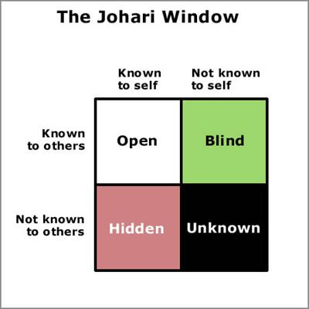**Open** or **Arena**: Adjectives that are selected by both the participant and his or her peers are placed into the **Open** or **Arena** quadrant. This quadrant represents traits of the subjects that both they themselves and their peers are aware of.

**Hidden** or **Façade**: Adjectives selected only by subjects, but not by any of their peers, are placed into the **Hidden** or **Façade** quadrant, representing information about them their peers are unaware of. It is then up to the subject to disclose this information or not.

*Courtesy of Jeff Wheeler*

**Blind**: Adjectives that are not selected by subjects but only by their peers are placed into the **Blind Spot** quadrant. These represent information that the subject is not aware of, but others are, and they can decide whether and how to inform the individual about these "**blind spots**".

**Unknown**: Adjectives that were not selected by either subjects or their peers remain in the **Unknown** quadrant, representing the participant's behaviors or motives that were not recognized by anyone participating. This may be because they do not apply or because there is collective ignorance of the existence of these traits.

https://upload.wikimedia.org/wikipedia/commons/thumb/b/b0/Copyright.svg/197px-Copyright.svg.png**What is Crack the Window**

**Cracking the Window** is the next step to self-awareness and personal growth by developing an action plan for those new personality traits you have now acknowledged.

Ask yourself – What is self-awareness? **Self**-**awareness** is a state in which people are aware of their traits, feelings and behavior. Alternately, it can be definedas the realization of oneself as an individual entity.

How Does Crack the Window work? Crack the Window is the next progression to Johari Window. This is the area in which you do the work. The work being – looking at the new information you have received and acknowledged from your Blind and Hidden self and developing an action plan to incorporate those new or acknowledged traits.

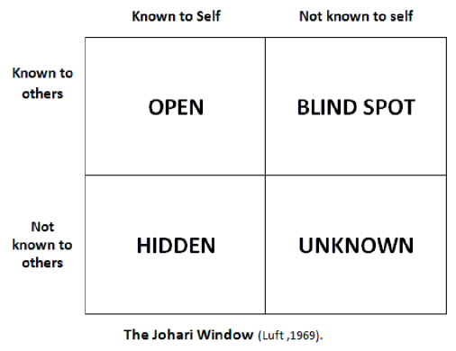

*Action Plan for Self -Awareness*

**Directions**: Using the blank Johari Window below fill in those new character traits that you now acknowledge from your blind and hidden sides. Develop you plan of action to either grow in the open or take time and grow from your hidden side to your open side.

Blind

Open

Unknown

Hidden