Chapter 6 Electronic Structure of Atoms
1) Which one of the following is correct?
A) ν + λ = c
B) ν ÷ λ = c
C) ν = cλ
D) λ = c ν
E) νλ = c

2) Of the following, ________ radiation has the shortest wavelength.
A) X-ray
B) radio
C) microwave
D) ultraviolet
E) infrared

3) The photoelectric effect is ________.
A) the total reflection of light by metals giving them their typical luster
B) the production of current by silicon solar cells when exposed to sunlight
C) the ejection of electrons by a metal when struck with light of sufficient energy
D) the darkening of photographic film when exposed to an electric field
E) a relativistic effect

4) Which one of the following is considered to be ionizing radiation?
A) visible light
B) radio waves
C) X-rays
D) microwaves
E) infrared radiation

5) Of the following transitions in the Bohr hydrogen atom, the ________ transition results in the emission of the lowest-energy photon.
A) n = 1 → n = 6
B) n = 6 → n = 1
C) n = 6 → n = 3
D) n = 3 → n = 6
E) n = 1 → n = 4

6) In the Bohr model of the atom, ________.
A) electrons travel in circular paths called orbitals
B) electrons can have any energy
C) electron energies are quantized
D) electron paths are controlled by probability
E) both A and C

7) According to the Heisenberg Uncertainty Principle, it is impossible to know precisely both the position and the ________ of an electron.
A) mass
B) color
C) momentum
D) shape
E) charge

8) All of the orbitals in a given electron shell have the same value as the ________ quantum number.
A) principal
B) angular momentum
C) magnetic
D) spin
E) psi

9) The de Broglie wavelength of a ________ will have the shortest wavelength when traveling at 30 cm/s.
A) marble
B) car
C) planet
D) uranium atom
E) hydrogen atom

10) The uncertainty principle states that ________.
A) matter and energy are really the same thing
B) it is impossible to know anything with certainty
C) it is impossible to know the exact position and momentum of an electron
D) there can only be one uncertain digit in a reported number
E) it is impossible to know how many electrons there are in an atom

11) All of the orbitals in a given subshell have the same value as the ________ quantum number.
A) principal
B) angular momentum
C) magnetic
D) A and B
E) B and C

12) Which one of the following is not a valid value for the magnetic quantum number of an electron in a 5d subshell?
A) 2
B) 3
C) 0
D) 1
E) -1

13) Which of the subshells below do not exist due to the constraints upon the angular momentum quantum number?
A) 2d
B) 2s
C) 2p
D) all of the above
E) none of the above

14) Which of the subshells below do not exist due to the constraints upon the angular momentum quantum number?
A) 4f
B) 4d
C) 4p
D) 4s
E) none of the above

15) An electron cannot have the quantum numbers n = ________, l = ________, ml = ________.
A) 2, 0, 0
B) 2, 1, -1
C) 3, 1, -1
D) 1, 1, 1
E) 3, 2, 1

16) An electron cannot have the quantum numbers n = ________, l = ________, ml = ________.
A) 6, 1, 0
B) 3, 2, 3
C) 3, 2, -2
D) 1, 0, 0
E) 3, 2, 1

17) Which one of the following is an incorrect subshell notation?
A) 4f
B) 2d
C) 3s
D) 2p
E) 3d

18) Which one of the following is an incorrect orbital notation?
A) 2s
B) 3py
C) 3f
D) 4dxy
E) 4s

19) Which quantum number determines the energy of an electron in a hydrogen atom?
A) n
B) E
C) ml
D) l
E) n and l

20) Which one of the quantum numbers does not result from the solution of the Schrodinger equation?
A) principal
B) azimuthal
C) magnetic
D) spin
E) angular momentum

21) Which quantum numbers must be the same for the orbitals that they designate to be degenerate in a one-electron system (such as hydrogen)?
A) n, l, and ml
B) n and l only
C) l and ml
D) ml only
E) n only

22) In a px orbital, the subscript x denotes the ________.
A) energy of the electron
B) spin of the electrons
C) probability of the shell
D) size of the orbital
E) axis along which the orbital is aligned

23) The ________ orbital is degenerate with 5py in a many-electron atom.
A) 5s
B) 5px
C) 4py
D) 5dxy
E) 5d2

24) Which one of the following orbitals can hold two electrons?
A) 2px
B) 3s
C) 4dxy
D) all of the above
E) none of the above

25) Which quantum numbers must be the same for the orbitals that they designate to be degenerate in a many-electron system?
A) n, l, and ml
B) n only
C) n, l, ml, and ms
D) ms only
E) n and l only

26) Which of the following is not a valid set of four quantum numbers? (n, l, ml, ms)
A) 2, 0, 0, +1/2
B) 2, 1, 0, -1/2
C) 3, 1, -1, -1/2
D) 1, 0, 0, +1/2
E) 1, 1, 0, +1/2

27) Which of the following is a valid set of four quantum numbers? (n, l, ml, ms)
A) 2, 1, 0, +1/2
B) 2, 2, 1, -1/2
C) 1, 0, 1, +1/2
D) 2, 1, +2, +1/2
E) 1, 1, 0, -1/2

28) Which electron configuration represents a violation of the Pauli exclusion principle?
A)
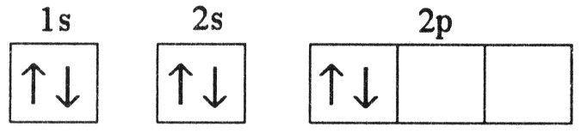
B)
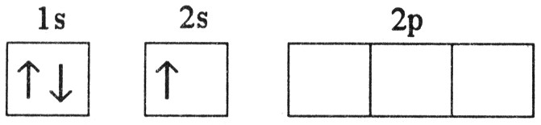
C)
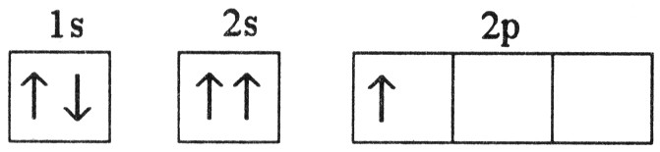
D)
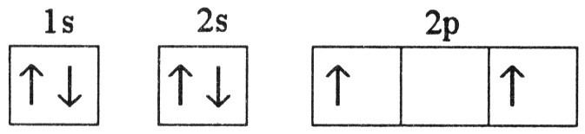
E)
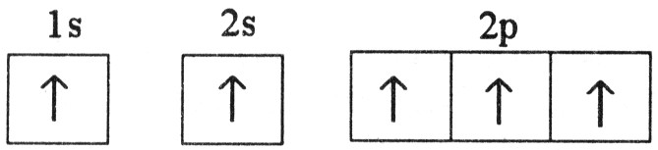

29) Which electron configuration represents a violation of the Pauli exclusion principle?
A)
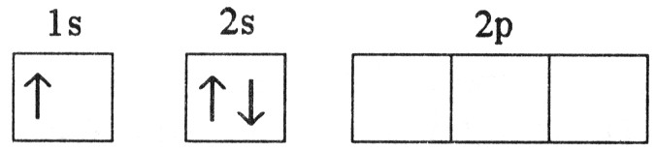
B)
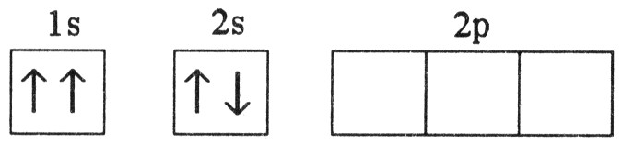
C)
D)
E)

30) Which electron configuration represents a violation of the Pauli exclusion principle?
A)
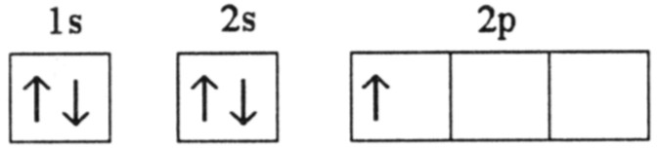
B)
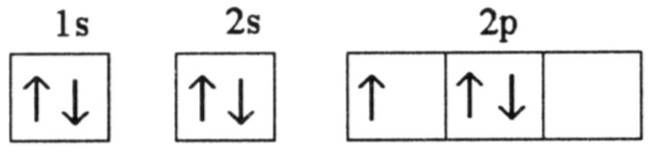
C)
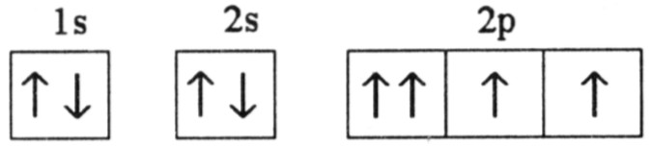
D)
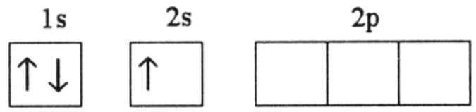
E)
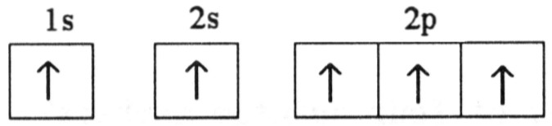

31) The ground state electron configuration of Ga is ________.
A) 1s22s23s23p64s23d104p1
B) 1s22s22p63s23p64s24d104p1
C) 1s22s22p63s23p64s23d104p1
D) 1s22s22p63s23p64s23d104d1
E) [Ar]4s23d11

32) The ground-state electron configuration of the element ________ is [Kr]5s14d5.
A) Nb
B) Mo
C) Cr
D) Mn
E) Tc

33) The ground-state electron configuration of ________ is [Ar]4s13d5.
A) V
B) Mn
C) Fe
D) Cr
E) K

34) Which one of the following configurations depicts an excited oxygen atom?
A) 1s22s22p2
B) 1s22s22p23s2
C) 1s22s22p1
D) 1s22s22p4
E) [He]2s22p4

35) Which electron configuration represents a violation of Hund's rule for an atom in its ground state?
A)
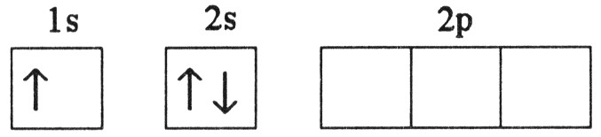
B)
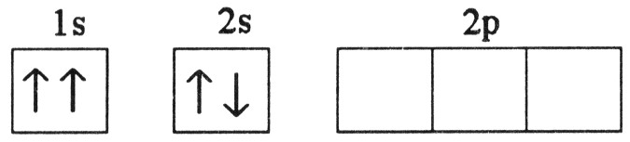
C)
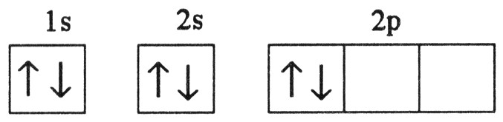
D)
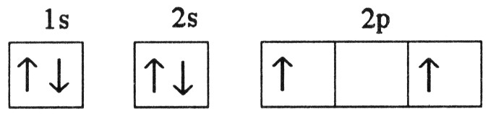
E)
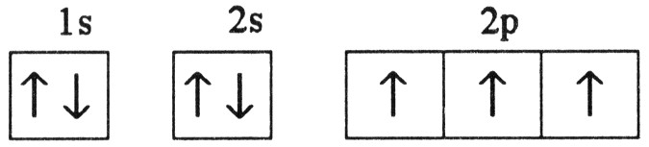
36) Which electron configuration represents a violation of Hund's rule for an atom in its ground state?
A)
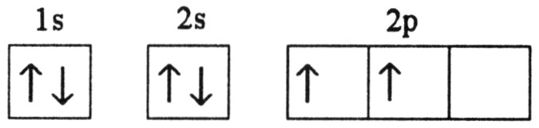
B)
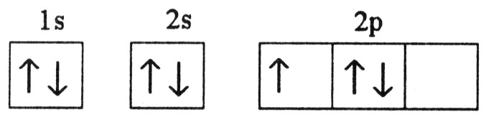
C)
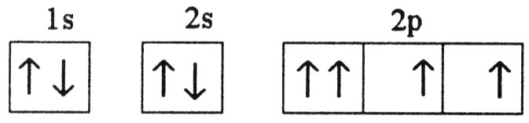
D)
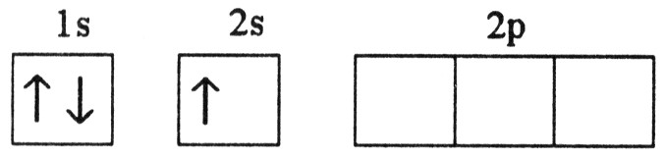
E)
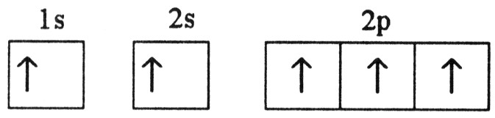

37) Which electron configuration represents a violation of Hund's rule for an atom in its ground state?
A)
B)
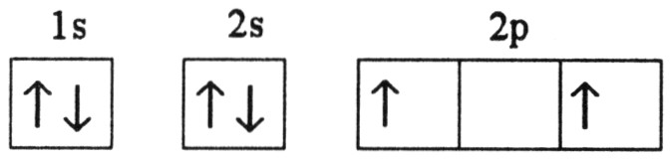
C)
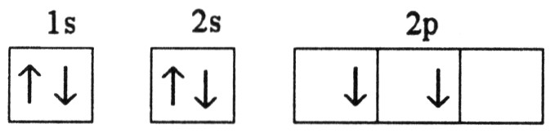
D)
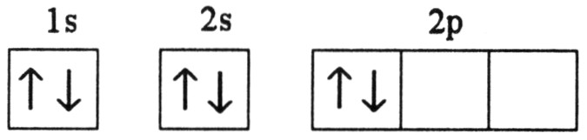
E)
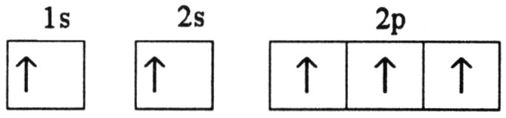

38) The ground-state configuration of fluorine is ________.
A) [He]2s22p2
B) [He]2s22p3
C) [He]2s22p4
D) [He]22s22p5
E) [He]2s22p6

39) The lowest orbital energy is reached when the number of electrons with the same spin is maximized. This statement describes ________.
A) Pauli Exclusion Principle
B) Planck's constant
C) deBroglie hypothesis
D) Heisenberg Uncertainty Principle
E) Hund's rule

40) Which of the following elements has a ground-state electron configuration different from the predicted one?
A) Cu
B) Ca
C) Xe
D) Cl
E) Ti

41) Which two elements have the same ground-state electron configuration?
A) Pd and Pt
B) Cu and Ag
C) Fe and Cu
D) Cl and Ar
E) No two elements have the same ground-state electron configuration.

42) How many different principal quantum numbers can be found in the ground-state electron configuration of nickel?
A) 2
B) 3
C) 4
D) 5
E) 6

43) The valence shell of the element X contains 2 electrons in a 5s subshell. Below that shell, element X has a partially filled 4d subshell. What type of element is X?
A) main group element
B) chalcogen
C) halogen
D) transition metal
E) alkali metal

44) Electromagnetic radiation travels through vacuum at a speed of ________ m/s.
A) 186,000
B) 125
C) 3.00 × 108
D) 10,000
E) It depends on wavelength.

45) The wavelength of light that has a frequency of 1.20 × 1013 s-1 is ________ m.
A) 25.0
B) 2.50 × 10-5
C) 0.0400
D) 12.0
E) 2.5

46) The wavelength of light that has a frequency of 1.66 × 109 s-1 is ________ m.
A) 0.181
B) 5.53
C) 2.00 × 10-9
D) 5.53 × 108
E) none of the above

47) Ham radio operators often broadcast on the 6-meter band. The frequency of this electromagnetic radiation is ________ MHz.
A) 500
B) 200
C) 50
D) 20
E) 2.0

48) The energy of a photon that has a wavelength of 8.33 × 10-6 m is ________ J.
A) 2.20 × 10-26
B) 3.60 × 1013
C) 2.39 × 10-20
D) 2.7 × 109
E) 4.5 × 10-25

49) What color of visible light has the longest wavelength?
A) blue
B) violet
C) red
D) yellow
E) green

50) The energy (J) required for an electronic transition in a Bohr hydrogen atom from n = 2 to n = 3 is ________ J.
A) 4.00 × 10-19
B) 3.00 × 10-19
C) -3.00 × 10-19
D) -7.90 × 10-19
E) 4.60 × 1014

51) The energy (J) required for an electronic transition in a Bohr hydrogen atom from n = 1 to n = 3 is ________ J.
A) -8.90 × 10-1
B) 3.00 × 10-19
C) -3.00 × 10-19
D) 1.94 × 10-18

