- On a certain day, a laboratory barometer indicates that the atmospheric pressure is 764.7 torr. A sample of gas is placed in a flask attached to an open-end mercury manometer (▶ Figure 10.3), and a meter stick is used to measure the height of the mercury in the two arms of the U tube. The height of the mercury in the open ended arm is 136.4 mm, and the height in the arm in contact with the gas in the flask is 103.8 mm. What is the pressure of the gas in the flask (a) in atmospheres, (b) in kilopascals?

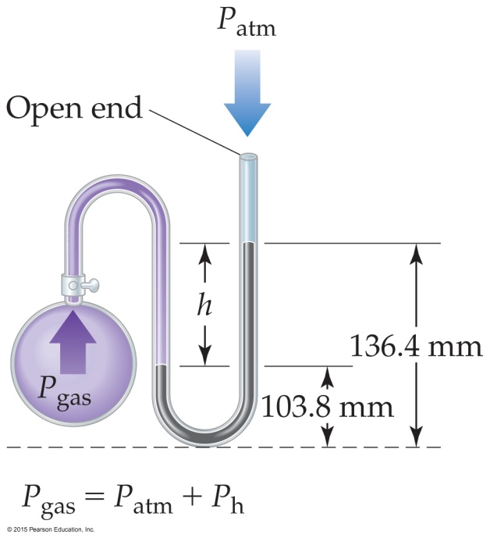

- Calcium carbonate, CaCO₃(s), the principal compound in limestone, decomposes upon heating to CaO(s) and CO₂(g). A sample of CaCO₃ is decomposed, and the carbon dioxide is collected in a 250-mL flask. After decomposition is complete, the gas has a pressure of 1.3 atm at a temperature of 31 °C. How many moles of CO₂ gas were generated?

- The gas pressure in an aerosol can is 1.5 atm at 25 °C. Assuming that the gas obeys the ideal-gas equation, what is the pressure when the can is heated to 450 °C?

- An inflated balloon has a volume of 6.0 L at sea level (1.0 atm) and is allowed to ascend until the pressure is
0.45 atm. During ascent, the temperature of the gas falls from 22 °C to –21 °C. Calculate the volume of the balloon at its final altitude.

