[This article was originally written by Alex Prud’homme for the “New Yorker” magazine in the January 23, 1989 issue. Its audience was for readers in the New York area who want to know the best restaurants, plays and movies to go to. Later on, this article and restaurant inspired an episode of the sitcom “Seinfeld” called “Soup Nazi.”]

New Yorker: The Talk of the Town
January 23, 1989 Issue

Slave
By Alex Prud'Homme
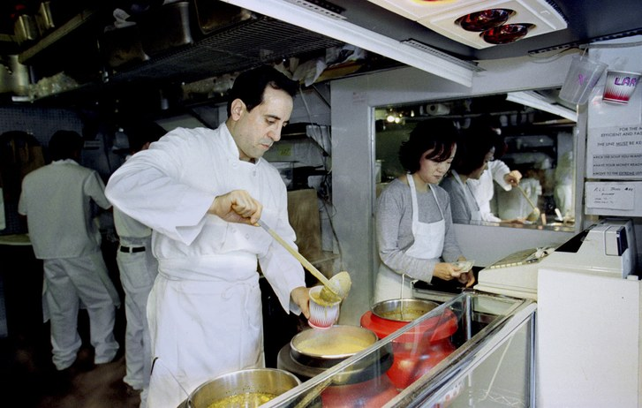
Photograph by Thomas Nilsson
When Albert Yeganeh says “Soup is my lifeblood,” he means it. And when he says “I am extremely hard to please,” he means that, too. Working like a demon alchemist in a tiny storefront kitchen at 259-A West Fifty-fifth Street, Mr. Yeganeh creates anywhere from eight to seventeen soups every weekday. His concoctions are so popular that a wait of half an hour at the lunchtime peak is not uncommon, although there are strict rules for conduct in line. But more on that later.
“I am psychologically kind of a health freak,” Mr. Yeganeh said the other day, in a lisping staccato of Armenian origin. “And I know that soup is the greatest meal in the world. It’s very good for your digestive system. And I use only the best, the freshest ingredients. I am a perfectionist. When I make a clam soup, I use three different kinds of clams. Every other place uses canned clams. I’m called crazy. I am not crazy. People don’t realize why I get so upset. It’s because if the soup is not perfect and I’m still selling it, it’s a torture. It’s my soup, and that’s why I’m so upset. First you clean and then you cook. I don’t believe that ninety-nine per cent of the restaurants in New York know how to clean a tomato. I tell my crew to wash the parsley eight times. If they wash it five or six times, I scare them. I tell them they’ll go to jail if there is sand in the parsley. One time, I found a mushroom on the floor, and I fired the guy who left it there.” He spread his arms, and added, “This place is the only one like it in . . . in . . . the whole earth! One day, I hope to learn something from the other places, but so far I haven’t. For example, the other day I went to a very fancy restaurant and had borscht. I had to send it back. It was junk. I could see all the chemicals in it. I never use chemicals. Last weekend, I had lobster bisque in Brooklyn, a very well-known place. It was junk. When I make a lobster bisque, I use a whole lobster. You know, I never advertise. I don’t have to. All the big-shot chefs and the kings of the hotels come here to see what I’m doing.”
As you approach Mr. Yeganeh’s Soup Kitchen International from a distance, the first thing you notice about it is the awning, which proclaims “homemade hot, cold, diet soups.” The second thing you notice is an aroma so delicious that it makes you want to take a bite out of the air. The third thing you notice, in front of the kitchen, is an electric signboard that flashes, say, “Today’s Soups . . . Chicken Vegetable . . . Mexican Beef Chili . . . Cream of Watercress . . . Italian Sausage . . . Clam Bisque . . . Beef Barley . . . Due to Cold Weather . . . For Most Efficient and Fastest Service the Line Must . . . Be Kept Moving . . . Please . . . Have Your Money . . . Ready . . . Pick the Soup of Your Choice . . . Move to Your Extreme . . . Left After Ordering. ”
“I am not prejudiced against color or religion,” Mr. Yeganeh told us, and he jabbed an index finger at the flashing sign. “Whoever follows that I treat very well. My regular customers don’t say anything. They are very intelligent and well educated. They know I’m just trying to move the line. The New York cop is very smart—he sees everything but says nothing. But the young girl who wants to stop and tell you how nice you look and hold everyone up—yah!” He made a guillotining motion with his hand. “I tell you, I hate to work with the public. They treat me like a slave. My philosophy is: The customer is always wrong and I’m always right. I raised my prices to try to get rid of some of these people, but it didn’t work.”
The other day, Mr. Yeganeh was dressed in chefs’ whites with orange smears across his chest, which may have been some of the carrot soup cooking in a huge pot on a little stove in one corner. A three-foot-long hand-held mixer from France sat on the sink, looking like an overgrown gardening tool. Mr. Yeganeh spoke to two young helpers in a twisted Armenian-Spanish barrage, then said to us, “I have no overhead, no trained waitresses, and I have the cashier here.” He pointed to himself theatrically. Beside the doorway, a glass case with fresh green celery, red and yellow peppers, and purple eggplant was topped by five big gray soup urns. According to a piece of cardboard taped to the door, you can buy Mr. Yeganeh’s soups in three sizes, costing from four to fifteen dollars. The order of any well-behaved customer is accompanied by little wax-paper packets of bread, fresh vegetables (such as scallions and radishes), fresh fruit (such as cherries or an orange), a chocolate mint, and a plastic spoon. No coffee, tea, or other drinks are served.
“I get my recipes from books and theories and my own taste,” Mr. Yeganeh said. “At home, I have several hundreds of books. When I do research, I find that I don’t know anything. Like cabbage is a cancer fighter, and some fish is good for your heart but some is bad. Every day, I should have one sweet, one spicy, one cream, one vegetable soup—and they must change, they should always taste a little different.” He added that he wasn’t sure how extensive his repertoire was, but that it probably includes at least eighty soups, among them African peanut butter, Greek moussaka, hamburger, Reuben, B.L.T., asparagus and caviar, Japanese shrimp miso, chicken chili, Irish corned beef and cabbage, Swiss chocolate, French calf’s brain, Korean beef ball, Italian shrimp and eggplant Parmesan, buffalo, ham and egg, short rib, Russian beef Stroganoff, turkey cacciatore, and Indian mulligatawny. “The chicken and the seafood are an addiction, and when I have French garlic soup I let people have only one small container each,” he said. “The doctors and nurses love that one.”
A lunch line of thirty people stretched down the block from Mr. Yeganeh’s doorway. Behind a construction worker was a man in expensive leather, who was in front of a woman in a fur hat. Few people spoke. Most had their money out and their orders ready.
At the front of the line, a woman in a brown coat couldn’t decide which soup to get and started to complain about the prices.
“You talk too much, dear,” Mr. Yeganeh said, and motioned to her to move to the left. “Next!”
“Just don’t talk. Do what he says,” a man huddled in a blue parka warned.
“He’s downright rude,” said a blond woman in a blue coat. “Even abusive. But you can’t deny it, his soup is the best.” ♦

