Dr. C. Carney Essay # 3
English 1301
Controversial Matters of Ecology
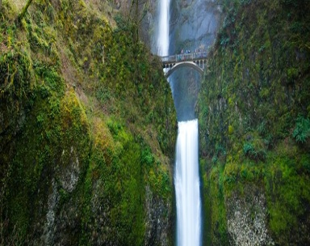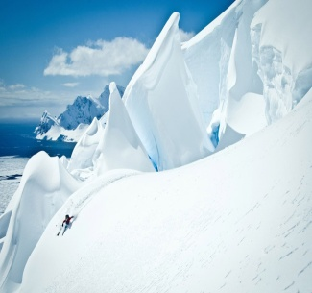
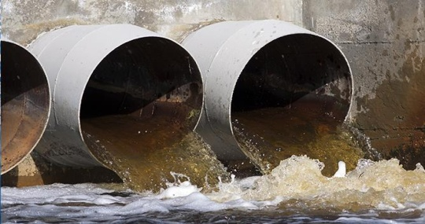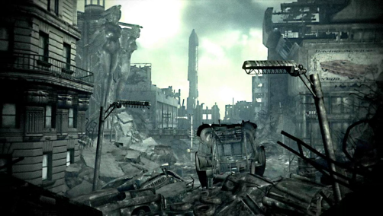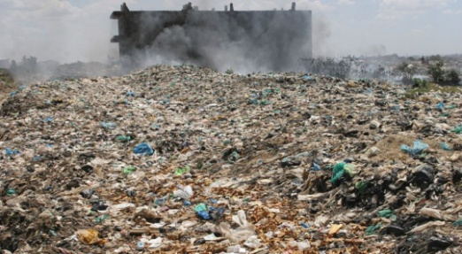

Before we get started: "Global Warming" is not an acceptable topic! As the prompt title denotes, this assignment pertains to genuine, tangible "matters of ecology," such as toxic waste being dumped into rivers and bays, or Cancer-causing toxins polluting the air and soil, or any number of ways poisonous elements affect humans and animals in a variety of specific environments. These are just a few examples of real issues. By sharp contrast, the subject of man-made causes for "global warming" is merely an unproven theory, disagreed with by a vast number of highly credible scientists who attribute natural causes to the very real issue of climate change. Therefore, since it is only a debate of theories and not a provable and tangible issue of cause & effect, the subject of global warming is not an acceptable issue for this assignment. The man-made causes theory of global warming hysteria operates much more like a cult or quasi-religious movement than science (skeptics in the scientific community, who are actually being scientists, are branded by the faithful as "heretics"), and it has also been weaponized into a power-hungry political movement (a movement with totalitarian ambitions). If you doubt this, read the testimony of Patrick Moore. He is a true ecologist and scientist who co-founded "Greenpeace" decades ago and practically founded ecology itself! Sadly, he had to abandon the organization he started because, in his words, "Marxist fanatics, who knew little or cared little about actual ecology, began to infiltrate the organization and take it over." Another way to get a very clear picture of what the global warming movement is really about is by viewing a film titled "The Great Global Warming Swindle" produced by the BBC. You can find on YouTube for free, and then you can decide for yourself if you've been duped by the popular media narrative on the subject. I guarantee it will be an entirely new perspective for you, as it was for me years ago. If you view the film, note the credentials/credibility of all the scientists who are featured in the film.

I. PROMPT
Here is a basic description of what you are asked to do in terms of the thinking processes you should go through as you RESEARCH: First, spend some time researching environmental issues (again, man-made causes of global warming is not a valid issue) and decide on a very specific environmental/ecological problem affecting a very specific region or population. Investigate the current status of the problem, the history of the problem, and efforts--if any--to address the problem to date. Examine the scope and IMPACT of the problem in terms of geographical size, and the people, animals, or living organisms the problem is harming or will potentially harm in the future (again, keeping it focused on a specific place--not a problem affecting regions all over the globe). Try to calculate the financial cost (of the damage). Then, get a sense of any controversy pertaining to the issue--namely, by looking at who caused it, or who is causing the problem now if it is ongoing and currently happening (if human and not merely natural). Try to identify precisely where the controversy lies; determine who is blaming whom for what. Can the accusing party prove it? It may be a whole group of people blaming another person or group of people for the problem, or perhaps nobody is blaming anyone at this point. What solutions, if any, are being proposed? What factors, among the talk about solutions, seems to be missing? NOW....WHAT DO YOU BELIEVE IS THE ISSUE AT HAND REGARDING THIS ENVIRONMENTAL PROBLEM, WHO OR WHAT DO YOU BELIEVE IS TO BLAME, and WHAT SOLUTION TO THIS SPECIFIC PROBLEM ARE YOU WILLING TO ARGUE FOR?
Note the three dimensions to the question above. These are three areas you'll need to address in your essay. Your THESIS needs to concisely capture all of this in one clear sentence!

II. GENERAL GUIDELINES:
READ THE FOLLOWING GUIDELINES CLOSELY!

A) This paper must be written entirely in the THIRD PERSON, and it must also present a focused, well-supported, and opinionated position paper. This is NOT an informative "report" on a topic or a discussion about a controversial issue without taking a position on it! It must be PERSUASIVE, using the appeals of ETHOS, LOGOS, and PATHOS throughout.

B) This Must be a Research Paper! This essay of AT LEAST 5 full pages must include 5-6 VALID SOURCES, with two of these sources being in the form of articles from academic/professional journals that are OBTAINED THROUGH THE HCC LIBRARY DATABASES. The other two sources must be VAILD websites. Q. What does "valid" mean with regard to websites? A. "Valid" here means NOT being in a .com domain for starters! It means the source needs to be in a .org , .gov , or .edu domain. It most certainly means it is NOT a "Wikipedia" page, which is NEVER a valid source for college papers--or any papers for that matter! Books are always valid sources (even in the 21st Century), should you choose to use them; however, books may only replace websites--NOT the academic/professional journal articles! Finally, regarding source types, the film you are asked to watch and reference is automatically one of your sources. I also allow for one more source type, such as another documentary or video; however, remember that these sources cannot replace any of the four required sources, as they can only be added to your list.
About your sources: keep in mind the ever-important rule of quote percentage in your essay! This means the number of words YOU write versus the number of words written by others and quoted in your essay. It is very much possible to fail a paper due to the overuse of sources! In a research paper like this, I consider a 75/25 percentage a "healthy" percentage (75% of all the words in the essay being YOUR words); I am flexible enough in this regard to extend that percentage out to 30% of the words in your essay being from sources if the essay is focused and strong--but not more than that. NOTE: the issue of quote percentage is a different issue entirely from the issue of plagiarism, as a paper with some 65-75% (or higher) of words from others will receive a very low grade, including failure, regardless of whether or not all of those words are cited or not! In other words, while giving credit to your sources is absolutely required and essential to academic integrity, doing so never gives a pass to the OVERUSAGE of sources.
REGARDING PLAGIARISM: It should go without saying in a college classroom, especially because we are in 1302 (ADVANCED Composition) and because we are so far along in the semester, that PLAGIARISM IS ENTIRELY UNACCEPTABLE AND WILL RESULT IN AN F! If you are still unclear about what plagiarism is, or what my policies are regarding this serious academic offense, read my "Behaviors" doc on Learning Web or read the official HCC policy. You can also view specific videos on the subject in the Canvas Media Gallery. There is also a plethora of information about plagiarism online as well, namely on YouTube, so students found plagiarizing (and subsequently failing) have no excuse. My opinion: If a student is a chronic. intentional plagiarizer, as opposed to someone who may accidentally plagiarize due to misunderstanding MLA rules, then he or she has no business being in college! Such a person is either so pathologically dishonest or shockingly incompetent (or both) that obtaining a college degree is an irrelevancy in light of a much larger problem they need to address first!
C) This Paper Must be Strictly MLA-Formatted! While it naturally goes without saying that the formatting of the paper (margins, spacing, font, pagination, title, and heading) must be in strict compliance with MLA, this paper must likewise comply with MLA requirements regarding the use of your sources--both WITHIN the essay and on the "Works Cited" page. NOTE: Essays without a correctly-formatted "Works Cited" page will NOT BE ACCEPTED until they have this essential part of a research paper! Thus, papers without this component will receive late penalties daily until the problem is corrected--or until the penalties dissolve any and all possible points that may be earned for the assignment!
Fact: the MLA provides THREE valid ways in which to cite sources within your essay: 1. in-text direct quotes of four lines or less; 2. block quotes of more than four lines; and 3. paraphrasing (putting other peoples' words into your own words and not using quotation marks). HOWEVER, while these are all perfectly valid and good ways to cite sources, I am limiting these options down to only ONE ACCEPTABLE way of citing sources in this particular essay, and that is through the first of these options: through in-text, direct quotes of less than four lines. This means that ALL of your references to sources must be in the form of short direct quotations that reside within your paragraphs (i.e. "in-text"), and not in large blocks of text that are set apart from your paragraphs. It also means that you are NOT permitted to put the words of your sources into your own words anywhere in the essay! Again, while paraphrasing is a wonderful MLA option for experienced writers who have mastered the ability to quote first, it is also the option that leads to many of the "accidental plagiarism" cases I encounter. I call paraphrasing "skating on the thin ice of lake plagiarism" because many well-intentioned students have "fallen through the ice" due to nothing more than their inability and/or inexperience with using sources and attempting to apply the citation method that is actually the most challenging of the three (many students incorrectly perceive paraphrasing as the "easiest" of the three).
Applying this rule of only using short, in-text quotes will make accidental plagiarism much less likely because the essay will consist of your words being your words for the majority of it. Then, when you cite a source as a direct quote within your paragraphs, the words of the person you quote will be clearly distinguished from your words! Following this rule throughout, and making an effort to reduce the content of your quotes to the most essential bits, will also assure you of not over-using your sources (see 75/25 percentage rule above).
III. OVERVIEW
1. Research and Identify a Very Specific Ecological Issue (specific problem, specific place, specific entity affected);
research and understand the definition of ecology; research and understand the larger scope of the problem itself (parties involved, laws/policies that are currently in place--laws of the specific region or country); research similar environmental problems--perhaps in other locations for comparative purposes.
2. Discuss the controversy/argument. Why is it controversial? How diverse are all of the various positions, or views, on the matter? What arguments are being made regarding the issue? What is the economic impact? What is the environmental impact? What is the political impact? What is the legal impact?
3. Identify and articulate your position. Be sure you are truly weighing-in on the subject and not merely operating like a reporter of a "controversial issue" from a neutral standpoint. Form a debatable thesis.
4. Research thoroughly once your position is established and look for sources (experts and data) that BOTH support your position AND accurately/strongly represents views of opponents.
5. Write a persuasive and focused argument that appeals strongly to ethos (credibility), logos (logic), and pathos (emotion)

