Dr. C. Carney / English 1301 / Essay # 3: Opinionated Research Paper on the Food Industry
1. First, we will watch the above documentary in class: What the Health!
This documentary officially begins this assignment because we will view it in class. As the name of the assignment denotes, and from the image above, this opinionated research paper (not merely an informative research paper) will pertain to the food industry, broadly speaking. It also extends, naturally, out to the areas of health and nutrition. The film above will also be your first official source in this assignment—a source everyone must use/cite in their paper.
2. Second, you will select a second documentary to view on your own.
In addition to What the Health, everyone will need to select and frequently use a second documentary from the list of 12 other documentaries provided on page two of this handout. The choice you make regarding the second documentary needs to occur after you view What the Health. Why? Because What the Health presents a virtual buffet line (pun intended) of issues related to the food industry, and the second film you select should be much more focused and in-depth—pertaining to one specific issue you discover in What the Health, Food INC * or Food Matters **. This is why you need to wait until you have identified a specific issue you plan to pursue in order to make your choice of a second documentary (two documentaries are required: What the Health AND another of your choice from the list).
* What the Health, in terms of structure, is very much like Food INC insomuch as it is likewise a “buffet line” documentary that covers many issues but doesn’t plunge too deeply into any one of them. While it is an excellent documentary, I would only recommend it to look for more topics if you do not find one in What the Health. It will not necessarily serve you well (pun intended again) to make this your second-choice film, only because it does not provide enough depth into any of the topics it covers. Again, for the second film/source, you should find one that plunges deep into the topic.
** Food Matters, like Food INC and What the Health, is yet a third film that covers multiple issues broadly as opposed to one issue in depth.
So, once you have found an issue (it needs to be a clearly-identified issue presented in the film What the Health, Food INC, or Food Matters), you then need to do some general Google/web research about the list of other documentaries (read summaries/comments about them).
Accessing the second film: The films below are available through a variety of mediums—Netflix, Hulu, Amazon, and Apple Movies. First, consider which of these options you personally have and try to see the film on your own; then consider friends or family who may have options to access these films that you do not (and consider bringing the healthy snacks to them and make it a party!)
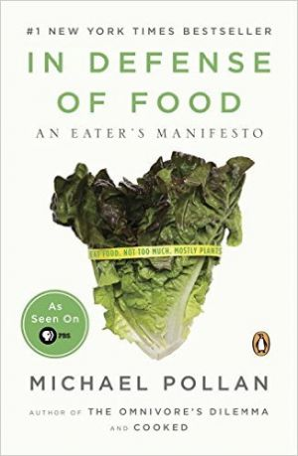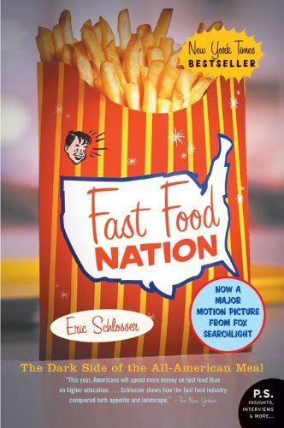
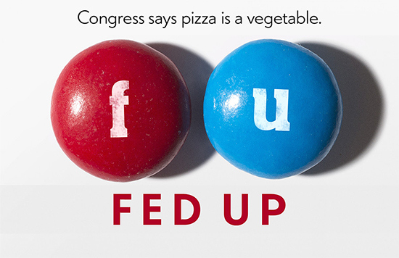
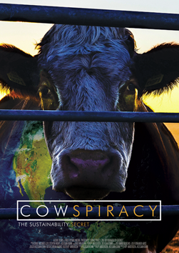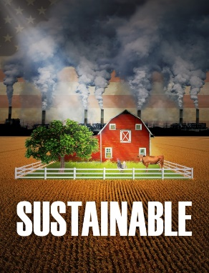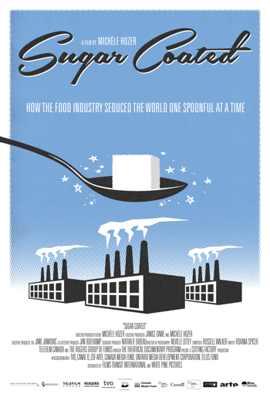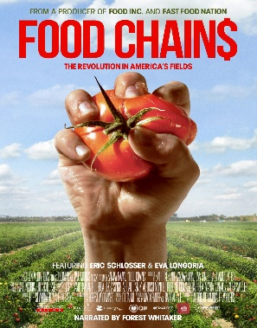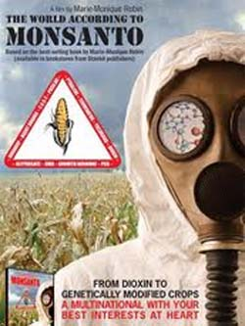
Farmageddon; Vegucated; Food, INC.; FED UP; FOODMATTERS; Forks Over Knives; Hungry for Change; Fat, Sick, and Nearly Dead; In Defense of Food; Fast Food Nation; Cowspiracy; Sustainable; Sugar Coated; Food Chains; The World According to Monsanto. Keep in mind the fact that several of these in-depth documentaries provide insightful content that transfers over to many issues beyond the film titles!
3. Forming Your Argument: Once you’ve made that decision and watched your second film, you will begin developing an opinionated argument paper that pertains to the specific issue you’ve identified. I am assuming you’ll take detailed notes on both films, since you are expected to cite them as sources in your paper. By “issue,” I mean a very specific and clearly-identified problem related to food or nutrition that you believe needs to be addressed.
NOTE: My overall evaluation will be based, in part, on the decision you make for the second film—in light of the issue you identify in What the Health (Food INC or Food Matters), AND the frequency to which you refer to particular individuals from the two documentaries and paraphrase what they say correctly.
4. Essay Objective: The focus of this argument essay will be to argue for a specific SOLUTION to the very specific problem you found and explored in the two films; it should be a solution you construct in your own mind and explain in this essay—attempting to convince your readers to accept. Hence, this is why the paper is called a PROPOSAL ARGUMENT and it should be very unique to you.
The introduction for an argument/paper like this should clearly identify the problem as you see it, along with naming one or both of the documentaries from which you learned about the existence of the problem. Feel free to articulate and/or define the problem as you see fit, provided you accurately express/represent what the documentaries say (this means you are likewise free to have views that are contrary to the documentary—but not necessary by any means).
The body of this essay should build your case with factual and opinionated information (the technical term for this activity in arguments is “inductive reasoning”). As you do this building of your case for a solution to the problem you’ve identified, you should make every effort you can to appeal to your audience on the basis of ethos (credibility), logos (logic), and pathos (emotion). The body of the paper should involve providing your readers with the most thorough and clearly-articulated explanation of the problem and your proposed solution to that problem (logos); your strongest and most convincing points must absolutely be supported by voices of authority/experts/sources beyond yourself (ethos), and the ethos/logos appeals are only effective if you can move your readers emotionally (pathos) throughout the essay (be creative in how you achieve this). For much more information on these three appeals, refer to the links I have provided in this essay folder on Learning Web. Finally, your conclusion should be your last pitch—your last opportunity to “close the deal” as it were and get your readers on board with you! It involves briefly walking your readers back through where you’ve just taken them, and reminding them that your specific solution to the specific problem you’ve addressed in the essay is the only sensible option!
5. Consider Your Opponents: Like anyone who plans to solve a problem of any kind, you should anticipate a range of opposing views. There are those who might generally agree with your feelings about the nature of the problem, yet who would differ with you regarding the details of your proposed solution. Then there are those who adamantly disagree with both your definition of the problem AND everything about your plan to solve it! Your essay should consider the broad range of possible responses to what you call a problem and how you propose to address the problem.
6. Regarding Sources:
Important Rule of Thumb: Sources in a paper are designed to support you, the author, as you orchestrate the argument—not the other way around! Source references should always serve to reinforce what you say in your thesis statement and all supporting points (logos appeal)! Even source references of opposing views, which must be included in every good argument btw, serve the same purpose of supporting the points you make in the essay as those sources that align with your views because you are willing to state that what they are saying is true (ethos appeal).

Required Sources (6): In addition to the two films you are expected to use (you spent the time watching them, so you should definitely plan to use them), you’ll be adding two articles and two websites with high levels of credibility (ethos). The two articles must come from academic/professional journals and the two websites must be from either .org, .gov, or .edu domains (NO .com domains).
NOTE: all citations to these sources, both in the essay—through short direct quotes—and on the Works Cited page, will need to be in strict adherence to MLA guidelines.

a. ARTICLES: The articles you need to use must be from academic and/or professional journals, obtained through the library databases. While there are generic databases, such as one called “EbscoHost”, that serve as sort of “one stop shop” for “peer reviewed” articles that cover all sorts of topics, I would strongly encourage you to focus on the particulars of your specific area of interest, or issue, and let that be your guide in determining more focused databases that go much deeper (i.e. databases devoted entirely to subjects like agriculture, nutrition, and public policy). The librarians are quite helpful in guiding you to such resources, so don’t hesitate to ask.

b. WEBSITES: The website(s) you choose should be a “.org” domain, as they should be non-profit organizations devoted to the kinds of issues discussed in the documentaries. In this essay folder on Learning web, I have provided several links to resources that will help you determine the credibility of websites, and you should definitely plan to use the checklists contained in them to determine whether or not your selected website(s) are indeed credible enough to use in your paper.

7. Basic Information:
* 5-6 Full Word Processed Pages in correct MLA format. This is not including the Works Cited page,
* Clear hardcopy evidence of the Writing Process and the Research Process (this should include notes on the various questions you asked/answered as you researched, various leads you pursued as you attempted to get answers, source information for sources you pursued, and anything else that comprises your research log).
* Final Draft submitted to turnitin.com

8. “Systems Thinking” and This Assignment: By this point in the semester, you have hopefully become somewhat proficient in your understanding of 21st-century “systems thinking” and/or Derek Cabrera’s DSRP specific approach to systems thinking! If so, then you can easily see how the kinds of issues pertaining to the food industry and health/nutrition are essentially “systemic” issues that lend themselves to applying systems thinking because of their complexity. Thus, a “systems” approach is essential to effectively navigating through any problem or issue you identify in your paper! So, without necessarily structuring your whole essay around Cabrera’s four components (distinctions, systems, relationships, perspectives), consider how you can use systems language in this essay to show readers the various interconnections involved with the problem you identify and seek to solve.

IT NATURALLY GOES WITHOUT SAYING THAT ALL WORDS IN THE ESSAY THAT ARE NOT IN QUOTES ARE YOUR WORDS! References to the articles and websites MUST be in the form short, direct quotes. References to the documentaries should only be summaries in your own words (don’t attempt to quotes documentaries directly).
NOTE:
PLAGIARISM IS ABSOLUTELY UNACCEPTABLE AND WILL RESULT IN A FAILING GRADE! While I consider myself understanding and reasonable when it comes to legitimate challenges in assignments, I have absolutely no tolerance whatsoever with plagiarism. Fair warning: if you plagiarize, you not only fail the assignment, but you lose all participation points and forfeit the opportunity to earn extra credit. For more detailed explanation of my plagiarism policy, see syllabus.

