Dr. C. Carney / English 1302 Essay # 2: Critical Literary Analysis of a Short Story

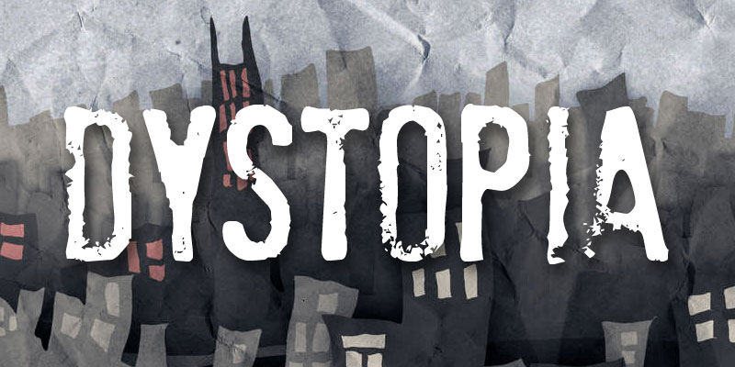
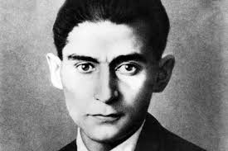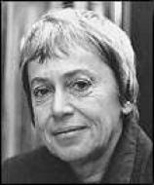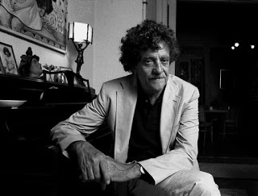
Franz Kafka Ursula Le Guin Kurt Vonnegut

Overview:

This assignment requires you to critically analyze one of three short stories by developing a focused and opinioned thesis about the story using literary elements as your primary language of discussion, just as any classic literary analysis paper should achieve! HOWEVER, this literary analysis is somewhat unique insomuch as it requires you--being the sharp, critically-thinking, and advanced composition students you are--to do a few additional things beyond a traditional literary analysis.

First, you are required to discuss this story within the context of the "dystopian" theme/genre of literature it is and represents (see the end of this prompt for more details about dystopian literature in addition to resources in the Learning Web folder for this assignment). The three stories are all quite dystopian by nature, so this requirement should not be terribly difficult to accomplish. Note that this requirement must be something that runs throughout the essay--not merely devoted to a paragraph or two within it.

Second, you are also required to utilize some or all of the symbolism in the story to make a statement about mass media in our society today (our course theme). Of course, mass media is just that: "mass" and/or massive. You may address television (news and other programs), print media, films, social media, particular websites/forums, or any other form of media prevalent today.

Third, you are also required to find and use several sources to support your ideas: two sources that pertain directly to the story and/or the author, which must be obtained through the HCC library databases, AND another two sources (websites preferably) that DO NOT pertain directly to the story nor to the author, but rather to the thematic content pertaining to mass media and dystopias.

I. The Purpose of a Literary Analysis:

A literary analysis is not merely a summary of a literary work. This kind of analysis, like any analysis, is just that: ANALYTICAL! It is intended to reveal and/or explain meaning. Thus, the assumption is that meaning exists, and it is the job of a (close/active) reader to ferret it out and offer a response to it! Far from being a mere summary, it is an argument, essentially, about the work that expresses the essay writer’s personal perspective, interpretation, judgment, or critical evaluation. This is accomplished by examining the literary devices, word choices, or writing structures the author uses within the work first, followed by a critical analysis of content. Another purpose of a literary analysis is to demonstrate why the author used specific ideas, word choices, or writing structures to convey his or her message.

II. How to Create a Literary Analysis (General):

1. Select and print one of the 3 short stories in the “Literary Analysis” folder (located in separate folder). The stories listed here are the only acceptable stories for this assignment, and they are all in full text so there’s no need to find them elsewhere.

2. Read the text closely several times (FYI: one or two readings of a story in which you are expected to produce a detailed and thorough analysis will NOT be sufficient). Focus on the ideas that are being presented. Think about the characters’ development and the author’s writing technique. What might be considered interesting, unusual, or important?

3. Brainstorm a list of potential topics. Highlight important passages in the text and take notes on these passages. Think of the ideas/concepts that strike you as you read. Later, when writing the paper, these notes should help a writer to remember which aspects of the story caught their attention. Generally speaking, the topic chosen should be based on a writer’s interpretation of the author’s message.

4. The following "Literary Elements" are the tools a writer needs to navigate his or her discussion of literature accurately. These terms (and more of them if you do a quick Google search for other lists) are essentially the language required to speak literary analysis!

Character: What observations might a writer make about the characters? Are there discrepancies in what they think, say, or do? Are the observations a writer makes different from what other characters say? How does the author describe the characters? Are the characters “dynamic” (a dynamic character is a character that undergoes important changes throughout the work)? Are the characters “static” characters (a static character is a character that stays the same throughout the work)? Are the characters “flat” characters (a flat character is a character that does not have vivid character traits) or “round” characters (a round character is a character that has vivid character traits)? Are the characters symbolic or representative of some universal quality? Is it possible that two characters in the text might be compared or contrasted?

Setting: Is there a relationship between the work’s setting and its mood? Does the setting reflect the work’s theme? How does the setting impact the characters? Does a change in the setting affect the mood, characters, or conflict?

Plot: How might the beginning of the work be interpreted? How does the plot build suspense? Does the author use techniques such as foreshadowing or flashback? Are there patterns of cause-effect relationships? Do events occur in a logical order? Examine the events that lead to the climax and determine how the work ends?

Theme: What is the major idea or theme of the work? How does the author relay this theme? Is there a greater meaning to the details given? How do the characters’ moods affect the theme? What allusions are made throughout the work? Are there repeating patterns or symbols? What does the title say about the theme?

Dialogue: What is the purpose of the dialogue? Is the dialogue appropriate in terms of word choice or sentence length? How does the dialogue impact the characterization? How does the author use the dialogue to show the mood of the characters? How does this aid the author’s message? How does the dialogue impact the plot?

Imagery: In what way might a specific image or series of images be analyzed? How might the development of images throughout the work be explained? Are the images important to the meaning of the work? How are images interrelated with other literary elements?

Figures of speech: How are figures of speech such as similes, metaphors, and hyperboles used throughout the text? How are these figures of speech important in relation to the meaning of the text? Are figures of speech interrelated between other literary elements?

Tone: How might describe the attitude of the author or the tone of the work be described? Is the tone serious, playful, casual, formal, or somber? How does the author achieve this tone? How does the tone impact the author’s message? Does the author say one thing but mean another? Does the author take the subject seriously or treat it lightly?

Point of View: What point of view do the characters display? First, second, or third? How does this point of view affect the theme, plot, or conflict of the work? How might the author’s point of view impact a writer’s analysis? Might the character’s first person point of view draw a writer to feel as though he/she is hearing a personal account and cause him/her to feel an intimate connection with the character? Might the author’s third person account cause a writer to feel as if the author is acting as the narrator of the story? Or might it cause a writer to believe that the narrator is an omniscient being who is distant but knows the character’s thoughts and feelings?

5. Think about what the author is trying to say. Why is this important? When viewing this work as a piece of art, what might a writer’s response be? What might a writer’s reactions be to the ideas presented in the work? Are these ideas truthful or relevant to today and how? If a writer were asked what they thought of this work how might they respond? What points might a writer make?”

6. Select a topic that has sufficient supporting evidence. A writer should make sure to include specific details to support the topic. Use highlighted sections of the book as evidence to support the topic that has been chosen.

7. Write a debatable thesis. The analysis will need a strong thesis that states a writer’s perspective but also allows it to be debated. The thesis should state a writer’s opinion, but it should also allow readers to arrive at their own conclusions.

Example of a debatable thesis (using the novel Pride and Prejudice by Jane Austin):
Pride and Prejudice is about Elizabeth Bennet’s effort to overcome her own proud behavior and discrimination towards Mr. Darcy, as well as how her family is affected by the haughtiness and preconceptions of the society around them. (This is a debatable thesis because it asks the reader, “Does Elizabeth actually exhibit haughtiness and preconceptions? Is this why she doesn’t get along with Mr. Darcy? How is Elizabeth’s family affected by the haughtiness and preconceptions of the society around them?”)

Example of a non-debatable thesis (avoid this):
Pride and Prejudice is about five sisters and their journey to find love. (This thesis is non-debatable because it is undisputable. The paper is framed as a summary rather than as a literary analysis.)

8. Make an extended list of evidence. Find more evidence from the text to support the working thesis. Then select the evidence that will be used in the paper.

9. Refine the thesis. Make sure the thesis fits with the evidence that has been presented.

10. Organize the evidence. Match the evidence to the order of the thesis. Delete any of the original textual supports that may no longer follow the thesis, and gather new evidence if needed.

11. Interpret the evidence. When writing a literary analysis, it is very important for writers to make sure they express their own personal interpretation of the work. Be careful that the literary analysis is not a summary.

III. Required:

6+ Pages in typed in MLA format (essays that do not meet this minimum length requirement will
receive significant deductions). This length requirement does NOT include the "Works Cited" page,
which always needs to start on a new, fresh page.

A Word About Source Usage . . .

The total percentage of words used directly from your sources, and the short story itself, cannot
exceed about 22% to 25% overall. You can assure yourself of having this percentage by using short, in-text direct quotes that do not exceed 2 lines each (no big block quotes) whenever you cite the story or the articles/websites.

Short Story Options for This Assignment (All of the following stories, with full text links, are located in the “Critical Literary Analysis” essay folder on Learning Web
- Harrison Bergeron (Kurt Vonnegut)
- A Hunger Artist (Franz Kafka)
- Those Who Walk Away from Omelas (Ursula Le Guin)

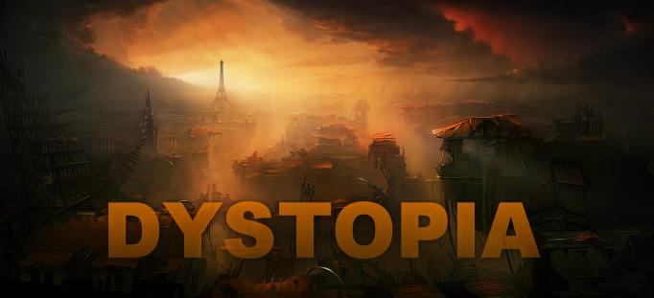

Finally, a few comments about the genre of all the stories listed above: these are all early “dystopian” works—long before Margaret Atwood or “Hunger Games”! Arguably, George Orwell’s timeless novel, 1984, published in 1951, was the first work of the genre, and it has grown significantly since then!

Here are the fundamentals of dystopian fiction:

It is a direct response to the concept of “utopia,” which is a place, state, or condition that is ideally perfect in respect of politics, laws, customs, and conditions.

Therefore, dystopia is a futuristic, imagined universe in which oppressive societal control and the illusion of a perfect society are maintained through corporate, bureaucratic, technological, moral, or totalitarian control. Dystopias, through an exaggerated worst-case scenario, make a criticism about a current trend, societal norm, or political system. While the particular details in a dystopia may be far-fetched, it is important to remember that the essence of many disturbing realities in dystopian works are as real as anything in readers’ everyday realities!

Characteristics of a Dystopian Society
• Propaganda is used to control the citizens of society.
• Information, independent thought, and freedom are restricted.
• A figurehead or concept is worshipped by the citizens of the society.
• Citizens are perceived to be under constant surveillance.
• Citizens have a fear of the outside world.
• Citizens live in a dehumanized state.
• The natural world is banished and distrusted.
• Citizens conform to uniform expectations. Individuality and dissent are bad.
• The society is an illusion of a perfect utopian world.

Types of Dystopian Controls Most dystopian works present a world in which oppressive societal control and the illusion of a perfect society are maintained through one or more of the following types of controls:

• Corporate control: One or more large corporations control society through products, advertising, and/or the media.
• Bureaucratic control: Society is controlled by a mindless bureaucracy through a tangle of red tape, relentless
regulations, and incompetent government officials.
• Technological control: Society is controlled by technology—through computers, robots, and/or scientific means.
• Philosophical/religious control: Society is controlled by philosophical or religious ideology often enforced through a dictatorship or theocratic government.

The Dystopian Protagonist
• often feels trapped and is struggling to escape.
• questions the existing social and political systems.
• believes or feels that something is terribly wrong with the society in which he or she lives.
• helps the audience recognizes the negative aspects of the dystopian world through his or her perspective.

NOTE: Per my very specific and direct policy regarding plagiarism, as explained in the "behaviors" doc on Learning Web and in my syllabus, I take a ZERO-TOLERANCE policy towards this form of academic theft and cheating--ESPECIALLY FOR 1302 STUDENTS WHO ABSOLUTELY MUST KNOW BETTER. If you are unclear about my policy, which aligns closely with the HCC Policy reagrding the matter, I suggest going back and re-reading it.

