Dr. Christopher Carney
Summer 1 (6/8 – 7/9)
Houston Community College, Northwest: Katy Campus, Office #229
Email: christopher.carney@hccs.edu
Office Hours:
Only by Appointment in Summer since I teach 3 classes from 8:00 – 2:00 every day

English 2327: Early American Literature (55365)

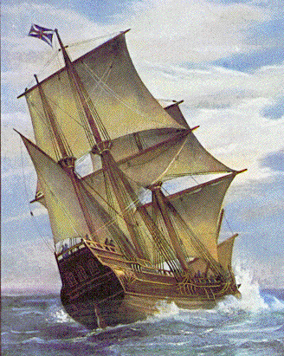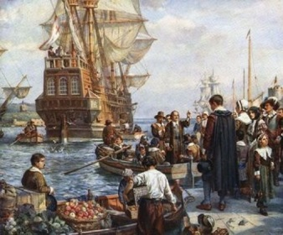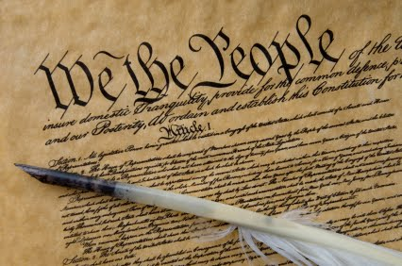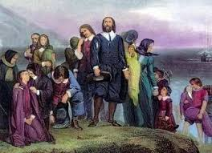
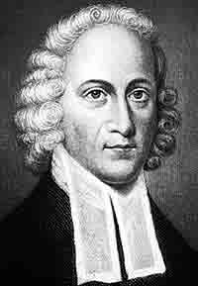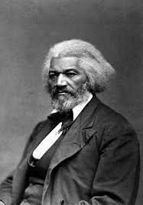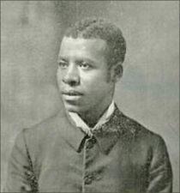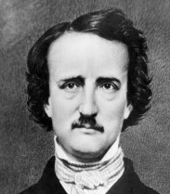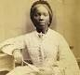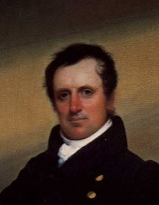

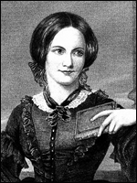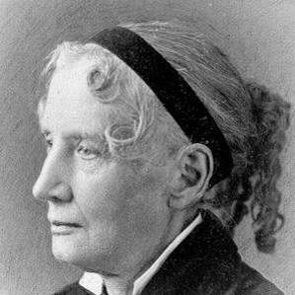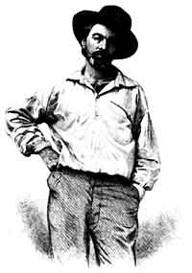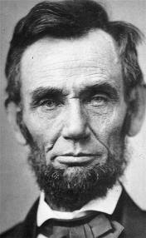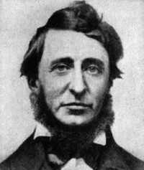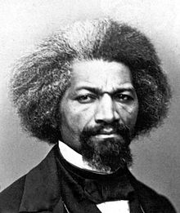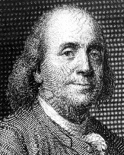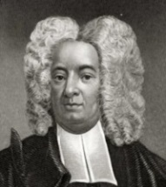

I. Communication and Contact:

ecause I firmly believe that communication is vital, both to your success and mine, please bring any concerns, questions, criticisms, suggestions, or comments in general to my attention as soon as they arise—regardless of how small or seemingly insignificant you might think they are. While I prefer that you talk to me in person about such concerns, please feel free to write an email or a handwritten note if you prefer. In short, when it comes to communication, never feel as though you cannot talk to me! Beyond official office hours and/or formal appointments, the best time to raise your question or discuss a concern with me is during class—either in our open forum setting for everyone to hear, or through a question directed at me individually when the class is engaged in a collaborative, group exercises.

I check my email frequently, and I usually try to reply to messages immediately after I read them unless I plan to write a lengthy response (in which case I will let you know of my plan in a quick reply). Some days certainly involve more frequent checking of email than others, but rest assured that I check my email a few times every day. On some occasions, especially if I receive an email within a short period of time before our class starts, I might determine that I can meet your needs more effectively if I address your email in class and/or in person as opposed to writing a long written response. NOTE: I will not reply to messages requesting a repeat of all the information a student misses in the event of an absence, as doing so uses time and energy that is better spent addressing concerns or questions students (possibly you) have with their actual assignments or other particular issues. Therefore, it is your responsibility to find out what you miss in the event of an absence by contacting one of your classmates and/or referring to the schedule. With that said, being part of a reliable group of peers (i.e. “study group”) goes a long way to ensure your success—and theirs! Again, I will not reply to messages requesting information about what you miss in the event of an absence, so don’t ask. Finally, be sure to have your HCC email account activated and check it often. Whenever I have announcements for the class, I send them to everyone in group message format via HCC email. If you prefer not to use your HCC email address (the one that aligns with Rosters Plus by default) to receive my messages, you need to contact Admissions and Records with the alternate email address you DO wish to use and officially change it (YOU are responsible for all information I send to the class through group messaging, regardless of whether or not you personally receive it due to a non-aligned email address).

A Word About Revisionism: If you are expecting rants of hatred for America and utter shame over the beginnings of our country, as though history can be reduced to a zero-sum game and/or that America’s beginnings have no redeeming value whatsoever, you’ve come to the wrong class. You can easily find misguided America-bashing from individuals such as noted revisionist Howard Zinn, but my aim in reading early American literature is to be objective. Yes, there are shameful chapters and/or events in our history, but where on earth—at what time on earth—has ANY society been perfect or without such chapters? What society has nothing for which they should be ashamed? America is the greatest experiment in true democracy human civilization has ever known, and THAT fact remains at the forefront of any criticism I might have. This fact is also why so many people, past and present, flock here in droves. In short, I believe America is exceptional.

II. Course Description, Purpose, and Content (Taken Directly from the HCC Catalog):

A. 2327:
A critical study of major American writers from the colonial period to 1865. This course requires substantial reading, writing, and research. Students may take ENGL 2327 and ENGL 2328 in any order. This is a Core Curriculum Course.

B. Purpose
To present a survey of American literature from the Colonial Period to the Civil War. Through the presentation of selected readings from the major writers, the student is acquainted with the literary forms, the philosophical attitudes, and the political trends of the seventeenth, eighteenth, and part of the nineteenth centuries.

C. Description of Course Content
In this course, students do extensive reading of American Literature from the colonial period through the Civil War. Typically, reading assignments include representative works of cultural diversity, such as Native American oral narratives; Puritan literature including sermons, journals, histories, captivity narratives and poetry; and slave narratives. Examples of fiction, essays, and poetry represent American Romanticism and Transcendentalism. In their research, students read literary criticism which may reflect the views of scholars from other cultures.

III. Course Objectives (Student Learning Outcomes):

1- General Objectives for the Study of Literature

• To provide a working knowledge of the characteristics of various literary genres.
• To develop analytical skills and critical thinking through reading, discussion, and written assignments.
• To broaden students’ intercultural reading experiences.
• To deepen students’ awareness of the universal human concerns, which serve as the basis for literary works.
• To stimulate a greater appreciation of language as an artistic medium and of the aesthetic principles that
shape literary works.

• To understand literature as an expression of human and societal values within an historical and social
context.
2- Specific Objectives for this Literature Course
• Explain and illustrate stylistic characteristics of representative works of major American writers from the colonial
period to 1865.

• Connect representative works of major American writers from the colonial period to 1865 to human and individual
values in historical and social contexts.

• Demonstrate knowledge of various works of major American writers from the colonial period to 1865.

• Analyze critical texts relating to the works of major American writers from the colonial period to 1865.

• Critique and interpret representative literary works of major American writers from the colonial period to 1865.
IV. Perspectives in the HCCS Core Curriculum:

In 2300-level literature courses, the student will gain increased capability in all six basic intellectual competencies in the HCCS Core Curriculum. Student progress in the Core Competencies will be measured in the activities outlined in the objectives and requirements for this course). Thus, 2300-level literature courses help students attain and demonstrate the following competencies:

• Establish broad and multiple perspectives on the individual in relationship to the larger society and world in
which he or she lives and to understand the responsibilities of living in a culturally and ethnically diverse
world.

• Stimulate a capacity to discuss and reflect upon individual, political, economic, and social aspects of life in
order to understand ways in which to be a responsible member of society.

• Develop personal values for ethical behavior.

• Develop the ability to make aesthetic judgments.

• Integrate knowledge and understanding of the interrelationships of the scholarly disciplines.

V. Objectives and Requirements (Catalog Description)

By the end of the semester, the student who passes with a final grade of “C” or above will have demonstrated the ability to:
1. Complete and comprehend reading assignments. Assignments vary in length, but a typical assignment requires 2 hours out of class
for each hour in class (e.g. 2 ½ to 3 hours reading to prepare for a 1 ½ hour class session).

2. Attend class regularly, missing no more than 12.5% (6 hours) of instruction.

3. Participate in small group and/or class discussions in which assigned literary works are analyzed and interpreted.

4. Write at least 3,000 words in completing written assignments of varying types and lengths that are relevant to course content. At
least one written assignment will include information obtained through research that is related to one or more prominent European
or American literary works of the eras covered and is presented in current MLA form.

5. Participate in at least one oral presentation (can be a collaborative effort) of a literary work.

6. Explain and illustrate stylistic characteristics of authors and literary works included in the course syllabus.

7. Express clearly and support convincingly an interpretation or analysis of a literary text.

8. Explain similarities and differences among writers studied and/or among literary works studied.

9. Explain the characteristics of each literary period covered, with particular attention to prominent literary themes.

10. Use a word processor (available in school labs) to fulfill written assignments and use the computer as well as the library to
research a literary topic.

11. Maintain an overall average of 70 or above on written assignments and tests.

VI. Required Books, Materials, Access, and Accounts:

1. Course Text: Baym, Nina, General Editor. The Norton Anthology of American Literature, 8th ed. New York:

W. W. Norton & Company, 2012. (Package 1 - Volumes A & B)
2. Access to a computer and word processor (labs provide these); an active email account with HCC
3. Access to an established account with “Turnitin.com” and “Prezi”
4. 4 Blue Books

VI. Behavior

eneral Premise: Because you are all adults who are taking this college course by choice, it should go without saying that everyone will demonstrate maturity, responsibility, and an eagerness to learn. The following policies ensure that everyone experiences a rewarding learning environment. NOTE: Disruptive behavior/activities which interfere with teaching and/or learning will not be tolerated, and may result in an administrative withdrawal without refund”

a. Attendance and Withdrawal Policies – Missing class means missing opportunities to learn; therefore, in keeping with the HCC policy on attendance, “students may be dropped after missing more than 6 hours of class time.” Attendance will be taken every day at the beginning of class.

Regarding absences, it is also very important to have a typed rough draft of assigned essays (meeting minimum length requirements) on RD due dates (3 of them) in order to be considered present on such days. Failure to come to class with a legitimate rough draft constitutes an absence, since our time will be spent responding to peer essays and a student with a missing essay has nothing to contribute to the exercise as a whole.

In accordance with HCCS policy, students with more than 6 hours of absences (3 classes) may be dropped for excessive absences, and a daily record of attendance will be maintained throughout the semester. Remember: it is your responsibility to keep updated on course information if you miss class, so please make arrangements to contact other students on such occasions, should they occur.

NOTICE: The State of Texas has begun to impose penalties on students who drop courses excessively . For example, if you take the same course more than two times, you have to pay extra tuition. (Students who enroll for most credit CEU classes for a third or more times will be charged an additional $50.00 per semester credit hour and $3.00 per contact hours.) In 2007, the Texas Legislature passed a law limiting new students (those starting college in Fall 2007) to no more than six total course withdrawals throughout their academic career in obtaining a baccalaureate degree. There may be future penalties imposed.

Please ask me or your counselor about opportunities for tutoring or other assistance prior to considering course withdrawl, or if you are not receiving passing grades. In consideration of the above law, I will not give “W” as a grade option unless you have submitted the withdrawal form yourself before the deadline for withdrawal. I will only give whatever grades you earn (A, B, C, D, F, or FX). If you stop attending the class, you need to officially withdraw yourself prior to the withdrawal deadline. If you do not do so and simply disappear from class, you will receive an “FX” in the course.

INTERNATIONAL STUDENTS: Receiving a W in a course may affect the status of your student Visa. Once a W is given for the course (after you have submitted a withdrawal form officially), it will not be changed to an F because of the visa consideration. Please contact the International Student Office at 713-718-8520 if you have any questions about your visa status and other transfer issues.

b. Class Arrival/Departure – A pattern of arriving late to class is not only disruptive, it is disrespectful–both to me and to the rest of the class. I understand that “life happens,” but odd circumstances should be the exception, not the rule, and should thusly occur on a rare occasions. I have no tolerance for patterns of late arrival, as it displays highly irresponsible behavior at best, and an outward display of arrogance at worst. However, if you are legitimately late, it is your responsibility to see me after class in order to change the recorded absence into a “late” in my record. Be advised that a late arrival of more than 30 minutes will not be changed from an absence to a late; it will simply remain as an absence for the day. I will also begin combining late arrivals into pairs of two after your second or third late arrival, regardless of the reason; I will then convert each pair of late arrivals into an absence. For those who acquire absences this way, the same policy regarding absences applies—namely, the potential of being dropped.

I consider early departures from class as a behavioral issue. This behavior conflicts with the “general premise” of section V (see above). Anyone who departs from class before it ends, aside from special circumstances discussed with me in advance, will not only be counted absent, but will forfeit the extra credit opportunity—in addition to losing all possible points that may have been earned in class for the day (this also affects the overall “participation” grade).

c. Disruptive Talking – Because I am a strong supporter of team learning in interactive groups, I provide ample opportunity throughout the semester to verbally engage in the learning process; I balance lectures with “workshops.” Therefore, disruptive chatting when we are assembled as an entire class is completely unacceptable, regardless of what you may be chatting about. Such behavior is both disrespectful and immature; if necessary, I will resort to separating pairs/groups of talkers and assigning them seats on opposite sides of the room…just like they do in elementary school! I reserve the right to ask distractors, who have been warned at least once, to leave class for the day (which means receiving an absence for that day). Also, it is unacceptable at the end of workshops to talk as a group when other groups are presenting their ideas, as each group should demonstrate the same courtesy they expect from others when presenting their findings to the class. Individuals, or entire groups for that matter, who talk and/or distract the class may nonetheless still lose credit on an assignment.

d. Classroom Attitude – How subtle it is, but ever so revealing of a student’s views towards his or her role in society, adulthood, higher education, future career goals, and general self-respect. A healthy outlook in these areas is characterized by a classroom behavior that reflects those qualities stated in the general premise above. A few examples of actions which reveal a negative attitude include, but are not limited to, the following behaviors: chatting, ignoring deadlines without communicating with me, sleeping, working on unrelated material, being confrontational, excessively exiting class, or refusing to participate in group activities. If you find yourself engaged in any of these behaviors, let me just ask you to honestly consider why you are in college at all. Really—ask yourself that question. I’m not being judgmental, nor am I being sarcastic; I’m simply saying you need to ask that question because these behaviors are indicative of an attitude that is not conducive to success in college. For what it’s worth, I know that attitude all too well because I had it myself when I was in high school….but not in college. The difference between these settings is huge, namely because college students are not required to attend—they do so by choice!

e. Academic Honesty, Plagiarism, Collusion – To plagiarize is to submit the words/ideas of another as one’s own
without giving them due credit. It is a form of theft, in addition to being academically dishonest and unethical. Like all other forms of cheating, plagiarism carries serious penalties that are not only enforced by me, but also by HCC administrators. Be advised that all three of your formal papers must be submitted to turnitin.com for review before they are submitted to me. HCC Policy: “Scholastic dishonesty includes, but is not limited to, cheating on a test, plagiarism, and collusion. Cheating on a test includes copying from another student’s paper; using, during a test, materials not authorized by the person giving the test; collaborating with another student during a test without authority; knowingly using, buying, selling, stealing, transporting, or soliciting in whole or in part the contents of an un-administered test; or bribing another person to obtain a test that is to be administered. ‘Plagiarism’ means the appropriation of another’s work and the unacknowledged incorporation of that work in one’s own written work for credit. ‘Collusion’ means the unauthorized collaboration with another person in preparing written work offered for credit.” If you consult any sources, whether oral or written, you must clearly distinguish between your words/ideas and theirs at all times. Students who plagiarize, collude, or cheat may face disciplinary action including the grade of 0 for the assignment, an F for the course, and/or dismissal from the college (see on-line student handbook). For more on plagiarism, refer to the HCC Library site (on the Northwest Writing Center site), or the HCC Student Handbook.

Be prepared to submit final drafts of all essays to turnitin.com: I strongly suggest not underestimating the ability I have to find evidence of plagiarism through such powerful resources as turnitin.com! Be advised: IF ONE OF YOUR THREE MAJOR PAPERS IN THE CLASS IS FOUND TO BE SIGNIFICANTLY PLAGIARIZED (I DETERMINE “SIGNIFICANT”), THEN YOU CAN BE ASSURED OF AUTOMATICALLY FAILING THAT ASSIGNMENT, LOSING THE ABILITY OF EARNING EXTRA CREDIT, AND LOSING ALL “PARTICIPATION” POINTS at the very least. Depending upon the degree of severity, I may decide to forward this serious academic violation for administrative review, accompanied by a strong recommendation that the student in question should fail the course entirely for one plagiarized paper alone.

f. Arrival / Exiting Class – Because we are all adults, there is no need to ask “permission” to use a restroom or exit the class to make an important phone call on a rare occasion; however, I will address students individually who appear to exit the room “excessively,” habitually using the restroom (or anywhere else for that matter) as an excuse for frequent interruptions. Generally speaking, it is inappropriate to consistently designate class time on a regular basis to use such facilities. Also, it is poor etiquette to let doors slam behind you when you exit or enter a room, especially when the class is in the middle of writing, reading, discussion, or viewing a film. Furthermore, late entrances and/or class departures/returns for the restroom are distracting enough as they are; doing so without trying to be as inconspicuous as possible (i.e. making an obvious visual display of oneself or noisily opening/closing doors) makes it even worse!

g. Recording Devices – Official HCCS policy concerning recording devices: camera phones, cameras,
audio/tape recorders, video recorders and any other electronic device that is capable of recording the human
voice or image declares that the “[u]se of recording devices, including camera phones and tape recorders, is
prohibited in classrooms, laboratories, faculty offices, and other locations where instruction, tutoring, or
testing occurs. Students with disabilities who need to use a recording device as a reasonable
accommodation should contact the Office for Students with Disabilities for information regarding [such]
accommodations.”

h. Concerning Various Forms of Learning and Emerging Technologies: As a student who is active in our
learning community, it is your responsibility to be respectful of our learning atmosphere in every way in which
you have control over your own behaviors. This applies to any or all of the electronic devices you bring into the
classroom! To show respect to your fellow students and myself, you are expected to treat all electronic devices
you bring with you to class as extensions of yourself—no different than the control you need to have over
your tongue or your hands. You are responsible for what you do with them, and you know the difference
between constructive and non-constructive uses of them. For example, a ringing phone that you fail to set on
silent mode is no different in my estimation than blurting out an inappropriate comment at an inappropriate time.
I can think of certain egregious ways of using tech devices in class that would be no different, in terms of their
level of offense in an collegiate setting, than physically assaulting someone. With that said, and knowing
clearly where I’m coming from on this issue, I will allow you to bring whatever devices and/or forms of
technology with you to class you deem necessary. You are responsible for your actions. With that said,
staring at screens of any kind during a lecture, group presentation, or video is never acceptable behavior.

NOTE: all of the listed “behaviors” above are either positive or negative; subsequently, negative behavior translates into negative “participation” on my grading scale as opposed to positive participation. Negative
Participation translates into a loss of participation points.

IX. Assignments:

1. Group Presentations: For information on this component to the course, please refer to the detailed “Weekly Group Assessment” sheet I have posted on my 2327 Course Learning Web page. Generally speaking, every student will be placed into a new group three times. These groups will actively “carry” the discussion of particular readings throughout our weeks together, as members of each group will essentially be considered the “experts” of the readings assigned to them (this is not just limited to delivering your presentation and written assessments on presentation days, of which you will certainly do). In each group, it is very important to establish contact information among group members and/or to determine things like who will do various tasks pertaining to assigned goals, both in terms of the written portion and the actual presentation. You may or may not designate a “leader’ per-se, but whether you elect someone to steer the ship or it becomes an egalitarian group effort, good communication and coordination will be vital to your success!

2. Journal Entries: The detailed prompts for these journal entries will pertain to your assigned readings and will be posted on the Learning Web (see “Journal Prompts” Word document). These journals are highly informal, and while they are not expected to be formally written in terms of grammar or spelling, students who have passed English 1301 and 1302 should not have glaring problems in these areas. If you write them by hand or if you type them, these journal entries simply need to have your name and the title of the work you’ve selected at the top of the page. Be familiar with what you say in your journal responses, as you will likely be called upon to share highlights from them as we go along.

3. Literary Research Paper/Project: Please see a special folder on Learning Web, in our 2327 class folder, for detailed information regarding this project.

X. Point Distribution:

• Literary Research Paper/Project: 400 points (3 parts: Part A: 150 + Part B: 200 + Annotated Bibliography: 50)
• Three Group Presentations (Written Assessment and Oral Presentation): 300 points (3 @ 100 pts each)
• Literary Connections Journal: 100 points (10 @ 10 pts. each)
• Reading Quizzes (from the “everyone reads” sections of the schedule): 100 Points
• Midterm Exam: 50 points
• Final Exam: 50 points
______________________
1,000 Points
____________________________________________________________________-
XI. Grading Criteria: The above 1,000-point scale is quite simple, and intentionally so. I do not use percentages. There “may” be an extra credit opportunity to earn up to 50 points, but I’ll wait and see how I feel about the overall degree of class participation by week 3 to determine whether or not I’ll offer it.
NOTE: Plagiarism, Collusion, or any other form of cheating is entirely unacceptable and will result in immediate dismissal/from the class with a grade of F (not FX).

Grading Scale

900 – 1,000: A
800 – 899: B
700 – 799: C 600 – 699: D 599 and below: F
NOTE: If you stop attending this class, do not expect me to drop you. The attendance roster will demonstrate missed classes and I will simply assign an FX grade at the end of the term. While not ideal, it is still better to drop the class yourself and (only) receive a W. Depending upon the degree of such an incident, I may take further action by referring a plagiarizing student to college administration for further disciplinary action.

XII. Where to Find Copies of Specific Assignments and Written Support for this Class:

On my Learning Web page, this syllabus and calendar, assignments, handouts, and open sources texts are available to read, download and/or print. Use this resource!!!!

XIII. HCC Student Services Information:

Student Services provides masters and doctoral-level counseling for the Northwest College student body. Counselors are available at each campus to assist students in creating class schedules, evaluating college transcripts, and completing degree/certificate plans.

Student Services regular business hours are the same at both campuses. Phone numbers:

* 8 a.m. – 7 p.m. M – Th.
* 8 a.m. – 1 p.m. F – Sat.
* Katy Campus, 713-718-5751
* Spring Branch Campus, 713-718-5669

Additional Information:
http://northwest.hccs.edu/northwest/campus-servies

Early Alert: HCC has instituted an Early Alert process by which your professor will “alert” you through counselors of concerns that you might fail a class because of excessive absences and/or poor academic performance.

Let’s Have a Great Summer!
Your Success is My Success!

My HCC Learning Web Page:
http://learning.hccs.edu/faculty/christopher.carney

NOTE: This syllabus is tentative and may be adjusted at the discretion of the instructor

