Assignment:
- Look up/ research a few of the artist listed below. After you have familiarized yourself with their works, chose one artist whose work most speaks to you. Once you have chosen an artist collect some facts about them. This means, find out a little bit about the life of this artist. Are they still alive? Where were they born? What is their artwork primarily about?

- Write a small paragraph about the artist. Next time we meet in class we will discuss your paragraphs and artist of your choice.

- Finally chose 3 figurative paintings by this artist that you find most compelling. In class we will look at your choices and make a final decision.

Artist
Kehinde Wiley
Caravaggio
Amy Sheralds
Elisabeth Vigee-Le Brun
Frida Kahlo
Alonsa Guevara

Sandro Botochelli

Zhang Xiaogang

Alice Neel

Rey Turner

Francoise Nielly

Heather Horton

Painting assignment:

- Once you have chosen a painter and painting that compels you. Take a photograph of yourself in the same pose or similar pose as the figure in the painting. For example:

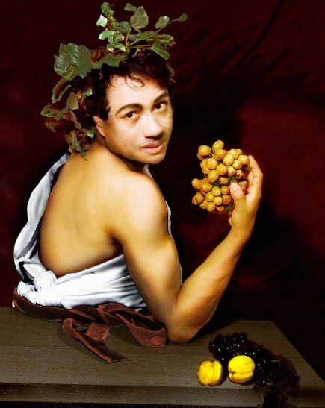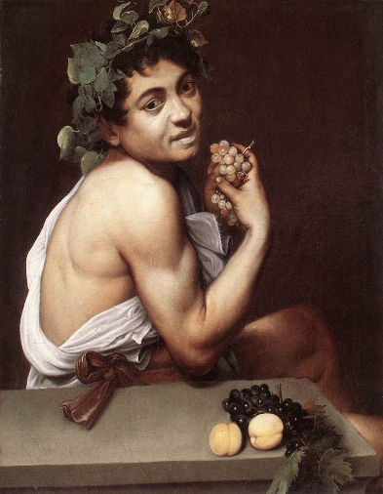

Note: When taking a photo be sure to have a good light source. Do not worry too much about background as we will tackle that later.
In Class
- Cut canvas roll to 36” x 48” or bigger.( I will provide materials)

- Use photo reference: from photo, sketch on the canvas a preparatory drawing in pencil. Example:

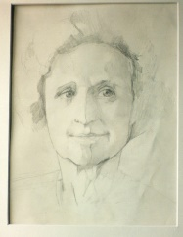
Note: you make take your time with these.

- Once you have your drawing you may add paint. In the beginning, we will use a light wash of burnt sienna as an under painting.
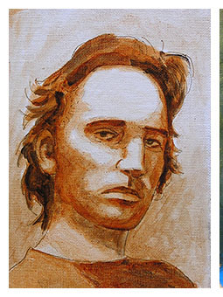

- Once the initial sketch is complete go crazy and have fun!

