**Scariest Tax Form? Omit It, And IRS Can Audit You Forever**

Before you file your taxes, consider how long you must look over your shoulder. In many cases, the IRS has three years to audit. The three years is doubled to six if you omitted more than 25% of your income. Plus, the [IRS now has six years to audit](http://www.forbes.com/sites/robertwood/2016/01/15/beware-irs-now-has-six-years-to-audit-your-taxes-up-from-three/) if you overstate basis and it has the effect of understating your income by more than 25%. The three years is also doubled if you omitted more than $5,000 of foreign income (say, interest on an overseas account).

But the exceptions from the three year rule get even worse if you miss certain forms that apply to you. If they apply, don’t omit [Form 3520](https://www.irs.gov/pub/irs-pdf/f3520.pdf) for gifts or inheritance from foreign nationals, or [Form 8938](https://www.irs.gov/uac/Form-8938,-Statement-of-Foreign-Financial-Assets) for overseas assets. If you don’t file, the IRS clock never starts to run. More generally, the IRS has no time limit if you never file a return. For unfiled tax returns, criminal violations or fraud, the IRS can take its time. In most criminal or civil tax cases, though, the *practical* limit is six years.

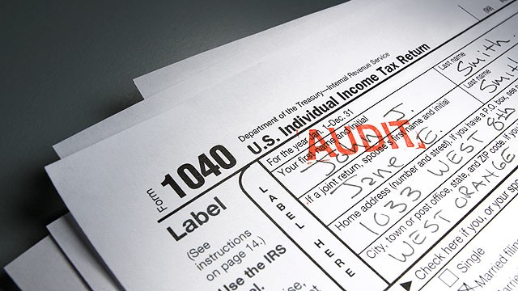If you miss some tax forms, the [IRS can audit forever](http://www.forbes.com/sites/robertwood/2014/03/03/scariest-tax-form-skip-it-and-irs-can-audit-forever/), and occasionally they do try to reach back 10 or more years. When a U.S. shareholder owns part of a foreign corporation, it can trigger reporting, including filing an IRS [Form 5471](https://www.irs.gov/uac/Form-5471,-Information-Return-of-U.S.-Persons-With-Respect-to-Certain-Foreign-Corporations). It is an understatement to say this form is important. Failing to file it means penalties, generally $10,000 per form. A separate penalty can apply to each Form 5471 filed late, incomplete or inaccurate. This penalty can apply even if no tax is due on the return. That is harsh, but the rule about the statute of limitations is even harsher.

If you fail to file a required Form 5471, *your entire tax return remains open for audit indefinitely*. This override of the normal IRS statute of limitations is sweeping. The IRS not only has an indefinite period to examine and assess taxes on items relating to the missing Form 5471. In fact, the IRS can make any adjustments to the*entire* tax return with no expiration until the required Form 5471 is filed.

Think of a Form 5471 like the signature on your return. Without it, it really isn’t a return. Forms 5471 are not only required of U.S. shareholders in controlled foreign corporations. They are also required when a U.S. shareholder acquires stock resulting in 10% ownership in any foreign company. The harsh statute of limitation rule for Form 5471 was enacted in 2010, part of the same law that brought us FATCA, the Foreign Account Tax Compliance Act.

The possibility that the IRS can audit forever is chilling. The potential for large civil penalties and perhaps even criminal liability can be real. Consider your audit exposure before you file.

For example, if you don’t sign your return, the IRS does not consider it a valid tax return. That means the three years can never start to run. Another big no-no is if you alter the penalties of perjury language at the bottom before you sign. If you do so, it also can mean the tax return does not count.  
  
These moves may sound like tax protester statements. However, some well-meaning taxpayers forget to sign or may unwittingly change the penalties of perjury wording. Some other taxpayers just miss a form to end up in audit purgatory. An example of the latter can arise if you have an offshore accounts held by a company. If you miss one, the IRS can audit you forever.

If you file early, do you shorten the audit period? Normally no, the IRS audit clock starts running on the *later* of your actual filing or the due date. If you file in January and your return is due April 15th, the audit clock starts to tick on April 15th. The time periods can be downright frightening in some cases.

Tax lawyers and accountants are used to monitoring the duration of their clients’ audit exposure, and so should you. Watch the calendar until you are clear of audit. In most cases, that will be either three years or six years. But in some cases, even though you filed and thought everything was in order, the statute of limitations *never* runs.