Division of Digital and Information Technology

Computer Programming Department

https://www.hccs.edu/programs/areas-of-study/science-technology-engineering--math/computer-programming/

COSC 1436: Programming Fundamentals I (Using Python) | Lecture| #18515
Spring 2020 | 16 Weeks (1.21.2020-05.17.2019)
MW 08:00 am-10:50 am
4 Credit Hours | 96 hours per semester

Instructor Contact Information

Instructor: Javad Ameri Office Phone:
Office: Office Hours:
HCC Email: javad.amerisianaki@hccs.edu Office Location:

Please feel free to contact me concerning any problems that you are experiencing in this course. Your performance in my class is very important to me. I am available to hear the concerns and just to discuss course topics.

Instructor’s Preferred Method of Contact

Students can contact me using my email address. I will respond to emails within 24 hours Monday through Friday; I will reply to weekend messages on Monday mornings.

What’s Exciting about This course

In this course, you will learn how computers work, how to solve problems in systematic and logical ways, and how to design these solutions and code them into programs that can be executed by a computer. You will learn the basic elements of Python which is one of the most widely used programming languages in the industry, the various ways of storing and organizing data, the fundamental programming constructs such a decision structures, loops, and functions, and the mechanics of testing and debugging programs.

My Personal Welcome

Welcome to Programming Fundamentals I. My name is Javad Ameri, professor of Computer Science at HCC. I’m delighted that you have chosen this course!
As its title indicates, this is an introductory course to computer programming. The course starts with an overview of computers, both at the hardware and software levels, and an introduction to programming languages and the programming process. The rest of the course will provide an introduction to computer programming using Python.
Please read the rest of this syllabus for course description, pre-requisites, students learning outcomes, required textbook and instructional material, course assignments/assessments, as well as other course policies (participation, makeup, etc.). See also the Course Calendar on Canvas for assignments/assessments due dates.

As the course progresses, you may encounter challenging ideas or difficulties completing your coursework. I am available to support you. The fastest way to reach me is through Canvas Inbox e-mail. If, for any reason, you can’t access Canvas, you can reach me at my HCC e-mail (Javad.AmeriSIanaki@hccs.edu). The best way to really discuss issues is in person and I’m available to tackle the questions. My goal is for you to walk out of the course with a solid understanding of computer programming and its applications. So please visit me or contact me by email whenever you have a question.

Prerequisites and/or Co-Requisites

Must be at college-level skills in reading and writing, place into MATH 1314 College Algebra or higher, and have had high school computer literacy or equivalent. If you have enrolled in this course having satisfied these prerequisites, you have a higher chance of success than students who have not done so. Please carefully read and consider the repeater policy in the HCCS Student Handbook.

Canvas Learning Management System

This section of COSC 1436 will use Canvas (https://eagleonline.hccs.edu) to supplement in-class assignments, exams, and activities
HCCS Open Lab locations may be used to access the Internet and Canvas. USE FIREFOX OR CHROME AS THE INTERNET BROWSER.

HCC Online Information and Policies
Here is the link to information about HCC Online classes including the required Online Orientation for all fully online classes: http://www.hccs.edu/online/

Scoring Rubrics, Sample Assignments, etc.
Look in Canvas for the scoring rubrics for assignments, samples of class assignments, and other information to assist you in the course. https://eagleonline.hccs.edu/login/ldap

Instructional Materials

Textbook Information

The textbook listed below is required for this course.

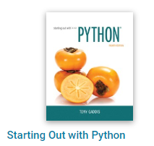
“Starting Out Python” by T. Gaddis 4th Edition Plus MyProgrammingLab with Pearson e-text -- Access Card Package.

The book is included in a package that contains the text as well as an access code to MyProgrammingLab and are found at the HCC Bookstore. You may either use a hard or electronic copy of the book or rent the e-book from Pearson. Order your book here: HCC Bookstore.

MyProgrammingLab is a Computer Assisted Leaning tool for computer programming. Please visit http://myprogramminglab.com for instructions on how to register on MyProgrammingLab. When registering you need (1) an access code and (2) our section Course ID. Your access code comes with the textbook you purchased as stated above and will be different for each student. Our section Course ID is UNAB-41377-ZWQD-43

Note: If you purchase a used textbook, make sure it has the access code to MPL. Most often used books don’t. If the textbook you purchase doesn’t come bundled with the MPL access code, you have to purchase an access code separately from the MPL website.

Tutoring
HCC provides free, confidential, and convenient academic support, including writing critiques, to HCC students in an online environment and on campus. Tutoring is provided by HCC personnel in order to ensure that it is contextual and appropriate. Visit the HCC Tutoring Services website for services provided.

Libraries
The HCC Library System consists of 9 libraries and 6 Electronic Resource Centers (ERCs) that are inviting places to study and collaborate on projects. Librarians are available both at the libraries and online to show you how to locate and use the resources you need. The libraries maintain a large selection of electronic resources as well as collections of books, magazines, newspapers, and audiovisual materials. The portal to all libraries’ resources and services is the HCCS library web page at http://library.hccs.edu.

Supplementary Instruction
Supplemental Instruction is an academic enrichment and support program that uses peer-assisted study sessions to improve student retention and success in historically difficult courses. Peer Support is provided by students who have already succeeded in completion of the specified course, and who earned a grade of A or B. Find details at http://www.hccs.edu/resources-for/current-students/supplemental-instruction/.

Course Overview

COSC 1436 introduces the fundamental concepts of structured programming and provides a comprehensive introduction to programming for computer science and technology majors. Topics include software development methodology, data types, control structures, functions, arrays, and the mechanics of running, testing, and debugging. (This course assumes computer literacy. CSOC 1436 is in the Computer Science Field of Study course list.)

Core Curriculum Objectives (CCOs)

COSC 1436 satisfies Component Area Option in the HCCS core curriculum. The HCCS Core Curriculum Committee has specified that the course address the following core objectives:
- Critical Thinking: Students will demonstrate the ability to engage in inquiry and analysis, evaluation and synthesis of information, and creative thinking by completing programming assignments that involve analyzing a problem, designing a solution to solve the problem, and implementing the solution including testing it against problem specifications and debugging it.
- Communication Skills: Students will demonstrate effective development, interpretation and expression of ideas through written, oral, and visual communication by analyzing the merits and drawbacks of alternative approaches to solving problems through online or in-class discussions and/or answering questions on quizzes and exams.
- Quantitative and Empirical Literacy: Students will demonstrate the ability to draw conclusions based on the systematic analysis of topics using observation, experiment, and/or numerical skills by completing assignments, and answering questions on quizzes and exams.

Program Student Learning Outcomes (PSLOs)

Can be found at:
https://www.hccs.edu/programs/areas-of-study/science-technology-engineering--math/computer-programming/

Course Student Learning Outcomes (CSLOs)

Upon completion of COSC 1436, the student will be able to:
- Describe how data are represented, manipulated, and stored in a computer.
- Categorize different programming languages and their uses.
- Understand and use the fundamental concepts of data types, structured programming, algorithmic design, and user interface design.
- Demonstrate a fundamental understanding of software development methodologies, including modular design, pseudo code, flowcharting, structure charts, data types, control structures, functions, and arrays.
- Develop projects that utilize logical algorithms from specifications and requirements statements.
- Demonstrate appropriate design, coding, testing, and documenting of computer programs that implement project specifications and requirements.
- Apply computer programming concepts to new problems or situations.

Learning Objectives

- Develop programs using fundamental concepts of structured programming.
- Use software development methodology in program problem solving.
- Code programs using data types, control structures, functions and arrays.
- Demonstrate the ability to run, test, and debug programs.

- Develop programs using fundamental concepts of structured programming.
- Use software development methodology in program problem solving.
- Code programs using data types, control structures, functions and arrays.
- Demonstrate the ability to run, test, and debug programs.

Official Day of Record (ODR):
Students that have not participated in an online class prior to the official
Day of record will be dropped from the course without exception. Official
Day of record is 2/3/2020.

HCC Policy Statement-- Course Withdrawal
If you feel that you cannot complete this course, you will need to withdraw from the course prior to the final date of April 05, 2020 (check HCCS Academic Calendar for any updates). Students must withdraw by the withdrawal deadline in order to receive a “W” on a transcript. Final withdrawal deadlines vary each semester and/or depending on class length, please visit the online Academic Calendar, any HCC Registration Office, or any HCC advisor to determine class withdrawal deadlines.
Be certain you understand HCC policies about dropping a course and consult with a counselor/advisor to determine if withdrawing is in your best interest. It is your responsibility to withdraw officially from a class and prevent an “F” from appearing on your transcript. Senate Bill 1231 and limits the number of W’s a student can have to 6 classes over the course of their entire academic career. This policy is effective for students entering higher education for the first time in fall 2007 and subsequent terms. Withdrawals accumulated at any other Texas public higher education institution count toward the 6 courses total. Withdrawals for certain circumstances beyond the student’s control may not be counted toward the 6-drop limit.
In addition, withdrawing from a course may impact your financial aid award or eligibility. Contact the Financial Aid Office or website to learn more about the impact of withdrawing on financial aid. For complete information on HCC Course Withdrawal policy including the three-peat rule refer to the HCC Student Handbook.

Student Success

Expect to spend at least twice as many hours per week outside of class as you do in class studying the course content. Additional time will be required for programming assignments. The assignments provided will help you practice the concepts discussed in class lectures and hone your programming hand-on skills. Successful completion of this course requires a combination of the following:
- Reading the textbook
- Attending class in person and/or online
- Completing assignments
- Participating in class activities

There is no short cut for success in this course; it requires reading and studying the material and more importantly completing the programming assignments.

Instructor and Student Responsibilities

As your Instructor, it is my responsibility to:
- Provide the grading scale and detailed grading formula explaining how student grades are to be derived
- Facilitate an effective learning environment through learner-centered instructional techniques
- Provide a description of assignments
- Inform students of policies such as attendance, withdrawal, tardiness, and making up assignments
- Provide the course outline and class calendar
- Arrange to meet with individual students ss as needed

As a student, it is your responsibility to:
- Attend class in person and/or online
- Participate actively by reviewing course material, interacting with classmates, and responding promptly in your communication with me
- Read and comprehend the textbook
- Complete the required assignments and exams
- Ask for help when there is a question or problem
- Keep copies of all paperwork, including this syllabus, handouts, and all assignments
- Be aware of and comply with academic honesty policies in the HCCS Student Handbook

Assignments, Exams, and Activities

Programming Assignment

There will be one programming assignment in each module. Unless indicated otherwise, all programming assignments will be assigned and submitted on MyProgrammingLab (MLP). Each programming assignment will consist of a set of short exercises and one programming challenge. For most MLP exercises your solution will consist of a short piece of code consisting of one to few lines of code. Programming Challenges, on the other hand, require you to write a full program. Programming Assignments are to be completed individually. See Grading Formula below for programming assignments weight toward your course grade.

Quizzes
Quizzes are short assessments administered online (on Canvas) each consisting of a set of multiple-choice question covering material in one module. The purpose of quizzes is to help you assess your knowledge of the material covered in a module and prepare for the major exams. Quizzes y are to be completed individually and may not be made up for any reason. There will be one quiz in each module.

Exams

There will be two exams, mid-term and final. All exams will be closed-book, closed-notes, and proctored exams to be taken in-person. Please see grading formula for the weight of each exam toward your course grade and see the Course Calendar on Canvas for scheduled exam dates and the time limit for each.
Make-up exams will be given only in cases of extenuating circumstances. Extenuating circumstances are unexpected and unavoidable situations such as hospitalization or auto accident. They don’t include forgetting about the date of the exam, busy work schedule, etc. You would need to provide documentation to your instructor as soon as possible after the missed assignment/assessment for consideration. Extenuating circumstances will be evaluated by your instructor on a case by case basis. It is your responsibility to contact your instructor with documentation of your situation as soon as possible, schedule a makeup exam, and submit the proper documentation to the department. All missed grades will be recorded as zeros

Final Exam

The final exam will be administered on campus (i.e. must be taken in person). It will be closed book, closed notes and comprehensive.

Students who are absent from the final exam without discussing their absence with the instructor in advance or within 24 hours afterward will receive a course grade of Incomplete. Any student who does not take a makeup exam by the end of the following long semester will receive a final exam grade of zero and a course grade of F.

Grading Formula

Programming Exercises | 20% | 200 points
Quizzes | 20% | 200 points
MyProgrammingLab assignments | 20% | 200 points
Mid-term exam | 20% | 200 points
Final exam | 20% | 200 points

Grade | Total Points
A | 900+
B | 800-899
C | 700-799
D | 600-699
F | < 600

Incomplete Policy:
In order to receive a grade of Incomplete (“I”), a student must have completed at least 85% of the work in the course. In all cases, the instructor reserves the right to decline a student’s request to receive a grade of Incomplete.

HCC Grading Scale can be found on this site under Academic Information:
http://www.hccs.edu/resources-for/current-students/student-handbook/

Course Calendar

Chapter | Description
Chapter  1 | 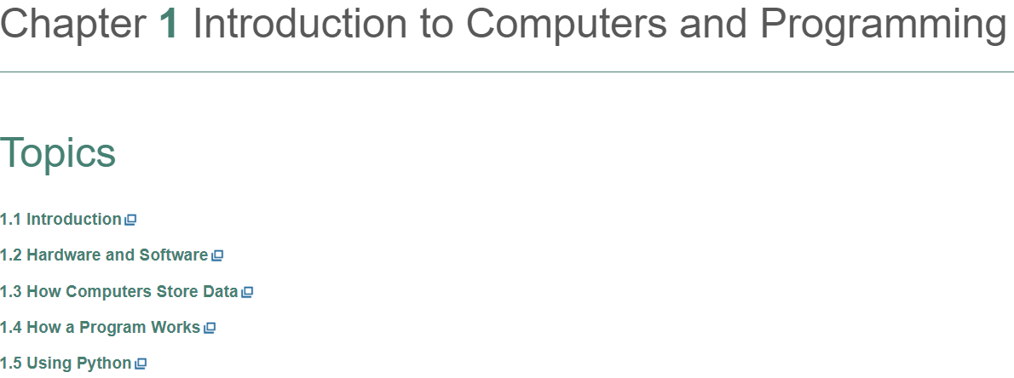  Activities:  - Chapter 1 - Read  - Provide the answer to Quick Review questions at the end of chapter  - Take Chapter 1 Quiz  - Provide the answer to MyProgrammingLab (MPL) assignments
chapter2 | 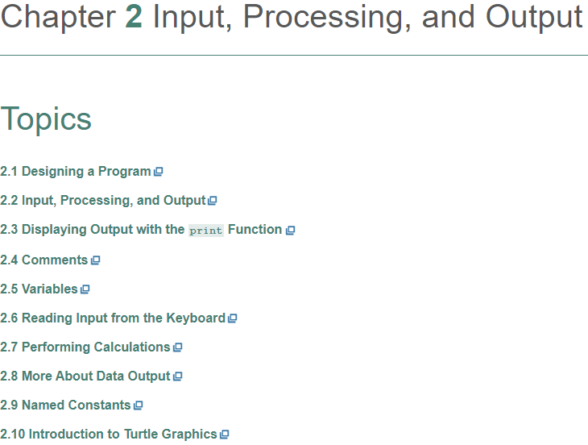  Activities:  - Chapter 2 – Read  - Provide the answer to Quick Review questions at the end of chapter  - Take Chapter 2 Quiz  - Provide the answer to programming Exercises  - Provide the answer to MyProgrammingLab (MPL) assignments
Chapter 3 | 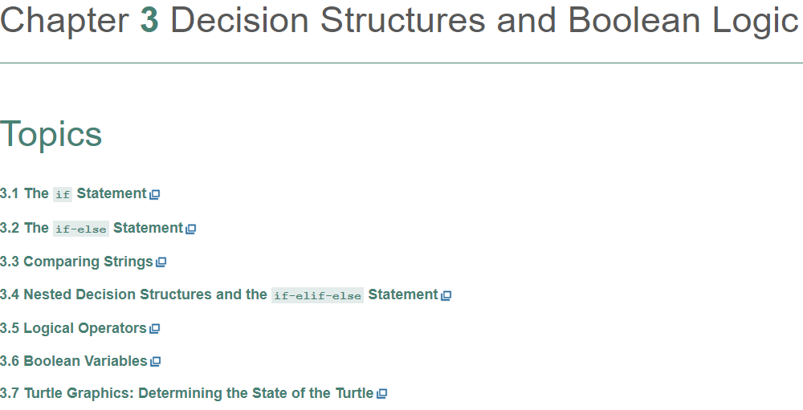  Activities:  - Chapter 3 – Read  - Provide the answer to Quick Review questions at the end of chapter  - Take Chapter 3 Quiz  - Provide the answer to programming Exercises  - Provide the answer to MyProgrammingLab (MPL) assignments
Chapter 4 | 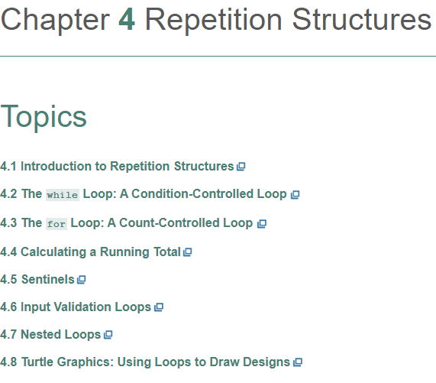  Activities:  - Chapter 4 – Read  - Provide the answer to Quick Review questions at the end of chapter  - Take Chapter 4 Quiz  - Provide the answer to programming Exercises  - Provide the answer to MyProgrammingLab (MPL) assignments
Chapter 5 | 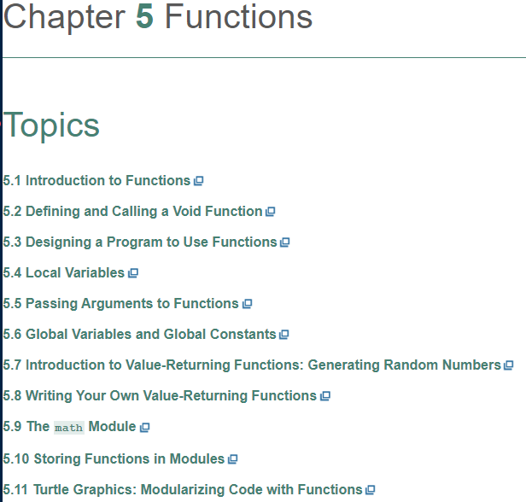  Activities:  - Chapter 5 – Read  - Provide the answer to Quick Review questions at the end of chapter  - Take Chapter 5 Quiz  - Provide the answer to programming Exercises  - Provide the answer to MyProgrammingLab (MPL) assignments
6 | 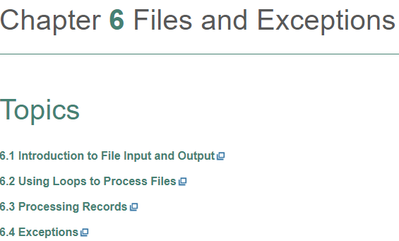  Activities:  - Chapter 6 – Read  - Provide the answer to Quick Review questions at the end of chapter  - Take Chapter 6 Quiz  - Provide the answer to programming Exercises  - Provide the answer to MyProgrammingLab (MPL) assignments
7 | 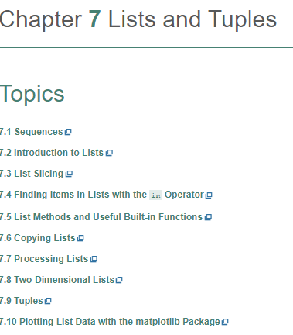  Activities:  - Chapter 7 – Read  - Provide the answer to Quick Review questions at the end of chapter  - Take Chapter 7 Quiz  - Provide the answer to programming Exercises  - Provide the answer to MyProgrammingLab (MPL) assignments
Chapter  8 | 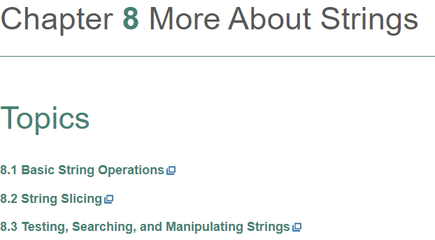  Activities:  - Chapter 8 – Read  - Provide the answer to Quick Review questions at the end of chapter  - Take Chapter 8 Quiz  - Provide the answer to programming Exercises  - Provide the answer to MyProgrammingLab (MPL) assignments

Review questions & Programming Challenges
The review questions and programming challenges are located at the end of each chapter in your textbook.

MyProgrammingLab assignments

You need to buy the access code for MyProgrammingLab (MPL). Students should provide the correct answer for all assignments including Programming challenges for each chapter listed in the syllabus in MPL. The first chapter is 1 and the last chapter is 8. You need to do all the assignments of MPL for each chapter and do not need to upload anything from MPL into D2L. Your grade will be based on the number of correct answers. I will transfer your grades from MPL to Eagle Online Canvas.

Syllabus Modifications
The instructor reserves the right to modify the syllabus at any time during the semester and will promptly notify students in writing, typically by e-mail, of any such changes.

Instructor’s Practices and Procedures

Missed Assignments
Insert your make-up policy for course work other than the departmental final exam. It is acceptable to have a “no makeups” for exams if you drop the lowest exam. You may also allow makeups accompanied by a late-work penalty. You might consider requiring documentation of an emergency to allow a make-up. Please also clearly state that a make-up exam is not a retake. That is, make-up exams are allowed only for missed exams. You are responsible for proctoring make-up exams if you allow them.

Academic Integrity
- Students are expected to follow the code of ethical standards and honesty in academic institution. The standards and values provide an educational environment in which all students can learn and take responsibility for their work. Copying from another student's test or homework, Allowing another student to copy from your test or homework, Using materials such as textbooks, notes, or formula lists during a test without the professor's permission, Collaborating on an in-class or take-home test without the professor's permission, and Having someone else write or plan a paper for you are examples of not following the code of ethical standards. Scholastic Dishonesty will result in a referral to the Dean of Student Services. See the link below for details.

Here’s the link to the HCC information about academic integrity (Scholastic Dishonesty and Violation of Academic Scholastic Dishonesty and Grievance):
http://www.hccs.edu/about-hcc/procedures/student-rights-policies--procedures/student-procedures/

Attendance Procedures
Students are expected to attend the class on regular basis. If you need to be absent, you must inform your instructor in advance.

Student Conduct
Students must abide with class regulations and prevent disruptive behavior.

Electronic Devices
Students are expected to turn off their cell phone or put it on silence during class time.

HCC Policies
Here’s the link to the HCC Student Handbook http://www.hccs.edu/resources-for/current-students/student-handbook/ in it you will find information about the following:

- Academic Information
- Academic Support
- Attendance, Repeating Courses, and Withdrawal
- Career Planning and Job Search
- Childcare
- disability Support Services
- Electronic Devices
- Equal Educational Opportunity
- Financial Aid TV (FATV)
- General Student Complaints
- Grade of FX
- Incomplete Grades
- International Student Services
- Health Awareness
- Libraries/Bookstore
- Police Services & Campus Safety
- Student Life at HCC
- Student Rights and Responsibilities
- Student Services
- Testing
- Transfer Planning
- Veteran Services

EGLS³
The EGLS³ (Evaluation for Greater Learning Student Survey System) will be available for most courses near the end of the term until finals start. This brief survey will give invaluable information to your faculty about their teaching. Results are anonymous and will be available to faculty and division chairs after the end of the term. EGLS³ surveys are only available for the fall and spring semesters. EGLS3 surveys are not offered during the summer semester due to logistical constraints.
http://www.hccs.edu/resources-for/current-students/egls3-evaluate-your-professors/

Campus Carry Link
Here’s the link to the HCC information about Campus Carry: http://www.hccs.edu/departments/police/campus-carry/

HCC Email Policy
When communicating via email, HCC requires students to communicate only through the HCC email system to protect your privacy. If you have not activated your HCC student email account, you can go to HCC Eagle ID and activate it now. You may also use Canvas Inbox to communicate.

Housing and Food Assistance for Students
Any student who faces challenges securing their foods or housing and believes this may affect their performance in the course is urged to contact the Dean of Students at their college for support. Furthermore, please notify the professor if you are comfortable in doing so.

This will enable HCC to provide any resources that HCC may possess.

Office of Institutional Equity

Use the link below to access the HCC Office of Institutional Equity, Inclusion, and Engagement (http://www.hccs.edu/departments/institutional-equity/)

Disability Services
HCC strives to make all learning experiences as accessible as possible. If you anticipate or experience academic barriers based on your disability (including long- and short-term conditions, mental health, chronic or temporary medical conditions), please meet with a campus Abilities Counselor as soon as possible in order to establish reasonable accommodations. Reasonable accommodations are established through an interactive process between you, your instructor(s) and Ability Services. It is the policy and practice of HCC to create inclusive and accessible learning environments consistent with federal and state law. For more information, please go to http://www.hccs.edu/support-services/ability-services/

Title IX
Houston Community College is committed to cultivating an environment free from inappropriate conduct of a sexual or gender-based nature including sex discrimination, sexual assault, sexual harassment, and sexual violence. Sex discrimination includes all forms of sexual and gender-based misconduct and violates an individual’s fundamental rights and personal dignity. Title IX prohibits discrimination on the basis of sex-including pregnancy and parental status in educational programs and activities. If you require an accommodation due to pregnancy, please contact an Abilities Services Counselor. The Director of EEO/Compliance is designated as the Title IX Coordinator and Section 504 Coordinator. All inquiries concerning HCC policies, compliance with applicable laws, statutes, and regulations (such as Title VI, Title IX, and Section 504), and complaints may be directed to:

David Cross
Director EEO/Compliance
Office of Institutional Equity & Diversity
3100 Main
(713) 718-8271
Houston, TX 77266-7517 or Institutional.Equity@hccs.edu
http://www.hccs.edu/departments/institutional-equity/title-ix-know-your-rights/

Office of the Dean of Students
Contact the office of the Dean of Students to seek assistance in determining the correct complaint procedure to follow or to identify the appropriate academic dean or supervisor for informal resolution of complaints.

https://www.hccs.edu/about-hcc/procedures/student-rights-policies--procedures/student-complaints/speak-with-the-dean-of-students/

Department Chair Contact Information
Jamshid Derakhshandeh
j.derakhshandeh@hccs.edu
(713)718-2067

