IC-20: Simple Machines
Rev 11-4-2022

20.1 OBJECTIVE
The purpose of this experiment is to analyze the working of different types of simple machines, including the inclined plane, wheel and axle, and a pulley system. We will compute their mechanical advantage and efficiency.
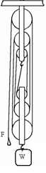
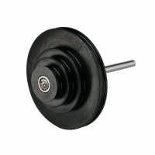

20.2 EQUIPMENT
Wooden Board Protractor
Wheel and axle Slotted weights
Pulley system Vernier Caliper
Weight hanger Wooden Block

20.3 THEORY
A simple machine is a device that makes it easier for us to do work by changing the direction or magnitude of the force. An external agent exerts a force F at the input point of the machine which in turn is used to lift a weight W at its output point. There are six classical simple machines:
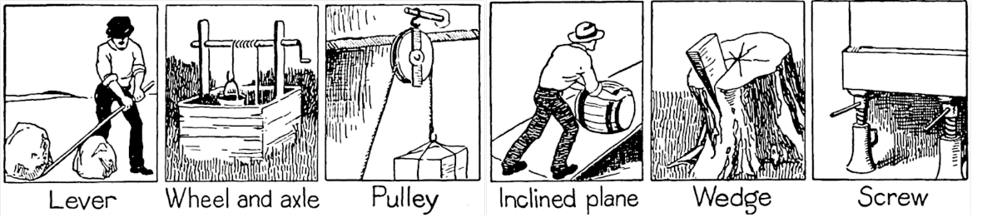

The purpose of these machines is to make a particular task much easier, either by needing a smaller force, or by changing the direction of the force. An example of this is the car jack: with a force F of 200 N applied at the handle (input), one can lift a car of weight W of 8000 N (output). We define the Mechanical Advantage (MA) of a machine as:
MA = weight lifted / force applied = W / F (1)
For an ideal machine, in which the friction is negligible, and all its parts are mass-less, we define its Ideal Mechanical Advantage (IMA) as:
IMA = d_{i} / d_{o} (2)
Where: d_{i} is the actual distance through which the applied force F moves and,
d_{o} is the vertical distance through which the weight W moves. (See figure 1 for the inclined plane)
In practice, there is always energy lost to friction. As such, we need to measure the efficiency ‘e’ of a machine as defined by:
e = (work out) / (work in)
= (W x d_{o}) / (F x d_{i}) (3)
= (W / F) / (d_{i} / d_{o}) = MA / IMA
The efficiency of a real machine is always less than one and an ideal machine would have an efficiency exactly equal to one. Efficiency can never be more than one.

Inclined Plane
A ramp is an inclined plane. It is a slanted surface used to raise an object. When an object is moved up an inclined plane, less effort is needed than if you were to lift it straight up, but you must move the object over a greater distance. From figure 1, the input force F needed to move the object of weight W at constant speed is
F = f + Wsin θ,
where f is the frictional force and W is the weight being lifted. We can show that:
W=Mg
F=mg
θ
d_{i}
d_{i}
d_{o}

MA = W / F
MA = 1 / ( sin θ + µ_{k} cos θ ) (4)
IMA = d_{i} / d_{o}
Where µ_{k} is the coefficient of kinetic friction, and its efficiency is
e = MA / IMA
or e = 1 / ( 1 + µ_{k} cot θ) (5)
Figure 1

Wheel and Axle
r
R
F
W
It is a lever that rotates in a circle around a center point or fulcrum. The larger wheel (or outside) rotates around the smaller wheel (axle). Bicycle wheels, Ferris wheels and gears are all examples of a wheel and axle.

An outside agent exerts an input force F on a string wrapped around a wheel of radius R while a load of weight W is lifted around an axle of radius r. We have
IMA = R / r (6)
MA = W / F
e = MA / IMA

Figure 2

Pulley
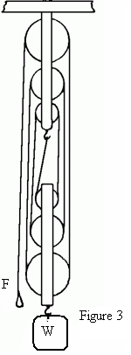
It is a chain, belt or rope wrapped around a wheel. The mechanical advantage MA of a pulley system is approximately equal to the amount of supporting ropes or strands. In Figure 3, since there are six strands of the cord pulling on the load of weight W then the input force F must move through a distance six times that through which the load is lifted, this means that IMA = 6. As such, the force F needed to lift the weight is equal to W/6 (if there is no friction). In practice, due to friction, the force F required to lift the weight W is slightly more than W/6.

IMA = Number of strands
MA = W / F
e = MA / IMA

20.4 EXPERIMENTAL PROCEDURE

Inclined Plane
- Get the mass of the wooden block (M), on the triple beam balance and calculate its weight (W = Mg), and record them.
- Make two marks on the wooden board. Measure the distance between them and record it as d_{i}. Your wooden block should move from one of these marks to the other.
- Set up the wooden board at an angle of 20⁰ with the horizontal as shown in Figure 1. Place the block on the board and run the cord over the pulley and attach a weight hanger to it. Slowly increase the load on the hanger until the block starts slowly moving up the plank, with constant speed, after the block is given a small push. Note this mass (m), calculate the force (F=mg), and record these. (Don’t forget to include the mass of the hanger in ‘m’.)
  - Measure the vertical height gained by the block as it moves between the two marks (see Figure 1). Record this value as d_{o}.
- Repeat procedure 3 and 4 for angles 30⁰ and 40⁰.
- Calculate the required values from the data collected.

Wheel and Axle
- Wrap a string around the axle of the assembly and attach a weight of mass M = 600 grams at the end of the string. Calculate the weight (W = Mg). Wrap another string around the wheel, in the opposite direction to the first one, and add enough mass (m) to it to make the load W move upward at a slow speed. Calculate the force (F = mg). Remember that the wheel has a larger radius than the axle.
- Using a Vernier caliper, measure the radius of the axle ( r ) and that of the wheel ( R ). Record the values.
- Calculate the required values from the data collected.

Pulley Systems
1 Take two pulley systems and pass the string through them as shown in Figure 3. Hang the top pulley system from some stand. Count the number of strands for the pulley system, and record this as the IMA.
2 Attach a mass M = 900 grams. Calculate the weight (W = Mg) to the lower pulley and add enough mass (m) on the string to cause the weight to start moving up at a slow, and constant speed. Calculate the force F = mg.

20.5 CALCULATIONS
- For the angle of incline of 20⁰, compute the Ideal Mechanical Advantage (IMA), Mechanical Advantage (MA), and the efficiency (e) of the inclined plane by using eqn. 1, 2, and 3, and record them.
- Compute the coefficient of kinetic friction between the block and board using equation (4) or equation (5).
- Repeat calculations 1 and 2 for the angle of incline of 30⁰.
- Repeat calculations 1 and 2 for the angle of incline of 40⁰.
- For the wheel and axle, compute the Mechanical Advantage (MA), Ideal Mechanical
- Advantage (MA), and the efficiency (e) and record them.
- For the pulley systems, compute the Ideal Mechanical Advantage (IMA), Mechanical
- Advantage (MA), and the efficiency (e) and record them.
- From these, calculate the friction coefficient µ_{k}.

20.6 IC-20 Simple Machines REPORT FORM
Name: __________________________________________ Date: ___________________

Inclined Plane
Mass of block (M): _______ Weight of block (W=Mg): _______ Length of board (d_{i}):_______

Angle of incline | 20° | 30° | 40°
Hanging mass (m)
Force F pulling the block (=mg)
Height (do)

Wheel and Axle
Radius of Axle (r): _______ Radius of Wheel (R): _______ IMA: ____________
Mass being lifted (M): _________ Weight being lifted (W = Mg): __________
Mass used to lift the weight (m):__________ Force lifting the weight (F = mg): _______

Pulley Systems
Mass being lifted (M): ________ Weight being lifted (W=Mg): ________
Number of strands:______
Mass used to lift the weight (m):________ Force lifting the weight (F=mg): _______

20.7 RESULTS:
 |  | IMA | MA | e | µk
Inclined Plane | Inclined at 20°
 | Inclined at 30°
 | Inclined at 40°
Wheel and Axle
Pulley system

20.8 REPORT SUBMISSION
Upload the following in the Report for this Lab:
 |  | Points in report
 | Report Form  Errors: Units wrong / missing, too many / too few Sig. Fig. | 10
 | Results | 5
 | Sample Calculations | 5
 | Picture of setup (any one) | 5
 | Sources of Error in this experiment. Make a list of sources of error.  Do not write: Human Error, Calculation Error, and Rounding Error. | 5
 | Discussion of the Results of this experiment.  Do not ignore major errors | 10
 | Total | 40
Keep “Sources of Error” as a separate heading, and “Discussion” as a separate heading.

20.9 ADDITIONAL INFORMATION
https://www.youtube.com/watch?v=9T7tGosXM58

20.10 SAMPLE DATA

