IC-15: CONSERVATION OF LINEAR MOMENTUM IN TWO DIMENSIONS
Rev 04-03-2023

15.1 OBJECTIVE
To show that momentum is conserved in a 2-D collision and find the fractional loss in kinetic energy.

15.2 EQUIPMENT
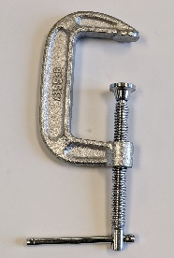
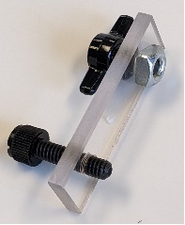
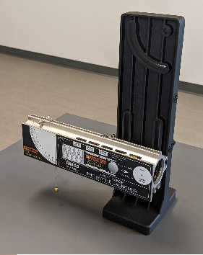
Projectile Launcher
Plumb Bob
Meter Stick
Protractor or angle indicator
Collision Attachment
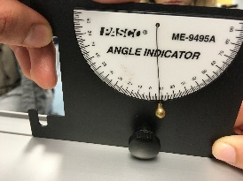
Tape
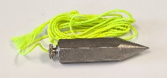
Carbon paper
Clamp

15.3 THEORY
Linear momentum is conserved in a collision in each of the three directions, provided there is no external force acting on the system. In this experiment, a ball moving with some velocity will collide with a stationary ball. The two will move in the horizontal X-Y plane, and also fall downwards. We will consider only the momentum conservation in the X-Y plane. It is convenient to take the initial direction of the launched ball as the X-direction. The vertical (up-down) is the Z-direction, in which gravity acts. The direction in the plane of the table and perpendicular to the direction of the launched ball is the Y-direction. The collision in 2D is represented by figure 1.

U₁

V₁

V₂

V₁Cosθ₁

V₂Cosθ₂

V₁Sinθ₁

V₂Sinθ₂

θ₂

θ₁
Y

X

Figure 1: Two-Dimensional Collision

We will use the following notation:
Subscript ‘1’ is used for the ball that is launched
Subscript ‘2’ is used for the ball that is struck by ball 1.
M = the mass of a ball
U = velocity before collision
V = velocity after collision.

Conservation of momentum in the x-direction implies that the sum of the x-components of momenta of the two balls before the collision is the same as the sum of the x-components after collision, i.e.
M₁*U_{1x} + M₂*U_{2x} = M₁*V_{1x} + M₂*V_{2x}
or M₁*U₁ + 0 = M₁*V₁*Cosθ₁ + M₂*V₂*Cosθ₂ (1)
In the Y-direction:

M₁*U_{1y} + M₂*U_{2y} = M₁*V_{1y} + M₂*V_{2y}
or 0 + 0 = M₁*V₁*Sinθ₁ - M₂*V₂*Sinθ₂ (2)
Equations (1) and (2) are simplified by using the following two observations:
a) Since M₁ = M₂ all the M₁ and M₂ will cancel out from eqn. (1) and (2)
b) We can replace the velocities by distances travelled. This is explained as follows:
The notation used for distances travelled by the balls before hitting the table are (see Fig. 2):
Ball 1 when there is no collision = X meters,
Ball 1 after collision = R₁ meters
Ball 2 after collision = R₂ meters
All distances are measured to and from the centers of the balls from the point of collision to where the balls hit the table.
These distances are proportional to their velocities and the time of travel. The time for falling to the table depends only in the height from where the balls are falling, and not on their horizontal velocity. Since both balls are falling from the same height, the time of travel of each ball is the same, which we write as ‘T’.
We can now see that:
Distance travelled by ball 1 without collision = X = U₁ * T.
Distance travelled by ball 1 after collision = R₁ =V₁ * T.
Distance travelled by ball 1 without collision = R₂ = V₂ * T.
Hence:
U₁ = X / T V₁ = R₁ / T V₂ = R₂ / T
Since 1/T is present is each term of both equations (1) and (2), it can be cancelled out. This is because T is the time it takes for the balls to hit the table, which is the same for both balls. We are then left with:

X = R₁*Cosθ₁ + R₂*Cosθ₂ (3)

0 = R₁*Sinθ₁ - R₂*Sinθ₂ (4)
To verify the conservation of momentum we only need verify that the equations (3) and (4) are true, instead of comparing the actual momenta.
(note: R₁ and R₂ are distances and hence positive, θ₁ is positive, and θ₂ is negative)

R₁

θ₂

θ₁

X

R₂

Figure 2: Distances on the table. Blue arrows indicate where the balls hit the table.

Figure 3: Launcher and attachment
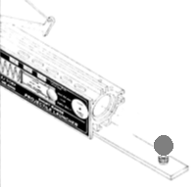
This experiment is performed by using the Projectile Launcher of a Ballistic Pendulum. The Launcher is kept horizontal, at a few inches height from the table. The Collision attachment has a place to put the (stationary) ball on it (see Fig. 3). When the ball inside the launcher comes out, it collides with the stationary ball.
Initially, the ball is launched without the stationary ball. The distance that it travels before hitting the table is X (proportional to U₁).
Then a ball is placed on the attachment, and the first ball is launched. After the collision, both balls travel some distance and hit the table.
Carbon papers placed on the white paper help to show the spots where the balls hit the table. In this experiment, four runs are made with different positions of the stationary ball, and different speeds of the launched ball. The white sheets with the marks that the balls made are used to measure the distances.

15.4 PROCEDURE
You can see the introduction to this Lab, and the procedure being done in the videos whose links are given at the beginning of this manual.
- Attach the Projectile Launcher to one end of the table with a clamp. Attach the Collision Attachment to the launcher (see Fig. 3). Make sure the launcher is horizontal.
- Shoot a ball a few times to get an idea of where it would land on the table. Tape white sheets of paper on the table, and put carbon paper on it.
- Shoot a ball four times. It will make marks on the white paper where it lands.
- Now put the ball in the launcher. This is the Launched Ball. Rotate the attachment and put a ball carefully on it. This is the Stationary Ball. Make sure that the Launched ball will hit the Stationary ball at an angle. Fire the launcher. Both balls will hit the table and leave marks on the white paper. Label them. Repeat four times with different positions of the stationary ball.
- Measure the distances R₁, R₂ and X, and the angles θ₁ and θ₂. (As an example, see the lines in fig 4 and Fig. 5). (Actually, you can get away without measuring the angles. You can measure x₁, x₂, y₁ and y₂ directly and put them in the table)
- Do the required calculations.
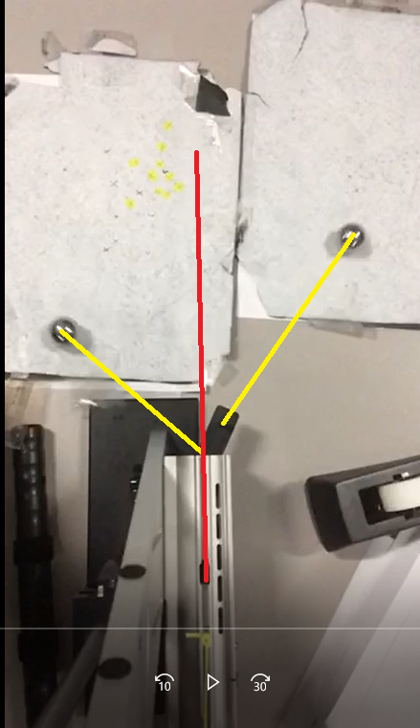
Figure 4: Image taken from Video B. Draw lines from the center of the balls when they collided, to where they landed on the table. The red line shows where the ball had gone to when there was no collision. This gives the U₁.

Figure 4. Distances to measure
Launcher
Stationary ball (ball 2) lands here after collision.
Measure R₂ and θ₂
(or x₂ and y₂)
Launched ball (ball 1) lands here after collision.
Measure R₁ and θ₁
(or x₁ and y₁)
Launched ball (ball 1) lands here when there is no collision.
Measure X

x
R₂
x₂

x₁

R₁

θ₁

θ₂

y

X

y₂

y₁

15.5 PRECAUTIONS
- Clamp the launcher on the table so that it does not move during the experiment.
- The diameter and mass of both balls should be the same. Use both yellow balls, or both steel balls.
- All distances are to be measured in the horizontal direction.
- Measure the distance R₂ from directly below the center of its initial position, to where it hits the table.

15.6 IC-15 CONSERVATION OF LINEAR MOMENTUM REPORT FORM

MEASUREMENTS:
 | Case 1 | Case 2 | Case 3 | Case 4
X
R1
R2
θ1
θ2
x1 = R1*Cosθ1
x2 = R2*Cosθ2
y1 = R1*Sinθ1
y2 = R2*Sinθ2

CALCULATIONS AND RESULTS:
 | 1 | 2 | 3 | 4
Initial Momentum in x-direction = Momentum without collision = X
Final Momentum in x-direction after collision = R1*Cosθ1 + R2*Cosθ2 = x1 + x2
Percent difference between initial and final momenta in x-direction
Initial Momentum in y-direction = Momentum without collision | 0 | 0 | 0 | 0

Final Momentum in y-direction after collision = R1*Sinθ1 - R2*Sinθ2 = y1 - y2
Percent difference between y1 and y2
 | cm² | cm² | cm² | cm²
Initial Kinetic Energy = kinetic energy without collision = X²
Final Kinetic Energy after collision= R1² + R2²
Percent difference between initial and final kinetic energies

15.7 REPORT SUBMISSION

Upload the following in the Report for this Lab (don’t make the mistakes in red):

 |  | Points in report
 | The completely filled up “Measurements Table”.  Errors: Units wrong / missing, too many / too few Sig. Fig. | 10
 | The completely filled up “Calculations Table”.  Errors: Units wrong / missing, too many / too few Sig. Fig. | 10
 | Photographs of the setup with marks where balls fall on ground / table | 5
 | Sources of Error in this experiment. Make a list of sources of error.  Do not write: Human Error, Calculation Error, and Rounding Error. | 5
 | Discussion of the Results of this experiment.  Do not ignore major errors | 10
 | Total | 40

Keep “Sources of Error” as a separate heading, and “Discussion” as a separate heading.
A video of the collision showing where the balls landed will get you up to 5 points extra credit.

15.8 ADDITIONAL INFORMATION
You can see the collision in these videos:
Link to Introduction to the experiment: https://youtu.be/-wRiGHan2iM
Link to Video A: https://youtu.be/aI7GteYSIPc
Link to Video B: https://youtu.be/-77lTAlJNcQ

15.9 SAMPLE DATA

MEASUREMENTS:
 | Case 1 | Case 2 | Case 3 | Case 4
 | cm
X | 57.6
R1 | 24.9
R2 | 35.2
θ1 | 38
θ2 | 23
x1 = R1*Cosθ1 | 19.6
x2 = R2*Cosθ2 | 32.4
y1 = R1*Sinθ1 | 15.3
y2 = R2*Sinθ2 | 13.8

CALCULATIONS AND RESULTS:
 | 1 | 2 | 3 | 4
Initial Momentum in x-direction = Momentum without collision = X | 57.6
Final Momentum in x-direction after collision = R1*Cosθ1 + R2*Cosθ2 = x1 + x2 | 52.0
Percent difference between initial and final momenta in x-direction | 10.2
Initial Momentum in y-direction = Momentum without collision | 0 | 0 | 0 | 0
Final Momentum in y-direction after collision = R1*Sinθ1 - R2*Sinθ2 = y1 - y2 | 1.5
Percent difference between y1 and y2 | 10.3
 | cm² | cm² | cm² | cm²
Initial Kinetic Energy = kinetic energy without collision = X² | 3318
Final Kinetic Energy = R1² + R2² | 1859
Percent difference between initial and final kinetic energies | 56.4

