IC-19: ARCHIMEDES PRINCIPLE (Force Sensor / Triple Beam Balance)
Rev 11-06-2023

19.1 OBJECTIVE
To measure the density of different materials by using Archimedes Principle. We will use EITHER the Force Sensor, OR the Triple Beam Balance.

19.2 EQUIPMENT

USING FORCE SENSOR:
A-Base 45 cm Steel Rod Multi Clamp Super Pulley Rod String
Density Set Container for water Force Sensor Vernier caliper

USING TRIPLE BEAM BALANCE:
Density Set Container for water Triple Beam Balance String Vernier Caliper
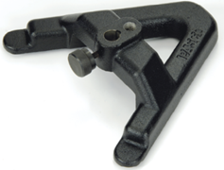
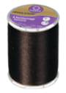
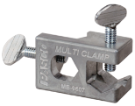
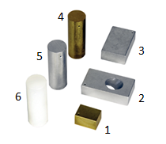
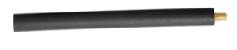

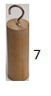
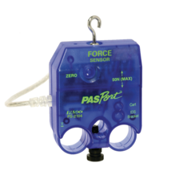
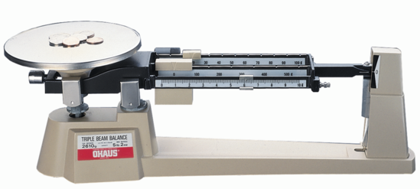

19.3 THEORY
Archimedes' Principle states: "When an object is submerged in a fluid, the fluid exerts an upwards buoyant force equal to the weight of the fluid displaced by the object".
This principle can be used to measure the density of solids without the need to measure their volumes. We will fine the density of a few different materials in the shape of cylinders and rectangular solids. We will use the force sensor of the smart cart to weigh the objects in air and submerged in water.
Any object of mass M and volume V has a density ρ given by:
$ρ= M/V$ ( 1 )
Archimedes principle states that any object totally submerged in a fluid of density ρ_{f} is buoyed up by a net upward force B equal to the weight of the fluid displaced by the object. The displaced fluid is the volume of fluid equal to the volume of the object below the fluid surface, V (effectively, the volume of solid inside the liquid). If an object is submerged in water, we have: B = ρ_{w} g V, where ρ_{w} is the density of water.
When an object is in air, a balance measures its true weight W_{A} = M_{A} g (see Fig.1).
We shall use the following notation:
M_{A} = mass of the object in air
M_{W} = apparent mass of the object when it is submerged in water
M_{AW} = Mass of the object in air and only the sinker submerged in water
M_{WW} = mass of both the object and sinker submerged in water
ρ_{w} = density of water
ρ = density of the object

Object denser than water:
When such an object is submerged in water (Fig. 2) then the balance reads its apparent weight in water W_{W} such that
W_{W} = M_{A} g – B ( 2 )
Using previous equations, the density ρ of the object is given by:
ρ = ρ_{w} [W_{A} / (W_{A} - W_{W})] ( 3 )

And also by: ρ = ρ_{w} [M_{A} / (M_{A} - M_{W})] (3a)

Object lighter than water:
For such objects (e.g. wood or plastic) one must use a sinker attached to the bottom of the object (Fig. 3) to make it submerge into the water. By following the same above procedure, we can calculate the density of plastic, ρ_{p,} to be:
ρ_{p} = ρ_{w} [W_{A} / (W_{AW} – W_{WW})] ( 4 )
And also by: ρ_{p} = ρ_{w} [M_{A} / (M_{AW} – M_{WW})] ( 4a )
Where W_{A} is the weight of only the plastic cylinder in air (no sinker attached, as in Fig. 1), W_{AW} is the weight when only the sinker is submerged and the plastic is in air (as in Fig. 3), and W_{WW} is the weight when both sinker and plastic are submerged (as in Fig. 4).
M
T = W_{WW}
B
Sinker
T = W_{AW}
B
Sinker
M
M
T = W_{W}
Mg
B

M
T = W_{A}
Mg
In air

Figure 1 Figure 2 Figure 3 Figure 4

19.4 EQUIPMENT SETUP

USING FORCE SENSOR:
- On the A-Base, fix the 45 cm Steel rod so that it is vertical.
- Attach the Multi Clamp to the steel rod.
- Attach the Super Pulley Rod to the Clamp, so that it is sticking out horizontally.
- Attach the Force Sensor to the Super Pulley Rod, such that the hook of the force sensor is pointing vertically downwards.
- Connect the Force Sensor to Science Workshop 850.
The setup should look like that shown in Figure 5. Depending on the equipment available, you may use other ways to hold the Force Sensor.

USING TRIPLE BEAM BALANCE:
Place the Triple Beam Balance at the edge of the table. Attach a thread under the pan of the Balance. See Figure 6.
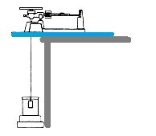
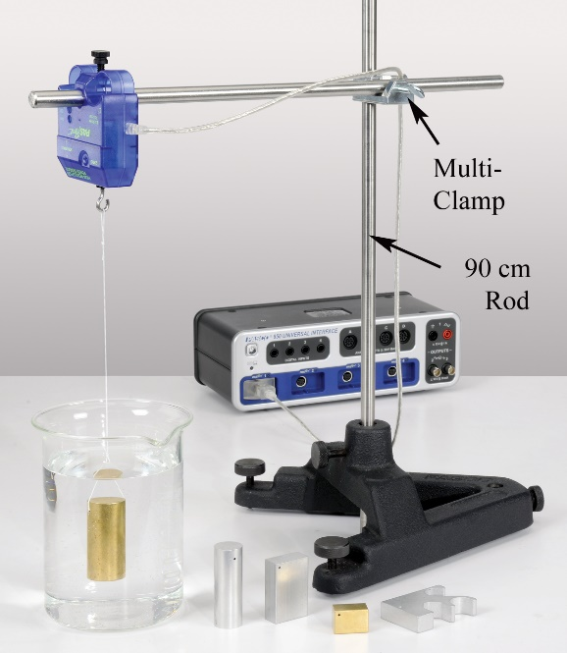

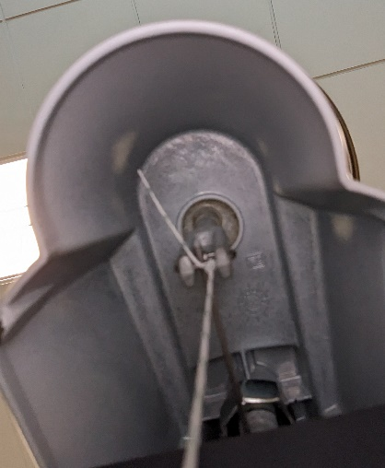

Figure 5: Experimental Setup Force Sensor

Figure 6: Using Triple Beam Balance and place to tie the string

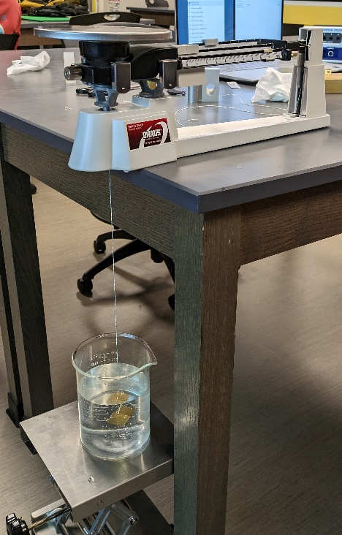
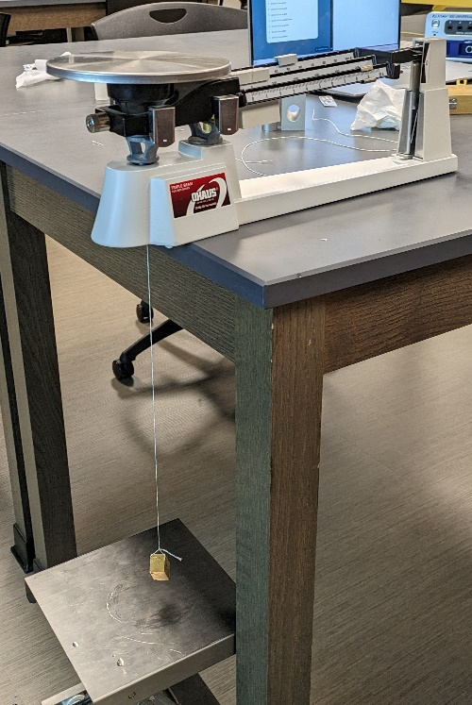

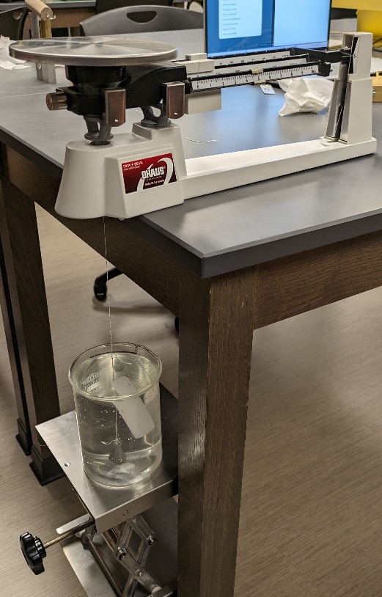
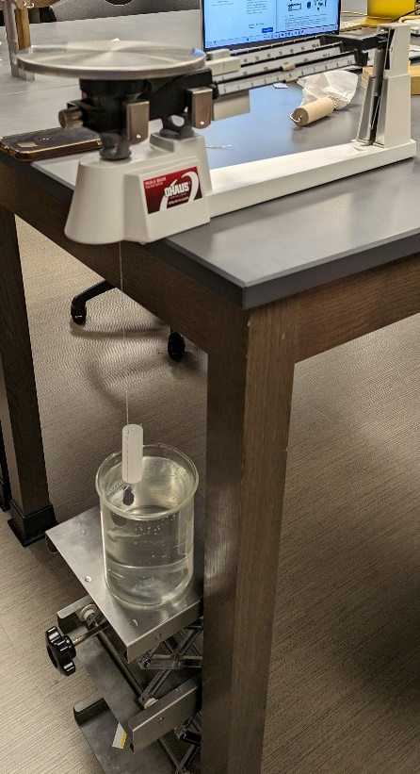

Figure 7: Weighing the objects in and out of water.

19.5 PROCEDURE

Part A: Solids that sink in water (objects 1-5):
- Tie a piece of string onto each of the masses found in the Density Set. Tie a loop on the other end of the string so that it can be hooked onto the sensor.
- Put enough water in a container so that the objects can fully submerge in it, but don't submerge the samples yet!

USING FORCE SENSOR
- Turn on Capstone, and select Force Sensor in Hardware Setup.
- Attach the first metal object to the hook of the Force Sensor. Hold the attached weight in your hand, make sure it’s not pulling on the hook. (See Fig 8a). Now Tare the force Sensor. Start recording (keep the weight in your hand). The graph should show a smooth horizontal line at 0 N. If it is not 0 N, note the value as the zero error of the force sensor.
- Lower the object slowly and release it. When the data stabilizes, it should be a horizontal line at its weight in air, W_{A}. (See Fig. 8b, where this is done by using the Force Sensor built in the Smart Cart)
- Put the container with water under the hanging object, and then raise it such that the metal object is fully submerged in the water, but it should not be touching any side or base of the container. Alternately, you can put the water container under the hanging object, and then lower the Force Sensor by loosening the nut on the Multi clamp, and lowering clamp plus Force Sensor along the steel rod until the object is dipped in water. Measure the apparent weight in water W_{W}. Use eqn. 3 to get the density. (See Fig 8c)
- Repeat steps 9 to 11 for the other metal objects in the density set.
Note: With Force Sensor, to get the weights, press “Record”, and wait a few seconds. You should get a constant value of force over time. Then highlight the data and find the “Mean Value”, see Figure 7.

USING TRIPLE BEAM BALANCE:
Attach a string under the Triple Beam Balance, and get the masses of the objects when they are hanging under the balance in air, and when they are dipped in water, just as you would with the force sensor. In equation 3 you can replace the weights W by the masses M.
Compare the densities of these items with their accepted values, and get the percent errors.

Part B: Solid that floats on water (object 6):

USING FORCE SENSOR
- The plastic cylinder has a density less than that of water.
- Hang only the plastic cylinder under the hook, and get its weight in air, W_{A}.
- Attach a sinker to the bottom of the plastic cylinder and submerge only the sinker in the water, while the plastic cylinder is outside the water, but both are hanging under the balance. Read the apparent weight W_{AW} (this is weight of the plastic cylinder in air + sinker inside water).
- Now lower the objects such that both the sinker and the plastic cylinder are in water. Read the apparent weight W_{WW.} Take care that neither the plastic cylinder nor the sinker are touching the sides of the container. Use eqn. 4 to get the density of Plastic Cylinder.

USING TRIPLE BEAM BALANCE:
Use the Triple Beam Balance in the same way as you would have used the force sensor. In equation 4 you can replace the weights W by the masses M.
You are un-likely to get the density of the floating object from the internet, so find the density by getting its volume by measuring its diameter and length, and calculating the density by eqn. 1. Calculate the percent difference between the two density values.

Part C: Solid that floats on water (object 6 or 7):
You now want to measure the density of the wooden or plastic cylinder, without using any of the data acquired so far. The equipment you have include ONLY the wooden/plastic cylinder, a graduated cylinder, an overflow can (optional), water, and a pen or pencil (i.e. no balance, strings, sinker etc.). Devise a way to get the value of the density, and record your data and results in your report. Also write in your report how you found the density.

19.6 PRECAUTIONS
- Make sure to Tare the force sensor with no weight attached to it, and the force sensor is in the position where it will be used.
- Check the zero error of the Triple Beam Balance before using it to get the masses.
- You can calibrate the force sensor by attaching a known weight to it and noting the value shown by the force sensor.
- Make sure that the force sensor is pointing vertically downwards (and not at an angle).
- Make sure to attach the string to the bottom of the Triple Beam Balance to the rod that is directly connected to the pan of the triple beam balance.
- Make sure that the objects in water are fully submerged, and that they are not touching the walls or the bottom of the container.
- Use a container that is large enough to submerge both the plastic cylinder and the sinker.
- The sinker should be an object of small size but high density.
- The objects should not have water sticking to them when being weighed in air.

19.7 IC-19 Archimedes Principle REPORT FORM
In these tables you can replace all weights W by masses M, and be consistent with the units.
Density of water = ρ_{w} = _________.

Part A: Solids that sink in water (objects 1-5):
Table-1: Density of Metal Objects
 | Weight in air W_{A} | Weight in water W_{W} | Density from Eqn. 3 | Material of object | Percent error
Object-1 |  |  |  | Brass
Object-2 |  |  |  | Aluminum
Object-3 |  |  |  | Aluminum
Object-4 |  |  |  | Brass
Object-5 |  |  |  | Aluminum

Part B: Solid that floats on water (object 6 or 7):
Table 2: Density of Plastic Cylinder
1 | Weight of Plastic Cylinder in air, W_{A}:
2 | Weight of Plastic cylinder in air + sinker in water, W_{AW}:
3 | Weight of Plastic cylinder + sinker in water, W_{WW}:
4 | Density of Plastic Cylinder from Eqn. 4:

Density of Plastic cylinder by using eqn. 1:
Diameter: _________ Length: _________ Mass: ___________
Density from Eqn. 1: ________
Percent difference between the two values of density: __________
.

Part C: Solid that floats on water (object 6 or 7):

19.8 REPORT SUBMISSION
Upload the following in the Report for this Lab (marks deducted for items in red font):
 |  | Points in report
 | Part A: Report Form  Units missing/wrong, calculation error, too many SF | 10
 | Part B: Report Form | 10
 | Part C | 5
 | Sample Calculations  No not write: Calculation error | 5
 | At least one picture showing your setup showing the plastic with the attached sinker. | 5
 | Sources of Error in this experiment. Indicate the biggest source of error.  No not write: Human Error, Calculation Error, and Rounding Error. These will not get you any points. | 5
 | Discussion of Results  No not ignore items with major % errors | 10
 | Total | 50
Extra Credit: A short video showing the experiment will get you up to 5 points EC

19.9 ADDITIONAL RESOURCES
Archimedes Principle: https://www.youtube.com/watch?v=ChK1en0pxi0

19.10 POINTS TO THINK ABOUT
- Why does a piece of metal sink, while a ship made of metal floats?
- Will a denser object have more buoyant force than a lighter one of the same volume?
- Will the buoyant force on a solid sphere be the same as on a hollow sphere of same diameter?
- Why is an iceberg about 90% inside water?
- Will a ship be submerged to the same extent when it is in sea water as it is in fresh water?
- Will the force of buoyancy be greater in sea water as compared to in fresh water?
- Will the force of buoyancy be more when a solid is dipped in mercury as compared to being dipped in water?
- Blocks of wood of different densities will submerge to different levels in water. Can this be used to measure the density of the wood? If the density of wood is known, can this be used to measure the density of a fluid?

19.11 SAMPLE GRAPH AND CALCULATIONS
Using Force Sensor built into the Smart Cart.
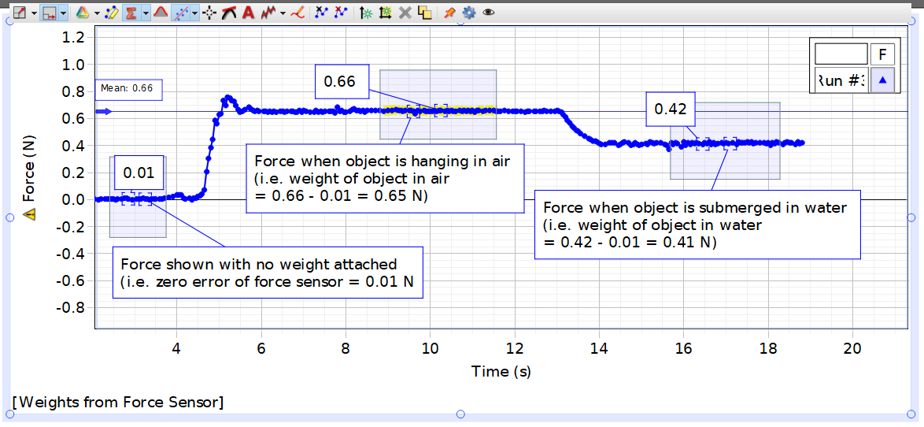
Figure 8: Capstone Graph for metal in air and water.

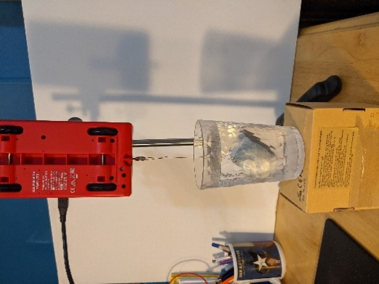
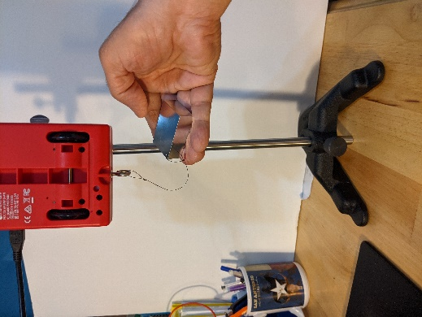
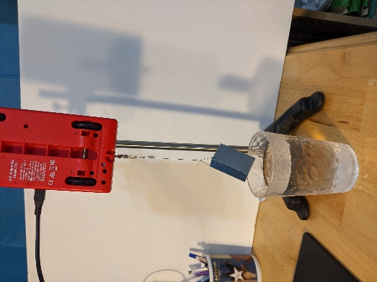

Fig. 9a: Tare (Zero Error) Fig 9b: Weight in Air Fig. 9c: Weight in Water

CALCULATIONS:
Weight of object in air: W_{A} = 0.66 – 0.01 = 0.65 N
Weight of object in water: W_{W} = 0.42 – 0.01 = 0.41 N
Equation (3) for density: ρ = ρ_{w} [ W_{A} / ( W_{A} - W_{W} )]
ρ = 1000 ( 0.65 / ( 0.65 – 0.41) ) = 2708 kg/m³
Object is Aluminum, density = 2700 kg/m³.
Percent error: $\frac{|ρ- ρ_{T}|}{ρ_{T}}x100= \frac{|2708-2700|}{2700}x100=0.3$

