IC-17B: CONSERVATION OF ANGULAR MOMENTUM (Rotary M. Sensor)
Rev 11-4-2022

17.1 OBJECTIVE
To study changes in angular momentum and rotational kinetic energy when two objects collide, one of which is spinning.

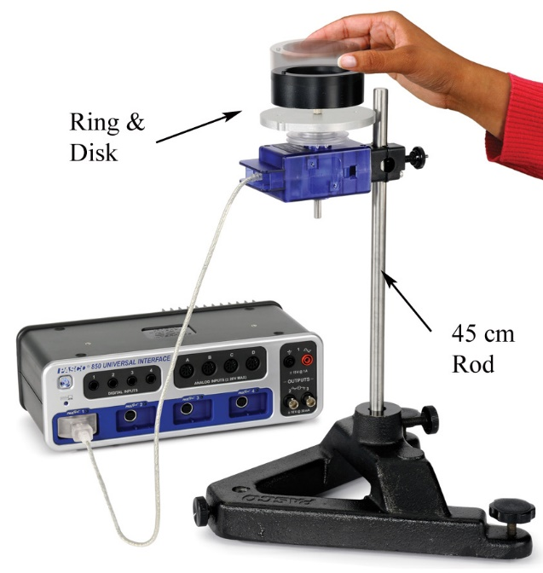
17.2 EQUIPMENT
Rotary Motion Sensor (PS-2120A)
Ring, Disc, 3-step Pulley
45 cm Rod (ME-8736)
Large Rod Base (ME-8735)
Calipers (SE-8710)
Level (SE-8729)
Balance Scale (SE-8723)
850 Interface

17.3 THEORY
The Law of Conservation of Angular Momentum states that in the absence of an external torque, the angular momentum of a system will remain unchanged. This is true if two objects collide. So if an object collides and sticks with another object, the sum of the angular momenta of the two objects should not change. In this laboratory, a non-rotating ring is dropped onto a rotating disk, and starts spinning with it. The angular speed is measured (by the Rotary Motion Sensor) immediately before the drop and immediately after the ring stops sliding on the disk.
The initial angular momentum (i.e. before the ring is dropped) is compared to the final angular momentum (i.e. after the ring is dropped on the disc), and the initial kinetic energy is compared to the final kinetic energy.
When the ring is dropped onto the rotating disk, there is no net external torque on the system. Therefore, there is no change in angular momentum (L), i.e. it is conserved.
L_{i} = L_{f}
or, I_{i} ω_{i} = I_{f} ω_{f} (1)
where I_{i} is the initial rotational inertia and ω_{i} is the initial angular speed. The initial rotational inertia is that of a disk (I_{d}) about an axis perpendicular to the disk (see Fig. 2) and through the center-of-mass (CM) is
I_{i} = I_{d} = ½ M_{d}R_{d}² (2)
where M_{d} is the mass and R_{d} is the radius of the disk. The rotational inertia of the ring about an axis through its CM and parallel to the symmetry axis of the ring is
I_{RCM} = ½ M_{R}(R₁² + R₂²) (3)
where M_{R} is the mass of the ring, R₁ and R₂ are the inner and outer radii of the ring. When the ring is dropped on the disc, it will usually not be exactly centered on the disc. The axis of rotation will still be the center of the disc. If the rotation axis of the ring is displaced by a distance D from its CM, the rotational inertia of the ring can be calculated from the parallel axis theorem and we have
I_{R} = ½ M_{R}(R₁² + R₂²) + M_{R}D² (4)
Where, (see figure 3):
D = |(X₂ - X₁)|/2 (5)
The final rotational inertia will be the sum of the rotational inertia of the disk plus the ring. The rotational kinetic energy of a rotating object is given by
KE = ½Iω² (6)

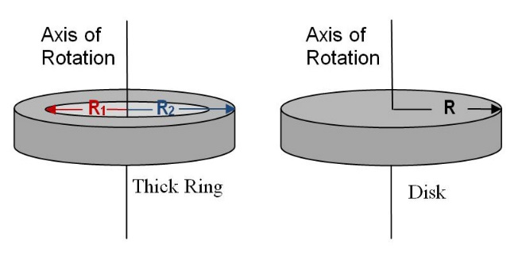

Figure 2: Rotational Axis for Ring and Disk Figure 1: Conservation of Angular Momentum

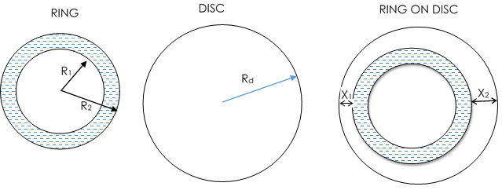

Figure 3: Ring, Disc, and possible position of ring on disc after being dropped.

17.4 EQUIPMENT SETUP
1 Use the large rod base and the 45 cm rod to support the Rotary Motion Sensor as shown in Figure 1. Plug the sensor into the interface.
2 Measure the mass and radii for the disk and ring.
3 Attach the disk to the clear three-step pulley on the Rotary Motion Sensor using the thumb-screw.
4 Place a level on the disk and level the system using the adjustable feet on the base.
5 In PASCO Capstone, set the sample rate for the Rotary Motion Sensor to 20 Hz. Create a graph of Angular Velocity vs. Time.

17.5 PROCEDURE
1 Hold the ring with the pins up, so the ring is centered on the disk and 2 to 3 mm above it. Dropping from too high causes a large vertical force on the bearing which produces a spike in the frictional drag and results in a torque which decreases the angular momentum. However, it is also critical that your fingers are clear of the ring when it strikes the spinning disk.
2 Spin the disk to give it a positive speed of about 30-40 rad/sec. Start collecting data and after about two seconds, drop the ring onto the spinning disk. Continue to collect data for a few seconds more. Fig 4 shows a screen shot of angular momentum versus time from a few seconds before to a few seconds after dropping the ring.
3 It is difficult to end up with the ring centered on the disk. Let the disc stop rotating. Measure the minimum distance between the ring and the edge of the disk. Measure the maximum distance directly on the opposite side. The distance D that the ring is off-center is half of the difference between these two measurements.
4 Use the Coordinates tool to measure the rotational speed of the last data point just before the collision, and the first data point just after the collision. These are the initial and final angular velocities, ω_{i} and ω_{f}.

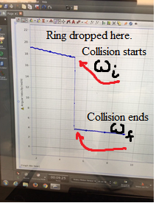
Figure 4: Capstone Screenshot. On the y-axis is angular velocity, on x-axis is time.

17.6 CALCULATIONS
- Use Equation (2) to calculate the initial rotational inertia.
- Use Equation (4) to calculate the final rotational inertia of the ring.
- Calculate the final rotational inertia of the system ( = I_{d} + I_{R}).
- Use Equation (1) to calculate the initial angular momentum of the system.
- Calculate the final angular momentum of the system and compare with initial angular momentum. Was angular momentum conserved?
- Use Equation (5) to calculate the kinetic energy before and after dropping the ring. Was energy conserved? Where did it go?
- How can angular momentum be conserved and energy not be?

17.7 PRECAUTIONS

17.8 IC-17 CONSERVATION OF ANGULAR MOMENTUM REPORT FORM

DISC:
Mass M_{d}:________ Radius R_{d} :___________ Moment of Inertia (eqn. 2) I_{d} :___________

RING:
Mass M_{R}:________ Inner Radius R₁ :_________ Outer Radius R₂ :___________
Moment of Inertia about its axis (eqn. 3) I_{RCM} :______________

 |  | Run 1 | Run 2 | Run 3
Angular speed just before dropping Ring | ω_{i}
Angular speed just after dropping Ring | ω_{f}
Minimum distance from Ring to edge of disc | X₁
Maximum distance from ring to edge of disc | X₂
Ring Offset | D
Moment of inertia of the offset ring | I_{R}
Final Moment of Inertia | I_{f}
Angular Momentum before dropping ring | I_{i} ω_{i}
Angular Momentum after dropping ring | I_{f} ω_{f}
Percent error in loss or gain of angular momentum
Kinetic Energy before dropping Ring
Kinetic Energy After dropping ring
Percent loss or gain in kinetic Energy

17.9 REPORT SUBMISSION
Upload the following in the Report for this Lab (don’t make the mistakes in red):
 |  | Points in report
 | The completely filled up “Report Form”. Make sure to include units of measurements. Clearly write all the calculated values as these will be checked.  Units wrong / missing, too many Sig. Fig. | 20
 | Three screenshots of Capstone showing the initial and final angular speeds. | 3*5 = 15
 | Sample Calculations  Calculation error | 5
 | Sources of Error in this experiment. Make a list of sources of error.  Human Error, Calculation Error, and Rounding Error. | 5
 | Discussion of the Results of this experiment. Do not ignore major errors | 10
 | Total | 55
Keep “Sources of Error” as a separate heading, and “Discussion” as a separate heading.
A short video of the experiment being performed can get you up-to 5 points extra credit. Video can be uploaded in canvas.

17.10 ADDITIONAL INFORMATION
This short video shows the experiment being done: https://youtu.be/L2cBU-smjRk

17.11 SAMPLE DATA

DISC:
Mass M_{d} : 120.16 g Radius R_{d} : 4.662 cm Moment of Inertia (eqn. 2) I_{d} : 1306 g⋅cm²

RING:
Mass M_{R:} 468.6 g Inner Radius R_{1:} 2.58 cm Outer Radius R_{2:} 3.67 cm
Moment of Inertia about its axis (eqn. 3) I_{Rcm} : 4715 g⋅cm²

 |  | Run 1 | Run 2 | Run 3
Angular speed just before dropping Ring (rad/s) | ω_{i} | 23.614
Angular speed just after dropping Ring (rad/s) | ω_{f} | 4.760
Minimum distance from Ring to edge of disc (cm) | X₁ | 0.5
Maximum distance from ring to edge of disc (cm) | X₂ | 1.3
Ring Offset (cm) | D | 0.4
Moment of inertia of the offset ring (g⋅cm²) | I_{R} | 4790
Final Moment of Inertia (g⋅cm²) | I_{f} | 6096
Angular Momentum before dropping ring (g⋅cm²/s) | I_{i} ω_{i} | 30840
Angular Momentum after dropping ring (g⋅cm²/s) | I_{f} ω_{f} | 29020
Percent error in loss or gain of angular momentum |  | 5.9%
Kinetic Energy before dropping Ring (g⋅cm²/s²) |  | 364100
Kinetic Energy After dropping ring (g⋅cm²/s²) |  | 69060
Percent loss or gain in kinetic Energy |  | 81%

SAMPLE CALCULATIONS
Initial moment of inertia $I_{i}≈\frac{1}{2}M_{d}R_{d}^{2}≈\frac{1}{2}120.16g{\left(4.662cm\right)}^{2}≈1306g⋅{cm}^{2}$
Case 1
Moment of inertia of the offset ring
$$I_{R}≈\frac{1}{2}M_{R}\left(R_{1}^{2}+R_{2}^{2}\right)+M_{R}D^{2}≈\frac{1}{2}×468.6g\left[{\left(2.58cm\right)}^{2}+{\left(3.67cm\right)}^{2}\right]+468.6g{\left(\frac{1.0cm-0.9cm}{2}\right)}^{2}≈4717g⋅{cm}^{2}$$
Final moment of inertia $I_{f}=I_{i}+I_{f}≈6022g⋅{cm}^{2}$
Angular Momentum before dropping ring $I_{i}ω_{i}≈I_{i}×31.494\frac{rad}{s}≈41120\frac{g⋅{cm}^{2}}{s}$
Angular Momentum after dropping ring $I_{f}ω_{f}≈I_{f}×5.498\frac{rad}{s}≈33110\frac{g⋅{cm}^{2}}{s}$
Percent error in loss of angular momentum $\frac{\left|I_{f}ω_{f}-I_{i}ω_{i}\right|}{I_{i}ω_{i}}≈19.5\text{\%}$
Kinetic Energy before dropping Ring $K_{i}≈\frac{1}{2}I_{i}{\left(ω_{i}\right)}^{2}≈647600\frac{g⋅{cm}^{2}}{s^{2}}$
Kinetic Energy after dropping ring $K_{f}≈\frac{1}{2}I_{f}{\left(ω_{f}\right)}^{2}≈91020\frac{g⋅{cm}^{2}}{s^{2}}$
Percent loss in kinetic energy $\frac{\left|K_{f}-K_{i}\right|}{K_{i}}≈86\text{\%}$

