# IC-04 UNDERSTANDING MOTION (Using Motion Sensor)

Rev 11-4-2022

## 4.1 OBJECTIVE

The purpose is to experiment with motion, both constant velocity and with acceleration, and also to familiarize you with the Capstone Software.

## C:\Users\khalid.bukhari\OneDrive - Houston Community College\LAB REVISION\images\science workshop 850.pngC:\Users\khalid.bukhari\OneDrive - Houston Community College\LAB REVISION\images\motion sensor - passport.png4.2 EQUIPMENT

Motion sensor

PASCO System Science Workshop UI 850

PASCO Capstone Software

## 4.3 THEORY

What is the relationship between the motion of an object – YOU – and a graph of position and time for the moving object?

### Background

When describing the motion of an object, knowing where it is relative to a reference point, how fast and in what direction it is moving, and how it is accelerating (changing its rate of motion) is essential. A sonar ranging device such as the PASCO Motion Sensor uses pulses of ultrasound that reflect from an object to determine the position of the object. As the object moves, the change in its position is measured many times each second. The change in position from moment to moment is expressed as a velocity (meters per second). The change in velocity from moment to moment is expressed as an acceleration (meters per second per second). The position of an object at a particular time can be plotted on a graph. You can also graph the velocity and acceleration of the object versus time. A graph is a mathematical picture of the motion of an object. For this reason, it is important to understand how to interpret a graph of position, velocity, or acceleration versus time. In this activity you will plot a graph of position in real-time, that is, as the motion is happening.

### For You To Do

For this activity, you will be the object in motion. Use the Motion Sensor to measure your position as you move in a straight line at different speeds. Use the *ScienceWorkshop* 750 or 850 and Capstone Software to plot your motion on a graph of position and time.

The challenge in this activity is to move in such a way that a plot of your motion on the same graph will “match” the line that is shown in the figures later in this manual.

## 4.4 PROCEDURE

#### A. POSITION-TIME

1. Connect the Science Workshop 850 (or other interface at your college) to the computer, and connect the motion sensor to the interface. In the black motion sensors, connect the yellow plug to Digital Channel 1, and the other plug to Digital Channel 2. In the blue motion sensors, make connection to any slot where the connector fits.
2. Place the Motion Sensor so that it is aimed at your midsection when you are standing in front of the sensor. Make sure that you can move at least 2 meters away from the Motion Sensor.
3. Position the computer monitor so you can see the screen while you move away from the Motion Sensor.
4. Click on the PASCO Capstone icon on the computer to open the software to use in this experiment. Click “Hardware Setup” (on left side of screen) to connect to the Science Workshop 850 (or the system that you are using as the interface).

(*Note: Start software after hardware is set up*)

1. An image of the Science Workshop will come up. Bring the pointer (mouse) on the image to the location where the motion sensor is attached and click it. This will open a list of equipment that can be used at that channel. Select “Motion Sensor”. This will open a window with some graphs on it.
2. Select a graph for the output. On the graph, set the Y-axis as Position and X-axis as Time. You can adjust the size of the graph, and the scale of the X- and Y-axes.
3. At the lower left of the screen is the ‘RECORD’ button. Once you click it, the system will start recording your position as a function of time. It will stop recording when clicked a second time.
4. Start recording, and move backwards in such a way, that the graph of position Vs. Time resembles the one shown in figure 3. Stop recording.
5. You can measure your velocity by clicking on the “DATA SELECTOR” icon to get a colored square on the screen. You can adjust its width and height, and move it around the screen. On the graph, move and adjust its size so that a portion of the data showing non-zero velocity is inside the box. Then click the icon for Curve Fits.
6. We would like to have a constant velocity, so select the linear fit, and get your velocity.
7. All members of the group should take turns to make their own graphs.
8. Repeat, so that you have two graphs for position versus time.

|  |
| --- |
| Highlight Data Apply Curve Fit to Highlighted Data  Figure 2: Capstone icons |

#### B. VELOCITY -TIME

1. Open a new graph, and set the Y-axis as Velocity, and X-axis as Time.
2. Now try to make movements to replicate the graph of Figure 4. You will need to move at a constant speed to get the horizontal line segments on the graph, and change your speed at a constant rate to get a constant slope (straight line) on the velocity-time graph.
3. Use the curve-fit options to find your acceleration.

Analyze how well you can maintain constant velocity, and constant acceleration.

Fill up the Position, Velocity and Acceleration values in the Data Tables corresponding to the positions marked in the Figures.

FIGURE -3: Position Vs Time

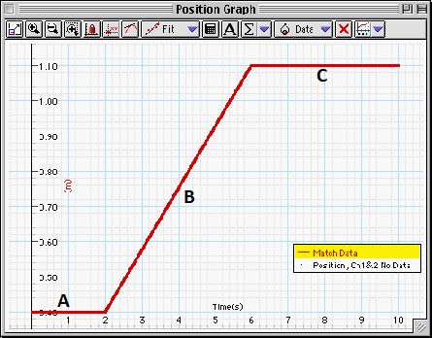

FIGURE-4: Velocity Vs Time

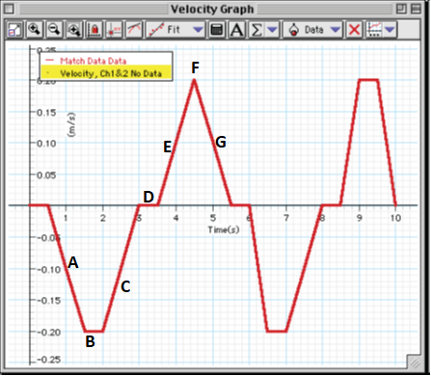

## 3.5 IC-05 UNDERSTANDING MOTION REPORT FORM

#### POSITION VERSUS TIME

|  |  |  |  |
| --- | --- | --- | --- |
| SEGMENT: | A | B | C |
|  |  |  |  |
| POSITION |  | X |  |
| VELOCITY |  |  |  |

|  |  |  |  |
| --- | --- | --- | --- |
| SEGMENT: | A | B | C |
|  |  |  |  |
| POSITION |  | X |  |
| VELOCITY |  |  |  |

#### VELOCITY VERSUS TIME

|  |  |  |  |  |  |  |  |
| --- | --- | --- | --- | --- | --- | --- | --- |
| SEGMENT: | A | B | C | D | E | F | G |
|  |  |  |  |  |  |  |  |
| VELOCITY | X |  | X |  | X |  | X |
| ACCELERATION |  | X |  | X |  | X |  |

## 3.6 REPORT SUBMISSION

Upload the following in the Report for this Lab:

|  |  |  |
| --- | --- | --- |
|  |  | Max Points in report |
| 1 | The completely filled up “Report Form”.  Make sure to include units of measurements. | 10 |
| 2 | Graphs from Capstone. Points will depend on how close they are to Fig. 2 and 3. The graphs should also show the points where position, velocity and/or acceleration are measured. All text in graphs should be legible (make sure the size is not too small). | 3*10 = 30 |
| 3 | Discussion of the results | 10 |
|  | Total | 50 |

Extra Credit: Uploading a video of your experiment being performed will get you up to 5 points extra credit.

## 3.7 ADDITIONAL INFORMATION:

Motion Sensor

<https://www.pasco.com/products/sensors/pasport/ps-2103#experiment-panel>

Graph Matching

<https://www.pasco.com/products/sensors/pasport/ps-2103>

## 3.8 SAMPLE DATA

#### POSITION VERSUS TIME

|  |  |  |  |
| --- | --- | --- | --- |
| SEGMENT: | A | B | C |
|  |  |  |  |
| POSITION [m] | 0.410 | X | 2.61 |
| VELOCITY [m/s] | 0.00 | 0.364 | 0.00 |

#### VELOCITY VERSUS TIME

|  |  |  |  |  |  |  |  |
| --- | --- | --- | --- | --- | --- | --- | --- |
| SEGMENT: | A | B | C | D | E | F | G |
|  |  |  |  |  |  |  |  |
| VELOCITY [m/s] | X | -0.393 | X | -2.05 | X | 0.374 | X |
| ACCELERATION [m/s2] | -1.35 | X | 1.66 | X | 1.60 | X | -1.45 |

Position Vs time using Motion sensor

Velocity versus time graph by using the motion sensor

Velocity versus time graph made by using smart cart

