IC-07 Projectile Motion
Rev 1-1-2023

7.1 OBJECTIVE
The purpose of this experiment is to predict and verify the range of a ball launched at an angle.
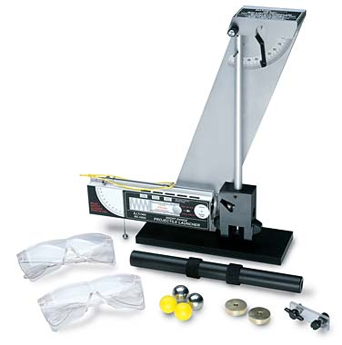

7.2 MATERIALS
Projectile Launcher (Ballistic Pendulum)
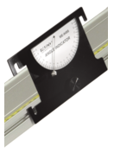
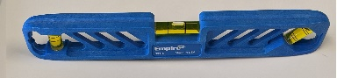
Meter stick
White paper
Carbon paper
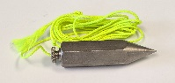
Plumb bob
Plastic or steel ball
Angle Indicator
Spirit Level

7.3 THEORY
A projectile is any object that is thrown in the air and follows some path as it falls to the ground. Under gravity, this path is a parabola. In this Lab we will shoot a ball at an angle from a table top, and predict and measure the maximum distance along the x- and y-axes that it travels along its path. To predict where a ball will land on the floor when it is launched off a table at some angle above the horizontal, it is necessary to first determine the initial speed (muzzle velocity) of the ball. This can be determined by launching the ball horizontally off the table and measuring the vertical and horizontal distances through which the ball travels. Then the initial velocity can be used to calculate where the ball will land when the ball is launched at an angle. The ball is then shot, and the measured position is compared to the calculated value. Air friction is assumed to be negligible. The equations of motion are:
x-direction: y-direction:
$v_{x_{f}}= {v_{x}}_{i}+ a_{x} (t_{f}- t_{i})$ $v_{y_{f}}= {v_{y}}_{i}+ a_{y} (t_{f}- t_{i})$
$x_{f}= x_{i}+ v_{x_{i}}\left(t_{f}- t_{i}\right)+\frac{1}{2} a_{x} {\left(t_{f}- t_{i}\right)}^{2}$ $y_{f}= y_{i}+ v_{y_{i}}\left(t_{f}- t_{i}\right)+\frac{1}{2} a_{y} {\left(t_{f}- t_{i}\right)}^{2}$
${v_{x_{f}}}^{2}= {v_{x_{i}}}^{2}+ 2 a_{x} (x_{f}- x_{i})$ ${v_{y_{f}}}^{2}= {v_{y_{i}}}^{2}+ 2 a_{y} (y_{f}- y_{i})$

A MEASURING THE LAUNCH VELOCITY:
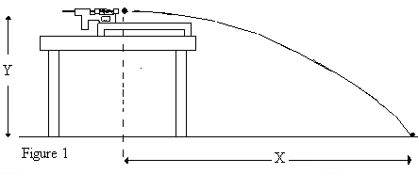
To measure this, launch the ball horizontally off a table. It will travel a parabolic path as shown in Fig. 1. In this figure, initial height of ball (projectile) = y_{i} = Y
Final height when it hits the ground = y_{f} = 0.0
Initial speed = V_{o}
Horizontal distance travelled by the ball = X
The time the ball is in the air = t.
Measure the values of X and Y, and use the y-direction equations of motion to first determine the time of flight, and from it, the initial speed V_{o} by using the x-direction equations. Remember that acceleration in the y-direction is $a_{y}$ = –g, and in the x-direction it is zero.

B PREDICTING THE RANGE WHEN FIRED AT AN ANGLE:
First predict the range, x, of a ball launched with an initial velocity at an angle θ, above the horizontal. To do this, calculate the time of flight using the equations for the vertical component of motion. Once the time is found, calculate the horizontal distance to hit the floor using the equations for horizontal component of motion. This is then compared with X, which is the measured distance.

7.4 EXPERIMENTAL PROCEDURE

Part A: Determining the Initial Velocity of the Ball (see figure 1)
- Secure the ballistic pendulum to the table, move the pendulum out of path of the ball.
- Measure the height Y from where the bottom of the ball would be in the Launcher to the ground by using a meter stick. Using the vertical height Y, calculate the time of flight and record it. This is the “Calculated Time of Flight” t.
- Fire the gun few times to get an approximate position of where it strikes the ground, and then tape a piece of white paper and center it around where the ball lands. Cover it with a carbon paper (carbon side down).
- Use a plumb bob to find the point on the floor that is directly beneath the release point on the barrel. Measure the horizontal distance along the floor from the release point to the leading edge of the paper. Record in Table 1.1.
- Shoot the ball at least five times and record the horizontal positions of each mark left on the paper. Measure the distance from the leading edge of the paper to each of the dots made where the ball hits the paper, and record these distances in Table 1.1.
- Find the average of the five distances and record in Table 1.1. Adding this to the distance from the leading edge of the paper gives the distance X.
- Using the average horizontal distance X and time of flight, calculate the initial velocity of the ball. Record in Table 1.1.

Part B: Measuring the Range of the Ball Launched at an Angle (see figure 2)
- Adjust the angle of the Projectile Launcher to an angle anywhere between 30 and 60 degrees.
- Measure the vertical height from the ground to the launch point at the barrel, y_{i}. Using the initial velocity found in Part A of the experiment (V_{o}), the vertical distance (y_{i}) and launch angle (θ), calculate the time of flight to hit the floor. From the initial velocity and time of flight, calculate the horizontal distance x where the ball is expected to hit the ground. Record in Table 1.2. This is the “Predicted Horizontal Range” x.
- Tape the white paper on the floor so that the predicted horizontal distance from the Projectile Launcher is near its middle. Cover the paper with carbon paper.
- Launch the ball five times. Measure the distances where the ball hits the ground and take the average. Record in Table 1.2.
- Calculate the percent difference between the predicted (x) and measured values (X).

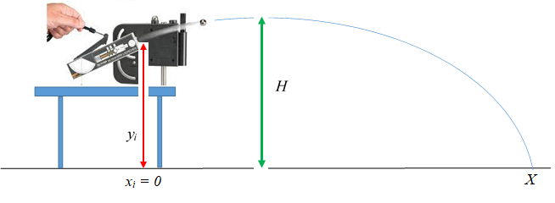
Figure 2: Ball shot at
an angle

Part C: Measuring the Maximum Height reached by the ball.
Using the same position and angle of the launcher as in Part B, calculate the maximum height h to which the ball should go in its trajectory, then measure this maximum vertical height H and compare with the calculated value. The procedures for measuring the maximum vertical height are to be developed by your group.
In your report, attach the two white sheets with the ball marks, and also state the procedure that you used for Part C.

Part D: Measuring the Angle for Maximum Range (see figure 3)
Normally, you would expect that the horizontal range would be greatest when the ball is shot at an angle of 45°. We want to now find if this is true for our situation. Figure 3 shows a simulation for balls shot at 10 m/s from a height of 10 m at different angles. You can see that the one shot at 30° went the farthest, not the one at 45°. Keep the launcher on the table, shoot the ball at different angles and find the angle at which the distance where the ball hits the floor is maximum. It will not be 30° for conditions of our experiment. Do this with the same number of clicks that you used for the first three parts (i.e. same initial speed). Explain your findings in the Discussion section of your report.

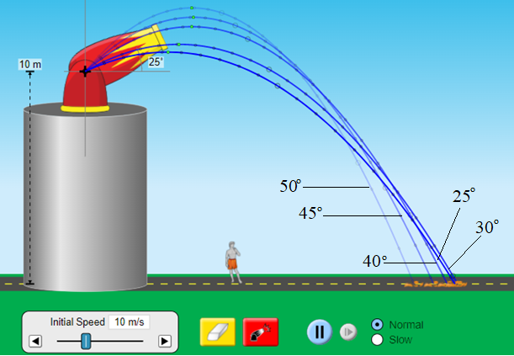
Figure 3: Ball shot at different angles at 10 m/s from a height of 10 m.

7.5 PRECAUTIONS
You need to be careful in avoiding the following sources of error in your measurements:
- Make sure the Launcher is horizontal for Part A. Use a spirit level to do this.
- Make sure the launcher does not move during the experiment. Clamp it to the table.
- If you are using the Ballistic Pendulum apparatus, make sure that the pendulum is out of the way of the ball.
- For part B. measure the angle carefully. You may use an app in your Cell phone to do this.
- Make sure the ball is placed all the way inside the barrel to the spring before pulling the trigger.
- Tape the white paper to the ground, so that it does not move during the experiment. You DO NOT have to tape the carbon paper on top of the white paper.
- Make sure you have the correct side of the carbon paper touching the white paper.
- Make sure the nuts holding the launcher are tight, else the angle may change when you fire it.
- The distance that the ball travels, X, should not be too small (less than 1.00 m), or too far (more than about 2.50 m), else you may have difficulty in performing all the cases. With the yellow plastic balls, 2 clicks on the launcher may be best.
- Use same ball, and same clicks in the launcher for all cases.

7.6 IC-07 PROJECTILE MOTION REPORT FORM

PART A: Table 1.1 Determining the Initial Velocity – ball shot horizontally.
Spring compressed to: ______ clicks Ball used: plastic / steel
Vertical distance of launch point = Y = __________
Horizontal distance to paper edge = L =_________ Calculated Time of Flight = __________

Trial number | Distance from edge of paper to impact
Average value = A
Distance X = L + A
Calculated value of initial velocity, V_{o} =__________

PARTS B and C: Table 1.2 Confirming Predicted Range and Maximum Vertical Height when ball is fired at an angle
Angle above horizontal = __________ Vertical distance of launch point = y_{i} = ___________
Calculated Time of Flight = ________ Horizontal distance to paper edge = L = _________
Predicted Horizontal Range = x = ______ Predicted Maximum Vertical Height = h = ______

Trial number | Distance from edge of paper to impact |  | Trial number |  | Measured Maximum Vertical Height
Average value = A |  |  | Average = H
Measured Horizontal Range = X = L + A
Percent error between predicted (x) and measured (X) Horizontal Ranges = ___________
Percent error between predicted (h) and measured (H) Maximum Vertical Heights = _______

PART D:

Table 1.3: Measuring the Angle that Results in Maximum Range
Launch Height = ___________ Launch Speed = V_{o} = ____________

Trial number | Angle above horizontal | Range
Angle for maximum range: __________

7.7 REPORT SUBMISSION
Upload the following in the Report for this Lab:

 |  | Points in report
 | Title Page, Table of Contents, Objectives, Equipment  Don’t make page number error. | 5
 | Theory  DO NOT copy the Theory from the manual. Notation | 5
 | Procedure. Write what YOU did, for cases A, B, C and D.  DO NOT copy Procedure from the manual. DO NOT tell the reader what to do. | 5
 | The completely filled up “Report Form”. 5 for A, 5 for B+C, 5 for D.  Units wrong / missing, too many Sig. Fig., errors in values | 15
 | Sample Calculations  Calculation error | 5
 | Table of Results  Significant Figures | 5
 | Sources of Error | 5
 | Discussion of the Results of this experiment. Specially discuss why the angle for maximum range is not 45°.  Ignoring major errors in discussion | 10
 | Total | 55

Extra Credit: Attaching a short video of any part of the Lab will give you up to 5 points extra credit.

7.8 ADDITIONAL INFORMATION
Simulation: https://phet.colorado.edu/en/simulations/filter?subjects=physics&type=html,prototype

7.9 SAMPLE DATA

PART A

Table 1.1 Determining the Initial Velocity – ball shot horizontally.
Spring compressed to: _2___ clicks Ball used: plastic / steel
Vertical distance of launch point = Y = ___1.20 m_____
Horizontal distance to paper edge = L =__2.30 m____ Calculated Time of Flight = 0.495 s

Trial number | Distance from edge of paper to impact
1 | 17.1 cm
2 | 18.4 cm
3 | 16.7 cm
4 | 15.8 cm
5 | 19.5 cm
Average value = A | 17.5 cm
Distance X = L + A | 2.475 m
Calculated value of initial velocity, V_{o} =_5.00 m/s__

PARTS B and C:

Table 1.2 Confirming Predicted Range and Maximum Vertical Height when ball is fired at an angle
Angle above horizontal = __30°____ Vertical distance of launch point = y_{i} = 1.30 m
Calculated Time of Flight = __0.83 s____ Horizontal distance to paper edge = L = 3.50 m
Predicted Horizontal Range = x = 3.594 m Predicted Maximum Vertical Height = h = 1.62 m
Trial number | Distance from edge of paper to impact |  | Trial number |  | Measured Maximum Vertical Height
1 | 6.5 cm |  | 1 |  | 1.50 m
2 | 4.7 cm |  | 2 |  | 1.62 m
3 | 7.1 cm |  | 3 |  | 1.56 m
4 | 8.3 cm |  | 4 |  | 1.71 m
5 | 5.8 cm |  | 5 |  | 1.53 m
Average value = A | 6.48 cm |  | Average = H |  | 1.58 m
Measured Horizontal Range = X = L + A | 3.565 m
Percent error between predicted (x) and measured (X) Horizontal Ranges = 1%
Percent error between predicted (h) and measured (H) Maximum Vertical Heights = 2.5%

PART D:

Table 1.3: Measuring the Angle that Results in Maximum Range
Launch Height = ___1.30 m______ Launch Speed = V_{o} = 5.00 m/s______

Trial number | Angle above horizontal (degrees) | Range  (Meters)
1 | 30 | 1.50
2 | 35 | 1.5
3 | 40 | 1.44
4 | 45 | 1.41
5 | 31 | 1.53
6 | 32 | 1.58
7 | 33 | 1.63
8 | 34 | 1.60
9 | 35 | 1.53
Angle for maximum range: 33°

