SOLUTION TO
HOMEWORK PROBLEMS Chapter-5: THE LAWS OF MOTION

1 At an instant when a 4.0-kg object has an acceleration equal to (5i + 3j) m/s², one of the two forces acting on the object is known to be (12i + 22j) N. Determine the magnitude of the other force acting on the object.

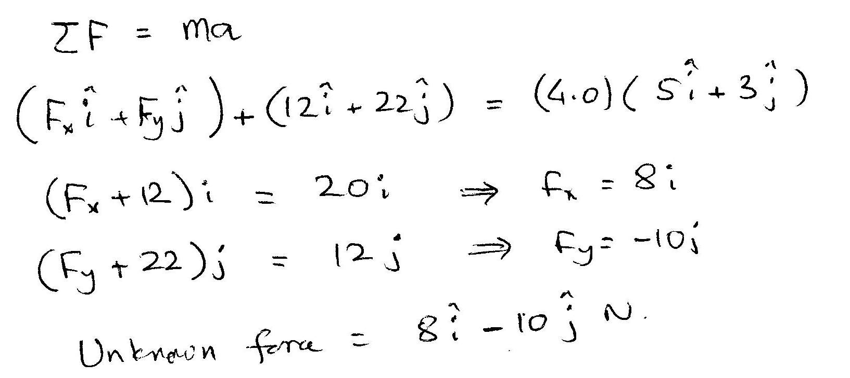

2 If F = 4.0 N and m = 2.0 kg, what is the magnitude a of the acceleration for the block shown below? The surface is frictionless.
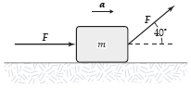
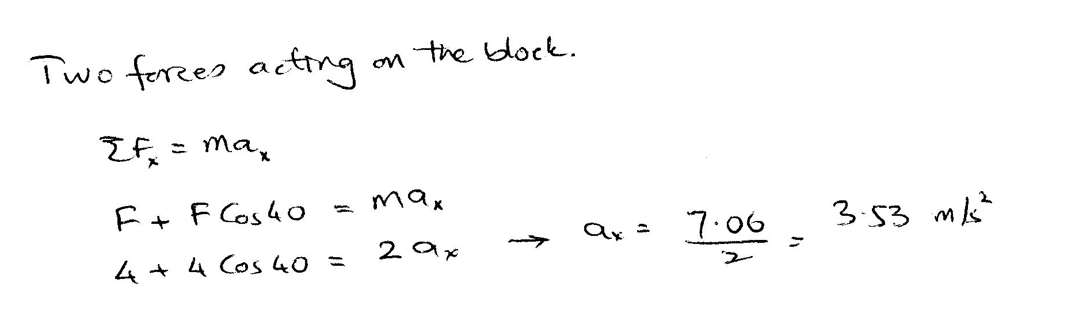

3 A block is pushed up a frictionless 30° incline by an applied force as shown. If F = 25 N and M = 3.0 kg, what is the magnitude of the resulting acceleration of the block?
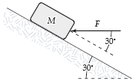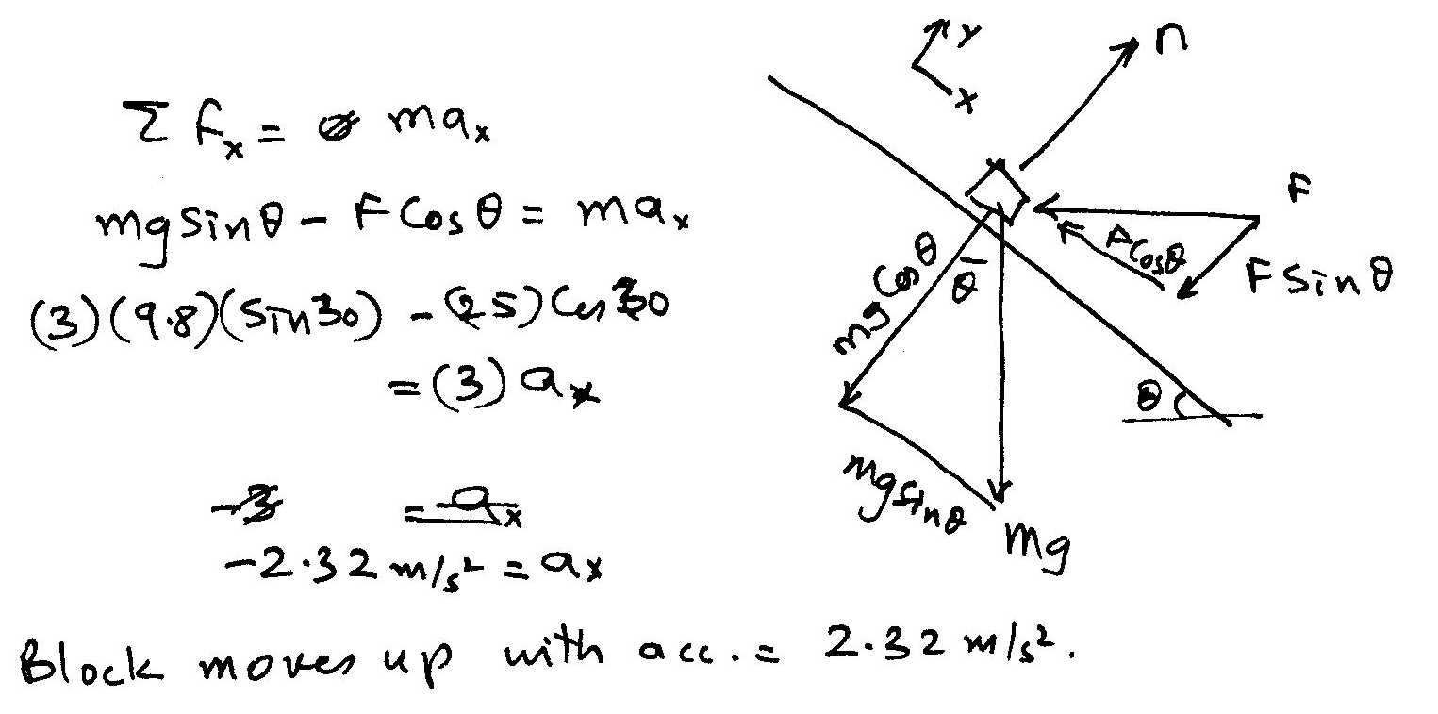

4 A 5.0-kg mass is suspended by a string from the ceiling of an elevator that is moving upward with a speed which is decreasing at a constant rate of 2.0 m/s in each second. What is the tension in the string supporting the mass?

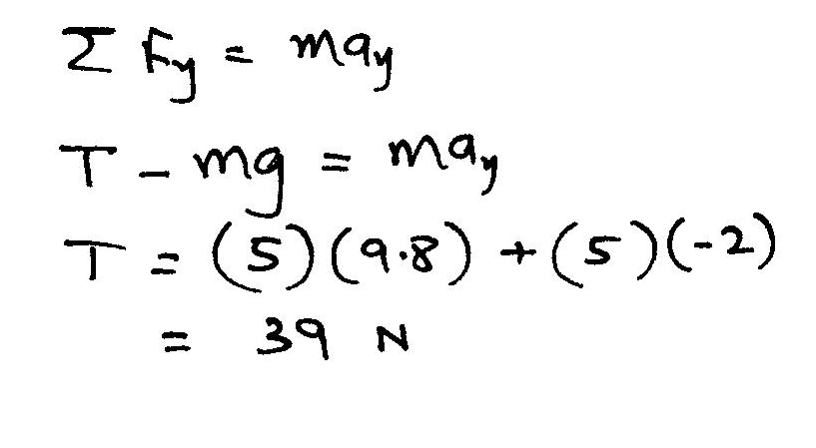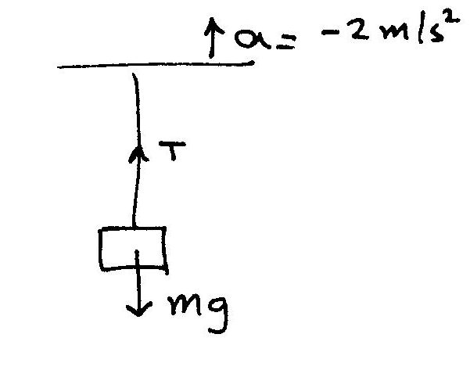
5 In the figure, if the tension in string 1 is 34 N and the tension in string 2 is 24 N, what is the mass of the object shown? (Note: the angle where strings 1 and 2 join is not 90°)
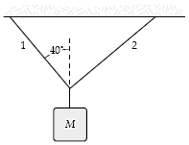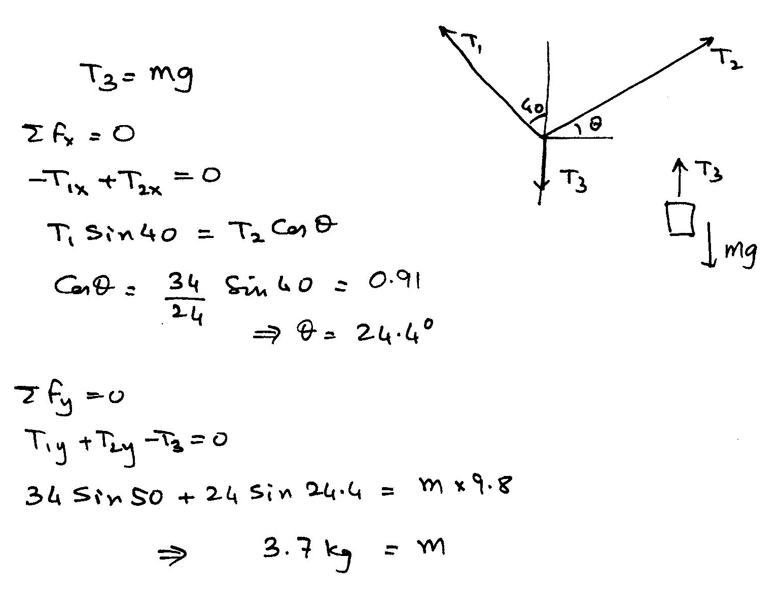

6 The horizontal surface on which the objects slide is frictionless. If M = 2.0 kg, the tension in string 1 is 12 N. Determine F.
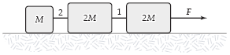
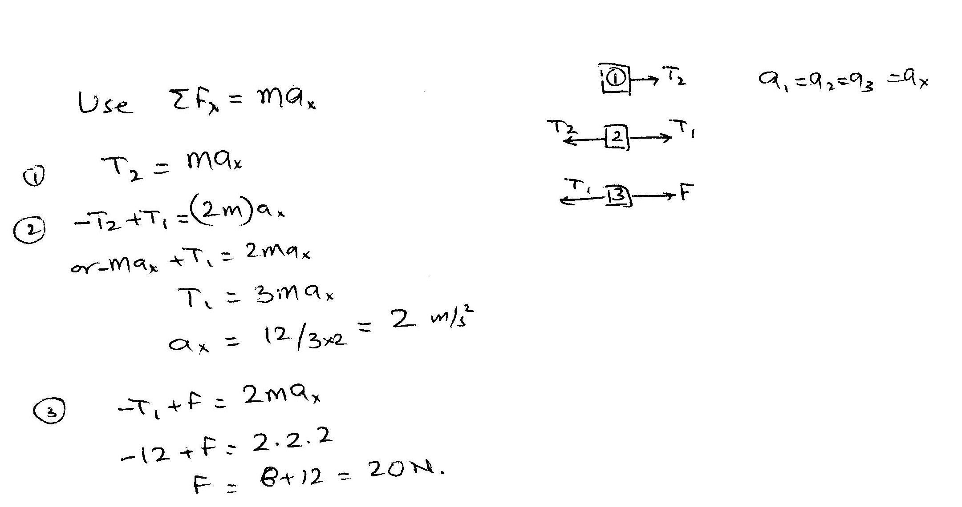
7 If angle θ = 40° and the tension in string 2 is 30 N, determine M.
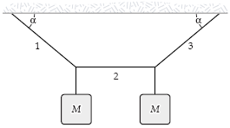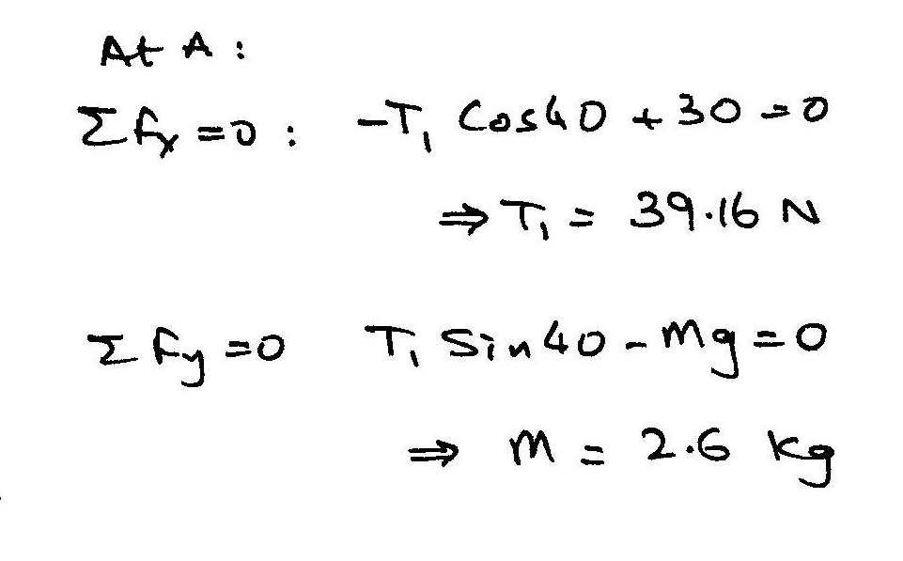

8. A 2.00-kg aluminum block and a 6.00-kg copper block are connected by a light string over a frictionless pulley. They sit on a steel surface as shown in Figure P5.60, where θ = 30.0°. When they are released from rest, will they start to move? If so, determine (a) their acceleration and (b) the tension in the string. If not, determine the sum of the magnitudes of the forces of friction acting on the blocks.
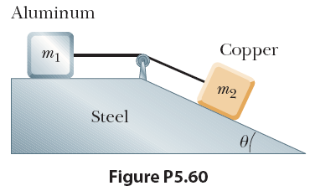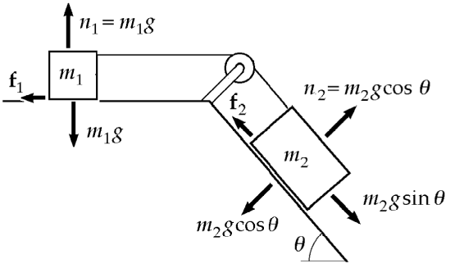

For the system to start to move when released, the force tending to move m2 down the incline, m g 2 sinθ, must exceed the maximum friction force which can retard the motion:

F = f(steel) + f(copper)
= µ1m1g + µ2m2g
= 0.61 x 2.0 x 9.8 + 0.53 x 6.0 cos(30) x 9.8 = 38.9 N

Force tending to cause the system to move = 6.0 x 9.8 x sin(30) = 29.4 N
Hence it will not start to move when released.

9 In a game of shuffleboard (played on a horizontal surface), a puck is given an initial speed of 6.0 m/s. It slides a distance of 9.0 m before coming to rest. What is the coefficient of kinetic friction between the puck and the surface?
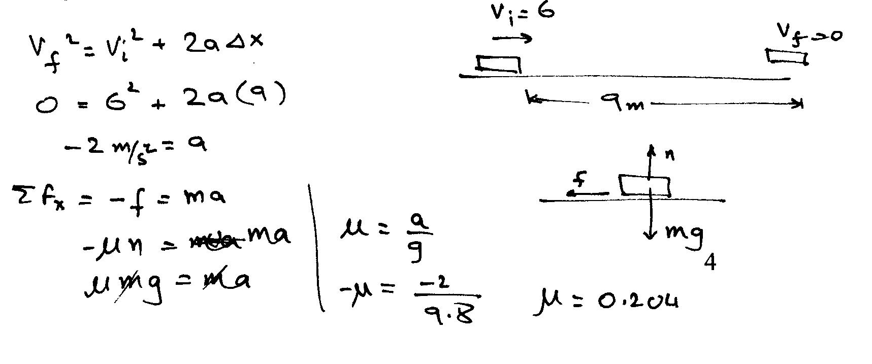
10 A 2.30 kg mass is suspended from the ceiling and a 1.70 kg mass is suspended from the 2.30 kg mass, as shown. The tensions in the strings are labeled and . A hand exerts an upward force of 6.70 N on the 1.70 kg mass. The magnitudes of the tensions are
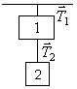
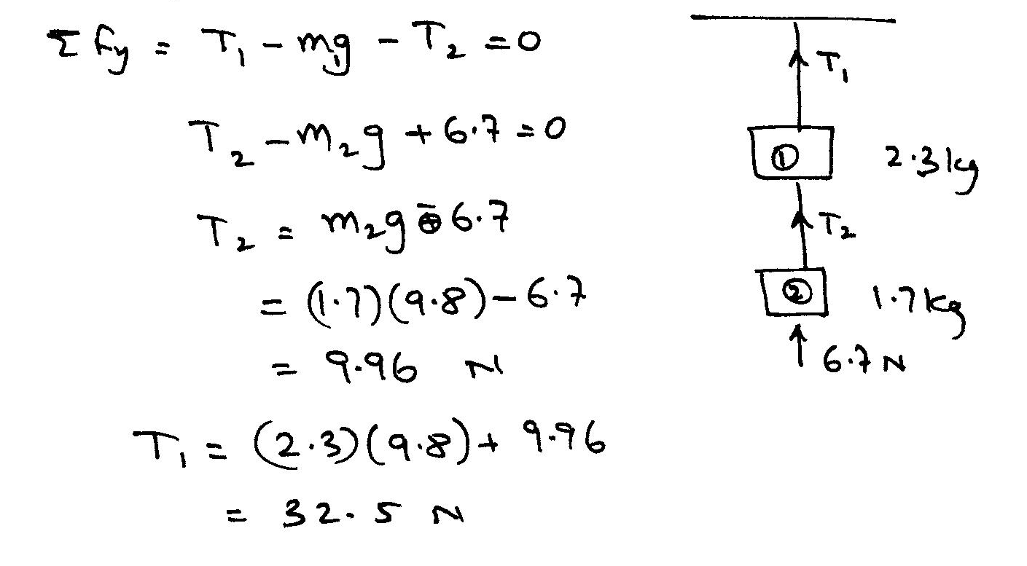

11 A 6.00 kg block is placed on a 30.0° incline and connected to another block on a 36.87° incline. Although the surfaces are frictionless the blocks do not move. What is the mass in kilograms of the block on the 36.87° incline?

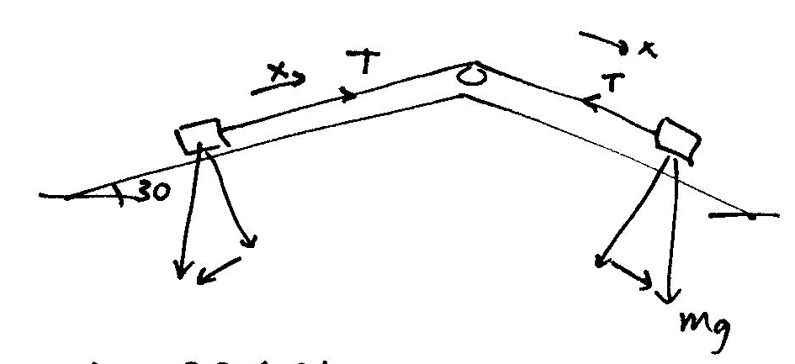

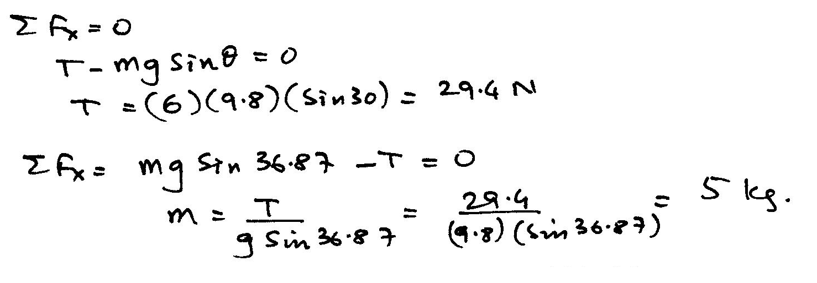

12 The horizontal surface on which the objects slide is frictionless. If F = 6.0 N and M = 1.0 kg, what is the magnitude of the force exerted on the large block by the small block?


