SOLUTION TO
HOMEWORK PROBLEMS Chapter-4: MOTION IN TWO DIMENSIONS

1 A particle starts from the origin at t = 0 with a velocity of 6.0 m/s and moves in the xy plane with a constant acceleration of (-2.0 + 4.0) m/s². At the instant the particle achieves its maximum positive x coordinate, how far is it from the origin?

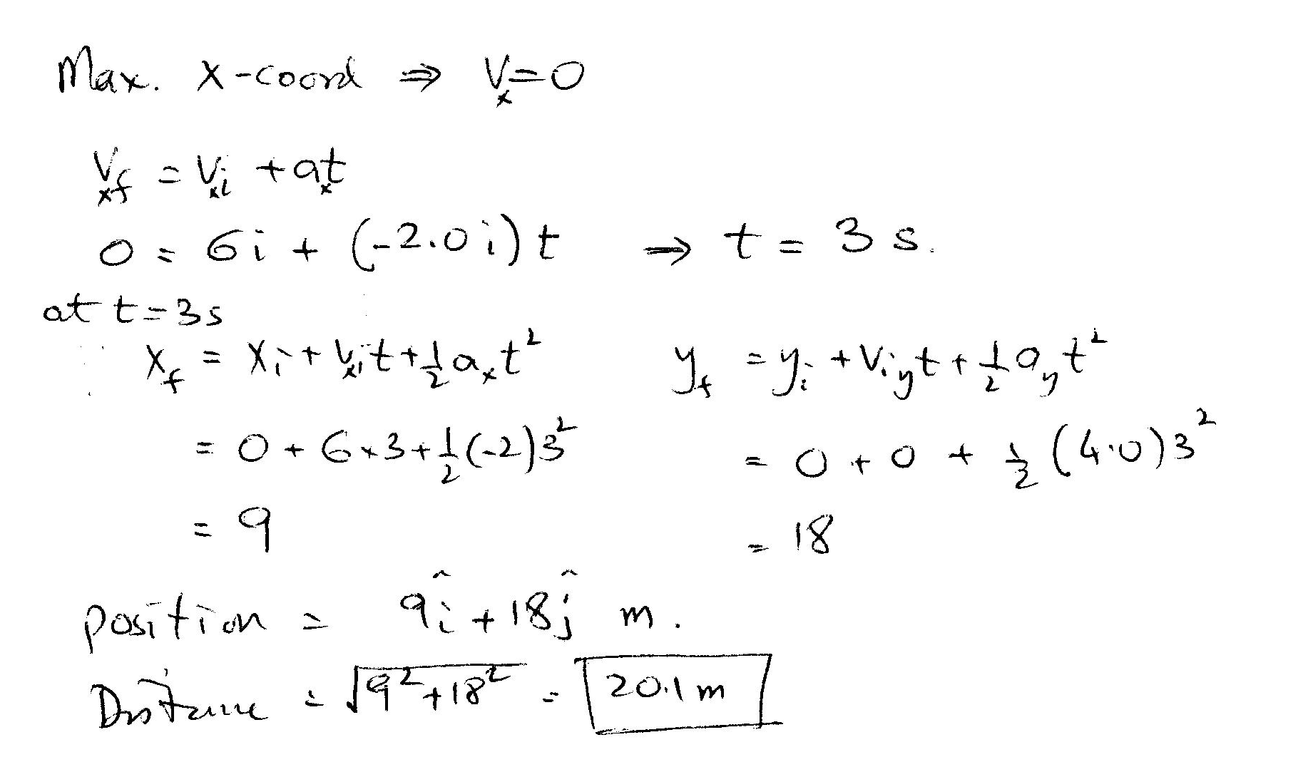

2 At t = 0, a particle leaves the origin with a velocity of 5.0 m/s in the positive y direction. Its acceleration is given by = (3.0 - 2.0) m/s². At the instant the particle reaches its maximum y coordinate how far is the particle from the origin?

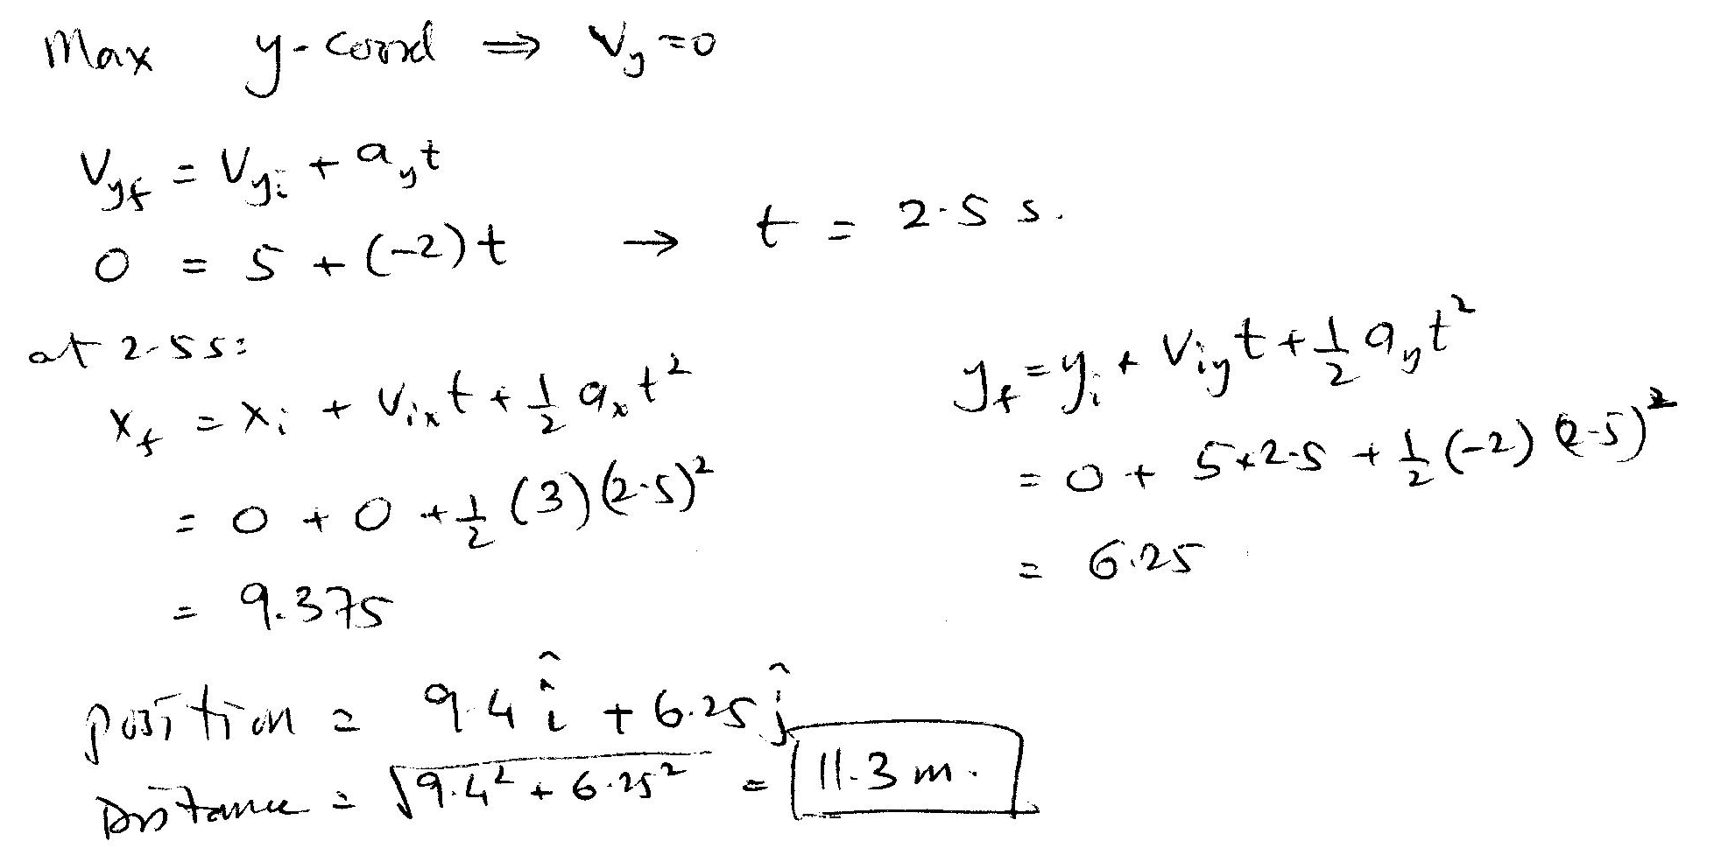

3 A particle starts from the origin at t = 0 with a velocity of (16 - 12) m/s and moves in the xy plane with a constant acceleration of = (3.0 - 6.0) m/s². What is the speed of the particle at t = 3.0 s?
v(t) = v(0) +a*t > v(3) = (16i – 12j) + (3i-6j)*3 = 25i – 30j
| v(3) | = √(25² + 30²) = 39

4 A ball is thrown horizontally from the top of a building 200 m high. The ball strikes the ground at a point 65 m horizontally away from and below the point of release. What is the speed of the ball just before it strikes the ground?

Y_{f} = Y_{i} + V_{i}t + (1/2) gt²
-200 = 0 + 0 + (-4.9)t² > t = 6.39 s
X = V_{ix}t > V_{ix} = 65/6.39 = 10.17 m/s = V_{fx}
V_{fy}² = V_{iy}² + 2aY > V_{fy} = √(0 + [2*(-9.8)*200] ) = 62.6 m/s
V = √(V_{fy}² + V_{yx}²) = √(62.6² + 10.17²) = 63.4 m/s

5 A rock is projected from the edge of the top of a building with an initial velocity of 12.2 m/s at an angle of 53° above the horizontal. The rock strikes the ground a horizontal distance of 25 m from the base of the building. Assume that the ground is level and that the side of the building is vertical. How tall is the building?

Find V_{x} by using V_{x} = 12.2 cos 53
Find time of flight by: X_{f} = X_{i} + V_{x} t + (1/2) a_{x} t² (use a_{x} = 0)
Use y_{f} = y_{i} + V_{y} t + (1/2) a_{y} t² (use a_{y} = -9.8) to calc. y_{f}, which is the height of the building.
Height of building comes to 23.6 m.

6 A rock is thrown from the edge of the top of a 100-ft tall building at some unknown angle above the horizontal. The rock strikes the ground a horizontal distance of 160 ft from the base of the building 5.0 s after being thrown. Assume that the ground is level and that the side of the building is vertical. Determine the speed with which the rock was thrown.
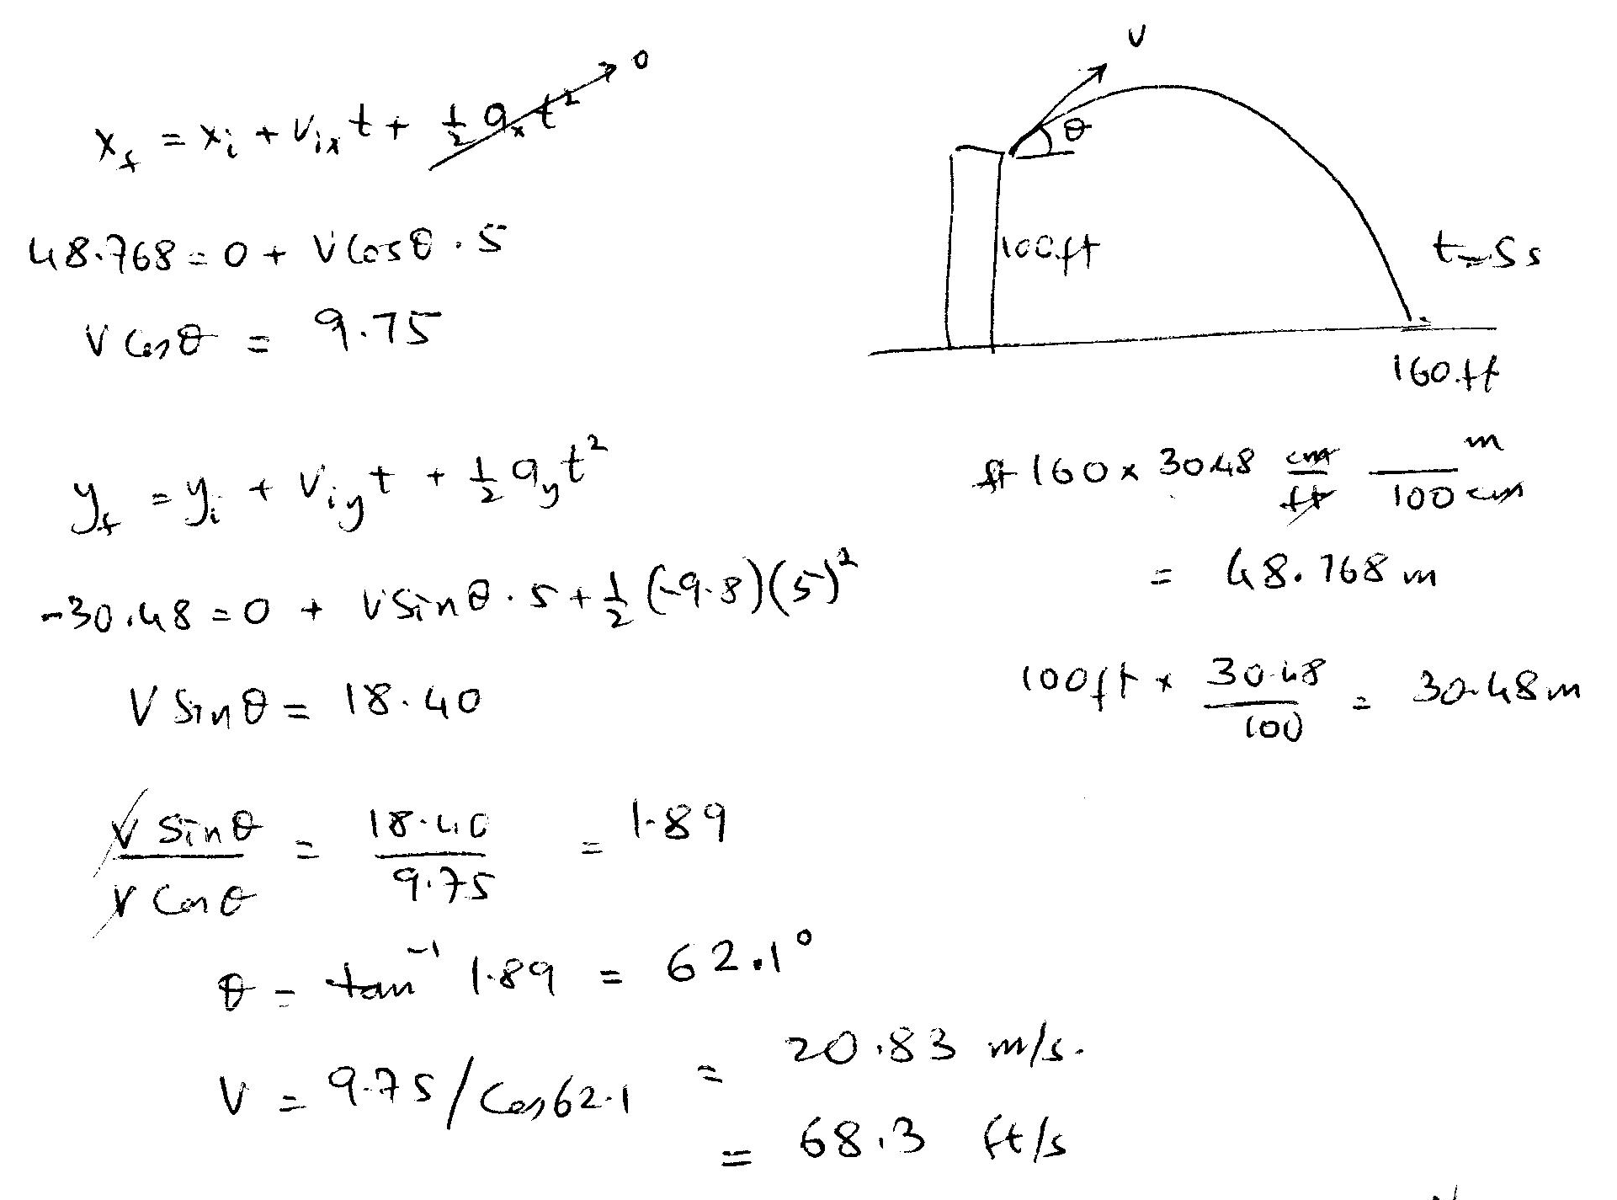
7 An airplane flies horizontally with a speed of 250 m/s at an altitude of 500 m. Assume that the ground is level. At what horizontal distance from a target must the pilot release a bomb so as to hit the target?

y = v_{i}t + 0.5at² > 500 = 0 + 0.5(9.8)t² > t = 10.1 s
x = vt > x = 250*10.1 > x = 2525 m

8 A race car moving with a constant speed of 40 m/s completes one lap around a circular track in 45 s. What is the magnitude of the acceleration of the race car?

x = V T = 40 * 45 = 2πR > R = 40*45 / 2π
a = V²/R = 40*40*2*π / (40*45) = 5.58 m/s²

9 A space station of diameter 60 m is turning about its axis at a constant rate. If the acceleration of the outer rim of the station is 3.0 m/s², what is the period of revolution of the space station?

a = V²/R > V = √(a*R) = √(3.0 * 30) = 9.5
T = 2πR/V = 2*π*30 / 9.5 = 19.84 s

10 A car travels in a flat circle of radius R. At a certain instant the velocity of the car is 24 m/s west, and the total acceleration of the car is 2.5 m/s² 53° north of west. Which of the following is correct?
i) The car is moving clockwise as seen from above
ii) The car is moving counter-clockwise as seen from above

11 The pilot of an aircraft flies due north relative to the ground in a wind blowing 50 km/h toward the east. If his speed relative to the ground is 120 km/h, what is the speed of his airplane relative to the air?
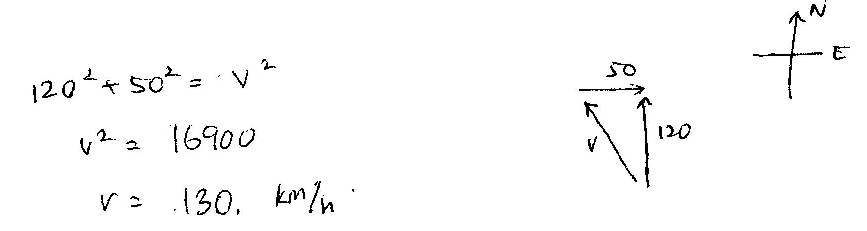

12 While her kid brother is on a wooden horse at the edge of a merry-go-round, Sheila rides her bicycle parallel to its edge. The wooden horses have a tangential speed of 6 m/s. Sheila rides at 4 m/s. The radius of the merry-go-round is 8 m. At what time intervals does Sheila encounter her brother, if she rides opposite to the direction of rotation of the merry-go-round?

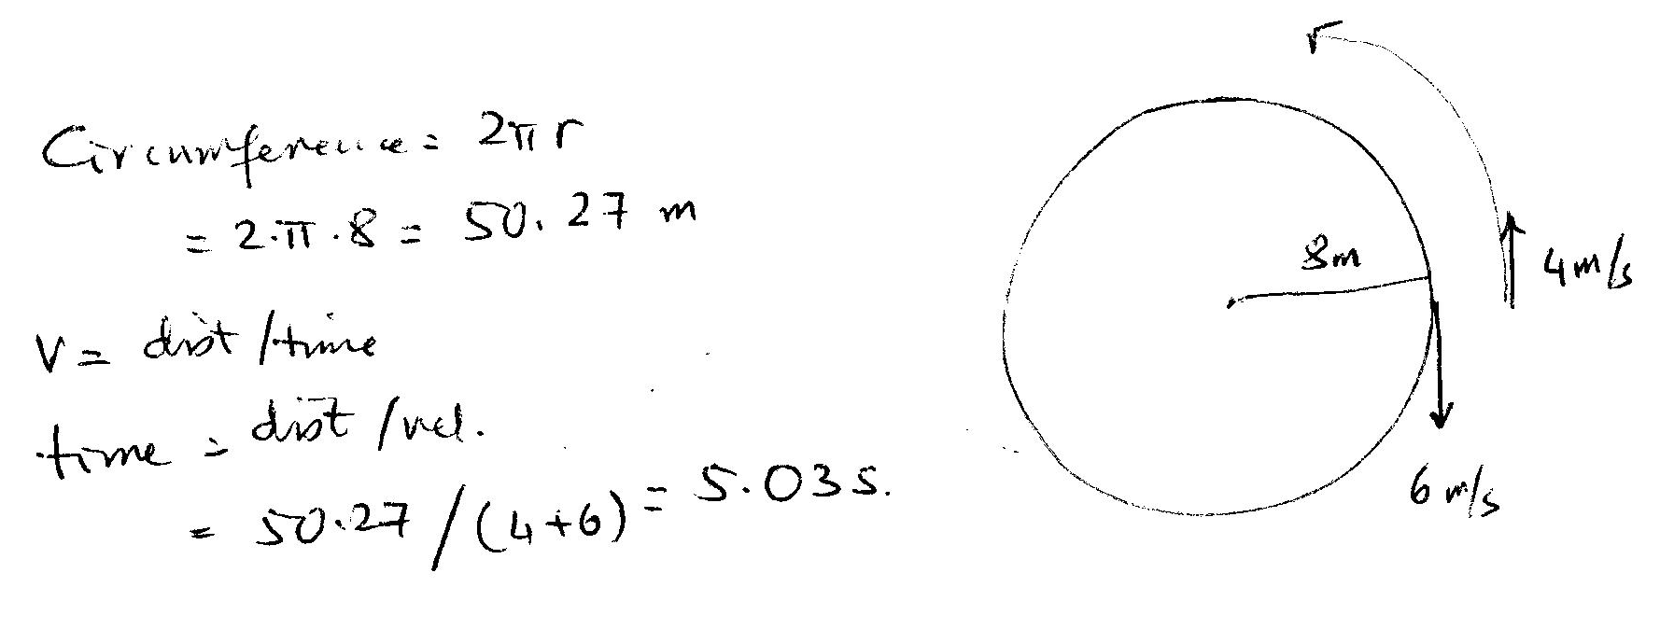

13 A car is moving at a constant speed of 4 m/s in a circular track of diameter 6 m. (i) calculate the magnitude of the centripetal acceleration, and (ii) if its speed is also increasing at the rate of 5 meters per second per second, what is the tangential acceleration.

ac = v² / r ( = 5.3 m/s²)
at = 5 m/s² (answer already given in the problem)

14 A race car moving with a constant speed of 50 m/s completes one lap around a circular track in 50 s. What is the magnitude of the radial acceleration of the race car? When the car is directly pointing due North, the brakes are applied, and the speed starts to decrease at the rate of 5 m/s². What is the tangential acceleration, and the resultant acceleration at this point (give answer in vector notation).

Find circumference = velocity x time ( = 2500 m )
Find radius of circle ( = 400 m )
Use ac = v² / r ( = 6.28 m/s² )
at = 5 m/s² (given)
a = -6.28i - 5.00 j

