LK-05 ONE DIMENSIONAL MOTION
Rev 4/02/2022

5.1 OBJECTIVE
The purpose of this Lab is to verify the equations of one-dimensional motion. This will be done by measuring the distance, time and velocity of an object that moves with constant acceleration, and hence calculating the value of acceleration due to gravity by using these equations.

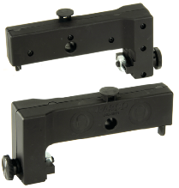
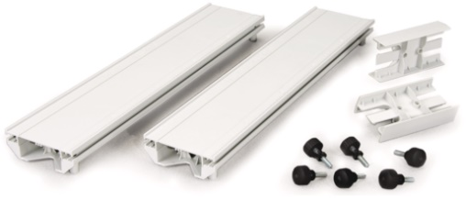
5.2 MATERIALS
- ME-6960 PasTrack
- ME-1240 Smart Cart
- ME-9495A Angle Indicator
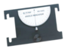
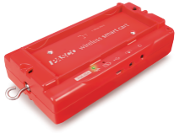
4. ME-8971 End Stops
- Capstone software

5.3 THEORY
An object in one-dimensional motion under constant acceleration satisfies the following equations of motion:
$v_{x_{f}}= {v_{x}}_{i}+ a_{x} (t_{f}- t_{i})$ (1)
$x_{f}= x_{i}+ v_{x_{i}}\left(t_{f}- t_{i}\right)+\frac{1}{2} a_{x} {\left(t_{f}- t_{i}\right)}^{2}$ (2)
${v_{x_{f}}}^{2}= {v_{x_{i}}}^{2}+ 2 a_{x} (x_{f}- x_{i})$ (3)
Where $x_{i}$ = initial position on the track (at time = $t_{i}$)
$x_{f}$ = final position on the track (at time = $t_{f}$)
${v_{x}}_{i}$ = Initial velocity in the x-direction (at time = $t_{i}$)
$v_{x_{f}}$ = Final velocity in the x-direction (at time =$t_{f}$)
$a_{x}$ = Acceleration in the x-direction (which is constant, not a function of time)
In the absence of air resistance, objects falling under the influence of gravity have a constant downwards acceleration. On and near the surface of the Earth this acceleration has a value of approximately 9.81 m/s² which is denoted by the symbol ‘g’. We will study the distance, time and velocity of an object as it slides without friction on an inclined plane, and hence determine its acceleration. As seen in the figure, for an inclined plane, the value of acceleration along the plane is:

g
g Cosθ
θ
g Sinθ
$a_{x}=g Sin(θ)$ (4)

Equation (1): $v_{x_{f}}= {v_{x}}_{i}+ a_{x} t_{f}$
Here $v_{xf}$ is the velocity at time $t_{f}$ and $v_{xi}$ is the velocity at time $t_{i}=0$. The equation of a straight line is:
$y=b+mx$
Equation (1) is an equation of a straight line, if we take $v_{xf}$ as the y-axis and $t_{f}$ as the x-axis. The slope of the line “m” will be the acceleration “$a_{x}$”, and the y-intercept “b” is “$v_{xi}$”. From the smart cart we can get the velocities at different times, and plot a graph between $v_{xf}$ on the y-axis and $t_{f}$ on the x-axis. The slope of the line will give us the value of $a_{x}.$ For the motion on the inclined plane, it should come out to $a_{x}=9.8 \sin{θ}m/s^{2}$ (with x along the inclined plane).

Equation (2): $x_{f}= x_{i}+ v_{x_{i}}\left(t_{f}- t_{i}\right)+\frac{1}{2} a_{x} {\left(t_{f}- t_{i}\right)}^{2}$
We will measure the position of the cart. The best fit line for the graph of $x_{f}$ on the y-axis and time on the x-axis will yield a parabola. This parabola equation will have form:
$x_{f}=At^{2}+Bt+C$
And acceleration of the cart is seen to be equal to 2$A$.

Equation (3): ${v_{x_{f}}}^{2}= {v_{x_{i}}}^{2}+ 2 a_{x} (x_{f}- x_{i})$
Comparing this equation with: y = b + mx, we can see that a plot of ${v_{x_{f}}}^{2}$ on the y-axis Vs position (i.e. $x_{f})$ on the x-axis should come as a straight line with the slope (m) being $2 a_{x}$ and y-intercept (b) being${{ v}_{x_{i}}}^{2}$.

Equation (4): $a_{x}=g Sin(θ)$
Once the value of acceleration for the cart (i.e. “$a_{x}$”) is obtained, Equation 4 can be used to find the value of “g”. If “g” comes out close to the correct value, that means that “$a_{x}$ “, and hence equations 1, 2, and 3 are correct.

The procedure will involve finding the values of acceleration of the cart i.e. ”$a_{x}"$by the three equations, and from them, finding the value of “g”. If the value of “g” comes out good, then we can assume that $a_{x}$ is good, which means the equations are good.

5.4 PROCEDURE
- Connect the two parts of the PASTrack to make a longer track. First level it by using the screw at its feet so that the two parts of the track are well aligned. See: PASTract assembly: https://edutube.hccs.edu/media/1-PASTrack%20and%20Accessories/1_edpfht0b
- Attach the angle indicator to the track. You can also measure the angle by downloading a Protractor App on your cell phone.
- Set up the track so that it is tilted to an angle θ about 3° to 5⁰. You can place a book at one end. Better to put something under the middle legs to that all six legs carry the weight of the track (else the track may buckle in the middle and will not remain straight).
- Attach an end-stop at the lower end to prevent the cart from rolling off to the ground, and place some soft item on the track before the end stop so that the cart does not hit it. Keep its magnets pointing away from the track.
- Click on the PASCO Capstone icon on the computer to open the software for use in this experiment. In the Tool Palette (on left side of screen), click “Hardware Setup”. This will open the Hardware Panel. Then press the power switch on the cart to turn it on (the red led should start blinking). In “Searching for Wireless Devices”, click the Bluetooth icon. Capstone should detect all Bluetooth devices that are nearby. Select the Smart Cart with the serial number of your Smart Cart. Click on it. Your instrument is now connected to the Software.
- The Options in the Smart Cart will appear. Select “Smart Cart Position Sensor” and turn off the rest. Click Hardware Setup once again. This will close the Hardware Panel, and you can now select the type of display (graphs and/or table) from the Display Panel. Select “Sensor Data”.
Note: Measure the angle carefully. Error in angle significantly effects the results.

Equation (1):
- Select Velocity on the Y-axis, and Time on the X-axis. If you see a graph and a table, minimize the table. You can adjust the size of the graph, and the scale of the X- and Y-axes.
- At the lower left of the screen is the ‘RECORD’ button. Start ‘RECORD’ and release the Smart Cart from near the top of the track. Press the same button again to stop the data recording after the cart reaches the bottom of the track. The data for velocity of the cart should show on the graph. (note: if the Velocity is negative, rotate the Cart 180° and retry).
- Click on the “Highlight Data…” icon to get a colored square on the screen. On the graph, move and adjust its size so that a portion of the data that is “good” is inside the box. Then click the icon for “Curve Fits”.
- Observe the data on the V-T curve. Equation (1) indicates that it should be a straight line. The slope on the V-T curve is the value of acceleration of the cart ‘$a_{x}$’. The value of the regression coefficient i.e. R, indicates how good the data fits the equation chosen. R should be greater than 0.95 for the fit to be acceptable. Note the value of the slope in the data table.
- Repeat steps 6 to 8 a few times till you are adept at doing this. Then clear all data from the software, and repeat the experiment at least four times (with different angles and masses on the cart – your choice of values). Use the values of acceleration ‘$a_{x}$’ to calculate the acceleration due to gravity ‘g’. Then find the average of the four values of ‘g’. Find the percent error in ‘g’.

Equation (2)
- Now change the variable on the Y-axis to ‘Position’. The data that you have already taken will show on the X-T curve (no need to roll the cart again). Equation (2) indicates that it should be a parabola. On this curve, the quadratic fit will give the equation
X = At² + Bt + C.
The value of acceleration $a_{x}$ of the cart will be equal to 2A. Note the value of acceleration in the data table.
- Get the acceleration for all four runs, calculate the value of ‘g’ from each $a_{x}$, then get the average of ‘g’. Find the percent error in ‘g’.

Equation (3)
- Change the Y-axis back to velocity. Click the icon for Velocity. This will open a box. Select “QuickCalc”. In QuickCalc, select V². Change the X-axis from Time to Position. You now have the V² versus Position graph. Fit a straight line to this and obtain the value of “2$a_{x}$” from the slope. Hence find the acceleration$a_{x}$.
- Do this for all four data sets, and get the values of ‘g’ from the $a_{x}$, then get the average ‘g’ and its percent error.

Note:
1n the software, instead of manually doing start and stop, you can set up automatic start and stop conditions. Click “Recording Conditions”, and set the start condition to when the cart has moved, say 10 cm, and a stop condition when it has moved, say, 80 cm (these values will depend on the length of your track). Then data recording will begin when the cart has moved 10 cm from where you release it, and stop when it reaches 80 cm.
Make sure you don’t forget to add the end-stop, so that the cart does not roll away and fall . down. Also, don’t let the cart hit the end stop, so place some soft material in front of it.

5.5 PRECAUTIONS
- Make sure that the track is not bent in the middle. Add extra support if needed.
- When selecting the data for the curve fits, do not try to get to the very last data points at either end.
- Measure the angle carefully. The angles are small, and so, even a 0.5° error at 5° may lead to a 10% error in the final result.
- The wheels of the cart should be in the two grooves on the Track.
- The weights added to the cart should not move around the cart while it is moving. Use the “cart weights” that fit into the cart.
- There may be some friction in the wheels of the cart.
- At higher speeds, air resistance may have some effect. Keep away from fans etc.

5.6 LK-05 One-Dimensional Motion REPORT FORM

Name: _____________________________ Date: ______________

Inclined Plane
 | T r i a l N u m b e r |  |  |  | Average value of ‘g’ | Percent Error in ‘g’
 | 1 | 2 | 3 | 4
Capstone Run Number |  |  |  |  | X | X
Angle of incline |  |  |  |  | X | X
Mass of the cart (kg) |  |  |  |  | X | X
‘$a_{x}$’ from velocity versus time graph (m/s2) |  |  |  |  | X | X
Value of “g” from ‘$a_{x}$’ by eqn. 4 (m/s2)
‘$a_{x}$’ from the position versus time graph (m/s2) |  |  |  |  | X | X
Value of “g” from ‘$a_{x}$’ by eqn. 4 (m/s2)
‘$a_{x}$’ from the V2 vs Position graph (m/s2) |  |  |  |  | X | X
Value of “g” from ‘$a_{x}$’ by eqn. 4 (m/s2)

5.7 RESULTS
 | Found by Inclined Plane in this Lab with |  |  | Found by  Picket Fence in earlier Lab | Found by Pendulum in earlier Lab
 | X-T Graph | V-T Graph | V2-X Graph
Value of ‘g’ (m/s2) |  |  |  | X | X
Percent Error in ‘g’ |  |  |  | X | X

5.8 REPORT SUBMISSION
Upload the following in the Report for this Lab:
 |  | Points in report
 | Using your camera to show your setup online during Lab time | 5
 | Sharing your screen to show at least one Capstone graph, showing velocity or acceleration value in selected area. | 5
 | The completely filled up “Report Form”. Make sure to include units of measurements. | 10
 | The three graphs from Capstone for one trial. The graphs should show selected data and curve fit equation. All text in graphs should be legible (make sure the size is not too small). | 3*5 = 15
 | Show detailed calculations for the same trial for which you are showing the graphs. | 5
 | Picture of your setup | 5
 | Sources of Error in this experiment. Indicate the major sources of error. Make a list. 2 points each major error. | 5
 | Discussion of your results | 10
 | Total | 60
Make “Sources of Error” and “Discussion” as two separate headings.
Extra Credit: Uploading a short video of your experiment being performed will get you 5 points extra credit. Video should show your equipment, you performing the experiment (or a part of it), and the resulting graphs on capstone.

5.9 ADDITIONAL INFORMATION
See these videos for additional information on this experiment that uses time of fall
2.35 min https://www.youtube.com/watch?v=wBIydqBHFes

5.10 POINTS TO THINK ABOUT WHEN WRITING CONCLUSION / DISCUSSION
- Your results and their errors.
- Are your results within ‘acceptable’ range of error (what is an ‘acceptable’ range?)
- Do your results verify the equations of motion within acceptable errors?
- What are the most likely sources of error, and how can the errors be reduced?
- Why are the values of ‘g’ different in the two graphs (X-T and V-T), if that is so.
- What was the effect of angle and mass on the acceleration found from the inclined plane, and how does this compare with what is expected from the equations of motion?
- Which of the two methods did you find to give better results?
- How can the accuracy of this experiment be improved?

5.11 SAMPLE DATA
Sample data and corresponding graphs for one data is shown. The angle and mass are not correct
 | T r I a l N u m b e r |  |  |  |  | Average value of ‘g’ |  | Percent Error in ‘g’
 | 1 | 2 | 3 | 4
Angle of incline | 3° |  |  |  | X |  | X
Mass of the cart | 280 g |  |  |  | X |  | X
‘$a_{x}$’ from velocity versus time graph (m/s²) | 0.434 |  |  |  | X |  | X
Value of “g” from $a_{x}$ (m/s²) | 8.29 |  |  |  | 8.29
‘$a_{x}$’ from the position versus time graph (m/s²) | 0.217*2 = 0.434 |  |  |  | X |  | X
Value of “g” from $a_{x}$ (m/s²) | 8.29 |  |  |  | 8.29
‘$a_{x}$’ from the V² versus Position graph (m/s²) | 0.869/2 = 0.435 |  |  |  | X |  | X
Value of “g” from $a_{x}$ (m/s²) | 8.31 |  |  |  | 8.31
Sample Calculation: a = g Sinθ → g = a / Sinθ → g = 0.434 / Sin(3) = 8.293

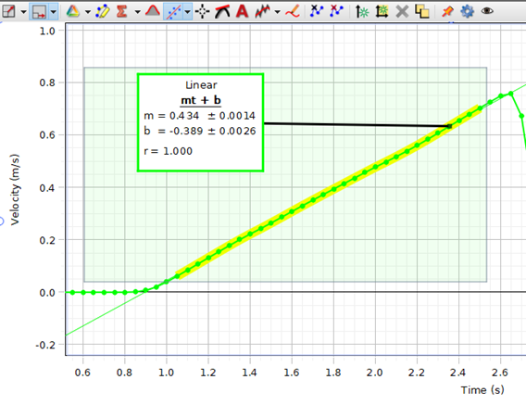
Figure 1: Velocity – Time Graph
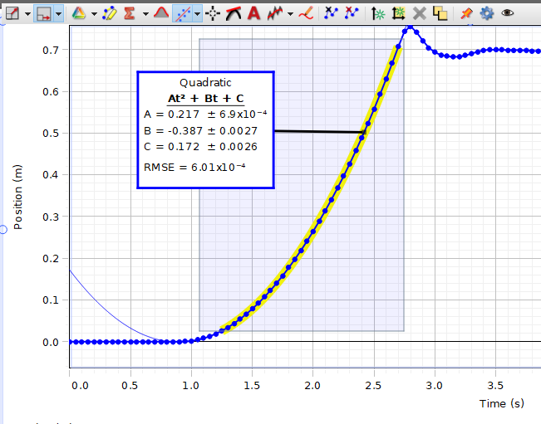

Figure 2: Position – Time Graph

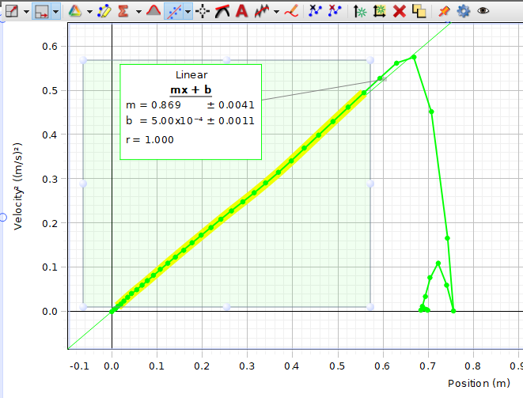

Figure 3: V² – Position Graph.

