# IC-32B Resistance, Voltage, Current in Parallel Circuits

04/23/2023 FOR IN-CLASS AND TAKE-HOME LAB KIT

## 32B-1 OBJECTIVE

The purpose of this lab is to experiment with the variables that contribute to the operation of an electrical circuit, specifically the resistance, voltage and current in Parallel circuits.

## Voltage SensorStudent MultimeterAC/DC Electronics Laboratory32B-2 EQUIPMENT

AC/DC Electronics Lab Board

Resistors

Multimeter

Voltage Sensor

Current Sensor

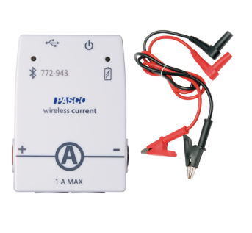Two D-cells

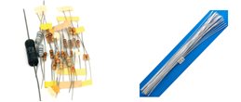Wires

Capstone Software

## 32B-3 THEORY

In this Lab we will study the effects on the values of the net resistance, voltage drops and currents when resistors are placed in parallel combination with each other.

When resistances are placed in parallel, the total, or equivalent, resistance is given by the following equations:

$$Resistors in parallel$$

$\frac{1}{R_{eq}}=\frac{1}{R_{1}}+\frac{1}{R_{2}}+\frac{1}{R_{3}}+…$ (1)

${I_{0}=I}_{1}+I_{2}+I_{3}=I_{4}$ (2)

${∆V=∆V}_{1}={∆V}_{2}={∆V}_{3}$ (3)

Figure-1

The Current through one or a combination of resistors is given by Ohm’s Law:

$I=\frac{∆V}{R}$ (4)

We will measure the resistance and voltage across the resistors and the current through the resistors and compare these to the calculated values.

The resistors are labelled by a colour coding shown in Figure 2. We will set up the circuit on the AC/DC Circuit Board. A diagram with labels for different points is shown in Figure 3.

Figure 2: Color Coding for Resistors.

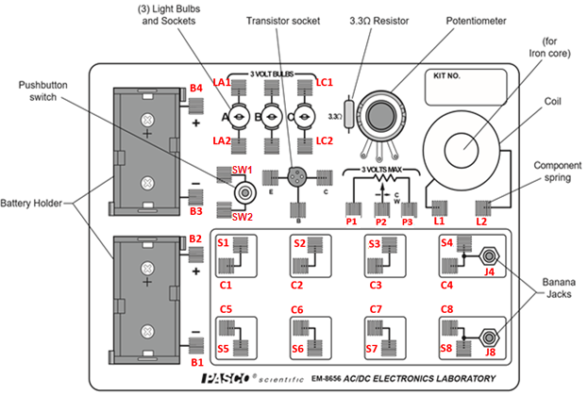

Figure 3: AC/DC Circuit Board with labels for different points.

## 32B-4 PROCEDURE

To measure the resistance, you will need the Multimeter. However, to measure the voltages and currents you may use either the Multimeter or the Voltage and Current Sensors, depending on what is available to you. In this Manual, we will be using the terms “Voltage Sensor” and “Current Sensor” to mean the device used to measure these parameters.

1. Better to select the same three resistors as were used for the Resistors in Series Lab. If they are not available, choose three resistors from those available. They may be of same or different values, but should range between 100 Ω to 1000 Ω (i.e., not smaller than 100 Ω and not larger than 1000 Ω). Refer to them as resistor #1, #2 and #3. Label them so that they do not get mixed up.
2. Determine the values of the resistances form the color code on them. Enter the Colors, Coded Value and Tolerance in Table 1. Use the Multimeter to measure the resistance of each of your three resistors. Determine the percentage experimental error of each resistance value and enter the values in the appropriate columns in Table 1. Use the measured values in all subsequent work.

#### A- Resistance in Parallel Circuit

1. DO NOT attach the battery to the circuit. Connect the three resistors into the Parallel Circuit, using the spring clips on the AC/DC Circuits Board to hold the leads of the resistors together. See Fig 4 for the circuit diagram, and Fig. 5 for the circuit on the AC/DC board (only a part of the board is shown).
2. Connect the Multimeter across C4 and C8. Set it up for resistance measurement.
3. In Fig. 5, the value of resistance that the Multimeter is showing is that of R1, R2 and R3 connected in parallel. Note this value in Table 2 as the measured value of R123.
4. Now take out resistance R3 from the circuit. To do this, you may disconnect any one side of the yellow-colored wire, i.e. at C3 or C7, or both sides. Now measure the resistances across C4 and C8 in the already connected Multimeter. This will be the resistance across R1 and R2 connected in parallel. Note this in Table 2 as the measured resistance for R12.
5. Reconnect R3 and take out R2 (the red wire). Note and record the resistance for R1 and R3 in parallel (i.e. R13 in Table 2).
6. Re-connect R2 and take out R1 (the blue wire). You now have R2 and R3 in parallel. Note this in Table 2 as R23.
7. Use the measured values of R1, R2 and R3 from Table 1, to obtain the calculated values of R12, R23, R13, and R123, as well as the percent errors.

Figure 4: Circuit Diagram for resistances in parallel Figure 5: Diagram on AC/DC box

#### B- Voltage in Parallel Circuit

1. In the circuit already made, add two D-Cells. Connect B2 and B3 so that the two batteries are now in series with each other.
2. Connect B4 to SW1, and SW2 to S4. Connect S8 to B1. The circuit should now be as in Figures 6 and 7 (without the Voltage sensors).
3. When the switch is pressed, the current will flow from the battery in the direction: B4 - SW1 - SW2 - S4 – S3 – S2 – S1. Then through R1, R2 and R3 to S5, S6 and S7 and then to S8 – B1. This completes the circuit.
4. Connect the Voltage Sensor to Capstone, and use it to measure the voltages V1, V2, V3 and V123 across R1, R2, R3 and R123 respectively, by connecting the Voltage Sensor at the points as shown by the green lines (of course, only one at a time, since there is only one voltage sensor).
5. In Table 3, enter the values of the resistances from Table 2, and the measured values of the voltage across these resistances.



Figure 6: Circuit Diagram for resistances in Parallel

Figure 7: Diagram on AC/DC box

#### C- Currents in Parallel Circuit

1. Now remove the wires between S5 and S6, and between S6 and S7. Connect S5 and S6 directly to S8 (see Fig. 9). To measure the current, you will connect the Current Sensor in the circuit at different positions. For this you will have to remove the connecting wires and replace them with the current sensor.
2. Connect the Current Sensor to Capstone Software.
3. First, remove the wire connecting the switch SW2 to S4, and attach the Current Sensor in its place. Make sure that the polarity of the sensor is correct. Press Record in Capstone, press the switch for a few seconds, release the switch, stop recording in Capstone. Note the current value *I0* in Table 3. Remember to start with a high current range and reduce the max range as needed.
4. Now replace the wire between SW2 and S4. Remove the wire between S5 and S8 and replace it with the current Sensor. Press Record in Capstone, press the switch for a few seconds, release the switch, stop recording in Capstone. Note the current value *I1* in Table 3.
5. Replace the wire between R1 and S8 and repeat the process for R2 and R3. Obtain *I2* and *I3* and record them.
6. Lastly, replace the wire between S8 and B1 with the current sensor, and measure *I4*.
7. Calculate and note what the current should be based on Ohm’s Law, i.e.

I = V / R

1. Where R and V are the resistance and voltage between the two points. Calculate and note the percent error (use the measured value as the theoretical value).

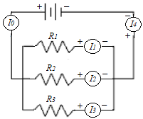

Fig 8: Circuit diagram for measuring current for resistors in parallel.

Figure 9: Circuit showing Current Sensor positions for measuring currents.

**32B-5 CALCULATIONS:**

Ohm’s Law: *ΔV = I R →I = ΔV / R*

*I0 = V123 / R123*

*I1 = V1 / R1*

*I2 = V2 / R2*

*I3 = V3 / R3*

*I4 = V123 / R123*

Use measured values of resistance in these calculations.

## 32B-6 PRECAUTIONS

1. Connect the batteries in the correct direction.
2. Make sure that the connections in the springs are well fitting.
3. Start measuring current and voltage with the highest range in the Multimeter / Sensor first, then lower the range to improve accuracy.

## 32B-7 DATA SHEET: RESISTORS, VOLTAGES AND CURRENTS IN CIRCUITS

#### Table 1: Coded and measured values of resistances

|  |  |  |  |  |  |
| --- | --- | --- | --- | --- | --- |
| No | Colors  1st 2nd 3rd 4th | Coded Resistance | Tolerance | Measured Resistance | Percent error |
| R1 |  |  |  |  |  |
| R2 |  |  |  |  |  |
| R3 |  |  |  |  |  |

#### Table 2: Measured values of Resistances in Parallel.

|  |  |  |  |
| --- | --- | --- | --- |
|  | Measured resistance | Calculated resistance | Percent error |
| R12 |  |  |  |
| R13 |  |  |  |
| R23 |  |  |  |
| R123 |  |  |  |

#### Table 3: Measured values of Voltages and Currents across Resistors in Parallel

|  |  |  |  |  |  |  |  |  |  |
| --- | --- | --- | --- | --- | --- | --- | --- | --- | --- |
|  | Measured Resistance from Tables 1 and 2 |  |  | Measured voltage |  |  | Measured current | Calculated Current | % Error |
| Units |  |  | Units |  |  | Units |  |  |  |
| R1 |  |  | V1 |  |  | *I1* |  |  |  |
| R2 |  |  | V2 |  |  | *I2* |  |  |  |
| R3 |  |  | V3 |  |  | *I3* |  |  |  |
| R123 |  |  | V123 |  |  | *I4* |  |  |  |
|  |  | *I0* |  |  |  |

## 32B-8 REPORT:

Upload the following in the DataSet for this Lab. Don’t make the errors mentioned in red:

#### For In-Class lab:

|  |  |  |
| --- | --- | --- |
|  |  | Points |
|  | Completely filled up “Report Forms”. Make sure to include units.  Units missing. | 20 |
|  | Photographs of the three cases showing the Resistance, Voltage and Current measurement for any one measurement | 3*5 = 15 |
|  | Sample calculations for Calculated current of Table 3 | 5 |
|  | Sources of Error in this experiment. Indicate the major source of error. No not write: Human Error, Calculation Error, and Rounding Error. | 5 |
|  | Discussion of Results | 10 |
|  | Total | 55 |

#### For Take-Home Lab-Kit lab:

|  |  |  |
| --- | --- | --- |
|  |  | Points |
|  | Show your setup for Case A: Resistances in Parallel | 5 |
|  | Show your setup for Case B or Case C: Voltages or Current | 5 |
|  | Completely filled up “Report Forms”. Make sure to include units.  Units missing. | 20 |
|  | Photographs of the three cases showing the Resistance, Voltage and Current measurement for any one measurement | 3*5 = 15 |
|  | Capstone screenshots showing Voltage and Current measurement for any case. | 2*5 = 10 |
|  | Sample calculations for Calculated current of Table 3 | 5 |
|  | Sources of Error in this experiment. Indicate the major source of error. No not write: Human Error, Calculation Error, and Rounding Error. | 5 |
|  | Discussion of Results | 10 |
|  | Total | 75 |

## 32B-9 ADDITIONAL INFORMATION

Resistors in Parallel, Khan Academy:

<https://www.khanacademy.org/science/physics/circuits-topic/circuits-resistance/v/circuits-part-3>

PhET Simulation:  
<https://phet.colorado.edu/sims/html/circuit-construction-kit-dc-virtual-lab/latest/circuit-construction-kit-dc-virtual-lab_en.html>

## 32B-10 POINTS TO THINK ABOUT

1. Why should the resistances be not too small or too large?
2. Why is the resistance R123 smaller than R1, R2 or R3, even though we now have three resistors?
3. Does it matter which side of the resistances is connected to the positive side of the circuit?

## 32B-11 SAMPLE DATA