# IC-32C R-I-V in Series-Parallel Combination Circuits

04/23/2023 FOR IN-CLASS AND TAKE-HOME LAB KIT

## 32C.1 OBJECTIVE

Build a combination of series and parallel circuit with three resistors and one DC source. Measure current passing through each resistor and measure the voltage across each resistor, and verify the equations of the combination of series and parallel circuit.

## Voltage SensorStudent MultimeterAC/DC Electronics Laboratory32C.2 EQUIPMENT

AC/DC Electronics Lab Board

Resistors

Multimeter

Voltage Sensor

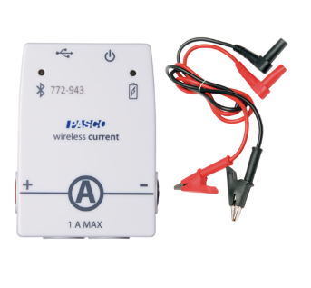Current Sensor

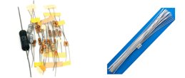Two D-cells

Wires

Capstone Software

## 32C.3 THEORY

Circuits combined by series and parallel wirings can be reduced into one equivalent resistance step by step. Each step is purely a series or parallel circuit. The circuit in the Figure 1 can be reduced into one equivalent resistance through two steps: $R_{2}$ and $R_{3}$ locally parallel equivalent to $R_{23};$ then, $R_{1}$ and $R_{23}$ locally series equivalent to $R_{total}$. The resistance, current, and voltage relations for three resistors the circuit are the following:

When resistances are placed in parallel, the total, or equivalent, resistance is given by the following equations:

*Combination Circuit:*

$$R_{2}$$

$$∆V_{total}$$

$$R_{3}$$

$$R_{1}$$

$\frac{1}{R_{23}}=\frac{1}{R_{2}}+\frac{1}{R_{3}}$ (1)

${I_{23}=I}_{2}+I_{3}$ (2)

${∆V_{23}=∆V}_{2}={∆V}_{3}$ (3)

$R_{total}=R_{1}+R_{23}$ (4)

${I_{total}=I}_{1}=I_{23}$ (5)

${∆V_{total}=∆V}_{1}+{∆V}_{23}$ (6) Figure-1

The Current through one or a combination of resistors is given by Ohm’s Law:

$I=\frac{∆V}{R}$ (7)

We will measure the resistance and voltage across the resistors and the current through the resistors and compare these to the calculated values.

The resistors are labelled by a colour coding shown in Figure 2. We will set up the circuit on the AC/DC Circuit Board. A diagram with labels for different points is shown in Figure 3.

Figure 2: Color Coding for Resistors.

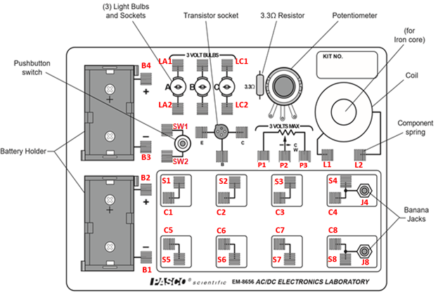

Figure 3: AC/DC Circuit Board with labels for different points.

## 32C.4 PROCEDURE

Better to select the same three resistors as were used for the Resistors in Series Lab. If they are not available, choose three resistors from those available. They may be of same or different values, but should range between 100 Ω to 1000 Ω (i.e. not smaller than 100 Ω and not larger than 1000 Ω). Refer to them as resistor #1, #2 and #3. Label them so that they don’t get mixed up.

Determine the values of the resistances from the color code on them. Enter the Colors, Coded Value and Tolerance in Table 1. Use the Multimeter to measure the resistance of each of your three resistors. Determine the percentage experimental error of each resistance value and enter the values in the appropriate columns in Table 1. Use the measured values in all subsequent work.

#### Resistances in Combination Circuit

1. DO NOT attach the battery to the circuit. Connect the three resistors into the Combination Circuit, using the spring clips on the AC/DC Circuits Board to hold the leads of the resistors together. See Fig 4 for the circuit diagram, and Fig. 5 for the circuit on the AC/DC board (only a part of the board is shown).
2. Connect the Multimeter across C4 and C8. Set it up for resistance measurement.
3. In Fig. 5, the value of resistance that the Multimeters are showing are those of R1, R23 connected in parallel, and R123 connected in combination. Note these values in Table 2 as the measured values.
4. Use the measured values of R1, R2 and R3 from Table 1, to obtain the calculated values of R1, R23, and R123, as well as the percent errors.

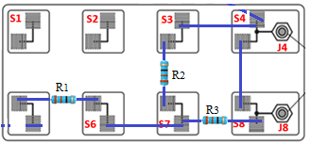

Figure 4: Circuit Diagram for resistances Figure 5: Diagram on AC/DC box

in Combination

#### Voltages in Combination Circuit

1. In the circuit already made, add two D-Cells. Connect B2 and B3 so that the two batteries are now in series with each other.
2. Connect B4 to SW1, and SW2 to S4. Connect S8 to B1. The circuit should now be as in Figures 6 and 7 (without the Voltage sensors).
3. When the switch is pressed, the current will flow from the battery in the direction: B4 - SW1 - SW2 - S4 – S3 – S2 and S1. Then through R2 and R3 to S6, and then to R1 to S8 and then to the battery B1. This completes the circuit.
4. Connect the Voltage Sensor to Capstone, and use it to measure the voltages V1, V23, and V123 across R1, R23 and R123 respectively, by connecting the Voltage Sensor at the points as shown by the green lines (of course, only one at a time, since there is only one voltage sensor).
5. In Table 3, enter the values of the resistances from Table 2, and the measured values of the voltage across these resistances.

Figure 6: Circuit Diagram for resistances in Combination

Figure 7: Diagram on AC/DC box – both for Voltage and Current measurements.

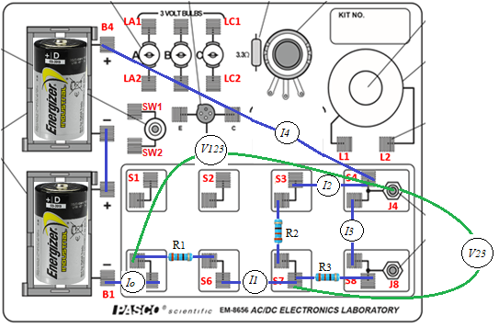

#### Currents in Combination Circuit

1. Now connect the Current Sensor to Capstone. The wiring as done for the Voltage measurements are the same as for the Current measurements.
2. Remove the wire between switch SW2 and S4 and replace it with the Current Sensor. Press the switch and measure the current *I4*. Replace the wire.
3. Take out the wire between S3 and S2 and replace it with the current sensor, and measure *I2*. Replace the wire.
4. Repeat the same with the wires between S3 and S1 for *I3*, S6 and S7 for *I1* and S8 and B1 for *I0*.
5. Calculate and note in Table 3 what the current should be based on Ohm’s Law, i.e.

I = V / R

Where R and V are the resistance and voltage between the two points. Calculate and note the percent error (use the measured value as the theoretical value).

R2

I0

R3

R1

I1

I2

I3

I4

Fig 8: Circuit diagram for measuring current for resistors in Combination.

## 32C.5 CALCULATIONS:

Ohm’s Law: *ΔV = I R →I = ΔV / R*

*I0 = V123 / R123*

*I1 = V1 / R1*

*I2 = V2 / R2*

*I3 = V3 / R3*

*I4 = V123 / R123*

Use measured values of resistance in these calculations.

## 32C.6 PRECAUTIONS

1. Connect the batteries in the correct direction.
2. Make sure that the connections in the springs are well fitting.
3. Start measuring current and voltage with the highest range in the Multimeter / Sensor first, then lower the range to improve accuracy.

## 32C.7 DATA SHEET: RESISTORS, VOLTAGES AND CURRENTS IN COMBINATION CIRCUITS

#### Table 1: Coded and measured values of resistances

|  |  |  |  |  |  |
| --- | --- | --- | --- | --- | --- |
| No | Colors  1st 2nd 3rd 4th | Coded Resistance | Tolerance | Measured Resistance | Percent error |
| R1 |  |  |  |  |  |
| R2 |  |  |  |  |  |
| R3 |  |  |  |  |  |

#### Table 2: Measured values of Resistances in Combination.

|  |  |  |  |
| --- | --- | --- | --- |
|  | Measured resistance | Calculated resistance | Percent error |
| R1 |  |  |  |
| R23 |  |  |  |
| R123 |  |  |  |

#### Table 3: Measured values of Voltages and Currents across Resistors in Combination

|  |  |  |  |  |  |  |  |  |  |
| --- | --- | --- | --- | --- | --- | --- | --- | --- | --- |
|  | Measured Resistance from Tables 1 and 2 |  |  | Measured voltage |  |  | Measured current | Calculated Current | % Error |
| Units |  |  | Units |  |  | Units |  |  |  |
| R1 |  |  | V1 |  |  | *I1* |  |  |  |
| R23 |  |  | V2 |  |  | *I2* |  |  |  |
| R123 |  |  | V3 |  |  | *I3* |  |  |  |
|  |  |  | V23 |  |  | *I4* |  |  |  |
|  | V123 |  |  | *I0* |  |  |  |

**32C.8 REPORT:**

Upload the following in the DataSet for this Lab. Don’t make the errors mentioned in red:

#### For In-Class lab:

|  |  |  |
| --- | --- | --- |
|  |  | Points |
|  | Completely filled up “Report Forms”. Make sure to include units.  Units missing. | 20 |
|  | Photographs of the three cases showing the Resistance, Voltage and Current measurement for any one measurement | 3*5 = 15 |
|  | Sample calculations for Calculated current of Table 3 | 5 |
|  | Sources of Error in this experiment. Indicate the major source of error. No not write: Human Error, Calculation Error, and Rounding Error. | 5 |
|  | Discussion of Results | 10 |
|  | Total | 55 |

#### For Take-Home Lab-Kit lab:

|  |  |  |
| --- | --- | --- |
|  |  | Points |
|  | Show your setup for Case A: Resistances | 5 |
|  | Show your setup for Case B or Case C: Voltages | 5 |
|  | Completely filled up “Report Forms”. Make sure to include units.  Units missing. | 20 |
|  | Photographs of the three cases showing the Resistance, Voltage and Current measurement for any one measurement | 3*5 = 15 |
|  | Capstone screenshots showing Voltage and Current measurement for any case. | 2*5 = 10 |
|  | Sample calculations for Calculated current of Table 3 | 5 |
|  | Sources of Error in this experiment. Indicate the major source of error. No not write: Human Error, Calculation Error, and Rounding Error. | 5 |
|  | Discussion of Results | 10 |
|  | Total | 75 |

## 32C.9 ADDITIONAL INFORMATION

PhET Simulation:  
<https://phet.colorado.edu/sims/html/circuit-construction-kit-dc-virtual-lab/latest/circuit-construction-kit-dc-virtual-lab_en.html>

## 32C.10 POINTS TO THINK ABOUT

## 32C.11 SAMPLE DATA