IC-39 Kirchhoff’s Rules
04/23/2023 FOR IN-CLASS AND TAKE-HOME LAB KIT

39-1 OBJECTIVE
The purpose of this lab will be to experimentally demonstrate Kirchhoff’s Rules for electrical circuits.

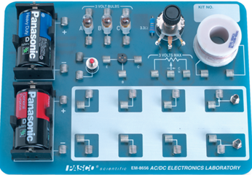
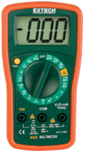
39-2 EQUIPMENT
AC/DC Electronics Lab Board
Resistors
Wire Leads
Two D-cell Batteries
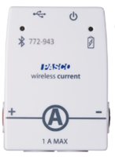
Digital Multimeter (DMM)
Voltage Sensor and Current sensor

39-3 THEORY
Electronic circuits that cannot be reduced to simple series of parallel circuits can be analyzed by different methods. As an example, consider the circuit of figure 1. The currents and voltage drops across the resistances cannot be found by a simple application of Ohm’s Law. In this circuit, points A and D are called Junctions, since more than two wires connect there. A closed loop is any path that starts at some point in the circuit, passes through the elements of the circuit, and arrives back at the same point, without passing through any element more than once. There are three such closed loops in the circuit of Figure 1. These are Loop 1: A-B-C-D-A shown by the blue line, Loop 2: A-D-E-F-G-A shown by the red line, and Loop 3: B-C-D-E-F-G-A-B shown by the green line. The junctions and loops are used in two Kirchhoff’s rules to analyze the circuit.
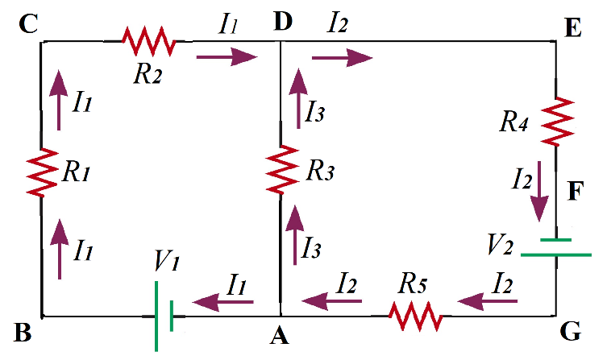
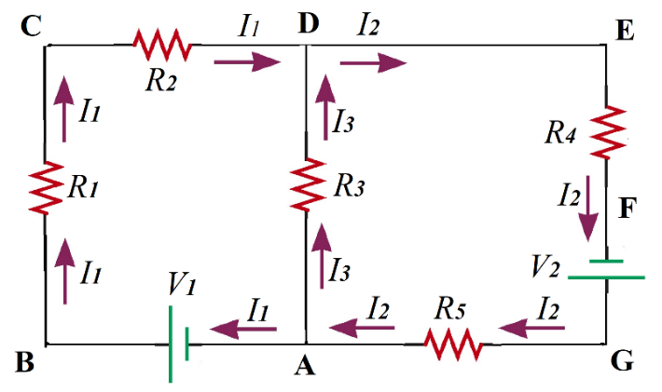

Figure 1: Circuit for Kirchhoff’s Rules and three possible Loops shown in blue, red and green lines.
KCR- Kirchhoff’s Current Rule: The sum of the currents entering a junction = sum of currents leaving a junction. Or equivalently: the net current entering a junction is zero.
KVR-Kirchhoff’s Voltage Rule: The algebraic sum of the voltage changes around any closed loop is zero.

We would usually know the values of the battery voltages and resistances. As a first step, we label and assign directions (arbitrarily) to the currents in each section of the circuit (i.e. between each junction). We then write the junction equation (assuming a current entering the junction is positive, and leaving the junction is negative) at node D as:
$I_{1}+I_{3}-I_{2}=0$ (1)
We now traverse the closed loops in any direction (clockwise or counterclockwise, the resulting equations are equivalent) and add up all the changes in the voltages and set them to zero, i.e.
$ΣΔV=0$ (2)
The voltage change across a resistor is found by Ohm’s Law as
$∆V=IR$ (3)
The sign of ΔV is positive if we are crossing the resistance in a direction that is against the direction of the current in that resistor, and it is negative if we go across the resistor in the same direction as the current. The ΔV across the battery is positive if we cross it from its negative to its positive side. With these, the equations for the three loops become:
Loop 1 (A-B-C-D-A) starting at the point A and going clockwise:
$V_{1}-I_{1}R_{1}-I_{1}R_{2}+I_{3}R_{3}=0$ (4)
Loop 2 (A-D-E-F-A) ) starting at the point A and going clockwise:
$-I_{3}R_{3}-I_{2}R_{4}+V_{2}-I_{2}R_{5}=0$ (5)
Loop 3 (A-B-C-D-E-F-A) ) starting at the point A and going clockwise:
$V_{1}-I_{1}R_{1}-I_{1}R_{2}-I_{2}R_{4}+V_{2}-I_{2}R_{5}=0$ (6)
Note that equation (6) is simply the sum of equations (4) and (5) and is therefore not an independent equation. The same would apply to the junction rule applied at node A. So, the useful (or independent) number of Junction equations that we can use are one less than the number of junctions, and the Loop equations are one less than the number of loops.
We then simultaneously solve equation (1) and any two out of equations (4), (5) and (6) to obtain the values of the currents$I_{1}$, $I_{2}$ and $I_{3}$. In case any of the currents comes out to be negative, it simply means that the direction of the current is opposite to what we had chosen as the direction in Figure 1.

39-4 PROCEDURE
1 Select five resistors and measure and measure their resistances. Label them as$R_{1}, R_{2}, … R_{5}$ and note these in Table 1. Select resistors that are in the range of 10 Ω to 100 Ω.
2 Connect the resistors on the ac/dc board to make the circuit as shown in Figure 1. Some of the ways in which this could be done is shown in Figures 3 and 4. Attach the two D-cells in the battery holders. Note the positions of the resistors $R_{1}, R_{2}, … R_{5}$ in the circuit (don’t mix up these resistors). Measure the voltages across the batteries and note these as V₁ and V₂.
3 Using the values of the resistances and battery voltages, calculate the currents $I_{1}$, $I_{2}$ and $I_{3}$ by using the two Kirchhoff’s Rules. Use the same notation and directions of the currents as used in Figure 1. Use the calculated currents to calculate the potential difference across each resistor by using Ohm’s Law. Note the calculated currents and voltages in Table 1.
4 Once the calculations are done, you have an idea of what values to expect. First measure the voltages across each of the resistors and note it in Table 1.
5 Now measure the currents $I_{1}$, $I_{2}$ and $I_{3}$. For this you would need to break the circuit and use the ammeter/current sensor to complete the loop. All the possible locations where you can break the circuit and place the ammeter to measure these currents are shown in Figure 3. You can measure the currents at any of the indicated positions.
6 Calculate the percent errors in the calculated and measured values of the currents and voltages. Check to see if the Kirchhoff’s Junction rule and Loop Rules are verified.
Note: The Canvas Module has a link to an excel file that you can use to verify your calculations. It will not give you the values of the currents and voltages, but only if your calculated values are correct to within +-3%.
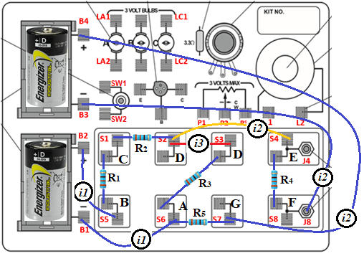

Figure 3: Kirchhoff’s Rules experimental setup. One of many possible ways to make the same circuit on this ac/dc board. You can measure I₁, I₂ and I₃ at any of the locations shown in the figure.

39-5 CALCULATIONS
- Use the equations (1) and any two of (4), (5) and (6) to obtain the three currents. You would have to solve these three equations simultaneously. It may be easier if you set them up as a matrix equation and use Gauss Elimination or Gauss-Jordan method to solve them.
- Once the currents are found, you can calculate the expected voltage drops across each of the resistors by using Ohm’s Law which is equation (3).
- Find the percent errors between the calculated and measured values. Use the calculated values as the theoretical value when finding the percent errors.

39-6 PRECAUTIONS:
- There should be no wire connecting B2 and B3. The two batteries are not in series.
- In Figure 3, the wires showing I₁, I₂ and I₃ are supposed to be there. Disconnect one of these and place the Current sensor to measure the current. The replace the connection with a wire.
- You can verify your calculations by using the excel file available in the canvas module.
- Measure the battery voltages when the circuit is active (i.e. all resistors and connections are in place).
- Do not use large resistances. Anything approaching 1000 Ω will make the current very small.
- All resistances should be comparable to each other, i.e. any one should not be very much larger or very much smaller than the rest.
- Make sure that the connections are firm, and the wires are touching both sides of the springs.

39-7 KIRCHHOFF’S RULES REPORT FORM

Battery voltages
V₁ =
V₂ =

Resistance, Current and Voltages
MEASURED RESISTANCE (ohms) |  | VOLTAGE |  |  |  |  | CURRENT
 |  | ACROSS | CALCULATED (volts) | MEASURED (volts) | % ERROR |  | CURRENT | CALCULATED (mA) | MEASURED (mA) | % ERROR
R₁ = |  | R₁ |  |  |  |  | I₁
R₂ = |  | R₂ |  |  |  |  | I₂
R₃ = |  | R₃ |  |  |  |  | I₃
R₄ = |  | R₄
R₅ = |  | R₅

39-8 REPORT:
Upload the following in the DataSet for this Lab.
 |  | Points
- 1 | Show your circuit setup | 5
- 3 | Completely filled up “Report Forms”. Make sure to include units. | 25
- 4 | Two Photographs of the circuit, one for showing voltage and one for current sensor in place for any one measurement | 2*5 = 10
- 5 | Detailed calculations for calculated currents and voltages of Table 3 | 10
- 6 | Sources of Error in this experiment. Indicate the major source of error. | 5
- 7 | Discussion of Results | 10
 | Total | 65

39-9 ADDITIONAL INFORMATION:
Figure 4: Kirchhoff’s Rules experimental setup and photograph. (One of many possible ways to make the same circuit on this ac/dc board)

$$I_{3}$$
$$I_{1}$$
$$I_{2}$$
$$V_{2}$$
$$V_{1}$$
$$A$$
$$A$$
$$B$$
$$C$$
$$D_{c}$$
$$D_{D}$$
$$D_{A}$$
$$E$$
$$F$$
$$G$$
$$R_{1}$$
$$R_{2}$$
$$R_{3}$$
$$R_{4}$$
$$R_{5}$$
To measure $I_{1}$: Open $D_{C}D_{D}$
To measure $I_{2}$: Open AA
To measure $I_{3}$: Open $D_{A}D_{D}$

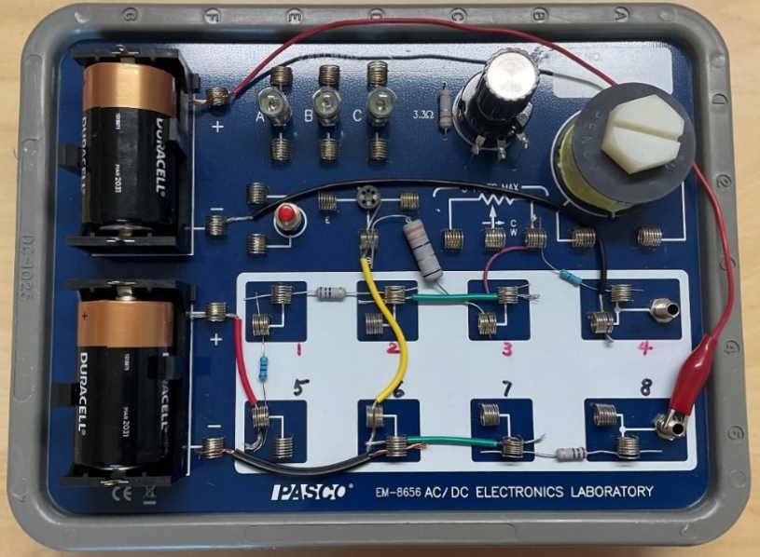
How to Solve a Kirchhoff's Rules Problem - Simple Example
https://www.youtube.com/watch?v=Z2QDXjG2ynU

Solving Circuit Problems using Kirchhoff's Rules
https://www.youtube.com/watch?v=dgkaE7eiY5w

39-10 POINTS TO THINK ABOUT
- What difference would it make if the battery resistance is measured when the batteries are in the circuit, or when they are outside the circuit (i.e. the emf)
- What will happen if you use large resistances, say in the kΩ range?
- What will happen of four resistances are under 100 Ω each, and one is in kΩ?
- If there are two junctions and you have two Junction Equations, why can you use only one Junction Equation, and not both in your calculations for the currents?
- If there are three loops and you have three Loop Equations, why can you use only two Loop Equations, and not all three in your calculations for the currents?

39-11 SAMPLE DATA
From Beniam Kumela, CRN 15141

REPORT FORM
Battery voltages
V₁ = 1.58 V
V₂ = 1.58 V

Resistance, Current and Voltages
MEASURED RESISTANCE (ohms) |  | VOLTAGE |  |  |  |  | CURRENT
 |  | ACROSS | CALCULATED (volts) | MEASURED (volts) | % ERROR |  | CURRENT | CALCULATED (mA) | MEASURED (mA) | % ERROR
R₁ = 549 |  | R₁ | 1.05 | 1.049 | 0.095 |  | I₁ | 1.91 | 1.8 | 5.76
R₂ = 321 |  | R₂ | 0.61 | 0.613 | 0.49 |  | I2 | 4.47 | 4.3 | 3.95
R₃ = 32 |  | R₃ | 0.08 | 0.082 | 2.5 |  | I3 | 2.56 | 2.4 | 6.25
R₄ = 325 |  | R₄ | 1.45 | 1.444 | 0.41
R₅ = 10 |  | R₅ | 0.05 | 0.044 | 12

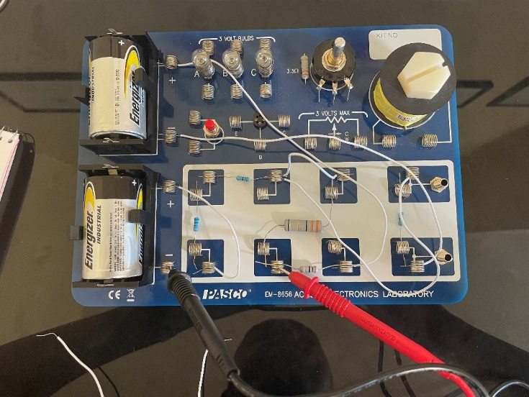
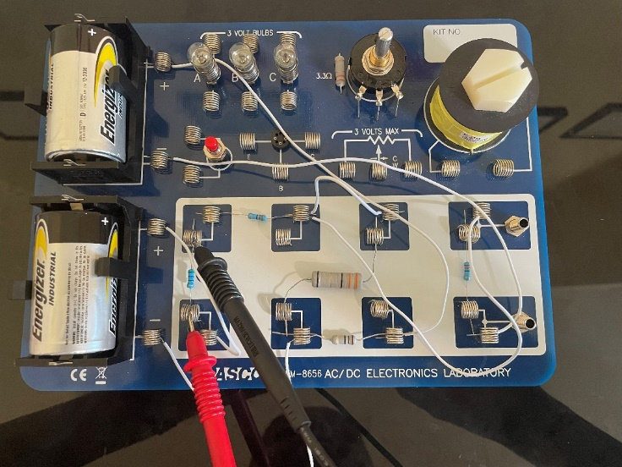

Figure 1: Voltage measurement setup Figure 2: Current measurement setup

