Here's how Texas polluters escape penalties

Lax enforcement means industry doesn't upgrade equipment, groups say
By Mark Collette July 7, 2017 Updated: July 7, 2017 10:15am
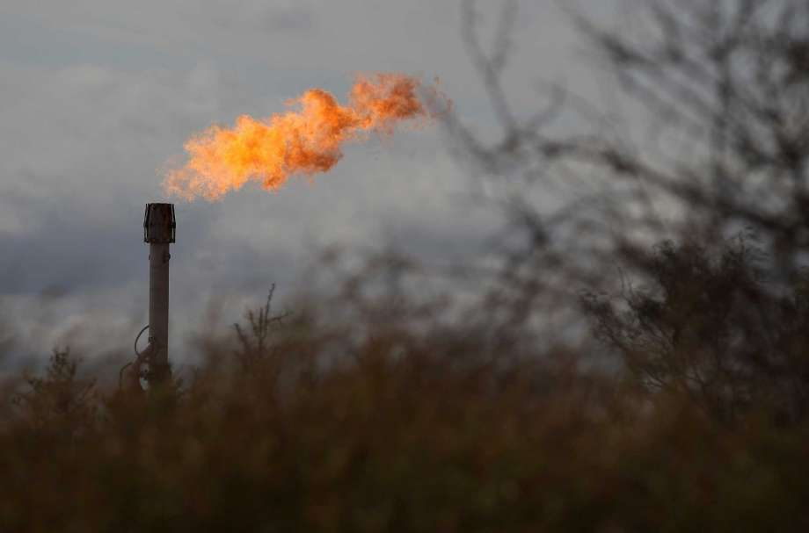
Photo: Kin Man Hui, Staff
A gas flare burns on an oil lease in La Salle county. A report released July 7, 2017 by Texas environmental groups says the state imposes penalties on just 3 percent of maintenance and upset events at industrial sites, including oil and gas wells. (Kin Man Hui/San Antonio Express-News)
From the chemical plants of Houston to the oil and gas wells of West Texas, the state is letting polluters off the hook, foregoing penalties in about 97 percent of incidents, environmental groups reported Friday.
Companies chalk up the releases as unavoidable consequences of complex chemical processes and necessary maintenance. But they could be stopped with equipment upgrades if companies had the incentive to do so in the form of stiffer penalties, according to the report, "Breakdowns in Enforcement."
Houston, with its massive industrial complex, had more such incidents than anywhere else during the six-year period examined in the report. But in one surprising finding, the analysis showed that supposedly small polluters were escaping penalties for big emissions by gaming the system.
"The result is that thousands of tons of illegal air pollution is threatening public health, but is not being taken into account by Texas regulators," said Gabriel Clark-Leach, an attorney for the Environmental Integrity Project, which produced the report with Environment Texas.
State officials and companies have not seen the report, because it was published early Friday.
The groups logged more than 400 million pounds of pollution in the incidents, and penalties averaged just 3 cents per pound.
In the absence of state enforcement, advocates have turned to lawsuits, including a recent one that netted a civil penalty of $20 million against Exxon Mobil for releases from its Baytown complex.
The analysis of state records reveals that Texas imposed penalties on 588 out of 24,839 malfunction and maintenance events reported by companies from 2011 through 2016. The total fines for these violations of the law were $13.5 million.
The Houston area had 453 incidents, which released 5.2 million pounds of illegal air pollution, the analysis found.
But the largest releases of illegal pollution, in terms of total pounds, happened in the oil fields of West Texas, where 10 million pounds were released.
Under state and federal law, sources that emit less than 25 tons of sulfur dioxide and volatile organic compounds each year can claim an exemption from the federal Clean Air Act's more stringent permitting requirements that call for public notice and modern air pollution control equipment.
But many Texas facilities that have claimed this exemption emitted more than 25 tons of these pollutants during 2016, meaning that they violated emission limits, the report said.
Of the 96 sites statewide that reported more than 25 tons of sulfur dioxide emissions during maintenance and malfunction in 2016, almost half — 47 — improperly claimed to be "insignificant sources" that are exempt, according to the analysis.
A Chronicle series last year, Chemical Breakdown, exposed the lack of penalties and oversight for chemical facilities across the nation.
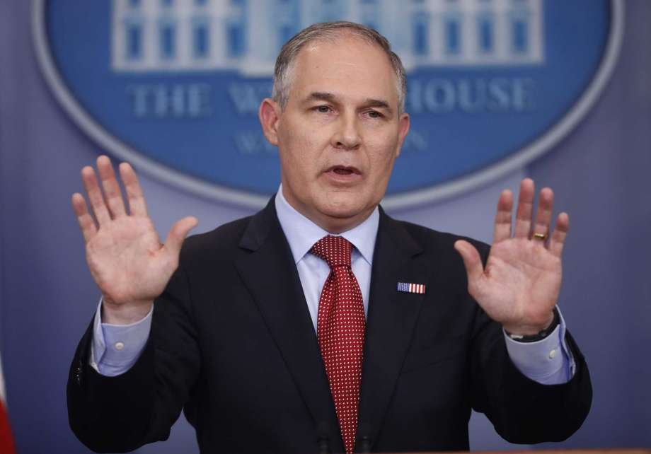
Editor's note: This story was updated with new numbers, provided by the Environmental Integrity Project, for malfunction and maintenance events statewide and in Houston. The changes did not alter the conclusions of the analysis.

EPA watch dog?

Scott Pruitt clearly wants to shift the priorities of the agency he leads.
Copyright 2017: Houston Chronicle July 6, 2017

Photo: Pablo Martinez Monsivais, STF
EPA Administrator Scott Pruitt speaks to the media on June 2 during the daily briefing at the White House. (AP Photo/Pablo Martinez Monsivais, File)
Sometimes it's helpful to divide people who work in certain government jobs into three categories: Attack dogs, lap dogs and watch dogs.
Take, for example, EPA Administrator Scott Pruitt. As Oklahoma's attorney general, he was an aggressive attack dog who won headlines in his state by criticizing and suing the Environmental Protection Agency. Now, as the man President Trump tapped to take charge of the EPA, he's earning a reputation as a lap dog for the very industries he's supposed to regulate.
Instead, we need him to become what we expect the EPA to be: a watchdog over our country's environment.
His supporters give the man credit for jumping into his job with both feet. Legal experts tracking the EPA have told The New York Times that in just four short months, Pruitt has taken steps to undo, delay or block more than 30 environmental regulations. That's the most dramatic rollback of rules in such a short period in the agency's history, a record one environmental law professor calls "astounding."
But it's also horrifying to environmental activists watching as Pruitt dismantles much of the authority of the regulatory body we trust to protect our nation's air, water and public health. Just this week, a coalition of states entered a legal challenge claiming Pruitt violated the law when he reversed a ban on a pesticide the EPA's scientists say can damage the brain development of fetuses and children.

