Texas faces a new normal under neutered EPA

State can lead way in generating energy to secure future of the many
By Heather Houser March 18, 2017
- 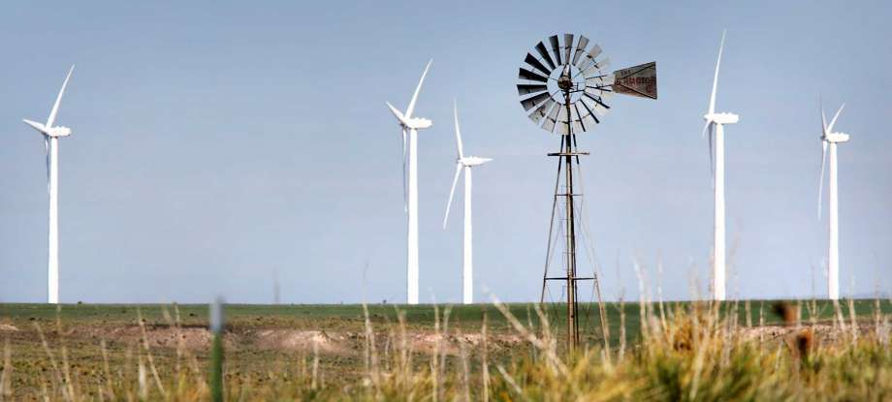
Photo: Bob Owen, Staff
Image 1 of 2
﻿New wind turbines near Amarillo produce electricity, helping Texas lead the nation in wind energy production. ﻿
With the confirmation of Scott Pruitt to head the U.S. Environmental Protection Agency, the path ahead for our climate is clearer - or perhaps dirtier - than ever.
With his reported ties to oil and gas corporations, Pruitt is set to defang the EPA in line with the 14 lawsuits he brought against the agency as Oklahoma attorney general. Appointing him to steer the United States' environmental agenda was just one sign of what's ahead. President Donald Trump is poised to slash the EPA budget and life-saving protections such as the Clean Power Plan and Clean Water Rule.
It's evident that the Trump administration does not intend to address our greatest threat to planetary health and security - climate change. Instead, the next four years will see us accelerate into the worst of the projections for the climate system.
This is not the course for our country or for our planet. We need to step out of the dirty, dangerous fossil age and into a prosperous, renewable future.
Just how bad are those climate projections? We don't have to peer into a crystal ball for a glimpse. Transformations in Texas show what increasing atmospheric carbon dioxide and rising global temperatures wreak. I moved to Texas in June 2011 at the start of a heat wave and historic drought, from which we've only recently emerged; the heat and drought will undoubtedly come again.
Flooding - drought's equal and opposite twin - seems to be the new normal in our state. Houston and the Sabine River region have been the hardest hit, accumulating $3.5 billion in damages last year. Seven severe weather events exceeding the billion-dollar damage mark landed here in 2016 alone - more than in any other state. On the more beautiful but no less troubling side, the redbud trees and Texas mountain laurel are aflame with blooms weeks before their expected arrival date. What might be a delightful sensory explosion for nature lovers indicates conditions that stress farmers and other land workers who rely on established climate patterns.
Just as Texas feels the heat of a carbon-intensive economy, it can also lead the way in generating energy to secure the future of the many, and not just augment the wealth of the few. We don't have to wait idly for the federal government to take the reins; local and state lawmakers have inordinate power on the climate front.
Texas already leads the nation in wind energy production, harnessing this renewable source for more than 12 percent of our electricity needs. Investing in mobility options and renewable energy sources, incentivizing conservation, and divesting from fossil fuel industries are just some state and municipal-level steps toward climate mitigation. Texans must push our lawmakers, from Austin Mayor Steve Adler to Houston Mayor Sylvester Turner to our representatives at the Texas Capitol, to take these steps.
Continuing with petrochemical business-as-usual compromises environmental, economic and health security and puts us all - but especially the poor and people of color - at risk. This is an ethical challenge as well as a scientific and legislative one. It therefore falls to educators, local officials and all concerned residents to learn about and communicate what inaction means for our ethical, environmental, economic and health futures.
Socially just climate action won't come from turning vegetarian and driving a hybrid. We require transformed minds and collective action to halt what environmentalist Bill McKibben has called our "Fossil Fuel Infatuation." Our school curriculums must reflect this knowledge and not undermine scientific consensus. Cities and states must invest in mobility options that decrease fossil fuel consumption and promote the conservation of water and recovery of goods. State lawmakers must lead in redesigning energy and agricultural systems for their long-term and publicly minded sustainability. We all must pressure the federal government to halt projects such as pipeline construction that will harm our environment and to regulate and appropriately price carbon pollution. These are the changes we need now.
Houser is an associate professor of English at the University of Texas at Austin.

