Conservatives seek to overhaul energy agenda

Texas congressman leading efforts to cut funds for renewable research By James Osborne
Lamar Smith
WASHINGTON — Over the past decade, the U.S. government has spent tens of billions of dollars to speed onto the market the energy technology that many believe is the future — from solar panels to industrial-size batteries to modernized nuclear reactors.
“Building the new energy economy,” the U.S. Department of Energy proclaims on its Twitter feed.
But with former President Barack Obama out of the White House, a coalition of conservative politicians led by San Antonio Rep. Lamar Smith — the powerful chairman of the House Science, Space and Technology Committee — is pressing to overhaul a system it says allows the government, rather than the market, to decide the future of the country’s energy industry in a bid to create a low-carbon economy.
Instead, Smith’s coalition of Republican politicians wants to cut funding for energy efficiency and renewable energy research. The politicians are questioning a program from the George W. Bush era that backs loans for advanced energy projects that can’t find financing in the private sector.
“You need to ask the philosophic question do we need to be in the loan-making business,” said Republican Rep. Randy Weber, an ally of Smith on the House science committee. “We’re going to be having a discussion with (Energy Secretary nominee Rick Perry) on this.”
Long an adversary of climate scientists, Smith has not wasted any time since President Donald Trump, another skeptic of climate change, took office last month in making clear his intentions to roll back Obama’s policies aimed at slowing global warming.
Smith, 69, has called for a congressional investigation into whether employees of the Environmental Protection Agency have communicated secretly about undermining the new administration’s environmental agenda via an encrypted messaging app. He also has claimed the National Oceanic and Atmospheric Administration carelessly rushed to publish data disproving a potential pause in global warming between the late 1990s and early 2000s. Climate change deniers have long pointed to that possible pause as evidence for their beliefs.
With Congress ready to begin work on next year’s budget, the science committee held a hearing last week on the alternative energy loan guarantee program, which was created in 2005 and has since loaned out more than $30 billion to projects ranging from the nation’s first utility-scale solar farms to one of the nation’s first new nuclear power plants in decades to a new electric car designed by Tesla.
All but a handful of the more than 30 loans are being paid down or were repaid, according to the Energy Department. But pointing at high-profile failures like the California solar panel manufacturer Solyndra and loans to entities backed by large investors such as the Wall Street investment bank Goldman Sachs and tech giant Google, Smith described a system that, “instead of the private sector taking on risk to develop new technology, the government steps in and risks taxpayer dollars.”
Such critiques have been made for years by conservative think tanks like the Heritage Foundation, which lobbies against any and all energy subsidies, including those to the oil and gas sector.
But Cherry Murray, who until last month served as director of the Department of Energy’s Office of Science, said the loan program has been critical in getting technologies like solar farms and electric cars through the difficult period between invention and commercial production — known as “the valley of death” in the startup world.
With limited options to obtain financing and no established supply chains, new technologies typically struggle to survive competitors until they can move into commercial production — and many don’t. In addition, with foreign governments doing much to subsidize the development of low-carbon technologies, alternative energy is fast becoming an international race.
“It’s difficult for these companies to find funding, because until you get economies of scale the costs are too high,” Murray said. “And you can’t get the economies of scale until the costs come down. The thinking is if we can get (companies) to pick up (this technology) sooner we can have this revolution here in the U.S., and it won’t be just in Europe and China.”
Smith declined to be interviewed. But staffers at the House science committee described his intent to focus the Energy Department on research into new frontiers of science, seeking breakthroughs in areas like supercomputers and calcium-ion batteries over helping established technologies onto the market.
But for Smith, a Yale University graduate and lawyer who has been in Congress since the late 1980s, a rapid transition toward low carbon energy could spell trouble for the oil companies and refineries that dominate the economy in his home state of Texas. With Trump promising to cut government spending and regulations while growing fossil fuel production, this might be Smith’s best chance to slow the low-carbon revolution sweeping the United States, political observers said.
But it won’t be easy.
The loan guarantee program has spurred multibillion-dollar construction projects that have meant plenty of hiring in states like Georgia and Louisiana, where the Department of Energy has offered $2 billion in loan guarantees for a new methanol plant that will capture and deliver carbon dioxide to nearby oil fields to help boost crude production.
“Energy subsidies are a bipartisan problem,” said Nick Loris, a research fellow at the Heritage Foundation. “Members of Congress like them whether they’re a ‘D’ or an ‘R’ because they can look good bringing home the bacon. These programs can be difficult to end once they’re in place.”
A spokesman for Perry, who is awaiting a Senate vote on his nomination as energy secretary, said the former Texas governor “was reserving comment on these policy matters while his confirmation is pending.”
Regardless of whether government is there to help, people on both sides of the debate agree the energy industry will keep innovating toward greater efficiency and lower carbon emissions. It’s simply a matter of how quickly they get there. james.osborne@chron.com twitter.com/osborneja

Lamar Smith takes on the clean energy agenda

San Antonio congressman promotes funding cuts for renewables research
By James Osborne February 23, 2017 Updated: February 23, 2017 8:31pm
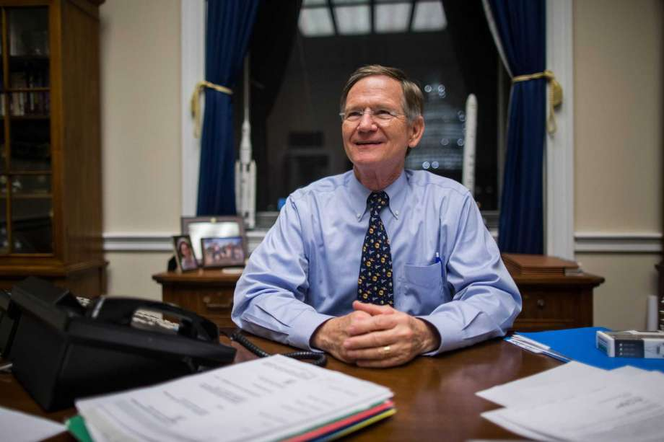
Photo: ZACH GIBSON, STF
FILE -- Rep. Lamar Smith (R-Texas), chair of the House Committee on Science, Space and Technology, at his office in the Rayburn House Office Building in Washington, Dec. 2, 2015. Smith and other Republicans on the committee have long attacked a 2015 study the National Oceanic and Atmospheric Administration published that likely negates data in an earlier 2013 scientific paper that seemed to show that global warming had slowed since the late 1990s. (Zach Gibson/The New York Times)
WASHINGTON - Over the past decade, the U.S. government has spent tens of billions of dollars to speed onto the market the energy technology that many believe is the future - from solar panels to industrial-size batteries to modernized nuclear reactors.
"Building the new energy economy," the U.S. Department of Energy proclaims on its Twitter feed.
But with former President Barack Obama out of the White House, a coalition of conservative politicians led by San Antonio Rep. Lamar Smith - the powerful chairman of the House Science, Space and Technology Committee - is pressing to overhaul a system it says allows the government, rather than the market, to decide the future of the country's energy industry in a bid to create a low-carbon economy.
Instead, Smith's coalition of Republican politicians wants to cut funding for energy efficiency and renewable energy research. The politicians are questioning a program from the George W. Bush era that backs loans for advanced energy projects that can't find financing in the private sector.
"You need to ask the philosophic question do we need to be in the loan-making business," said Republican Rep. Randy Weber, an ally of Smith on the House science committee. "We're going to be having a discussion with (Energy Secretary nominee Rick Perry) on this."
Long an adversary of climate scientists, Smith has not wasted any time since President Donald Trump, another skeptic of climate change, took office last month in making clear his intentions to roll back Obama's policies aimed at slowing global warming.
Smith, 69, has called for a congressional investigation into whether employees of the Environmental Protection Agency have communicated secretly about undermining the new administration's environmental agenda via an encrypted messaging app. He also has claimed the National Oceanic and Atmospheric Administration carelessly rushed to publish data disproving a potential pause in global warming between the late 1990s and early 2000s. Climate change deniers have long pointed to that possible pause as evidence for their beliefs.
With Congress ready to begin work on next year's budget, the science committee held a hearing last week on the alternative energy loan guarantee program, which was created in 2005 and has since loaned out more than $30 billion to projects ranging from the nation's first utility-scale solar farms to one of the nation's first new nuclear power plants in decades to a new electric car designed by Tesla.
All but a handful of the more than 30 loans are being paid down or were repaid, according to the Energy Department. But pointing at high-profile failures like the California solar panel manufacturer Solyndra and loans to entities backed by large investors such as the Wall Street investment bank Goldman Sachs and tech giant Google, Smith described a system that, "instead of the private sector taking on risk to develop new technology, the government steps in and risks taxpayer dollars."
Hazards of startups
Such critiques have been made for years by conservative think tanks like the Heritage Foundation, which lobbies against any and all energy subsidies, including those to the oil and gas sector.
But Cherry Murray, who until last month served as director of the Department of Energy's Office of Science, said the loan program has been critical in getting technologies like solar farms and electric cars through the difficult period between invention and commercial production - known as "the valley of death" in the startup world.
With limited options to obtain financing and no established supply chains, new technologies typically struggle to survive competitors until they can move into commercial production - and many don't. In addition, with foreign governments doing much to subsidize the development of low-carbon technologies, alternative energy is fast becoming an international race.
"It's difficult for these companies to find funding, because until you get economies of scale the costs are too high," Murray said. "And you can't get the economies of scale until the costs come down. The thinking is if we can get (companies) to pick up (this technology) sooner we can have this revolution here in the U.S., and it won't be just in Europe and China."
Smith declined to be interviewed. But staffers at the House science committee described his intent to focus the Energy Department on research into new frontiers of science, seeking breakthroughs in areas like supercomputers and calcium-ion batteries over helping established technologies onto the market.
But for Smith, a Yale University graduate and lawyer who has been in Congress since the late 1980s, a rapid transition toward low carbon energy could spell trouble for the oil companies and refineries that dominate the economy in his home state of Texas. With Trump promising to cut government spending and regulations while growing fossil fuel production, this might be Smith's best chance to slow the low-carbon revolution sweeping the United States, political observers said.
But it won't be easy.
The loan guarantee program has spurred multibillion-dollar construction projects that have meant plenty of hiring in states like Georgia and Louisiana, where the Department of Energy has offered $2 billion in loan guarantees for a new methanol plant that will capture and deliver carbon dioxide to nearby oil fields to help boost crude production.
"Energy subsidies are a bipartisan problem," said Nick Loris, a research fellow at the Heritage Foundation. "Members of Congress like them whether they're a 'D' or an 'R' because they can look good bringing home the bacon. These programs can be difficult to end once they're in place."
Perry reserves comment
A spokesman for Perry, who is awaiting a Senate vote on his nomination as energy secretary, said the former Texas governor "was reserving comment on these policy matters while his confirmation is pending."
Regardless of whether government is there to help, people on both sides of the debate agree the energy industry will keep innovating toward greater efficiency and lower carbon emissions. It's simply a matter of how quickly they get there.
In Texas, wind energy has turned into a big business. Weber acknowledged its importance and knack for innovation.
"Can they make it more efficient?" he said "Sure, but that's the task of GE and Siemens and the rest of them as they want to become the world's largest wind turbine manufacturer. They have the motivation. We don't need to step in."
Wind energy is an established industry. But what about technologies that have not found their footing, like industrial-scale batteries for the power grid, carbon capture for coal plants and the next generation of nuclear reactors, on which China is hard at work.
Solar energy is an example of the role government can play as a catalyst, said those who support federal research and development programs. Early in this decade, solar panels were going up on homeowner's rooftops at a fast clip, but electrical utilities had yet to get in on the act. Then the Department of Energy loaned billions of dollars for the construction of utility-scale solar farms across California, Colorado and Arizona.
In 2016, power companies connected almost 10 gigawatts of utility-scale solar farms to the power grid, more than natural gas, wind or any other power source, according to the Energy Department.
"Financiers were watching," said Tom Kimbis, executive vice president of the Solar Energy Industries Association and a former Energy Department official under Bush. "Other solar companies were watching. And it went from there.
"It's about getting the right support at the right time."

Texas Rep. Lamar Smith: Get news from Donald Trump, not media
Kevin Freking, Associated Press January 25, 2017 Updated: January 26, 2017 11:46am
Source: memegenerator.net
Image 1 of 21
In this June 7, 2012 file photo, House Science Committee Chairman Rep. Lamar Smith, R-Texas speaks on Capitol Hill in Washington.

Keep going for a look back at how the internet reacted to the inauguration of President Donald Trump.
WASHINGTON (AP) — The Republican chairman of the House Science panel is encouraging Americans to get their news from President Donald Trump and not the news media.
Rep. Lamar Smith of Texas said if Trump were a Democrat, the media would be saying he has tremendous energy, how he "is courageous, even fearless," and how he is a great father, among many other positive attributes.
But Smith said the "national, liberal media" won't print or air such attributes.
The congressman said Monday night during a speech on the House floor: "Better to get your news directly from the president. In fact, it might be the only way to get the unvarnished truth."
Autoplay: On | Off
Trump has repeatedly made false claims about fraudulent balloting costing him the popular vote and has disputed the turnout for his inauguration. Kellyanne Conway, an aide to Trump, said this weekend that the White House was offering "alternative facts" to the ones reported by the media.
The House Science panel that Smith chairs has jurisdiction over agencies that have a major focus on research and development, such as NASA and the Department of Energy. In his role as chairman, he has voiced skepticism about the extent of climate change and the role of human behavior, saying that the Obama administration engaged in alarmism and exaggeration to promote an extreme climate agenda.

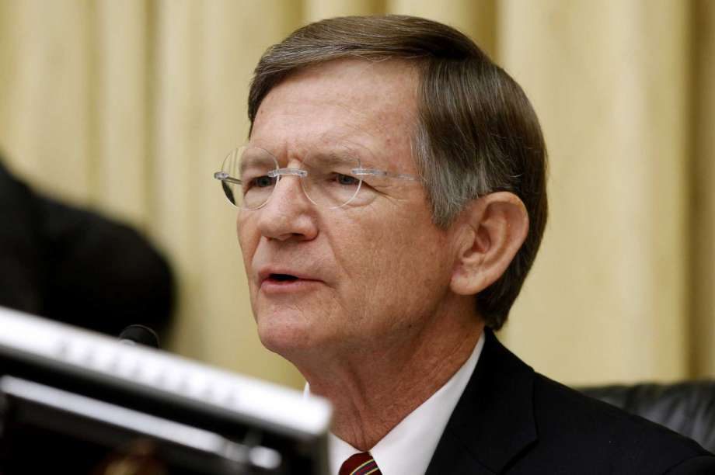
Republicans, Democrats clash over climate change investigations
By James Osborne September 14, 2016 Updated: September 14, 2016 10:18pm
Photo: Charles Dharapak, STF
Image 1 of 2
FILE - In this June 7, 2012 file photo, House Science Committee Chairman Rep. Lamar Smith, R-Texas speaks on Capitol Hill in Washington. Escalating a political fight over global warming, Smith issued subpoenas ... more
WASHINGTON - Democrats and Republicans clashed Wednesday in a hearing examining the legal authority of House Republicans to force state attorneys general to turn over documents related to their investigation into whether Exxon Mobil and other oil companies committed fraud in questioning climate change research.
Led by Rep. Lamar Smith of San Antonio, Republicans have accused state law enforcement officials of trying to suppress opposing views and what they describe as legitimate scientific research into alternative theories of climate change that question the effect of human activities.
The overwhelming consensus of scientists, however, is that the burning of fossil fuels, such as oil, coal and natural gas, is accelerating climate change by releasing carbon dioxide and other gases that trap heat in the Earth's atmosphere.
Sitting next to Smith during Wednesday's hearing in the House Science, Space and Technology Committee, Rep. Eddie Bernice Johnson, D-Dallas, said the committee had taken to harassing law enforcement officials, environmental groups and scientists from federal agencies and was setting a dangerous precedent.
"I have to go back to the Red Scare of the 1950s to find a similar effort," Johnson said. "I hope all the members think about the precedent the chairman is setting here and how you would like it if Democrats were to take the same action at conservative-minded groups."
State attorneys general and environmental groups who received subpoenas from the House committee this summer have so far ignored them. New York Attorney General Eric Schneiderman, who is leading the states' investigation, argues that the congressional subpoenas are not allowed under the Constitution and described them recently as "an improper fishing expedition for the benefit of a private party," a reference to Exxon Mobil Corp.
On Wednesday, however, constitutional law professors told the House committee that despite their own belief in climate change, House Republicans do have the authority to investigate state attorneys general.
Jonathan Turley, a law professor at George Washington University, said the Supreme Court has upheld congressional committees' subpoena authority.
"You risk becoming a decorative element," he said. "Legislative authority means nothing if committees cannot investigate."
The question of congressional authority has been a matter of great debate. Earlier this week 12 legal scholars from law schools including Yale University and Columbia University wrote to Smith, arguing he did not have constitutional authority to issue his subpoenas, both against the attorneys general and environmental groups including 350.0rg.
"No House committee has ever tried or should ever try to enforce subpoenas against state attorneys general," Charles Tiefer, former acting general counsel of the House and now a law professor at the University of Baltimore, testified Wednesday.
Smith showed little sign he planned to back off his investigation, arguing he was defending Congress' constitutional obligation to protect citizens' right to free speech.
"The refusal of the AGs should trouble everyone sitting on this dais, every American," Smith said. "Allowing subpoenaed parties to ignore subpoenas based on the sensitivity of the subject sets a dangerous precedent."

House to investigate climate change investigation
By James Osborne September 3, 2016
WASHINGTON - The Republican-controlled House this month will examine the climate change investigations launched by several state attorneys general - investigations that some lawmakers and officials from energy-rich states have blasted as "witch hunts" and "extortion."
Rep. Lamar Smith, the San Antonio Republican who chairs the Committee on Space, Science and Technology, has scheduled a hearing Sept. 14 to tackle the issue of whether Exxon Mobil and other oil companies committed fraud by downplaying the impact of climate change in statements to investors and the public. Smith has sharply criticized the investigations as undermining the free speech rights of those who have different opinions about the impact of fossil fuels on global warming.
The overwhelming consensus of scientists is that burning fossil fuels such as oil, gas, and coal accelerates global climate change by spewing large amounts of carbon dioxide, which traps heat in the earth's atmosphere. Last year, several state attorneys general led by New York's Eric Schneiderman launched investigations into whether oil companies knew about climate change decades ago and hid it from the public and investors.
Exxon Mobil and industry lawyers have strongly denied such allegations.
In July, Smith's committee began investigating the investigation, issuing subpoenas to attorneys general and environmental groups. So far, they have refused to comply with subpoenas on constitutional grounds.
Environmental groups accuse Smith of putting the needs of Exxon Mobil, based in the Dallas suburb of Irving, over those of the planet.
"Maybe instead of this buffoonery, the House Science committee could call on, you know, a scientist, to re-explain the threat of climate change," said Jamie Henn, spokesman for 350.org, a website for climate activists.
So far, three law professors so far are scheduled to testify before the committee: Jonathan Turley of George Washington University Law School; Ronald D. Rotunda of Chapman University Dale E. Fowler School of Law; and Elizabeth Price Foley of Florida International University College of Law.

Poll: 79 percent say climate change happening

Most Americans from both political parties want government action on climate
By Chris Tomlinson, Houston Chronicle October 28, 2016 Updated: October 28, 2016 8:44am
Photo: LEXEY SWALL, STR
Image 1 of 5
Texas Tech professor Katharine Hayhoe didn't set out to be a climate crusader, until she realized many people don't believe climate change is real.
About 79 percent of Americans say global warming is happening, with majorities from both political parties supporting government action to address the problem.
So when will Republican politicians accept scientific fact and do something?
The UT Energy poll of 2,043 Americans by the University of Texas at Austin's Energy Institute found that 89 percent of self-identified Democrats and 62 percent of self-identified Republicans accept the overwhelming scientific consensus about global warming. In 2012, only 45 percent of Republican accepted climate change science as fact.
That's in direct contrast with Republican leaders, both nationally and in Texas, who still question whether humans burning fossil fuels for the last 250 years has contributed to a warming planet and rising sea levels.
"Some of these findings reflect entrenched positions of the two parties," Sheril Kirshenbaum, the poll's director, said. "But it's worth noting that nearly a majority of Republicans, along with 76 percent of Democrats, support steps to reduce carbon emissions."
Most importantly, perhaps, 91 percent of Americans under the age of 35 accept climate science. This might account for why millennials overwhelmingly reject Republican presidential candidate Donald Trump, who has called climate science a Chinese hoax to destroy the U.S. economy.
Not surprisingly, 62 percent of millennials support phasing out coal as a source of electricity, while only 28 percent of seniors do. About 52 percent of millennials support a carbon tax, while 77 percent of senior citizens oppose one.
On hydraulically fracturing wells, only 47 percent of Americans said they understood what the technology involved, but of those, 45 percent oppose the technology, with only 40 percent support it. Opposition to fracking has grown 8 percent since last year, according to the poll.
The results appear to show greater awareness of the issues surrounding fossil fuels. The industry needs to think about how it will respond to these changing attitudes, because if history serves, any attempt by fossil fuel companies to change the public's mind will likely fail.
Republicans should also recognize they need to get with mainstream scientific opinion, because the American public already has.

