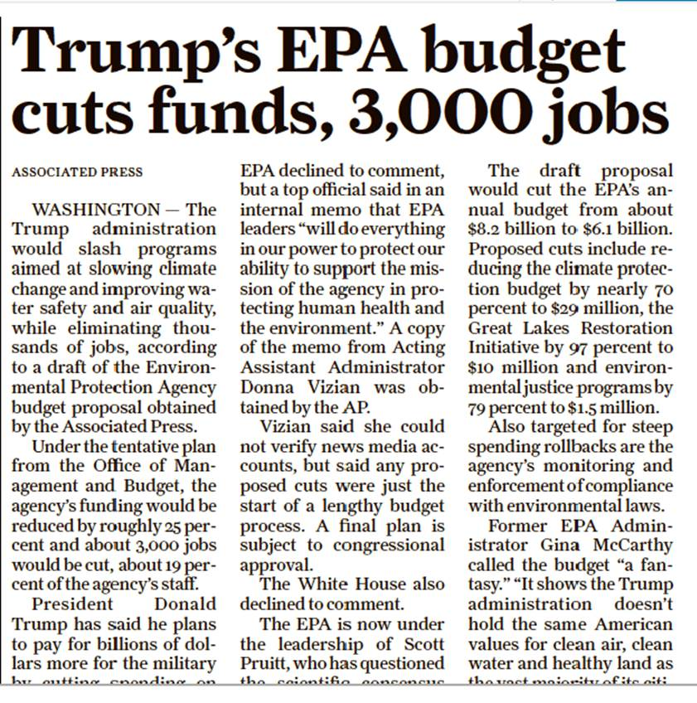

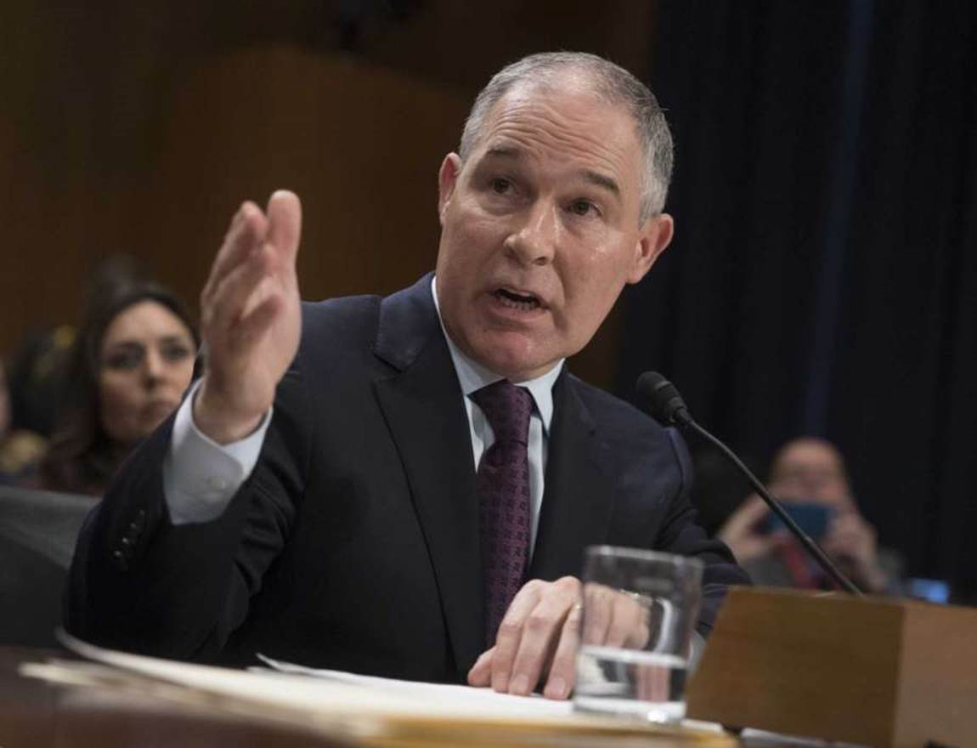

**EPA chief vows quick rollback of Obama-era rules**

Jennifer A. Dlouhy, BLOOMBERG NEWS February 26, 2017

Photo: J. Scott Applewhite, STF

FILE - In this Jan. 18, 2017 file photo, Environmental Protection Agency Administrator-designate, Oklahoma Attorney General Scott Pruitt testifies on Capitol Hill in Washington at his confirmation hearing before the Senate Environment and Public Works Committee. Pruitt on Friday, Feb. 17, 2017, won Senate confirmation to head the EPA, a federal agency he repeatedly sued to rein in its reach during the Obama administration. (AP Photo/J. Scott Applewhite, File)

U.S. environmental chief Scott Pruitt unveiled plans to roll back at least three Obama-era rules at the EPA while vowing to give businesses "regulatory certainty."

Those policy reversals, set to start next week, will empower the Environmental Protection Agency to focus on its core mission of protecting the air and water, Pruitt said Saturday in a speech and question-and-answer session on the final day of the Conservative Political Action Conference in Oxon Hill, Md.

"The previous administration was so focused on climate change and so focused on CO2, some of those other priorities were left behind," Pruitt said in his first detailed remarks since being sworn in on Feb. 17 to lead the EPA. "I really believe that at the end of eight years, we're going to have better air quality, we're going to have better water quality because it's going to be vested in a partnership" with states.

As soon as Monday, President Donald Trump is slated to sign documents compelling the EPA to begin undoing recent regulations, including the Clean Power Plan that slashes greenhouse gas emissions from electricity generation and the Waters of the U.S. rule that defined which waterways are subject to pollution regulation. Documents drafted by the Trump administration would direct Pruitt to begin dismantling those measures, helping fulfill the president's pledge to eviscerate rules he describes as throttling U.S. energy development.

"There are some regulations that in the near term need to be rolled back in a very aggressive way," Pruitt said. "In the next week you may be hearing about some of those."

"We know what those are: The previous administration took the Waters of the United States rule and transformed the Clean Water Act and made puddles and dry creek beds across this country subject to the jurisdiction of Washington, D.C.," Pruitt said. "That's going to change."

Pruitt described another high-priority target on Saturday: an EPA rule imposed last year that limits methane gas emissions from oil and gas wells. Pruitt took aim at the measure while he was Oklahoma's attorney general, with the urging of oil and gas producer Devon Energy Corp., according to recently disclosed emails.

Pruitt built his political career fighting federal regulations he said usurped states' power, joining more than a dozen lawsuits challenging EPA actions. After eight days on the job, Pruitt's view of the agency didn't appear to have changed dramatically.

"People across the country look at the EPA much like they look at the IRS - and I hope to be able to change that," Pruitt said.

Pruitt reiterated earlier vows to collaborate with states and stay within the contours of federal statutes when crafting environmental mandates - an approach he said would help ensure regulatory certainty.

"Those in industry should know what's expected of them," Pruitt said. "Those in industry should know how to allocate their resources to comply with the regulations passed by the EPA."

In keeping with the theme of working with states, the agency said Pruitt hosted 11 western governors Sunday for a breakfast discussion in Washington, where the nation's governors are holding their annual winter meeting.

"They want to protect their water and air and grow their economies," Pruitt said in a release. "The Environmental Protection Agency is going to help them do that."