[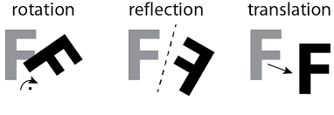](https://www.google.com/imgres?imgurl=https%3A%2F%2Ffreethoughtblogs.com%2Fatrivialknot%2Ffiles%2F2018%2F04%2Ftransformations-1.png&imgrefurl=https%3A%2F%2Ffreethoughtblogs.com%2Fatrivialknot%2F2018%2F04%2F27%2Ftessellation-symmetry%2F&docid=PaW4jQYUj0kNdM&tbnid=pv0HtZQjWWhtAM%3A&vet=10ahUKEwi0o-uR657hAhUJPq0KHXfICdYQMwibAShRMFE..i&w=663&h=230&bih=501&biw=1024&q=how%20to%20make%20a%20rotation%20tessellation&ved=0ahUKEwi0o-uR657hAhUJPq0KHXfICdYQMwibAShRMFE&iact=mrc&uact=8)

Geometric shapes can be translated, reflected, rotated, and glide reflected. These movements create more complex tessellation designs.

[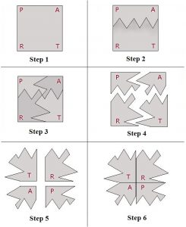](https://www.google.com/url?sa=i&rct=j&q=&esrc=s&source=images&cd=&cad=rja&uact=8&ved=2ahUKEwiR6uS67Z7hAhUIIqwKHfzwBU0QjRx6BAgBEAU&url=http%3A%2F%2Fmathengaged.org%2Fresources%2Factivities%2Fart-projects%2Ftessellations%2F&psig=AOvVaw0HnVhmD2zr8UiojAlZ_2oA&ust=1553656945647639)

[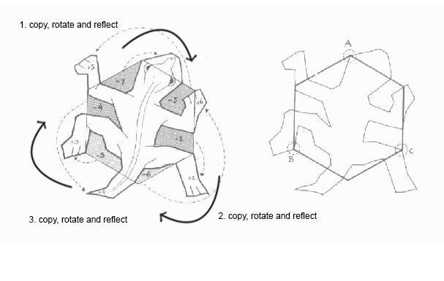](https://www.google.com/url?sa=i&rct=j&q=&esrc=s&source=images&cd=&cad=rja&uact=8&ved=2ahUKEwiR0oyU7J7hAhVLPq0KHQkDCIYQjRx6BAgBEAU&url=https%3A%2F%2Fplasticaescolabetulia.wordpress.com%2F2015%2F01%2F11%2Ftessellation%2F&psig=AOvVaw3lmRTmifyiIqwl4TKRweWR&ust=1553656595359229)