Eng 1301- LAB
Composition I – 16 Wks. /Fall 2018/CRN# 18690

Course Description
Intensive study and practice in writing processes, from invention and research to drafting, revising, and editing, both individual and collaboratively. Emphasis on effective rhetorical choices, including audience, purpose, arrangement, and style. Focus on writing the academic essay as a vehicle for learning, communicating, and critical analysis. A Core curriculum course. Prerequisite: A satisfactory assessment score, completion of INRW 0420 or (for non-native speakers) ESOL 0360.

Vital Information
Instructor: Mrs. N. Puder
Email: nichelle.puder@hccs.edu
Learning Web: http://learning.hccs.edu/faculty/nichelle.puder
Office/Phone: AD8 - Spring Branch
Phone: 713-718-5498
Office Hours: In Person or by Appointment

Required Material
Website: Connect-Learn-Smart-Achieve for Writing and Grammar. Cost $42.50 – Future Sign-in is www.connect.mheducation.com
Includes: Pretest, Diagnostic labs, and Posttest.
McGraw-Hill Handbook, 3rd Edition, EBook
75 Readings Plus, Reading Selections, EBook
Guide: English 1301 Study Guide

Additional Resources
Computer or access to one, USB drive, notebook with pockets, stapler, correction fluid, pens, pencils, dictionary/thesaurus, pack of scantrons, and mini-essay books.

Learning Outcomes
Upon successful completion of this course, students will:
- Demonstrate knowledge of individual and collaborative writing as processes.
- Develop ideas with appropriate support and attribution.
- Write in a style appropriate to audience and purpose.
- Read, reflect, and respond critically to a variety of texts.
- Use Edited American English in academic essays.

Core Objectives
Students enrolled in this core curriculum course will complete assignments designed to cultivate the following core objectives:
- Critical Thinking Skills - to include creative thinking, innovation, inquiry and analysis, evaluation, and synthesis of information.
- Communication Skills - to include effective development, interpretation, and expression of ideas through written, oral, and visual communication.
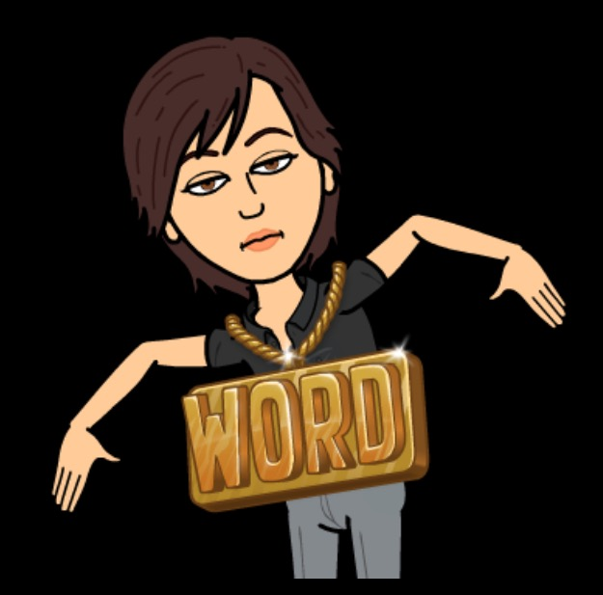
- Personal Responsibility - to include the ability to connect choices, actions, and consequences to ethical decision-making.

Grade Percentages
Unless the professor makes changes and announces otherwise, the overall breakdown of graded assignments and their corresponding values will be calculated as follows:
Essay 1 10%
Essay 2 20%
Midterm Exam 20%
Essay 3 20%
Group Argue Pres. – Solo Essay
Essay 4 20%
Indiv. Pres/Final Exam Essay

Other Assignments 10%
- Connect Lab Exercises
- Connect Posted Assignments
- Quizzes
- In-Class Group Work
- Outlines
- Drafts
- Peer-Analysis
- Other
- Teamwork - to include the ability to consider different points of view and to work effectively with others to support a shared purpose and goal.

Attendance
Texas State Law designates 87.5% minimum attendance for college courses. This requirement allows for a 12.5 absence maximum, which computes as 6 hours. MW and TR classes have 6 absences. A student who exceeds the maximum will be dropped from the course.
Tardiness
A student who is tardy may sign the roll at the end of class. A tardy student who fails to sign the roll or notify the professor of their attendance will be counted absent. Excessive tardies, either individual or as a class, are an interruption of instruction. Official tardy count is recorded as follows: Three tardies (or early leaves) count as one class absence.

Makeup Work/Late Policy
Makeup work without any points deducted will be accepted without penalty at the discretion of the professor. All other late work will loss ten points per class day late. In class quizzes and in class group work cannot be made up.

W (Withdrawn)
A (W) is given to a student who exceeds the 12.5% maximum absence or to a student who withdraws from the course before the last drop date. F may be given in cases of poor performance, scholastic dishonesty, or other severe academic violations. An F or W grade requires that the student repeat the course.
HCC POLICY STATEMENTS: WITHDRAWAL
If you feel that you cannot complete this course, you will need to withdraw from the course prior to the final date of withdrawal. Before you withdraw from your course, please take time to meet with the instructor to discuss why you feel it is necessary to do so. The instructor may be able to provide you with suggestions that would enable you to complete the course. Your success is very important. Beginning in fall 2007, the Texas Legislature passed a law limiting first time entering freshmen to no more than SIX total course withdrawals throughout their educational career in obtaining a certificate and/or degree.
FX Grade
If the student fails the course because he/she did not attend and or complete assignments, then the FX grade will be given. This grade adversely affects Financial Aid as well as academic standing.
Scholastic Dishonesty:
- Plagiarism. A student who knowingly submits for evaluation the words of others disguised as his or her own has committed an act of plagiarism.
- Collusion. Working with another person in preparation of notes, themes, reports, or other written work offered for credit unless the instructor specially approves such collaboration in advance.
- Cheating on an examination or quiz. Giving or receiving, offering or soliciting information, or using prepared material in an examination or testing situation. On examinations and quizzes students are expected: to remain in the examination room until the examination is finished, to refrain from talking, and to refrain from bringing notes and books into the examination room.
- Impersonation. Allowing another person to attend classes, take examinations, or to do graded assignments for an enrolled student under his/her name is strictly forbidden. If a student commits any of the above offenses, he or she will receive a "0" on the assignment and may lose total credit in the course and or expulsion from the university.

Student Conduct
The guidelines for student conduct are specifically defined in The Student Handbook 2002/2003. [As] “Mature, responsible adults …they will voluntarily observe these rules as a matter of training and habit. Students [will] not interfere with or disrupt the orderly educational processes of the College System.” It is expected that students will demonstrate both courtesy and cooperation in the classroom. A student who either cannot or will not extend both courtesy and cooperation may not continue the course.
Campus Carry:
“At HCC the safety of our students, staff, and faculty is our first priority. As of August 1, 2017, Houston Community College is subject to the Campus Carry Law (SB11 2015). For more information, visit the HCC Campus Carry web page at http://www.hccs.edu/district/departments/police/campus-carry/.”

EGLS3 -- Evaluation for Greater Learning Student Survey System
At Houston Community College, professors believe that thoughtful student feedback is necessary to improve teaching and learning. During a designated time, you will be asked to answer a short online survey of research-based questions related to instruction. The anonymous results of the survey will be made available to your professors and division chairs for continual improvement of instruction. Look for the survey as part of the Houston Community College Student System online near the end of the term.
HCCS Policy
Ringing cellular phones, texting, using computers (unless for note taking during class) interrupts instruction. Students must remember to TURN OFF phones and refrain from texting and surfing the Internet when they are in class. A student who does not cooperate may be dismissed from class. It is also disruptive to leave the classroom after receiving a call. Unless it is an emergency, answer or return calls AFTER class is dismissed.
ADA (American Disabilities Act)
HCCS is compliant with the American Disabilities Act and Sec. 504 of the Rehabilitation Act of 1973. If you have any special needs or disabilities that may affect your ability to succeed in college courses, contact a Disability Support Service Counselor (DSSC) in the college you plan to attend.
Northwest ADA Counselor: Mohnaz Kolaini (713) 718-5422

Course Calendar – Fall 2018 – Tuesday and Thursday Schedule
(Bring readings and other downloaded materials to class every class period.)
(English 1301 Freshman Composition I)
Week 1 (August 28/30, 2018)
Tues.
- Pick up a student questionnaire, and complete it. (Think carefully about your answers.)

- Explore Class Resources
  - HCCS App
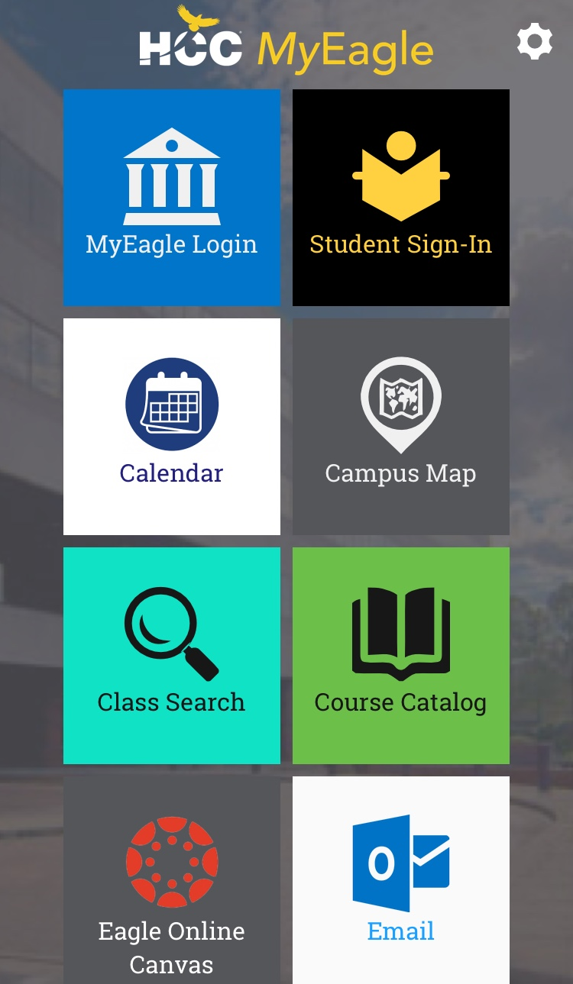
    - Download it.
    - Register with Connect, and sign up for the two-week free trial.
      - What is Connect?
        - Online Class Resource
        - Syllabus/CC
        - Grammar/Writing Exercises
        - Assignments
        - Class Readings - 75 Readings Plus (Instructor Access)
        - Ebook –McGraw-Hill Handbook
        - Comp. I Study Guide
        - Lecture Notes
        - Samples
- Purchase Connect, online access and Ebooks, through the Connect website or through the campus bookstore as an access code. You have two weeks grace.

- Think about topics for Argumentative Group Presentation and Essay to begin in October.
  - Previous topics have been:
    - HCCS Campus Carry
    - Ride-Share (Uber/Lyft) Cap in New York City
    - Red Flag Law in Texas to Address School Shootings
    - Keystone Pipeline
    - Net Neutrality
    - DACA (Deferred Action Childhood Arrivals)
    - Trump Tax Plan

- Send a Selfie or Photo Collage to my email address, nichelle.puder@hccs.edu . Within the email, explain how the Selfie or Photo Collage represents who you are. This email response can be as short as a few sentences or as long as a view paragraphs. You are explaining how the photo, Selfie or collage expresses who you are. Due Friday, August 31, 2018 by 11 p.m. Students who turn in the assignment by Thursday, August 30, 2018 will receive ten extra points on the assignment.
  - Rubic Specifics
    - 70 pts. Emailing Effectively
      - Subject, Addressing the Audience, Message, Salutation
    - 10 pts. Ability to Attach Information
    - 20 pts. Ability to Proofread
      - Grammar, Spelling, Punctuation, Word Choice, Word Structure
- Ice Breaker for the next two weeks:
  - Introduce yourself to at least four or more people in class, and exchange email addresses and phone numbers.

Homework
- Read and make a copy of the “Getting the Most Out of Writing” Power Point Slides found on Connect. Also, read and make a copy of the “Getting the Most Out of Reading” Power Point Slides found on Connect. See other instructions on the assignment.
- Begin reading Chap. 1 and 2 in The McGraw-Hill Handbook found through Connect website.
- Download and or print out the English 1301 Study Guide found on Connect.
Reminder:
Connect Online Assignments (Additional exercises may be added after Oct. 8th) – Due Tuesday, October 9, 2018 – by 11 p.m.
- Reading to Understand Literal Meaning
- The Writing Process
- Generating Ideas
- Planning and Organizing
- Drafting
- Parallelism
- Revising
- Proofreading and Formatting
- Run-on – Comma-Splices
- Phrases and Fragments
- Commas
- Subject-Verb-Agreement
- Pronoun- Ant-Agreement
Thurs.
- Questions/Confusions/New Students
- Email/Selfie or Photo Collage Assignment due to nichelle.puder@hccs.edu by Friday, August 31, 2018.
- Syllabus/Course Calendar Quiz.
- Discuss Richard Marius’ Writing Drafts essay found on Connect.
- Receive Essay #1 Topics
  - (Interview and survey due Tues., Sept. 4, 2018. Post questions and results through Connect.)
  - Go ahead and create an essay draft, but prewriting, outlying, and draft are not due for discussion until Tues., Sept. 18, 2018.
- Use Reading and Essay Writing Assignment #1 As Springboards for Class Discussion.
Homework
- Journal 1 Posted to Connect – Explain and Relate to the Quote – Due on Tuesday, Sept. 11, 2018 by 11 p.m.
- Read Chapter 3 and 4 in The McGraw-Hill Handbook found through Connect.

Week 2 (September 4/6, 2018)
Tuesday
- Survey and interviews due.
- Discuss using the library effectively. – Library Session – Library Visit.
- Using the library, find three scholarly resources databases (vetted newspaper, magazine, journal articles) and one video to explore Essay #1 - Social Media:
- Social Media - Defined
- Background and History of Social Media
- Advantages and Disadvantage of Social Media
- Target Audiences
- Incorporation Into Everyday Life
Homework:
Complete these two exercises through Connect – Due Fri., Sept. 14, 2018 – 11p.m.
- Evaluating the Effectiveness and Appropriateness of Text
- Evaluating Information and Sources

Thurs.
- Group Discussion – Library Social Media Assignment
- Social Media Library Assignment Due – submit to instructor. Remember to keep a copy for yourself because I will meet with students who have essay drafts.

Week 3 (September 11/13, 2018)

Tues.
- Journal 1 Due to Connect by 11 p.m. – Due today – Sept. 11th.
- Journal 2 – Text Messaging Posted to Connect – Due Thursday, Sept. 27, 2018 – 11 p.m.
- Return Graded Social Media Library Assignment.
- Discuss prewriting and drafts with instructor or continue process in class.
- Sign up for instructor conference, tutor visit, or Upswing online tutor submission.
  - Whatever method chosen for review of Essay 1, make changes after receiving feedback. Revise and edit. There should be two drafts – the one that was reviewed and the one that was revised and edited from reviewer comments – Due Wed. Sept. 19th.
  - If sending essay to Upswing, online tutors, send by Monday, Sept. 10th to give the tutor enough time to get the essay back to you. Turn around time can be up to 48 hours.
Thurs.
- Alternative Class Assignment
  - Instructor conference, tutor visit, Upswing submission to improving Essay #1.
  - Meet me in my office, AD8, at the appointed time if you signed up to conference with me about Essay #1.
  - Meet writing tutor at assigned time.
  - Review Upswing returned Essay.
Homework
- Keep initial prewriting, outlying, and draft 1, but revise and edit outline and draft creating a draft 2. Due Tuesday, Sept. 18th.
Week 4 (September 18/20, 2018)
Tues.
- Class Discussion – Essay 1 at this point.
- Credit given for proof of prewriting, outlying, and two drafts – one reviewed and one revised and edited.
Homework
- Do a final revision and editing to Essay 1, and submit to Connect by 11 p.m. Thursday, Sept. 20, 2018.
- Students still feeling unsure can bring final drafts to class for peer-instructor analysis.

Reminder:
Connect Online Assignments (Additional exercises may be added after Oct. 8th) – Due Tuesday, October 9, 2018 – by 11 p.m.
- Reading to Understand Literal Meaning
- The Writing Process
- Generating Ideas
- Planning and Organizing
- Drafting
- Parallelism
- Revising
- Proofreading and Formatting
- Run-on – Comma-Splices
- Phrases and Fragments
- Commas
- Subject-Verb-Agreement
- Pronoun- Ant-Agreement
Thurs.
- Essay 1 due to Connect as a Microsoft Word attached file by 11 p.m.
  - Peer-Instructor Analysis – Last Chance View and Feedback
Homework
- Retrieve, print, or download, and read Brent Staples’ Black Men and Public Space and Sandra Cisneros’ Only Daughter found on Connect. Submit question answers through Connect for class grade. Due Tuesday, Sept. 24 – 11 p.m.
- Read Chapter 7 in McGraw-Hill Handbook found through Connect.
Week 5 (Sept. 24/26, 2018)

Tues.
- Get into Class Discussion Groups/Discussion for Black Men and Public Space/Only Daughter.
- Submit for Class Grade Black Men and Public Space and Only Daughter questions answers through Connect by 11 p.m. tonight.
Homework
- Retrieve, print, or download, and read Amy Tan’s Mother Tongue and Scott Russell Sanders’ Under the Influence found on Connect. Submit question answers through Connect for class grade. Due Thursday, Sept. 26th – 11 p.m.
Thurs.
- Midterm Exam Study Review Topics Posted to Connect
  - This semester’s Midterm Exam, include editing passages, multiple-choice questions and short answer takes place on Tues.,Oct.16, 2018.
  - Journal 3 Posted to Connect – Due October 30, 2018 by 11 p.m.
- Get into Class Discussion Groups/Discussion for Mother Tongue/Under the Influence.
- Submit for Class Grade Mother Tongue and Under the Influence question answers through Connect by 11 p.m. tonight.

- Receive Essay Assignment 2
Homework
- Review Essay 2 Topics and other handout attachments, and bring 2-5 questions back to class about the assignment.
- Questions will be turned in and used as a minor grade.
Week 6 (Oct. 2/4, 2018)
Tues.
- Class Discussion – The Assignment – Essay 2
- Work on Prewriting and Outlining In- Class or Out of Class.
- Sign up for instructor conference, tutor visit, or Upswing online tutor submission.
  - Whatever method chosen for review of Essay 2, make changes after receiving feedback. Revise and edit. There should be two drafts – the one that was reviewed and the one that was revised and edited from reviewer comments – Due Tues., Oct. 9th.
  - If sending essay to Upswing, online tutors, send by Friday, Sept. 28th to give the tutor enough time to get the essay back to you. Turn around time can be up to 48 hours.

Reminder:
Connect Online Assignments (Additional exercises may be added after Oct. 8th) – Due Tuesday, October 9, 2018 – by 11 p.m.
- Reading to Understand Literal Meaning
- The Writing Process
- Generating Ideas
- Planning and Organizing
- Drafting
- Parallelism
- Revising
- Proofreading and Formatting
- Run-on – Comma-Splices
- Phrases and Fragments
- Commas
- Subject-Verb-Agreement
- Pronoun- Ant-Agreement
Thurs.
- Alternative Class Assignment
  - Instructor conference, tutor visit, Upswing submission to improving Essay 2.
  - Meet me in my office, AD8, at the appointed time if you signed up to conference with me about Essay 2.
  - Meet writing tutor at assigned time.
  - Review Upswing returned Essay.
Homework
- Keep initial prewriting, outlying, and draft 1, but revise and edit outline and draft creating a draft 2. Due Tuesday, Oct. 9th.

Complete these two exercises through Connect – Due Sun., Oct. 7th , 2018 – 11 p.m.
- Integrating Source Material into Text
- Using Information Ethically and Legally

Week 7 (Oct. 9/11, 2018)
Tues.
- Class Discussion – Essay 2 at this point.
- Credit given for proof of prewriting, outlying, and two drafts – one reviewed and one revised and edited.
Homework
- Do a final revision and editing to Essay 2, and submit to Connect by 11 p.m. Thurs., Oct. 11, 2018.
- Students still feeling unsure can bring final drafts to class for peer-instructor analysis.
Thurs.
- Essay 2 due to Connect as a Microsoft Word attached file by 11 p.m.
  - Peer-Instructor Analysis – Last Chance View and Feedback
Homework
- Open – additional information may be given in class.

Week 8 (Oct. 16/18, 2018)
Tues.
- Midterm Exam
Homework
- Open – additional information may be given in class.
Thurs.
- Discuss Writing an Argumentative Essay
- Types of Controversial Topics – Local, National, and International
- Argumentative Thesis
- Defining Terms
- Background/History
- Establishing Credibility
- Gathering Evidence
- Evaluating Evidence
- Appealing to the Audience
- Refutation
- Receive Group Presentation and Essay Assignment
- Class Discussion of Group Argumentative Presentation
Homework:
- Think about who you want to choose as group members. Four –five students can form a group.

Week 9 (October 23/25, 2018)
Tues.
- Continue discussion of Group Argumentative Presentation.
Thurs.
- Work on Group Argumentative Assignment (Do It Your Way)
- Meet in or out of class.
  - The group work can be done at a time and place of your choosing.
  - The team captain of the group who wants to meet outside of class can email me, so I know I will not see your group in class.
- Of course, if you would like to, use our room. It is open. I will be in my office.
Week 10 (October 30/Nov. 1, 2018)
Tues./Thurs
- Group Argumentative Presentation Progress Update with Instructor
  - Mandatory.
    - All group members must be present.
    - Each group member that is missing will cost the group ten points on the Presentation Progress Grade.
    - Bring sources to be used and any other parts of the assignment that are ready for review.
Week 11 (Nov. 6/8, 2018)
Tuesday/Thursday
- Journal 4 and 5 Posted to Connect – Due Tuesday, Nov. 27, 2018, 11 p.m.
- Group Argumentative Presentations Due – Group 1-3
- Group Argumentative Presentations Due – Group 4-5
Homework

Week 12 (Nov. 13/15, 2018)
Tues.
- Receive Argumentative Presentation Back
- Review Argumentative Writing Assignment Again – Essay 3
- Work on Prewriting and Outlining In- Class or Out of Class.
- Sign up for instructor conference, tutor visit, or Upswing online tutor submission.
Thurs.
- Alternative Class Assignment
  - Instructor conference, tutor visit, Upswing submission to improving Essay 3.
  - Meet me in my office, AD8, at the appointed time if you signed up to conference with me about Essay 3.
  - Meet writing tutor at assigned time.
  - Review Upswing returned Essay.

Week 13 (Nov. 20/22, 2018)
Tues.
- Class Discussion – Essay 3 at this point.
- Credit given for proof of prewriting, outlying, and two drafts – one reviewed and one revised and edited.
Homework
- Do a final revision and editing to Essay 3, and submit to Connect by 11 p.m. Wed., Nov. 21, 2018. Essay 3 – (Research Assignment) due to Connect as a Microsoft Word attached file.
Thurs.
  - No class or homework. Happy Thanksgiving.

Week 14/15 (Nov. 27/29, 2018 - Dec. 4/6, 2018)
Tues. and Thurs.
- Cinema Music Message Indiv. Presentation and Final Exam Essay 4

Week 16 (Dec. 11-13, 2018)
- TBA – To Be Announced

