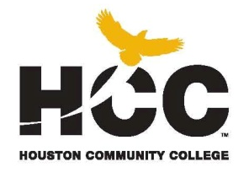
Integrated Reading and Writing
Central College
INRW 0410 – Integrated Reading & Writing I
CRN 72542– Semester Summer II 2018
3 hour lecture /2 hour lab course / 80 hours per semester/ 14 weeks
Class Time: M-F 11:30-2:425a.m. Location: Central 174

Instructor: Professor Peggy Porter

Instructor Contact Information: peggy.porter@hccs.edu
INRW Dept. (713) 718-5410 (To leave a message) http://learning.hccs.edu/faculty/peggyporter
Office location and hours: MW 11:00-11:30 a.m.
And by Appointment

Please feel free to contact me concerning any problems that you are experiencing in this course. You do not need to wait until you have received a poor grade before asking for my assistance. Your performance in my class is very important to me. I am available to hear your concerns and just to discuss course topics. Feel free to come by my office anytime during these hours.

Course Description
This course is a combined 3 hour lecture/ 2 hour lab (1 hour technology lab & 1 hour writing lab), performance-based course designed to develop students’ critical reading and academic writing skills. The focus of the course will be on applying critical reading skills for organizing, analyzing, and retaining material and developing written work appropriate to the audience, purpose, situation, and length of the assignment. The course integrates complementary reading and writing assignments with special emphasis given to reasoning and responding to issues arising from class readings. This course is designed to prepare students for college level reading and writing intensive courses including ENGL 1301. Students will learn to write effective, logical essays, utilizing textual support to develop reading comprehension strategies, and to analyze, synthesize and make value judgments using critical thinking. Lab required. The course fulfills TSI requirements for reading and writing. Students who successfully complete thus course will qualify to take INRW 0420.

Prerequisite for INRW 0410 - Placement based on scores from TSI Assessment
Placement | Reading | ABERD | Writing | ABEWD | WS
INRW 0410 + INRW 0100 | 310-341 | 3-4 | 310-349 | 3-4 | NA
INRW 0410 + INRW 0100 | 310-341 | 3-4 | 310-349 | 3-4 | 0-3
INRW 0410 | 310-341 | 5-6 | 310-349 | 5-6 | NA
INRW 0410 | 342-350 | NA | 310-349 | 5-6 | 0-3
INRW 0410 | 342-350 | NA | 350-362 | NA | 0-3

ABERD: Adult Basic Education Reading Diagnostic (TSIABER)
ABEWD: Adult Basic Education Writing Diagnostic (TSIAWD)
Course Goal
The goal of INRW 0410 is to prepare students for college-level courses such as Freshman Composition, History, Government, Psychology, and other freshman college courses.

Student Learning Outcomes
Upon successful completion of this course, students will be able to:

- Locate explicit textual information, draw complex inferences, and describe, analyze, and evaluate the information within and across multiple texts of varying lengths.
- Comprehend and use vocabulary effectively in oral communication, reading, and writing.
- Identify and analyze the audience, purpose, and message across a variety of texts.
- Describe and apply insights gained from reading and writing a variety of texts.
- Compose a variety of texts that demonstrate reading comprehension, clear focus, logical development of ideas, and use of appropriate language that advance the writer’s purpose.
- Determine and use effective approaches and rhetorical strategies for given reading and writing situations.
- Generate ideas and gather information relevant to the topic and purpose, incorporating the ideas and words of other writers in student writing using established strategies.
- Evaluate relevance and quality of ideas and information in recognizing, formulating, and developing a claim.
- Develop and use effective reading and revision strategies to strengthen the writer’s ability to compose college-level writing assignments.
- Recognize and apply the conventions of Standard English in reading and writing.

5 WEEK CALENDAR
(Scheduled Activities or Materials, Subject to Change by Instructor)

Week 1 | Diagnostic essay  Introducing ourselves; Review syllabus  Preview textbook; Annotate Chapter 1 together  Annotate Chapter 2, individually  Discuss Writing Assignment #1 (the paragraph)  Writing Processes  Write rough draft of Writing Assignment #1 and submit to Upswing
Week 2 | Discuss Ch. 5 Drafting and Revising: The Writing Process  Discuss Ch. 6 Narration: Writing That Tells Important Stories  Ch 21 Adjectives and Adverbs: Using Descriptive Words  Reading and analyzing narratives  Use of description in narratives: Chapter 8 Description: Writing That Creates Pictures in Words  Discuss Ch. 6 Narration: Writing That Tells Important Stories  Ch 21 Adjectives and Adverbs: Using Descriptive Words
Week 3 | Midterm Exam  Discuss Ch. 3 Finding Your Topic and Writing Your Thesis Statement: Making a Point  Prewriting, topic sentences, thesis statements  Writing summaries  Discuss Chapter 12 Comparison and Contrast: Writing That Shows Similarities and Differences  Writing effective essays  Identifying and writing main ideas and supporting details  Chapter 15 The Basic Sentence
Week 4 | Discuss Ch. 13 Cause and Effect: Writing That Explains Reasons and Results  Reading and analyzing cause and effect reading selections  Cause and effect essay structure  Incorporating borrowed sources in your essay
Week 5 | Final Essay and Department Final Exam

Instructional Methods
A variety of instructional methods are used throughout the semester. Examples may include class discussions, lectures, readings, reflections, group projects, research, assessments, video/DVD, internet searches, and presentations.

As an instructor, I want my students to be successful. I feel that it is my responsibility to provide you with knowledge and opportunities for critical thinking and applications as appropriate.

As a student wanting to improve your academic reading and writing ability, it is your responsibility to do the assigned readings and writings, submit assignments on time, participate in discussions and other activities, attend class (face-to-face and online portions), and enjoy this learning experience as you learn how to better your comprehension and writing skills.

Student Assignments
Assignments have been developed that will enhance your learning. You will be required to successfully
---Complete reading and writing assignments/activities
---Compose and revise paragraphs or essays
---Complete weekly Launchpad Solo online activities

Student Assessments
Knowledge checks in the format of quizzes, essays, projects, online lab exercises, flipped lessons, and exams.
Three-four essays and selected revisions
Final Exam

EGLS3 -- Evaluation for Greater Learning Student Survey System (Fall and Spring only)
At Houston Community College, professors believe that thoughtful student feedback is necessary to improve teaching and learning. During a designated time, you will be asked to answer a short online survey of research-based questions related to instruction. The anonymous results of the survey will be made available to your
professors and division chairs for continual improvement of instruction. Look for the survey as part of the Houston Community College Student System online near the end of the term.

Instructor Requirements
As your Instructor, it is my responsibility to:
- Provide the grading scale and detailed grading formula explaining how student grades are to be derived
- Facilitate an effective learning environment through class activities, discussions, and lectures
- Description of any special projects or assignments
- Inform students of policies such as attendance, withdrawal, tardiness and make up
- Provide the course outline and class calendar which will include a description of any special projects or assignments
- Arrange to meet with individual students before and after class as required

To be successful in this class, it is the student’s responsibility to:
- Attend class and participate in class discussions and activities
- Read and comprehend the textbook
- Complete the required assignments and exams:
- Ask for help when there is a question or problem
- Keep copies of all paperwork, including this syllabus, handouts and all assignments

Program/ Discipline Requirements
In this class you will be required to take a pretest and posttest as well as complete any supplemental lab materials.

HCC Grading Scale
A = 100 – 90:……………………………………4 points per semester hour
B = 89 – 80: …………………………………….3 points per semester hour
C = 79 – 70: …………………………………….2 points per semester hour
69 and below = F or IP………………………….0 points per semester hour
IP (In Progress) …………………………………0 points per semester hour
W(Withdrawn)…………………………………..0 points per semester hour
IP (In Progress) is given only in certain developmental courses. The student must re-enroll to receive credit. COM (Completed) is given in non-credit and continuing education courses. To compute grade point average (GPA), divide the total grade points by the total number of semester hours attempted. The grades “IP,” “COM” and “I” do not affect GPA.

Grading Criteria
Your instructor will conduct quizzes, exams, and assessments that you can use to determine how successful you are at achieving the course learning outcomes (mastery of course content and skills) outlined in the syllabus. If you find you are not mastering the material and skills, you are encouraged to reflect on how you study and prepare for each class. Your instructor welcomes a dialogue on what you discover and may be able to assist you in finding resources on campus that will improve your performance.

Grading Percentages (Revise percentages or criteria)
Instructor’s Choice 15%
Lab Component 15%
Writing Assignments (3) 30%
Midterm 10%
Final Exam 30%
(Multiple Choice and In class Writing Assignment)

Total 100%

Instructional Materials
Real Writing with Readings 7th ed. with Access Code by Susan Anker
ISBN: 978-1-319-06619-2 Bedford/St. Martin’s (Macmillan Education Imprint)

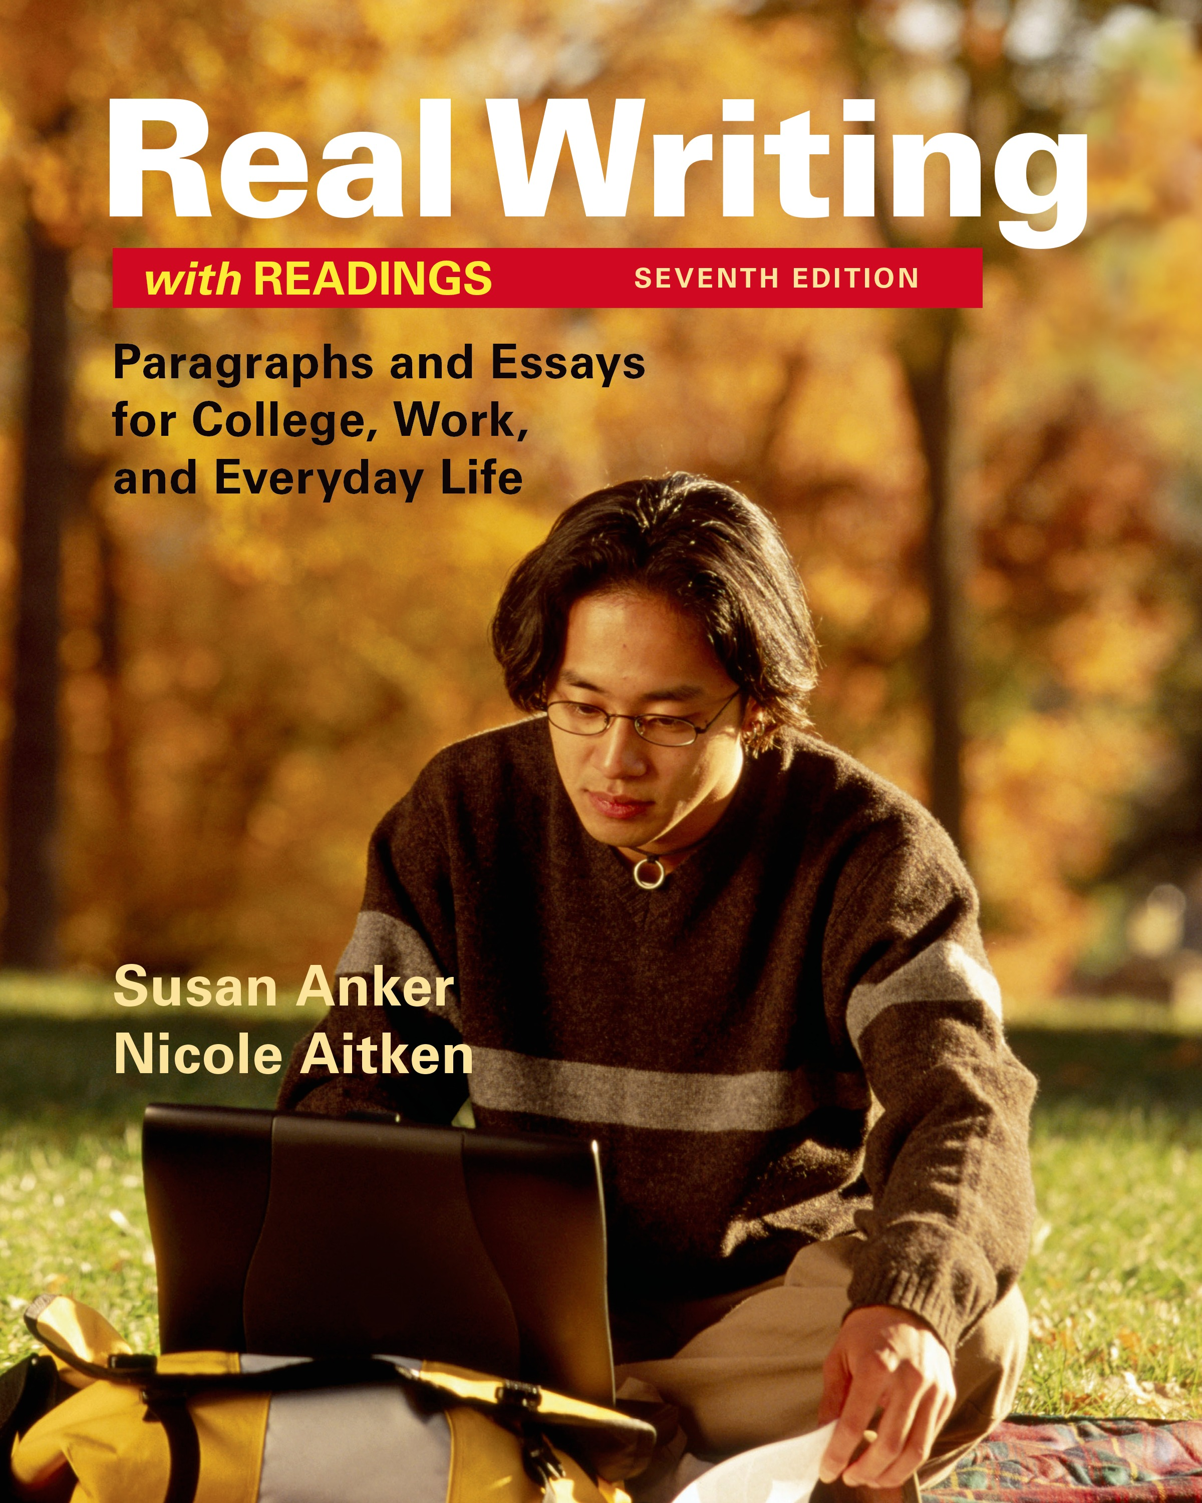

Flash Drive (8GB), College Level Dictionary and Thesaurus, Binder/Folder, Notebook/Notebook Paper, Pens/Pencils, Highlighter, Scantrons (Form 882-E)

HCC Policy Statements
Access Distance Education Policies on their website:
All students are responsible for reading and understanding the HCC Online Student Handbook, which contains policies, information about conduct, and other important information. For the HCC Online Student Handbook click on the link below or go to the HCC Online page on the HCC website.

The HCC Online Student Handbook contains policies and procedures unique to the online student. Students should have reviewed the handbook as part of the mandatory orientation. It is the student's responsibility to be familiar with the handbook's contents. The handbook contains valuable information, answers, and resources, such as HCC Online contacts, policies and procedures (how to drop, attendance requirements, etc.), student services (ADA, financial aid, degree planning, etc.), course information, testing procedures, technical support, and academic calendars. Refer to the HCC Online Student Handbook by visiting this link:
http://www.hccs.edu/media/houston-community-college/distance-education/student-services/HCC-Online-Student-Handbook.pdf

Access Continuing Education Policies on their website:
http://www.hccs.edu/continuing-education/

Access Students Rights, Policies, and Procedures on their website:
http://www.hccs.edu/district/students/student-handbook/

Disability Support Services
HCC strives to make all learning experiences as accessible as possible. If you anticipate or experience academic barriers based on your disability (including mental health, chronic or temporary medical conditions), please meet with a campus Abilities Counselor as soon as possible in order to establish reasonable accommodations. Reasonable accommodations are established through an interactive process between you, your instructor(s) and Ability Services. It is the policy and practice of HCC to create inclusive and accessible learning environments consistent with federal and state law. For more information, please go to http://www.hccs.edu/district/students/disability-services/

Discrimination
Houston Community College is committed to cultivating an environment free from inappropriate conduct of a sexual or gender-based nature including sex discrimination, sexual assault, sexual harassment, and sexual violence. Sex discrimination includes all forms of sexual and gender-based misconduct and violates an individual’s fundamental rights and personal dignity. Title IX prohibits discrimination on the basis of sex-including pregnancy and parental status-in educational programs and activities. If you require an accommodation due to pregnancy please contact an Abilities Services Counselor. The Director of EEO/Compliance is designated as the Title IX Coordinator and Section 504 Coordinator. All inquiries concerning HCC policies, compliance with applicable laws, statutes, and regulations (such as Title VI, Title IX, and Section 504), and complaints may be directed to:

Any student who faces challenges securing their foods or housing and believes this may affect their performance in the course is urged to contact the Dean of Student for support. Furthermore, please notify the professor if you are comfortable in doing so. This will enable us to provide any resources that HCC may possess.

David Cross
Director EEO/Compliance
Office of Institutional Equity & Diversity
3100 Main
(713) 718-8271
Houston, TX 77266-7517 or Houston, TX 77266-7517 or Institutional.Equity@hccs.edu

Campus Carry Law
At HCC the safety of our students, staff, and faculty is our first priority. As of August 1, 2017, Houston Community College is subject to the Campus Carry Law (SB11 2015). For more information, visit the HCC Campus Carry web page at http://www.hccs.edu/district/departments/police/campus-carry/.

Useful Web Resources:
- Information: www.hccs.edu ; http://learning.hccs.edu/faculty/annie.tsui
- Online Tutoring & Support: https://hccs.upswing.io
- Purdue OWL: http://owl.english.purdue.edu/owl/resource/747/01/
- Grammar PP: http://grammar.ccc.commnet.edu/grammar/powerpoint.htm
- HCCS Prep Online: http://tlr.hccs.edu/gcpass/prep_home.htm
- Turnitin: http://www.turnitin.com/en_us/training/student-training/student-quickstart-guide
- Eagle Online (CANVAS): https://eagleonline.hccs.edu

The Integrated Reading and Writing Program Statement

The Integrated Reading and Writing Program at Houston Community College provide opportunities for students to refresh and advance their reading and writing skills in order to maximize their ability to perform in college-level courses. The program offers courses for both native and non-native students who demonstrate a need to develop the critical reading and writing skills that will be required throughout their college careers and beyond by the TSI assessment. These courses focus on key reading and writing skills with an emphasis on reading comprehension, composition, and critical reading and analysis of a variety of texts.

OPTIONAL

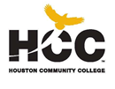

XXXX COLLEGE
INRW 0410 Integrated Reading and Writing I
CRN – Term XXXX
3 hour lecture/ 2 hour lab / 80 hours per semester/ 16/12/F8A/F8B/5 weeks
Class Time: XXXXXXXXXXX

Acknowledgment of Syllabus
I read, understood, and agreed to the policies and requirements stated in the course syllabus provided by Professor XXXXXX. I understand that I am responsible for reading the syllabus and for asking my instructor to clarify any information on the syllabus that I do not understand. I also understand that the syllabus and calendar of assignments and/or tests may change, and that I will be informed of any changes.

Student Name: Date:

Student Signature: Student ID

