My Secret Pepsi Plot
By Boris Fishman
- July 25, 2014

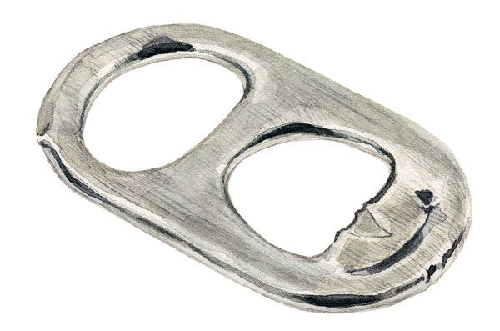
Credit...Illustration by Melinda Josie

In 1988, when my family declared its desire to emigrate, our homeland imposed a brutal discouragement: No person could leave with more than several hundred dollars’ worth of possessions on hand. (What would you take? My mother tried to bring her wedding ring, but it was seized at customs.)
In the Soviet Union, we were secretly wealthy, but we arrived in Brooklyn as paupers. We patrolled curbsides, washed floors for $3 an hour and reused paper towels. I was 10 years old, and I helped how I could. It’s an old story for immigrant kids: You learn English faster than the adults, becoming their ambassador in this new world. You argue with Nynex over the 10-cent discrepancy on the telephone bill and with the grocery clerk over how the potatoes are rung up; joy is when you manage to ease the anxiety on the faces of people who, until now, were the ones you looked to for reassurance and calm. You wish you were old enough to earn real money instead.
I don’t remember how 24 Pepsi-Colas ended up in our fridge. I can’t imagine the adults springing for such an indulgence. There must have been a sale. Then again, our first Pepsi, in transit to America, had been dizzying — that aristocratically minimalist little can, with its sine wave of a logo, was finally in my hands. How lightheaded I was after gulping the bubbles too quickly. (But memory misleads: It was my first Pepsi, the indulgence sprung only for me.)
Around this time I learned that American supermarkets gave back 5 cents for every returned empty. (Some states, like Michigan, its very name like a granite monument, gave you 10 cents.) I decided I would return those cans and give the money to my parents. My secret — a surprise. The problem: No one else in the family would touch them. The indulgence remained for the child.

Boris FishmanCredit...Rob Liguori

That week, I drank Pepsi. After school, with dinner, before bed. When I woke up bleary and jangled, was it from the soda or my anticipation of returning them to Super Duper, the market on 20th Avenue? (We were at once confused and delighted by its name, so exquisitely frivolous compared with the Soviet anonymity of “Grocery Store.”) I came to hate Pepsi. No matter how much I drank, there seemed to be more. Surreptitiously, I poured one down the drain. But the longed-for day came. Twenty-four empties.
On Saturday afternoon, with my parents out and my grandmother resting, I washed each can as if it were a newborn — water, soap, swish, repeat. I didn’t know how stringent the checking at the supermarket would be, so I would give the inspectors no excuse to turn me away. I washed, dried (Mom’s hair dryer) and restacked the cans as if I were handling diamonds. But when I wedged my nose into a couple of the openings, I couldn’t help catching a whiff of the Ivory soap that — fool! — I had used; it was the cheapest, and it smelled that way too. Now Super Duper would never accept them!
The apartment ticking with a sunny weekend afternoon’s silence, I crept into my parents’ bedroom, where, on a lacquered bureau, my mother kept her one indulgence: a bottle of Climat perfume from Paris. I tiptoed back into the hallway to make sure Grandmother was still sleeping. Then I sprayed the Climat 24 times into 24 washed-and-blow-dried Pepsi cans.
My heart beat so fast when I stole out of the apartment, Grandmother snoring lightly, that I don’t remember the walk to the supermarket. I do remember the lines — the Italian mothers of Bensonhurst were shopping for the week. But the kid among them got his turn. I gazed at the cashier with helplessness and pre-emptive resentment. Please, I thought. Please. She rang up my cans with all the ceremony of, well, a bottle return and handed me a dollar and four nickels. I don’t think she looked at me once. I stood there, vibrating slightly.

It would be some time before I learned that the bottle deposit is factored into the original cost of the bottle. I was merely reimbursing my parents for something already due to them. But that afternoon, returning from the store, my feet didn’t feel the pavement. At home, Grandmother was waking to a missing 10-year-old; somewhere in the neighborhood, the other adults were going curbside to curbside to check for loot; and I was running toward them with their ransom burning a fire in my pocket.
Boris Fishman is the author of “A Replacement Life,” a novel.
email submissions for Lives to lives@nytimes.com. Because of the volume of email, the magazine cannot respond to every submission. Share comments on this essay at nytimes.com/magazine.
A version of this article appears in print on July 27, 2014, Page 50 of the Sunday Magazine with the headline: The Empties. Order Reprints | Today’s Paper | Subscribe

