

Chemistry 2423
Exam 3A

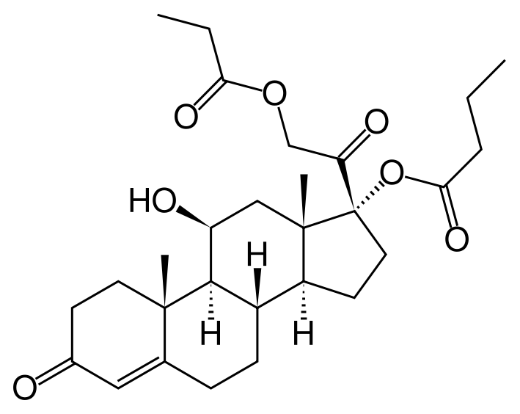

Hydrocortisone- Used as an antagonist in the treatment of allergies and
inflammation

CHEM 2423 EXAM # 3A (Chapters 8-11) \
Dr. Pahlavan

PART I- Multiple Choice (3 points each)

____ 1. Compounds contain two or more chiral centers, but are achiral overall, are called:

A. enantiomers compounds B. meso compounds
C. diastereomers D. reference compound

____ 2. How many chiral centers does the following compound have?

CH₃ – CHBr – CHCl – CH₂ – CH₃

A. 1 B. 2 C. 3 D. 4

____ 3. Consider the following structures, identify the type of isomers.

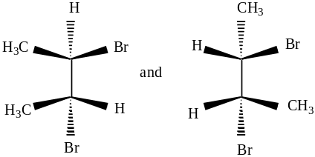

A. identical B. Constitutional isomers C. diastereoisomers D. enantiomers

____ 4. What is the correct absolute configuration for the following compouds?
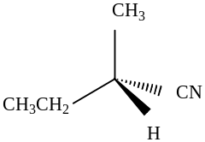

A. R B. S C. achiral D. cannot be determined

____ 5. The (+) enanthiomer of a compound has an observed optical rotation of 1.75 degrees
when measure in a one dm tube at a concentration of 0.3 g/ 15 ml. What is thespecific rotation ,
[α], of the molecule?

A. 30 º B. 45 º C. 87.5º D. 1.75 º

____ 6. Which of the following reagents would be used to complete the following reaction?

CH₃ – CH₂ – CH₂ – C ≡ C - H à CH₃ – CH₂ – CH₂ – CH₂ – CHO

A. 1. BH₃,THF 2. H₂O₂, NaOH , H₂O B. HgSO₄, H₂SO₄, H₂O
C. KMnO₄ / H₃O⁺ D. none of these

____ 7. What is the correct configuration for the following compound ?
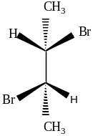
A. (2R,3S) B. (2S,3S) C. (2R,3R) D. (2S,3R)

____ 8. Identify the correct order of the following reaction mechanisms as S_{N}1, S_{N}2, E1, or E2

I. CH₃CH₂Br + H₂O → CH₃CH₂OH + HBr
II. Rate = k[RX] for this elimination reaction
III. Using Nu– = Cl – or I – does not affect the rate of this substitution reaction
IV.
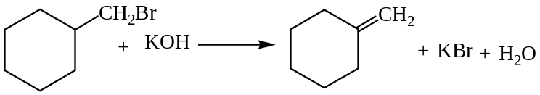
V. Results in inversion of configuration

A. S_{N}2, E2, S_{N}2, E1, S_{N}1 B. S_{N}2, E1, S_{N}1, E2, S_{N}2
C. S_{N}1, E2, S_{N}1, E1, S_{N}2 D. S_{N}1, E1, S_{N}2, E2, S_{N}1

____ 9. The transformation is ____________________.
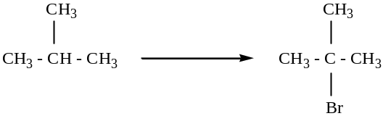
A. an oxidation B. a reduction
C. neither an oxidation nor reduction D. cannot be determined

____ 10. How many allylic hydrogens does the following compound have?

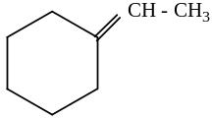
A. 3 B. 4 C. 6 D. 7

____ 11. Oxidation of a terminal alkyne with either O₃ or acidic KMnO₄ will yield
__________________________.

A. one mole of a carboxylic acid B. one mole of carbon dioxide
C. both A and B D. two moles of carboxylic acids

____ 12. What is the order of increasing oxidation level of the following compounds? (least oxidized to more
oxidized)

A. I < II < III < IV B. II < IV < III < I C. IV < III < II < I D. III < I < IV < II
____ 13. What is the relationship between the following compounds?

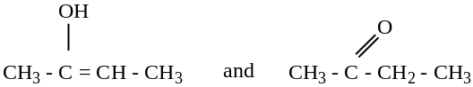

A. tautomers B. enantiomers C. diastereomers D. identical
____ 14. Which one of the following is a tertiary alkyl halide?

A. 1-chloro-2-methylpentane B. 2-chloro-2-methylpentane
C. 2-chloro-3-methylpentane D. 1-chloropentane

____ 15. Alkyl halides undergo elimination of HX, dehydrohalogenation, on treatment with a _______ .

A. strong base B. weak base C. strong acid D. weak acid

____ 16. A compound that possesses an internal plane of symmetry (where one half of the molecule is the
mirror image of the other half of the molecule) is __________.

A. enantiomeric B. achiral C. optically active D. chiral

____ 17. The organometallic reagent R – Mg – X is called a

A. Gilman reagent B. Simons-Smith reagent C. Grignard reagent D. Ficher reagent

____ 18. How many stereoisomers does the following compound has?
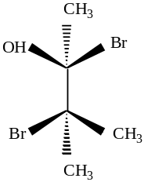

A. 1 B. 2 C. 4 D. 0

____ 19. Which of the following represents vinylic carbocation?
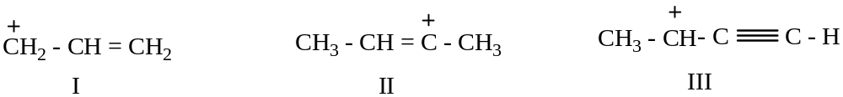

A. I only B. I and II C. I and III D. II only

____ 20. What is the final product of the following reaction?
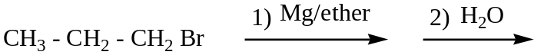

A. CH₃ – CH₂ – CH₂OH B. CH₃ – CH₂ – CH₃

C. CH₃ – CH₂ – CH₂ Mg Br D. CH₃ – CH = CH₂
PART II- Show your work

21. Naming and Structures ( 8 points)
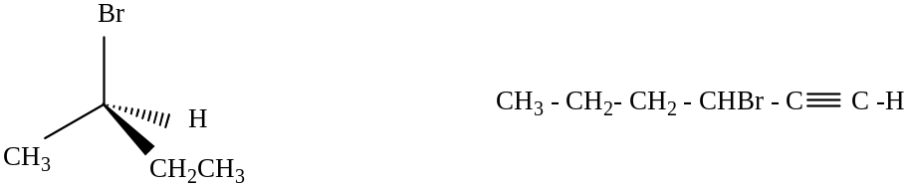

_______________________________ __________________________________

Cis- 1-bromo-3- isopropylcyclohexane 4-chloro-2-hexyne

22. Propose a mechanism to account for the following reaction. Please show the structures of
the intermediates and using curved arrows to indicate electron flow in each step.
(Rearrangement may occur)(2points)

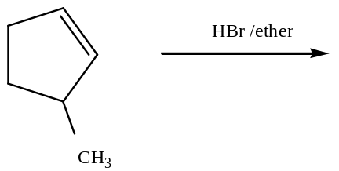

23. Complete the following reactions. (20 points)

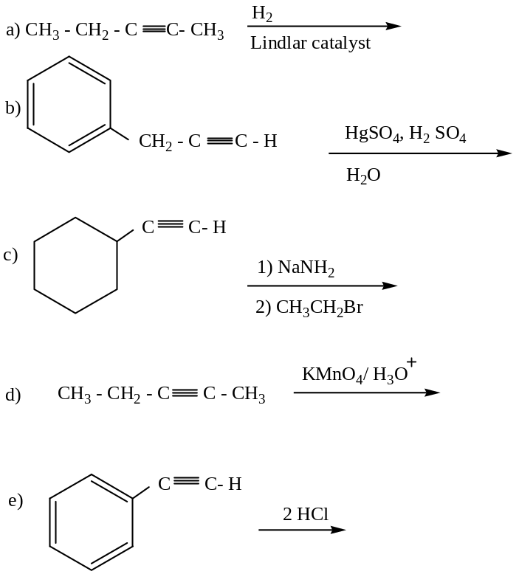

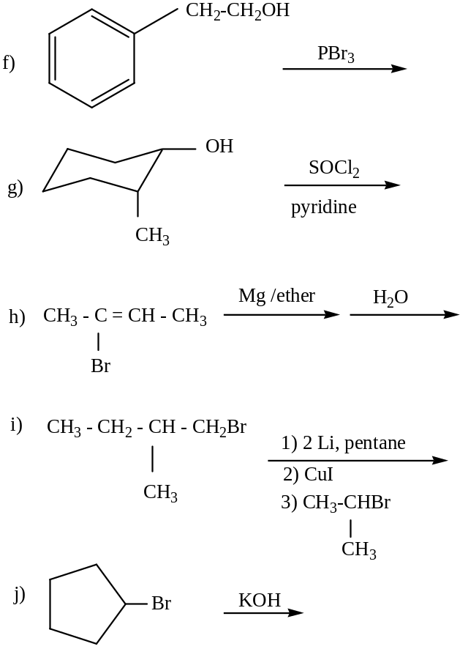
24. Show by a series of reactions how could you prepare the following compounds from the
indicated starting compound. Be sure to clearly indicate the reagents used in each step. ( 10 points)
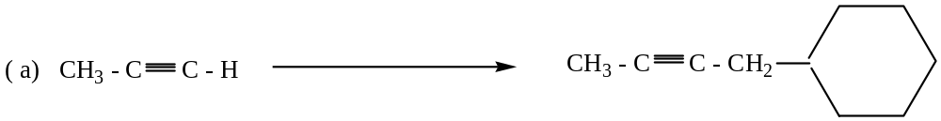

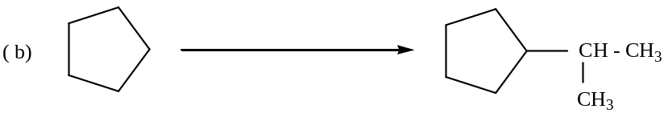

BONUS Question(10 points)- Show all your work. (Do only one of these a or b)

a) Draw one enantiomer, and one diastereomer of the following compound.

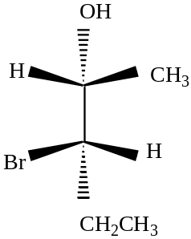

b) Given The MS spectrum for a compound with only one oxygen, C_{x}H_{y}O , answer the
following questions.
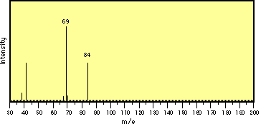

  - Determine the position of parent peak and base peak.

  - Determine the possible structure of the compound.

  - What fragment has the highest intensity?

ORGANIC CHEM 2423 EXAM #3A (Answers)

PART I- Multiple Choice (3 points each)

1. B 2. B 3. D 4. B 5. C 6. A 7. B
8. B 9. A 10. D 11. C 12. B 13.A 14.B
15. A 16.B 17.C 18. B 19. D 20. B

PART II- Show youe work (8 points)

21.
(R) – 2- bromobutane 3 – Bromo – 1- hexyne

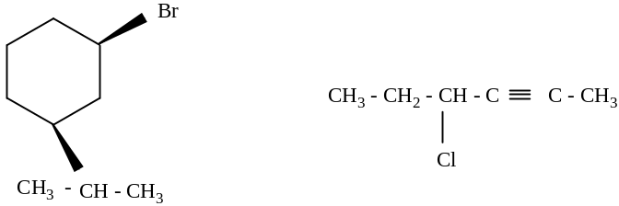
22.

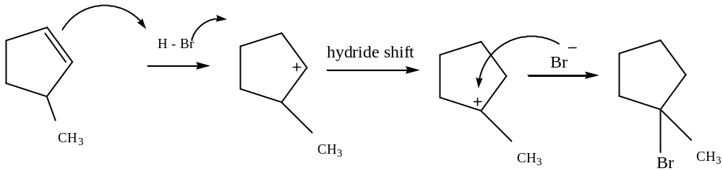
23.
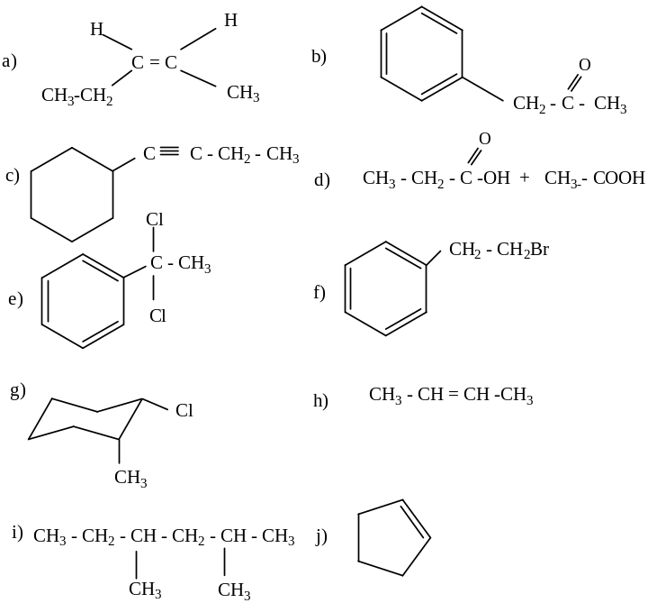

24.
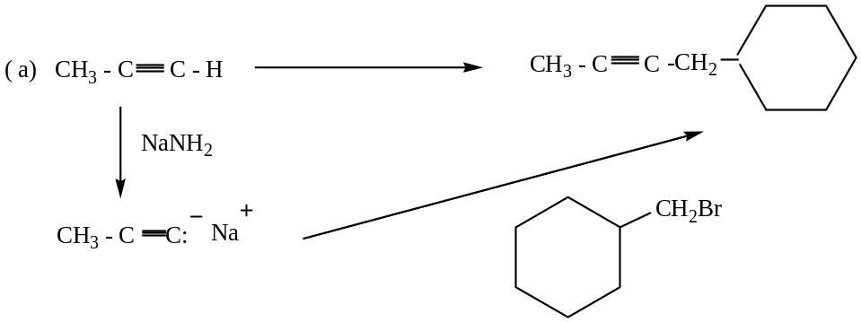

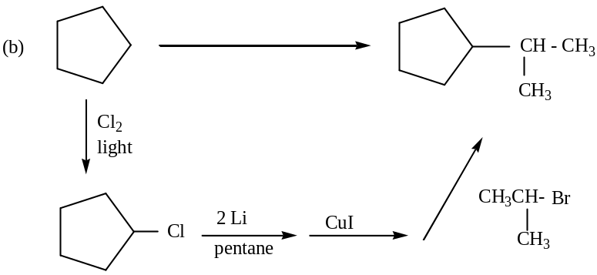

Bonus Question (10 points) – Show all your work.

a)
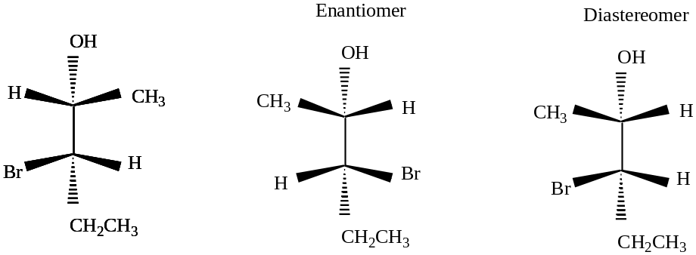

b) parent peak , m/e = 84 base peak , m/e = 69

C₅H₈O , D.U. = (5) – (8/2) +1 = 2 (two double bond) or one triple bond

Structure:
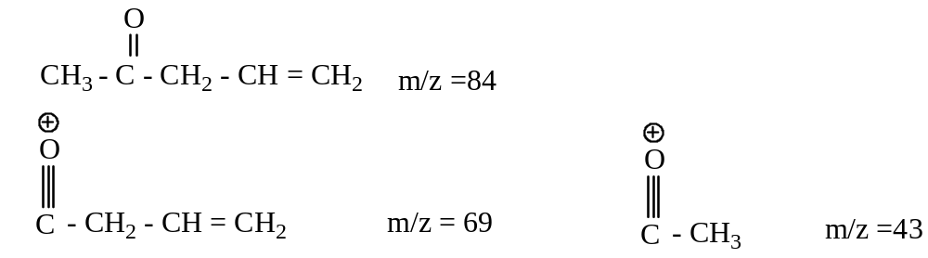

Chemistry 2423

Exam 3B

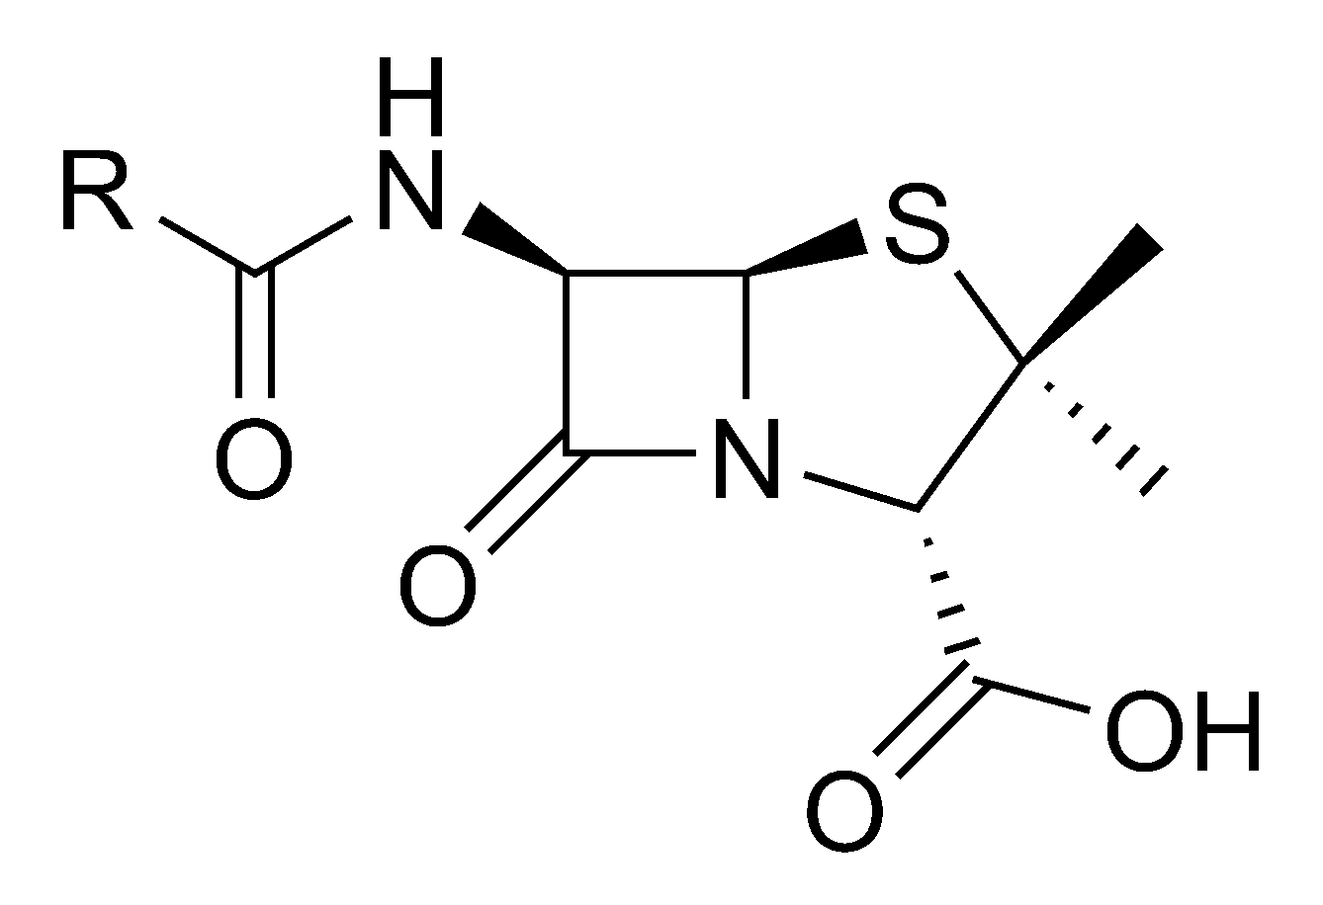

Benzylpenicillin- is a group of Beta-lactam antibiotics used in the treatment of bacterial infections
caused by susceptible, usually Gram-positive, organisms.

CHEM 2423 EXAM # 3B (Chapters 8-11) \
Dr. Pahlavan

DIRECTIONS- Please answer all questions in the space provided as completely and clearly as possible . Show all your work for the writing portions of the exam.
PART I- Multiple Choice (3 points each)

____1. Which of the following bromoalkanes is secondary alkylhalide?

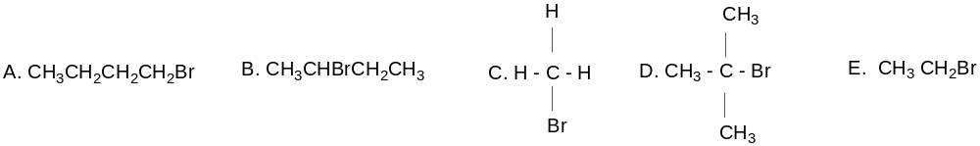

____2. Which statement most correctly describes the rate determining step (stable intermediate carbocation) in
the reaction below?
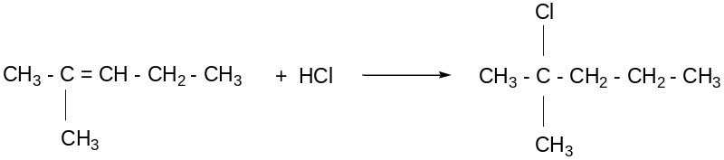

A. Formation of a 3º carbocation B. Formation of 2º carbocation
C. Formation of 3º radical D. Rearrangement of a 2º to 3º carbocation
E. Addition of Cl⁻ to a carbocation

____3. 1-Butyne (shown below) contains which of the following hybridized orbitals?
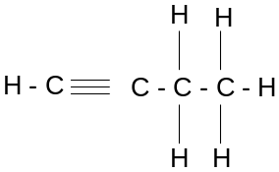

A. sp³ only B. sp, sp², and sp³ C. sp and sp³ D. sp only E. sp² and sp³

____4. What is the product of the following reaction?

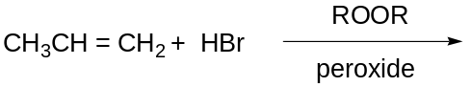

____5. How many sigma (δ ) and pi (π )bonds are found in ethyne?

A. 2 δ , 2 π B. 3 δ , 2 π C. 1 δ , 2 π D. 4 δ , 1 π D. 1 δ , 1 π

____6. Which of the following best describes the relationship between these two compounds?
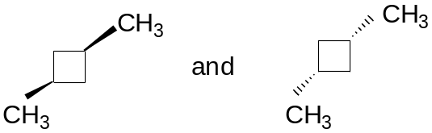

A. Structural isomers B. Enantimers C. Diastereomers
D. Identical compounds E. Meso compounds

____ 7. According to the Cahn-Ingold-Prelog convention, what is the correct designation of the follown
stereoisomers?
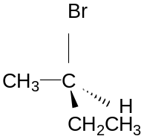

A. (S) B. ( R) C. (R,S) D. (Z) E. Meso

____ 8. Which one of the following compounds below is chiral?

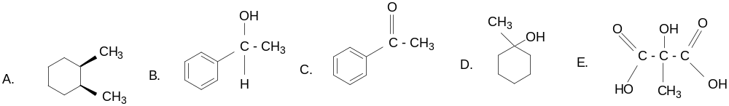

____ 9. What is the correct IUPAC name of the following compound?
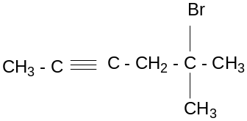

A. 5-Bromo-2-heptyne B. 3-Bromo-5-heptyne
C. 2-Bromo-2-methyl-4-hexyne D. 5-Bromo-5,5-dimethylhexyne
E. 5-Bromo-5-methyl-2-hexyne

____10. Which of the alkyne addition reactions below involves an enol intermediate?

A. hydroboration/oxidation B. treatment with HgSO₄ in dilute H₂ SO₄
C. hydrogenation D. hydrohalogenation
E. both A and B

____11. The reagent needed to convert 2-butyne to trans-2-butene is _______________.

A. H₂/Pt B. H₂/ Lindlar’s catalyst C. Li/NH₃ D. Na/NH₃ E. both C and D

____ 12. Which of the following compounds is NOT super-imposable on its mirror image?

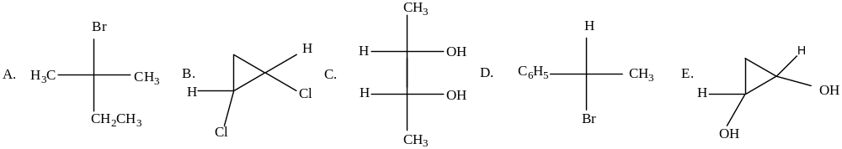

____13. What is the product of the following reaction?

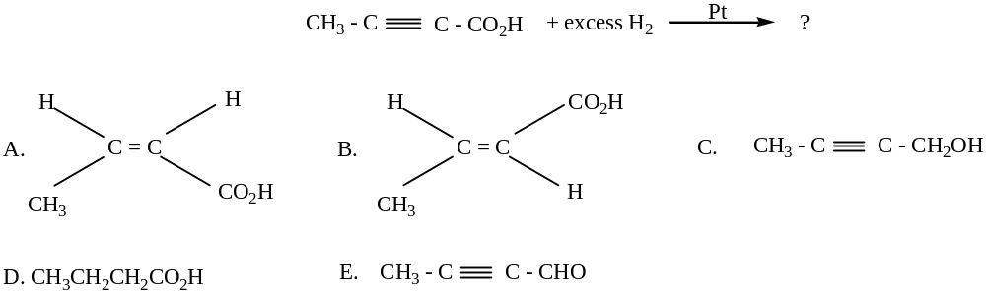

____14. The structure
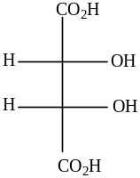

A. has two chiral and is optically active B. rotates polarized light counterclockwise
C. rotates polarized light clockwise D. has no chiral carbons
E. has a plane of symmetry and is optically inactive

____15. Which of the following represents the intermediate formed in the reaction below?

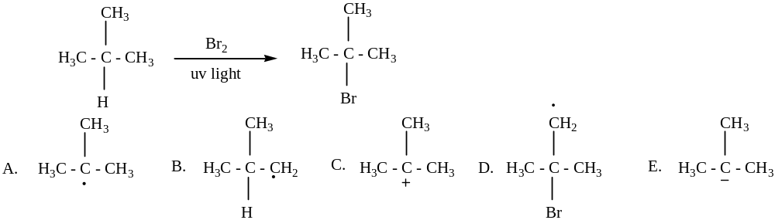
____16. What is the principle organic product of this reaction sequence?

____17. What is the major product of the following reaction?

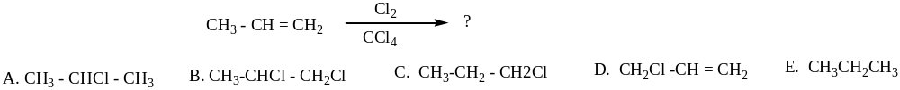

____18. Which of the following compound consider to be chiral?

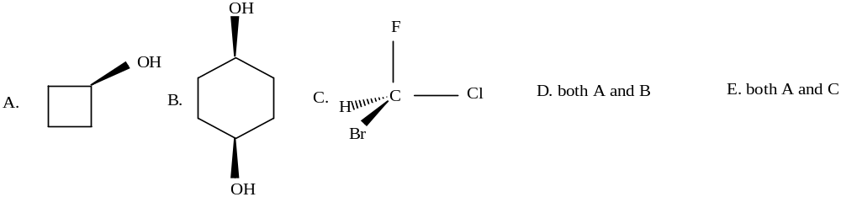

____19. A newly isolated natural product was shown to be optically active. If a solution of 2.0 g in 10 ml of
ethanol in a 50 cm tube gives a rotation of +2.57º, what is the specific rotation of this natural
product?

A. -2.57 º B. +0.257 º C. +2.57 º D. +0.0257 º E. none of these

____20. A mixtur of equal amounts of two enantiomers are _____________________.

A. is called racemic mixture B. is optically inactive
C. implies that the enantiomers are meso forms D. both A and B D. none of these

PART II – Show your work

16. Naming and structures ( 3 points each)

- Give IUPAC names for the following compounds
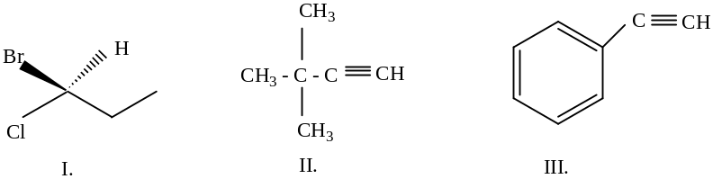

I. _______________________________________ II. _______________________________________

III. ______________________________________

- Draw structures corresponding to the following systematic names;

(R ) – 2- chlorobutane 2,5,5-trimethyl-3-heptyne

17. ( 5 points) Show by a series of reactions how could you prepare the following compounds from the
indicated starting compound. Be sure to clearly indicate the reagents used in each step.
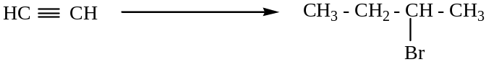

18. ( 5 points) Propose a mechanism to account for the following reaction. Please show the structures of
the intermediates and using curved arrows to indicate electron flow in each step.
(Rearrangement may occur)

19. (5 points) Give an example for the followings;

I. an enol II. a tertiary alkyl halide

III. a terminal alkyne IV. a chiral compound

V. a meso compound

20. Predict the major product in each of the following reactions. (2 points each)

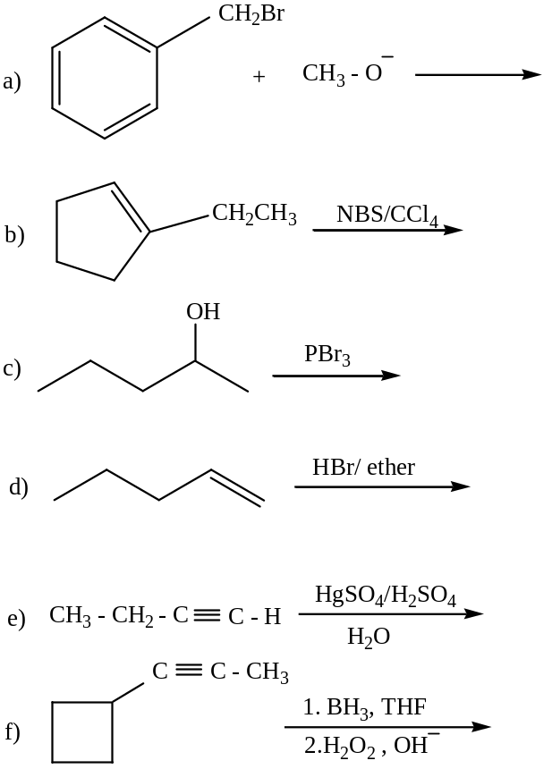

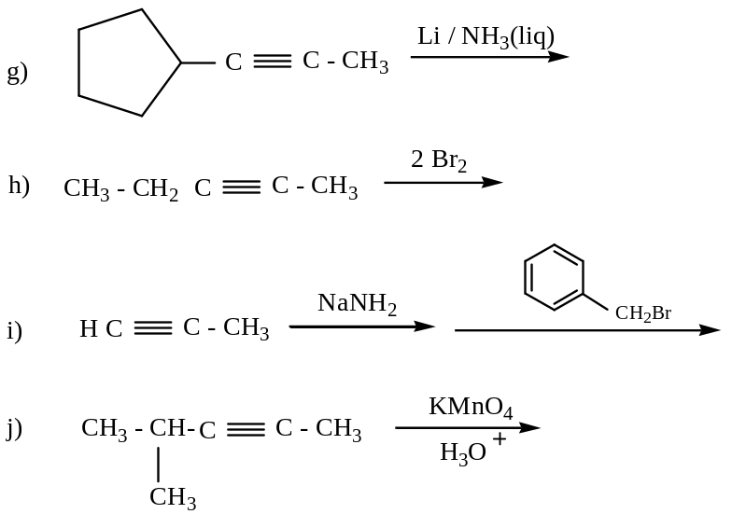

Bonus Question ( 10 points) – Please show all your work for complete credit.

a) Complete the following tree of reactions by giving the major products. Identify structures for compounds
A, B ,C, D, and E.
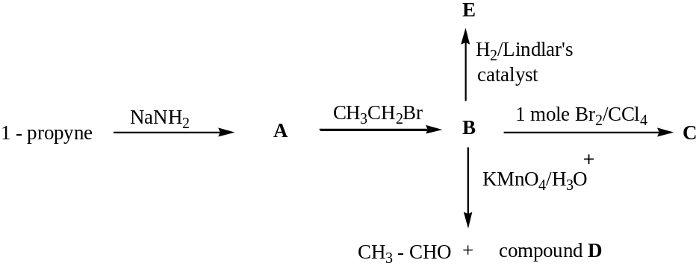

b) Given The MS spectrum for a compound with only one oxygen, C_{x}H_{y}O₂ , answer the following
questions.

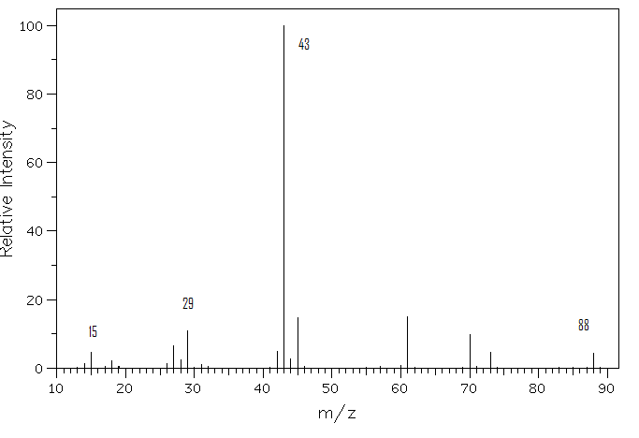

- Determine the position of parent peak and base peak.

- Determine the possible structure of the compound.

- What fragment has the highest intensity?

ORGANIC CHEM 2423 EXAM #3B (Answers)

1. B 2. A 3. C 4. A 5. B 6. D 7. B 8. B 9. E 10. E 11. E
12. D 13.D 14. E 15. A 16. A 17. B 18. C 19. C 20.D

16. a) I. (S) –1-Bromo-1-chloropropane
- 3,3-dimethyl-1-butyne or t-butyl acetylene2-Ethyl-1-pentene
- phenyl acetylene or ethynyl benzene
b)
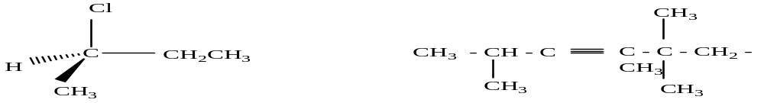
17.
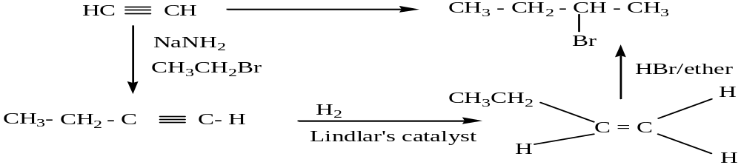
18.
19. Student answers varies
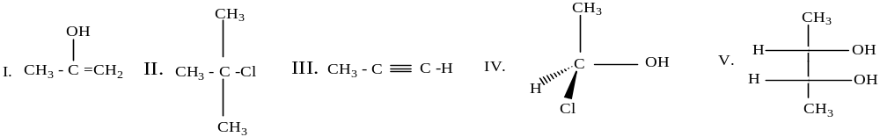
20.
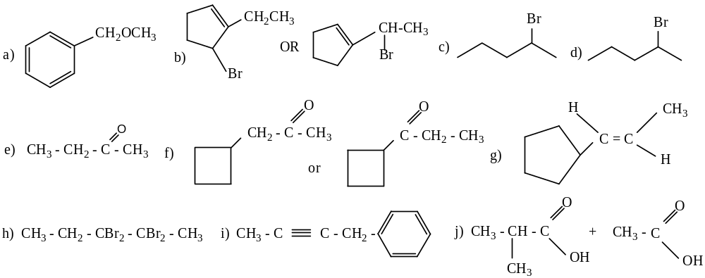

Bonus Question

a)
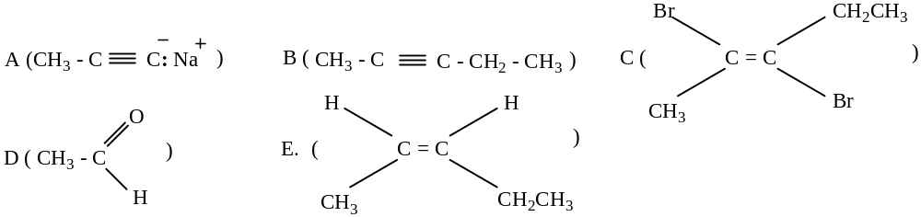

b) parent peak , m/e = 84 base peak , m/e = 43

DU = (4) – (8/2) +1 = 1 db (C=O)
Fragments appear due to bond cleavage next to C=O (alkyl loss, .OCH₂CH₃ = 45 and CH₃CO⁺ = 43) and
hydrogen rearrangements.

Structure: C₄H₈O₂, MW = 88.11, Ester - Ethyl acetate


