Division of College Readiness
Academic Student Success Department

EDUC 1300: Learning Framework | Lecture | #11970 & 11973
Fall 2018 | 16 Weeks (8/27/2018-12/16/2018)
In-Person | Northline - Room223 | Fri 8:00-10:50 a.m.
3 Credit Hours | 48 hours per semester

Instructor Contact Information

Instructor: Robin Raborn, MEd Office Phone: 713-718-2823
Office: Northline, Room 310 Office Hours: TR 9:30-11 / F 11:00-12
HCC Email: robin.raborn@hccs.edu or by appoinmtent

Please feel free to contact me concerning any problems that you are experiencing in this course. Your performance in my class is very important to me. I am available to hear your concerns and just to discuss course topics.

Instructor’s Preferred Method of Contact

Please use HCC email to contact me. I will respond to emails within 24-48 hours Monday through Friday; I will reply to weekend messages on Monday mornings. If you call my phone, please leave a message and it will go to my email.

What’s Exciting About This Course

This course is about you! Through research and experience, Houston Community College has determined that many life and career management skills are necessary for students to make the most of their college investment. A student success course is designed to prepare students for the demands of college and for success in the world of work. This course emphasizes setting priorities, time management, note-taking, learning/concentration techniques, retention of information, book analysis, comprehension techniques, and test-taking skills. This course also incorporates modules that are designed to facilitate the use of library databases in conducting research, career exploration, planning and setting educational objectives, lifelong career assessment, decision-making, financial aid, financial planning, tutoring, and student support services enabling the student to maximize the use of college resources.

My Personal Welcome

Welcome to EDUC 1300: Learning Framework! It is my distinct pleasure to be your instructor this semester. This course will provide you with the tools to help you be successful in college and after. Take this course seriously because it could be one of the most important courses you take throughout your collegiate career. One of my goals this semester is to help you feel confident as you embark upon the rest of your studies. I will guide you, cheer for you, coach you, and hold you accountable. This class, as well as your other courses, will require time management, dedication, and motivation. You are capable of completing this course successfully, and it is my greatest desire that you do. Please work hard to avoid falling behind, keep up with the due dates, complete your assignments as they are assigned, and always know that you can ask me for help. I look forward to working with you this semester.

Prerequisites and/or Co-Requisites

The only requirements for this course are that you have taken the TSI Assessment. You are not required to achieve any specific scores. This is a college level course, and you will be required to read and submit college level work. Please carefully read and consider the repeater policy in the HCCS Student Handbook.

Eagle Online Canvas Learning Management System

Every section of EDUC 1300 uses Eagle Online Canvas (https://eagleonline.hccs.edu) to supplement in-class assignments, exams, and activities. You will be required to submit assignments both online and in class. Please always be aware of the desired form of submission for each assignment and the deadlines. I will also help to be sure you are aware.
HCCS Open Lab locations may be used to access the Internet and Eagle Online Canvas. You may also check-out a Chromebook laptop from your HCCS library if you do not have a computer at home http://library.hccs.edu/chromebooks. It is recommended that you USE FIREFOX OR CHROME AS YOUR BROWSER. Having your technology fail on you at the last minute before an assignment is due, is NOT an excuse for it being late. Be prepared and work ahead.

HCC Online Information and Policies
Here is the link to information about HCC Online classes including the required Online Orientation for all fully online classes: http://www.hccs.edu/online/

Scoring Rubrics, Sample Assignments, etc.
Look in Eagle Online Canvas for the scoring rubrics for assignments, samples of class assignments, and other information to assist you in the course. https://eagleonline.hccs.edu/login/ldap

Instructional Materials

Textbook Information

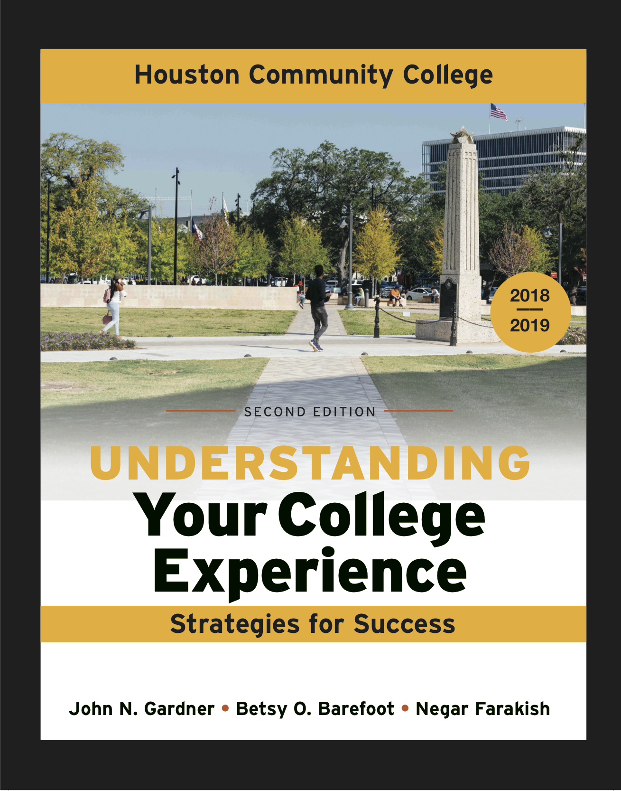 | The textbook for this class is:  Understanding Your College Experience, Strategies for Success 2nd Gardner, Barefoot and Farakish. (2017) Edition. Boston: Bedford/St. Martin’s  The custom textbook for this class may ONLY be purchased at any HCC bookstore, brand new for $54. It is bundled in a package that contains the text as well as a LaunchPad access code you will need to use for this course. Do not throw any items away that are packaged with your textbook. Temporary access to LaunchPad is available for a limited time (up to 21 days) to give students access to the online textbook and LaunchPad activities while they are arranging to obtain their texts and permanent codes. The LaunchPad code for this course is not sold separately online.  HCCS Bookstore: http://hccs.bncollege.com

Temporary Free Access to E-Book

You will be able to register for free temporary access to the textbook and LaunchPad. You can register through your EagleOnline course when the course becomes active on the first day of class.

Other Instructional Resources

LaunchPad
Launchpad is an online learning system that accompanies your textbook. Students will be required to complete weekly assignments within the system. Launchpad assignments will be accessible inside of EagleOnline. A new textbook is required to access Launchpad.

Tutoring
HCC provides free, confidential, and convenient academic support, including writing critiques, to HCC students in an online environment and on campus. Tutoring is provided by HCC personnel in order to ensure that it is contextual and appropriate. Visit the HCC Tutoring Services website for services provided.

Libraries
The HCC Library System consists of 9 libraries and 6 Electronic Resource Centers (ERCs) that are inviting places to study and collaborate on projects. Librarians are available both at the libraries and online to show you how to locate and use the resources you need. The libraries maintain a large selection of electronic resources as well as collections of books, magazines, newspapers, and audiovisual materials. The portal to all libraries’ resources and services is the HCCS library web page at http://library.hccs.edu.

Supplementary Instruction
Supplemental Instruction is an academic enrichment and support program that uses peer-assisted study sessions to improve student retention and success in historically difficult courses. Peer Support is provided by students who have already succeeded in completion of the specified course, and who earned a grade of A or B. Find details at http://www.hccs.edu/resources-for/current-students/supplemental-instruction/.

Course Overview

EDUC 1300 is a study of the research and theory in the psychology of learning, cognition, and motivation; factors that impact learning; and application of learning strategies. Theoretical models of strategic learning, cognition, and motivation serve as the conceptual basis for the introduction of college-level student academic strategies. In addition, the course focuses on numerous college, career, and life management topics necessary for students to make the most of their college investment.

Core Curriculum Objectives (CCOs)

EDUC 1300 is a part of the social and behavioral sciences you will study in the HCCS core curriculum. The HCCS Academic Student Success Program Committee has specified that this course addresses the following core objectives:

- Critical Thinking Skills (CT): students will demonstrate creative thinking, innovation, inquiry, and analysis, evaluation and synthesis of information through researching career and project information, analyzing information, and synthesizing information to create a final product (essay and presentation).
- Communication Skills (COM): students will demonstrate effective development, interpretation and expression of ideas through written, oral and visual communication on various assignments, the career research essay, and by creating and presenting a group project.
- Empirical and Quantitative Skills (EQS): students will demonstrate the manipulation and analysis of numerical data or observable facts resulting in informed conclusions by determining the annual salary needed to maintain a desired standard of living, determining the median salary and job outlook for their career field, comparing the cost of living in Houston to other cities, synthesizing this information and determining if the student will be able to live a comfortable lifestyle in Houston with their proposed salary as well as explaining the conclusions drawn from the analysis.
- Teamwork (TW):students will demonstrate the ability to consider different points of view and to work effectively with others to support a shared purpose or goal throughout the course in various activities, assignments, and the group presentation.
- Social Responsibility(SR): students will demonstrate intercultural competence, knowledge of civic responsibility, and the ability to engage effectively in regional, national, and global communities by considering the skills the student will acquire in training for their proposed field and seeking volunteer organizations or charities to explain how they could use those skills to serve the community.
- Personal Responsibility (PR): students will demonstrate the ability to connect choices, actions and consequences to ethical decision-making through weekly case studies and activities throughout the course.

Program Student Learning Outcomes (PSLOs)

EDUC 1300 is the only course offered by the Academic Student Success program, thus the program student learning outcomes and course student learning outcomes are the same as listed below.

Course Student Learning Outcomes (CSLOs)

Upon completion of EDUC 1300, the student will be able to:

1. Develop and use an academic/personal/professional action plan to include long-term goals, with detailed emphasis on time spent at HCCS.
2. Identify and use strategies to manage your time, energy, finances, and personal responsibilities.
3. Identify and use various services at HCCS.
4. Identify strategies to increase learning, motivation, memory, test-taking abilities, note-taking abilities, and reading comprehension.
5. Learn and practice essential skills of academic, career, and personal success.

Learning Objectives

SLO #1: Develop and use an academic/personal/professional action plan to include long-term goals, with detailed emphasis on time spent at HCCS.
1.1 Create and prioritize short-term and long-term goals related to your academic/personal/professional development at HCCS.
1.2 Use inventories or assessments to identify career interests, values, and abilities.
1.3 Examine various career options and use available resources (e.g. career center, college library, etc.) to research and analyze information pertaining to career options.
1.4 Select an academic/workforce pathway and select a degree plan.
1.5 Construct and use an academic plan to achieve career goals and select classes for subsequent semesters.
1.6 Learn and demonstrate etiquette appropriate for transitioning from college to sustained employment.
1.7 Practice the strategies of collaborative learning and team building.
SLO #2: Identify and use strategies to manage your time, energy, finances, and personal responsibilities.
2.1 Through careful time analysis, determine and practice strategies to manage your time.
2.2 Develop and follow a financial plan to support your academic goals.
2.3 Evaluate and use strategies to balance academic and personal responsibilities.

SLO #3: Identify and use various services at HCCS.
3.1 Discuss your educational/career plans with an advisor or appropriate personnel at HCCS.
3.2 Use HCCS websites and publications (especially the college catalog) to locate pertinent college information.
3.3 Identify and utilize tutoring services provided on-campus or online.
3.4 Identify and utilize campus resources.

SLO #4: Identify strategies to increase learning, motivation, memory, test-taking abilities, note-taking abilities, and reading comprehension.
4.1 Identify personal learning styles and develop effective study skills/learning strategies based on individual results.
4.2 Identify personal strengths and weaknesses to develop successful strategies.
4.3 Apply knowledge of learning to adapt to various classroom environments.
4.4 Attend a library orientation/instruction session to access resources and technologies available on campus and online.
4.5 Practice information literacy skill building by utilizing library sources and technology.
4.6 Participate in experiential learning activities such as those linked to career selection and/or community service.
4.7 Understand and apply strategies to improve memory.
4.8 Learn and use strategies for effective note-taking, reading, and test-taking.
4.9 Understand how grit, growth mindsets, and motivation impact learning.

SLO #5: Learn and practice essential skills of academic, career, and personal success.
5.1 Use oral, written, and visual communication (e.g. PowerPoint) to express oneself effectively.
5.2 Use social networking and electronic communications appropriately as defined by the rules of netiquette.
5.3 Learn what constitutes academic dishonesty and plagiarism.
5.4 Learn and practice critical thinking and problem solving.
5.5 Construct a plan to promote social and personal development (e.g. physical and mental wellness plans, volunteer/service learning, participate in participate in co-curricular activities).

Student Success

Expect to spend at least twice as many hours per week outside of class as you do in class studying the course content. Additional time will be required for written assignments. The assignments provided will help you use your study hours wisely. Successful completion of this course requires a combination of the following:
- Reading the textbook
- Attending class in person and/or online
- Completing assignments
- Participating in class activities
There is no short cut for success in this course; it requires reading (and probably re-reading) and studying the material using the course objectives as your guide.

Instructor and Student Responsibilities

As your Instructor, it is my responsibility to:
- Provide the grading scale and detailed grading formula explaining how student grades are to be derived
- Facilitate an effective learning environment through learner-centered instructional techniques
- Provide a description of any special projects or assignments
- Inform students of policies such as attendance, withdrawal, tardiness, and make up
- Provide the course outline and class calendar which will include a description of any special projects or assignments
- Arrange to meet with individual students before and after class as required

As a student, it is your responsibility to:
- Attend class in person and/or online
- Participate actively by reviewing course material, interacting with classmates, and responding promptly in your communication with me
- Read and comprehend the textbook
- Complete the required assignments and exams
- Ask for help when there is a question or problem
- Keep copies of all paperwork, including this syllabus, handouts, and all assignments
- Attain a raw score of at least 50% on the departmental final exam
- Be aware of and comply with academic honesty policies in the HCCS Student Handbook

Assignments, Exams, and Activities

Written Assignments

Assignments have been developed that will enhance your learning. You will be required to successfully complete these assignments. Please see the Course Calendar for due dates.

Class Assignments (30%)

Assignment 1: HCC Email & Etiquette – Students will send answers to questions about themselves to the instructor, using professional email etiquette.

Assignment 2: Campus Resources Scavenger Hunt—Students will utilize various strategies to identify resources available on campus.

Assignment 3: Goal Setting Assignment – Students will create goals and action steps to guide them throughout their college careers.

Assignment 4: Time Management Assignment - Students will analyze their time to identify areas of improvement and develop a schedule that will allow them to succeed in college.

Assignment 5: Financial Planning Assignment - Students will analyze spending and develop a budget that will allow them to be successful in college.

Assignment 6: Annotating and Note Taking Assignment - Students will apply annotation strategies to a selected reading and utilize strategic note taking methods to gather information.

Assignment 7: In Class-Activities/Attendance - All students will start with 100 points. Five points will be deducted for each absence and partial points will be removed for tardiness, leaving early, or non-participation.

Launchpad Assignments (15%)
Students will access LaunchPad through EagleOnline and will be required to complete weekly assignments within the system.

Career Research Essay (10%) – no late work accepted
Students will conduct research and prepare a Career Research Essay.

Group Presentation (10%) – no late presentations
Students will conduct research and deliver a group presentation over an assigned topic from the course.

Exams
Knowledge checks are given in the form of a midterm exam (15%). No make-up

In-Class Activities

During class you will engage in multiple activities to enhance your understanding. You are expected to participate and to have completed the necessary pre-class activities to adequately participate in all activities.

Final Exam

All students will be required to take a comprehensive departmental final exam (20%) consisting of 50 multiple- choice and true and false questions. Students will be provided with a final exam study guide.

Grading Formula

Grading Percentages:

15% Midterm Exam
20% Final Exam
15% Launchpad Activities
30% Instructor’s Choice Assignments
20% Career Essay and Oral Group Presentation
100%Total

A = 100- 90 4 points per semester hour
B = 89 - 80: 3 points per semester hour
C = 79 - 70: 2 points per semester hour
D = 69 - 60: 1 point per semester hour
F = 59 and below 0 points per semester hour
FX (Failing due to non-attendance) 0 points per semester hour
IP (In Progress) 0 points per semester hour
W(Withdrawn) 0 points per semester hour
I (Incomplete) 0 points per semester hour
AUD (Audit) 0 points per semester hour
IP (In Progress) is given only in certain developmental courses, not this class. The student must re-enroll to receive credit. COM (Completed) is given in non-credit and continuing education courses. To compute grade point average (GPA), divide the total grade points by the total number of semester hours attempted. The grades "IP," "COM" and "I" do not affect GPA.

HCC Grading Scale can be found on this site under Academic Information:
http://www.hccs.edu/resources-for/current-students/student-handbook/

Course Calendar

Fall 2018
* Subject to Change
*All Launchpad Assignments are due weekly on Sunday nights.
Week  Number | Lecture Topic & Activities | Reference Chapters | Assignment Due Dates
1 | Introduction to the course  HCC Webpages & resources  Chapter 1 | EagleOnline  Pgs. 4-9 & 13-26 | HW#1 Email - Due: 9/7  HW#2 Resources Scavenger Hunt - Due: 9/7
2 | Launch Pad, Career Coach & OOH  Chapter 1 (cont.)  Chapter 12 | Lab  Pgs. 10-12  Pgs. 278-282 & 287-288 | HW#3 Goal Setting  Due: 9/21  LaunchPad: 1 Due: 9/9
3 | Chapter 9  Chapter 4 | Pgs. 199-213  Pgs. 78-101 & 276-277 | Career Essay- Due: 10/27  Launch Pad- 9 Due: 9/16
4 | Chapter 4 (cont.)  Chapter 3 | Pgs. 48-76 | HW#4 Time Management Due: 10/12  LaunchPad – 4 Due: 9/23
5 | Chapter 3 (cont.)  Chapter 5 | Pgs. 106-126 | HW#5 Financial Planning  Due: 11/9  LaunchPad – 3 Due: 9/30
6 | Library Orientation  Chapter 5 (cont.) |  | LaunchPad – 5 Due: 10/7
7 | Chapter 6 | Pgs. 128-152 | HW#6 Annotating & Note Taking - Due: 11/30  LauchPad – 6 Due: 10/14
8 | Chapter 8  Midterm Exam | Pgs. 172-196  Chapters 1, 3, 4, 5, & 6 (partial 9 & 12) | LaunchPad – 8 Due 10/21
9 | Lab Day (APA format) – Papers due at end of class  No late work accepted!  Chapter 7 | Pgs. 154-170
10 | Chapter 7 (cont.)  Assign groups for presentation  Chapter 2 | Pgs. 28-46 | Group Presentation  Due: 12/4  LaunchPad – 7 Due 11/4  Last day to Withdraw  11/2
11 | Chapter 2 (cont.)  Chapter 9 (Power Point Guidelines) | Pgs. 214-215 | LaunchPad – 2 Due 11/11
12 |  |  | Thanksgiving Holiday – 11/23
13 | Chapter 10  Chapter 11 | Pgs. 224-240  Pgs. 242-270 | LaunchPad – 10 & 11 Due 11/25
14 | Chapter 12 | Pgs. 282-292 | LaunchPad -12 Due 12/2
15 | Group Presentations (12/4) – No late work  Wrap up anything leftover and Review for final exam.
16 | Final Exam | Chapters 1-12 | 12/14 Final exam

Syllabus Modifications
The instructor reserves the right to modify the syllabus at any time during the semester and will promptly notify students in writing, typically by e-mail, of any such changes.

Instructor’s Practices and Procedures

Missed Assignments
Learning to turn in assignments on time is an important skill for success in other courses. I do not allow late work for your Career Essay and Presentation. However, I do allow late work for your 6 Homework assignments. There will be 10 points deducted for each class period it is late, so try your best to get it done on time. A low grade is ALWAYS better than a zero. I do not allow make-up exams unless there is an extreme circumstance and you have documentation for me.

Academic Integrity

Here’s the link to the HCC information about academic integrity (Scholastic Dishonesty and Violation of Academic Scholastic Dishonesty and Grievance):
http://www.hccs.edu/about-hcc/procedures/student-rights-policies--procedures/student-procedures/

Attendance Procedures
It is imperative that you attend class in order to be successful. You are expected to attend all scheduled classes. Although it is your responsibility to drop a course for nonattendance, the instructor has the authority to drop you for excessive absences. You may be dropped from a course prior to the college drop deadline (see academic calendar) once you accumulate absences in excess of 12.5 percent of the total hours of instruction (lecture and lab). For a 3 credit hour lecture class meeting 3 hours per week like this one (48 hours of instruction), you can be dropped after 6 hours of absence (after missing more than 3 classes). The 6 hours includes accumulated minutes for arriving late to class and leaving class early and lab time missed. In an online class, the equivalent would be failing to turn in assignments for two weeks.

Student Conduct
Students are expected to maintain a cooperative and collaborative learning environment. Disrespect of others and unnecessary distractions in the learning environment will not be tolerated.

Electronic Devices
It is everyone’s responsibility to monitor the use of electronic devices in a respectful manner. Devices that prove to be distracting will not be permitted. Please turn off ring-tones, do not pull out phones during class, and take emergency calls out in hallway.

HCC Policies
Here’s the link to the HCC Student Handbook http://www.hccs.edu/resources-for/current-students/student-handbook/ In it you will find information about the following:

Academic Information | Incomplete Grades
Academic Support | International Student Services
Attendance, Repeating Courses, and Withdrawal | Health Awareness
Career Planning and Job Search | Libraries/Bookstore
Childcare | Police Services & Campus Safety
disAbility Support Services | Student Life at HCC
Electronic Devices | Student Rights and Responsibilities
Equal Educational Opportunity | Student Services
Financial Aid TV (FATV) | Testing
General Student Complaints | Transfer Planning
Grade of FX | Veteran Services

EGLS³
The EGLS³ (Evaluation for Greater Learning Student Survey System) will be available for most courses near the end of the term until finals start. This brief survey will give invaluable information to your faculty about their teaching. Results are anonymous and will be available to faculty and division chairs after the end of the term. EGLS³ surveys are only available for the Fall and Spring semesters. EGLS3 surveys are not offered during the Summer semester due to logistical constraints.
http://www.hccs.edu/resources-for/current-students/egls3-evaluate-your-professors/

Campus Carry Link
Here’s the link to the HCC information about Campus Carry: http://www.hccs.edu/departments/police/campus-carry/

HCC Email Policy
When communicating via email, HCC requires students to communicate only through the HCC email system to protect your privacy. If you have not activated your HCC student email account, you can go to HCC Eagle ID and activate it now. You may also use Canvas Inbox to communicate.

Housing and Food Assistance for Students
Any student who faces challenges securing their foods or housing and believes this may affect their performance in the course is urged to contact the Dean of Students at their college for support. Furthermore, please notify the professor if you are comfortable in doing so.

This will enable HCC to provide any resources that HCC may possess.

Office of Institutional Equity

Use the link below to access the HCC Office of Institutional Equity, Inclusion, and Engagement (http://www.hccs.edu/departments/institutional-equity/)

disAbility Services
HCC strives to make all learning experiences as accessible as possible. If you anticipate or experience academic barriers based on your disability (including mental health, chronic or temporary medical conditions), please meet with a campus Abilities Counselor as soon as possible in order to establish reasonable accommodations. Reasonable accommodations are established through an interactive process between you, your instructor(s) and Ability Services. It is the policy and practice of HCC to create inclusive and accessible learning environments consistent with federal and state law. For more information, please go to http://www.hccs.edu/support-services/disability-services/

Title IX
Houston Community College is committed to cultivating an environment free from inappropriate conduct of a sexual or gender-based nature including sex discrimination, sexual assault, sexual harassment, and sexual violence. Sex discrimination includes all forms of sexual and gender-based misconduct and violates an individual’s fundamental rights and personal dignity. Title IX prohibits discrimination on the basis of sex-including pregnancy and parental status in educational programs and activities. If you require an accommodation due to pregnancy please contact an Abilities Services Counselor. The Director of EEO/Compliance is designated as the Title IX Coordinator and Section 504 Coordinator. All inquiries concerning HCC policies, compliance with applicable laws, statutes, and regulations (such as Title VI, Title IX, and Section 504), and complaints may be directed to:

David Cross
Director EEO/Compliance
Office of Institutional Equity & Diversity
3100 Main
(713) 718-8271
Houston, TX 77266-7517 or Institutional.Equity@hccs.edu
http://www.hccs.edu/departments/institutional-equity/title-ix-know-your-rights/

Department Chair Contact Information
Dr. Pamela Bilton Beard, Pamela.Biltonbeard@hccs.edu, 713.718.5567

