Directions for signing up for QuizStar

Go to the following website: http://quizstar.4teachers.org/indexs.jsp

- Click on “Sign Up”
- Fill out the Student Registration Information…this includes creating a password that is unique to you. Please be sure to remember to write down the password so you will not forget it.
- Click “Register”
- Select “Click here to search a new class”
- Under tab that says “Class Search”, use the drop down menu and select teacher’s name…type in Hinchen-Bryan and then Keyword search.
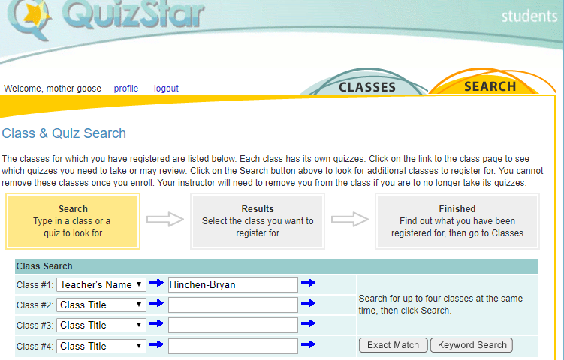

- Check the box for your class and then select “Register”.

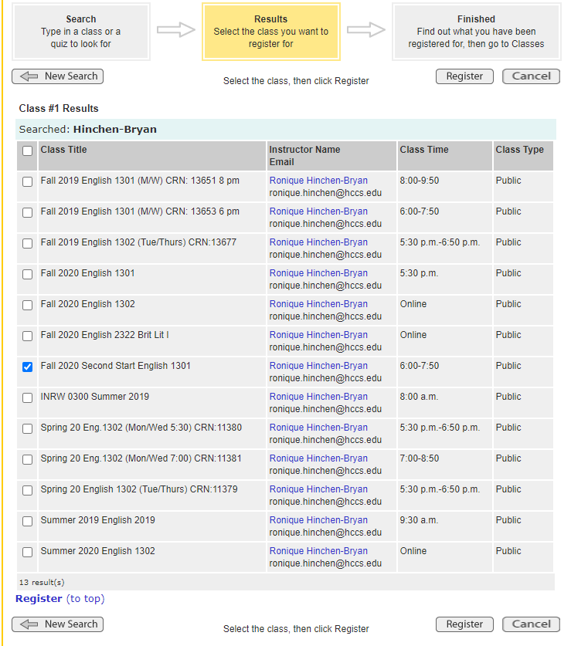

- It should then say:

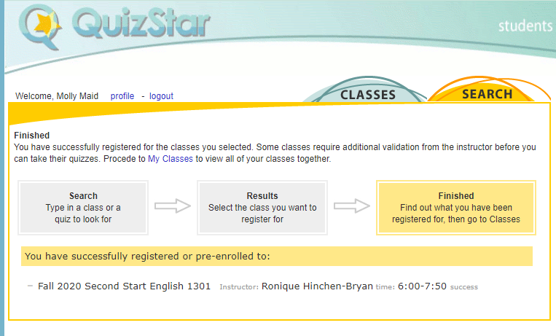

Or whatever class you are enrolled in….Log OUT

