Division of Earth, Life & Natural Sciences

Biology Department
https://www.hccs.edu/programs/areas-of-study/science-technology-engineering--math/biology/

BIOL. 2101: Anatomy And Physiology 1 | Lab | 22770
Fall 2020 | 15 Weeks
Monday 11-1:50PM
1 Credit Hour | 48 hours per semester

Instructor Contact Information

Instructor: Dr Tom Loesch Office Phone: 713-718-7340
Office: Eastside, Room FM 124.2B Office Hours: TTH 9:30-10:45 a.m.
HCC Email: tom.loesch@hccs.edu Office Location: 6815 Rustic

Please feel free to contact me concerning any problems that you are experiencing in this course. Your performance in my class is very important to me. I am available to hear the concerns and just to discuss course topics.

Instructor’s Preferred Method of Contact

HCC Email: tom.loesch@hccs.edu Office phone no. 713-718-7340. I will respond to emails within 24-48 hours Monday through Friday; I will reply to weekend messages during the following week.

What’s Exciting About This Course

You will learn so much about your life and living organisms. Do you know how the brain works? How memory works? Why the bones can break? How muscles work? How the heart sends blood to all the body structures with the oxygen the lungs bring in? The course will look at how and why the body works the way it does. What happens? Anatomy and physiology is the study of life and living organisms. But what exactly does being ALIVE mean? What qualities make one a living organism? How do we stay alive? Anatomy and Physiology are the opposite sides of the same biological coin.
Anatomy, provides a map of how a body is put together, human or animals.
Physiology is the instruction manual that explains how this miraculous machine works.
The information in this course will enable you to understand the life and living plus diseases and effects, as well as develop new habits to increase your personal success. You will use what you learn in this course; your knowledge will come in handy later in the course of your professional career.

My Personal Welcome

Welcome to Anatomy and Physiology—I’m delighted that you have chosen this course! I am very passionate about the human body and how it works, and I can hardly wait to pass that knowledge and passion on. I will present the information in the most exciting way I know, so that you can grasp the concepts and apply them now and hopefully throughout your life.

As you read and wrestle with new ideas and facts that may challenge you, I am available to support you. The fastest way to reach me is by my HCC email. The best way to really discuss issues is in person and I’m available during posted office hours to tackle the questions. My goal is for you to walk out of the course with a better understanding of the subject matter and its relationship to illnesses and health. So please visit me or contact me by email whenever you have a question.

Prerequisites and/or Co-Requisites

Anatomy and Physiology requires Math 0106 or higher placement by testing, must be placed in college level reading.
Co-requisites: None.
The recommendations for this course include College Level Reading as determined by SAT, ACT, TASP or successfully passing ENGL0305 with “C” or better. Biology 1406 (General Biology) is strongly recommended.
If you have enrolled in this course having satisfied these prerequisites and recommendations, you have a higher chance of success than students who have not done so. Please carefully read the repeater policy in the HCCS Student Handbook.

Canvas Learning Management System

All Biology sections utilize Canvas (https://eagleonline.hccs.edu) for assignments, exams, and activities.

Open Lab Locations

HCCS Open Computer Lab locations may be used to access the Internet and Canvas. USE FIREFOX OR CHROME AS THE INTERNET BROWSER.

HCC Online Information and Policies

For online/hybrid students. As an online /hybrid student, you are responsible for all information/requirements provided by the online college. Here is the link to information about HCC Online classes http://www.hccs.edu/online/. This includes the mandatory online course prior to start of class.

Scoring Rubrics, Sample Assignments, etc.

When applicable, look in Canvas for the scoring rubrics for assignments, samples of class assignments, and other information to assist you in the course.
https://eagleonline.hccs.edu/login/ldap

Instructional Materials

Required Resources

- As a student you have the following options to buy the required lab manual for this course;
Option 1 (Highly recommended): Click on the following URL based on the course you are enrolled in

BIOL 2101: https://store.macmillanlearning.com/us/product/HM-AP-I-Lab-Manual/p/9781533929853
  - Click on the Accordion (arrow) sign on left of the e-book
  - Choose the “Subscribe” option. This will give you access to the lab manual for a semester (6 months). If you would like to have access to the lab manual for a longer period, please choose the “buy” option.
Option 2: If the bookstore is open, you can buy the print copy of the lab manual from the bookstore. Note: If you choose this option, you will have to complete your lab reports, scan and upload them into our Canvas Course Shell.

- For online option 1: We recommend the use of Chrome or Firefox to access the lab manual. You may be asked to create an account to access the lab manuals.
  - These Lab manuals can be accessed from “My Bookshelf” tab on top right.
  - From the Lab Manual homepage, click on “Continue reading” to access the content

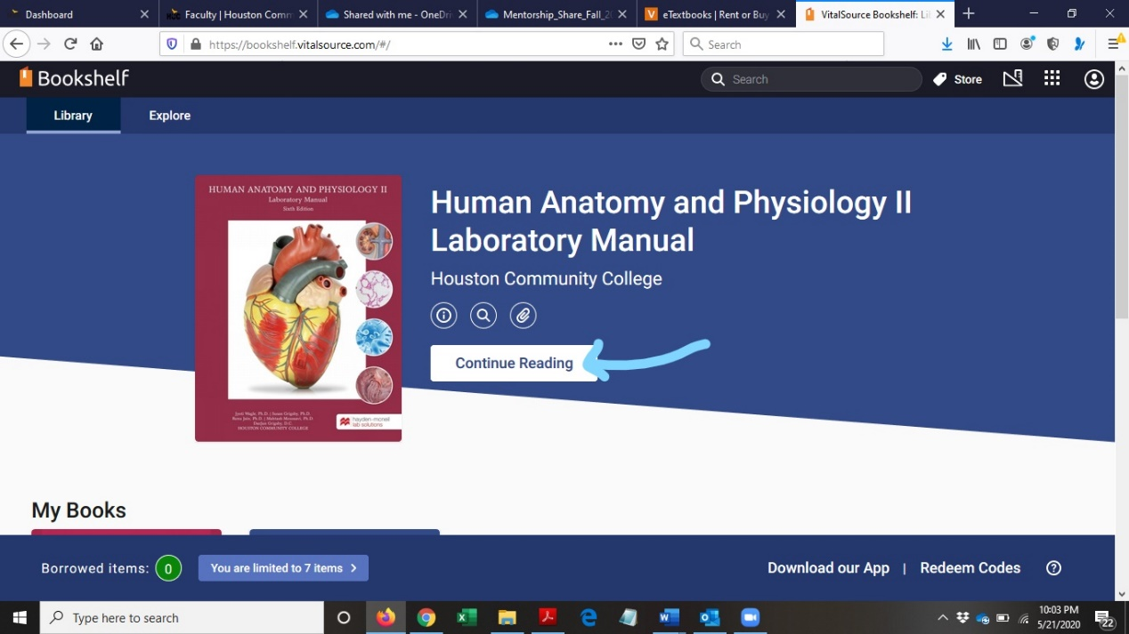

- Labs can be accessed/navigated in two different ways,
  - 1. By going through the table of content
  - 2. By clicking on the NEXT and PREVIOUS
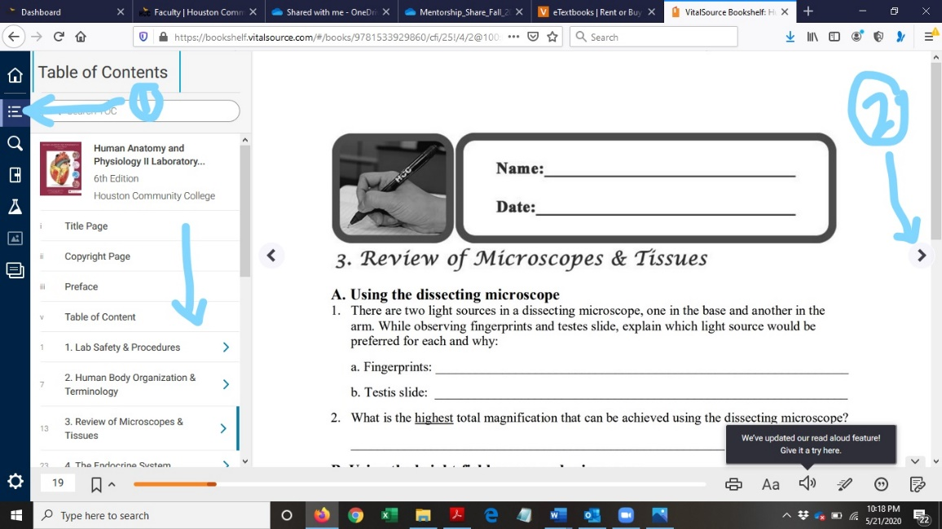

- To access the fillable pdf lab reports, click on the attach icon above the Continue Reading tab. A window will open up with lab report number
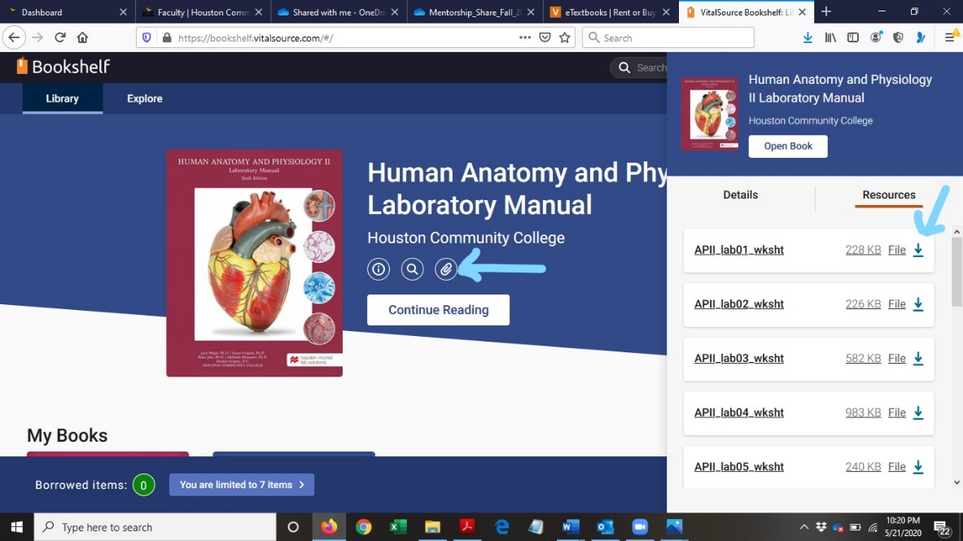

- Click on the down arrow highlighted above to download the lab reports and save them on your computer. Do not start filling the lab reports on the browser itself!! you will not be able to save the data. After saving, open the lab reports to confirm they open in the adobe reader. Now complete the lab reports and save them with lab report # and your last name (e.g. Jain_labReport#10). As the final step, follow your professors’ instructions to submit the files on canvas.

The Lab manual listed above is required for this course.
"Human Anatomy and Physiology, Jyoti Wagle et al.l"

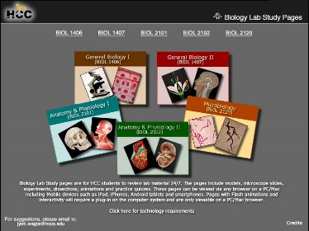

HCCS Biology Lab Study Pages
Click here to access Biology lab study pages online.

OER???

Other Instructional Resources

Tutoring
HCC provides free, confidential, and convenient academic support, including writing critiques, to HCC students in an online environment and on campus. Tutoring is provided by HCC personnel in order to ensure that it is contextual and appropriate. Visit the HCC Tutoring Services website for services provided.

Libraries
The HCC Library System consists of 9 libraries and 6 Electronic Resource Centers (ERCs) that are inviting places to study and collaborate on projects. Librarians are available both at the libraries and online to show you how to locate and use the resources you need. The libraries maintain a large selection of electronic resources as well as collections of books, magazines, newspapers, and audiovisual materials. The portal to all libraries’ resources and services is the HCCS library web page at http://library.hccs.edu.

Supplementary Instruction
Supplemental Instruction is an academic enrichment and support program that uses peer-assisted study sessions to improve student retention and success in historically difficult courses. Peer Support is provided by students who have already succeeded in completion of the specified course, and who earned a grade of A or B. Find details at http://www.hccs.edu/resources-for/current-students/supplemental-instruction/.

Course Overview

A course of study covering the structure and function of human cells, tissues and organ systems including the integumentary, skeletal, muscular and nervous systems. It is a Core Curriculum Course.
This course is intended for students majoring in one of the physical sciences or life sciences, engineering, or for students who are pursuing pre-professional programs in medicine, dentistry, pharmacy, veterinary medicine, or other health programs. The course is also beneficial to students who are preparing themselves for higher-level science courses in their respective curricula.

*** Use ACGM course description per course.

Core Curriculum Objectives (CCOs)

BIOL. 2101 satisfies the Life science requirement in the HCCS core curriculum. The HCCS Biology Discipline Committee has specified that the course address the following core objectives:
- Critical Thinking: Students will demonstrate the ability to engage in inquiry and analysis, evaluation and synthesis of information, and creative thinking by completing a written assignment such as a book report, research paper, or essay.
- Communication Skills: Students will demonstrate effective development, interpretation and expression of ideas through written, oral, and visual communication by completing a written assignment such as a book report, research paper, or essay.
- Quantitative and Empirical Literacy: Students will demonstrate the ability to draw conclusions based on the systematic analysis of topics using observation, experiment, and/or numerical skills by completing textbook reading assignments, completing assignments, and answering questions on quizzes and exams that pertain to Course Student Learning Outcome #2 below.
- Social Responsibility: Students will demonstrate cultural self-awareness, intercultural competency, civil knowledge, and the ability to engage effectively in regional, national, and global communities by completing textbook reading assignments, completing assignments, and answering questions on quizzes and exams that pertain to Course Student Learning Outcomes.
*** Do NOT CHANGE the texts highlighted in red as All courses MUST address the first 2 CCOs, though you can remove the red color. Go to the HCC CCO link to determine more applicable objectives, if any. Then delete this explanatory text.

Program Student Learning Outcomes (PSLOs)

- Will display an understanding of biological systems and evolutionary processes spanning all ranges of biological complexity, including atoms, molecules, genes, cells, and organisms.
- Will integrate factual and conceptual information into an understanding of scientific data by written, oral and/or visual communication. (This may include successful completion of a course-specific research project or a case study module).
- Will demonstrate proficiency and safe practices in the use of laboratory equipment and basic laboratory techniques.
- Will apply principles of the scientific method to problems in biology in the collection, recording, quantitative measurement, analysis and reporting of scientific data.

Course Student Learning Outcomes (CSLOs)

Anatomy and Physiology I is the first part of a two-course sequence. It is a study of the structure and function of the human body including cells, tissues and organs of the following systems: integumentary, skeletal, muscular, nervous and special senses. The lab provides a hands-on learning experience for exploration of human system components and basic physiology. Emphasis is on interrelationships among systems and regulation of physiological functions involved in maintaining homeostasis.

Completion of the specific course Student Learning Outcomes listed below does NOT and will NOT guarantee the student any specific final course grade at the end of the semester!
- Use anatomical terminology to identify and describe locations of major organs of each system covered.
- Explain interrelationships among molecular, cellular, tissue, and organ functions in each system.
- Describe the interdependency and interactions of the systems.
- Explain contributions of organs and systems to the maintenance of homeostasis.
- Identify causes and effects of homeostatic imbalances.
- Describe modern technology and tools used to study anatomy and physiology.

Learning Objectives
1. Consistently able to demonstrate understanding and application of feedback loops on homeostasis without the instructor’s help.
2. Consistently able to explain membrane transport and determine the outcome of scenarios concerning membrane transport
3. Always able to describe muscle structure and use that knowledge to explain muscle function
4. Always able to apply knowledge of the structure of the skeletal system to its functions.
5. Consistently able to demonstrate knowledge of interactions involving changes in membrane polarity without the instructor’s help.
6. Consistently able to demonstrate all parts, functions, and steps involved in a reflex arc.
7. Consistently prepared and able to demonstrate skills using the body system models and laboratory techniques at the classroom standards. Consistently able to find and focus the specimen on the microscope slide without the instructor’s help.
8. Consistently uses online tools to prepare for class, always ready for classroom discussions and instructor’s Q&A sessions, completes all online quizzes prior to due date.

Student Success

Academic standards require a minimum of 3 study hours for every contact hour; meaning for a class that meets 3 hours per week, you need to budget and set aside a minimum of 9 hours each week to study and prep for your course success. Expect to spend at least twice as many hours per week outside of class as you do in class studying the course content. Additional time will be required for written assignments. The assignments provided will help you use your study hours wisely. Successful completion of this course requires a combination of the following:
- Reading the required lab book.
- Viewing the available lectures and movies.
- Timely completion and uploading of assignments
- Participating in class discussions
- Successful exam performance

There is no short cut for success in this course; it requires reading and studying the material using the course objectives as a guide.

Instructor and Student Responsibilities

As your Instructor, it is my responsibility to:
- Provide the grading scale and detailed grading formula explaining how student grades are to be derived
- Facilitate an effective learning environment through learner-centered instructional techniques
- Provide a description of any special projects or assignments
- Inform students of policies such as attendance, withdrawal, tardiness, and making up assignments
- Provide the course outline and class calendar that will include a description of any special projects or assignments
As a student, it is your responsibility to:
- Attend class in person and/or online
- Participate actively by reviewing course material, interacting with classmates, and responding promptly in your communication with me
- Read and comprehend the textbook
- Complete the required assignments and exams
- Ask for help when there is a question or problem
- Keep copies of all paperwork, including this syllabus, handouts, and all assignments
- Be aware of and comply with academic honesty policies in the HCCS Student Handbook

Assignments, Exams, and Activities

Written Assignment

Your lab book exercises and related questions are required and will make the value of 10 points each. The written exercises are to be complete BEFORE the lab test that will cover that material. The time using the available resources will be used to relate the models and structures to the material in your lab book. Reference material is available on our Canvas shell to help.

Exams

Topics and concepts covered during lab or included in the assigned reading will be included in exams. !!!!!
There will be a total of 5 exams in this course. The exams will be on models used in the lab and questions will be fill in the blank or write in the answer type of questions. The exams are made up of 50 to 75 questions.

Grading Formula

Lab Exam 1 100
Lab Exercises 150
Lab Exam 2 100
Lab Exam 3 100
Lab Exam 4 100
Final Score 550

Grade | Total Points
A | 90%
B | 80%
C | 70%
D | 60%
F | <60%

Incomplete Policy:
In this course, the purposes of the “I” (incomplete) grade is for students who are caught up and passing at the student withdrawal deadline, and then have a medical or other problem that prevents them from completing the course. If you are not passing at the student withdrawal deadline, you should drop yourself from the course, or you will likely earn an “F.” An incomplete “I” grade will be given only if all of the following conditions are met:
- You have earned at least 85% of the available points by the date that the “I” grade is requested.
- You can provide documentation showing why you should earn an incomplete, such as a doctor's note, etc.
- You must be passing with a grade of “C” or better.
- You must request the incomplete in writing BEFORE the official drop date.
- In all cases, the instructor reserves the right to decline a student’s request to receive a grade of Incomplete.

HCC Grading Scale can be found on this site under Academic Information:
http://www.hccs.edu/resources-for/current-students/student-handbook/

Course Calendar

Course Calendar:

Week Lab Schedule
1 | Lab Ex. 1  Lab Ex. 2
2 | Lab Ex. 3
3 | Lab Ex. 4 | Lab Test 1, Ex. 1-3
4 | Lab Ex. 5
5 | Lab Ex. 6
6 | Lab Ex. 7 | Lab Test2, Ex. 4-6
7 | Lab Ex. 8
8 | Lab Ex. 9
9 | Lab Ex. 10 | Lab Test 3, Ex. 7-9
10 | Lab Ex. 11
11 | Lab Ex. 12
12 | Lab Ex. 13 | Lab Test 4, Ex. 10-12
13 | Lab Ex. 14
14 | Lab Ex. 15 | Lab Test 5, Ex. 13&15
15
16

Syllabus Modifications
The instructor reserves the right to modify the syllabus at any time during the semester and will promptly notify students in writing, typically by e-mail, of any such changes.

Instructor’s Practices and Procedures

Missed Assignments

- Missed lab exams are not CANNOT be made up but if necessary, Only one make-up exam per semester COULD BE allowed (with proper medical documentation) and must be arranged with instructor ASAP. No other excuses will be accepted for missing a test or assignment. A grade of ZERO will be awarded for any missed work or test without proper documentation of a health emergency. A make up is NOT a retake of the same exam. The Instructor must be given advance notice of absence.

- There will be NO reopening of missed quizzes, discussions and NO redo for missed clinical questions. If you miss any of these, you will get a ZERO!!!

- The Instructor DOES NOT have to announce/tell you of upcoming assignments in person. This is a college course and you have to keep yourself informed by keeping up with your canvas. All assignments and quizzes will be posted with dates and the dates will be updated as the semester goes on. It is your responsibility to keep up.

Academic Integrity

This instructor is committed to a high standard of academic integrity in the academic community. In becoming a part of the academic community, students are responsible for honesty and independent effort. Failure to uphold these standards includes, but is not limited to, the following: plagiarizing written work or projects, cheating on exams or assignments, collusion on an exam or project, and misrepresentation of credentials or prerequisites when registering for a course. Cheating includes looking at or copying from another student's exam, orally communicating or receiving answers during an exam, having another person take an exam or complete a project or assignment, using unauthorized notes, texts, or other materials for an exam, and obtaining or distributing an unauthorized copy of an exam or any part of an exam. Plagiarism means passing off as his/her own the ideas or writings of another (that is, without giving proper credit by documenting sources). Plagiarism includes submitting a paper, report, or project that someone else has prepared, in whole or in part. Collusion is inappropriately collaborating on assignments designed to be completed independently. These definitions are not exhaustive. When there is clear evidence of cheating, plagiarism, collusion, or misrepresentation, disciplinary action may include but is not limited to requiring you to retake or resubmit an exam or assignment, assigning a grade of zero or "F" for an exam or assignment; or assigning a grade of "F" for the course. Additional sanctions including being withdrawn from the course, program or expelled from school may be imposed on a students who violate the standards of academic integrity.
Scholastic Dishonesty will result in a referral to the Dean of Student Services. See the link below for details.

Here’s the link to the HCC information about academic integrity (Scholastic Dishonesty and Violation of Academic Scholastic Dishonesty and Grievance):
http://www.hccs.edu/about-hcc/procedures/student-rights-policies--procedures/student-procedures/

Attendance Procedures
Attendance is mandated by the state. You are expected to attend the entirety of the scheduled lab classes. You are also responsible for all lab materials covered. Instructors may be willing to consult with you for make-up assignments, but it is your responsibility to contact the instructor. Class attendance is monitored daily. Although it is your responsibility to drop a course for nonattendance, the instructor has the authority to drop you for excessive absences. You may be dropped from a course after accumulating absences in excess of 12.5 percent of the total hours of instruction (lab). For example:

- For a 3 credit-hour lecture class meeting 3 hours per week (48 hours of instruction), you can be dropped after 6 hours of absence.
- Departments and programs governed by accreditation or certification standards may have different attendance policies. Administrative drops are at the discretion of the instructor. Failure to withdraw officially can result in a grade of “F” or “FX” in the course.

- Students who stopped attending class: The Department of Education now requires that we make a distinction between an “earned” grade of “F” (i.e. for poor performance) and a grade of “F” due to a lack of attendance. To make that distinction, we have created a new grade, “FX” for failure due to lack of attendance. Faculty will not be allowed the option of submitting a grade change form changing the grade of FX (or F) to W, if the student stopped attending class. Failure to alert instructor of missed exams and lack of attendance will result in this grade option.

Student Conduct

Students are expected to conduct themselves as adults. This includes courteous and respectful behavior towards instructor and classmates. Disruptive behavior or any behavior that interferes with any educational activity being performed by the instructor will not be allowed. Additionally, no student may interfere with his/her fellow students’ right to pursue their academic goals to the fullest in an atmosphere appropriate to a community of scholars. Disruptive behavior may result in removal from the class.

Students are expected to respect the learning rights of all others in the classroom. Individual conversations, chatting online, text messaging, arriving to class late, sleeping during class, working on online assignments, playing computer games, surfing the internet and studying for another class during classroom time are unacceptable behaviors. Students who demonstrate these behaviors may be asked to leave class.

Instructor’s Course-Specific Information (As Needed)

I will teach you to the best of my ability and I will push you to get to that point where you will be more knowledgeable and able to perform at- and above par with students from other institutions. I promise to teach you in a way that you will be prepared to handle questions on your Hesi or TEAs exams and in your future medical/health programs. Lab tests will be reviewed immediately after the test and exam results will be returned by the next class period.

Electronic Devices

Absolutely no phone or other personal electronic devices are to be used during lab tets without the instructors permission. You will be required to use the Respondus Lockdown Browser for all lab tests. This includes making or taking a call, reviewing messages, texting, playing games, checking email, surfing the web, anything that involves a phone or other personal electronic device while taking the tests. Notify your friends, family, employers, and anyone else who regularly contacts you that you will be in class and that you should be contacted only when necessary. The taking of calls during at test is forbidden. STUDENTS ARE NOT PERMITTED TO HANDLE CALLS DURING EXAMS.

Biology Program Information

The Biology area of study here at HCC covers the smallest and simplest organisms (microbiology) to the largest and most complex organisms (human anatomy and physiology, zoology, botany).

AWARD TYPES: Associate in Science
AREA OF STUDY: Science, Technology, Engineering & Math

Please visit link: https://www.hccs.edu/programs/areas-of-study/science-technology-engineering--math/biology/

HCC Policies
Here’s the link to the HCC Student Handbook http://www.hccs.edu/resources-for/current-students/student-handbook/ In it you will find information about the following:

- Academic Information
- Academic Support
- Attendance, Repeating Courses, and Withdrawal
- Career Planning and Job Search
- Childcare
- disAbility Support Services
- Electronic Devices
- Equal Educational Opportunity
- Financial Aid TV (FATV)
- General Student Complaints
- Grade of FX
- Incomplete Grades
- International Student Services
- Health Awareness
- Libraries/Bookstore
- Police Services & Campus Safety
- Student Life at HCC
- Student Rights and Responsibilities
- Student Services
- Testing
- Transfer Planning
- Veteran Services

EGLS³
The EGLS³ (Evaluation for Greater Learning Student Survey System) will be available for most courses near the end of the term until finals start. This brief survey will give invaluable information to your faculty about their teaching. Results are anonymous and will be available to faculty and division chairs after the end of the term. EGLS³ surveys are only available for the Fall and Spring semesters. EGLS3 surveys are not offered during the Summer semester due to logistical constraints.
http://www.hccs.edu/resources-for/current-students/egls3-evaluate-your-professors/

Campus Carry Link
Here’s the link to the HCC information about Campus Carry: http://www.hccs.edu/departments/police/campus-carry/

HCC Email Policy
When communicating via email, HCC requires students to communicate only through the HCC email system to protect your privacy. If you have not activated your HCC student email account, you can go to HCC Eagle ID and activate it now. You may also use Canvas Inbox to communicate.

Housing and Food Assistance for Students
Any student who faces challenges securing their foods or housing and believes this may affect their performance in the course is urged to contact the Dean of Students at their college for support. Furthermore, please notify the professor if you are comfortable in doing so.

This will enable HCC to provide any resources that HCC may possess.

Office of Institutional Equity

Use the link below to access the HCC Office of Institutional Equity, Inclusion, and Engagement (http://www.hccs.edu/departments/institutional-equity/)

disAbility Services
HCC strives to make all learning experiences as accessible as possible. If you anticipate or experience academic barriers based on your disability (including long and short term conditions, mental health, chronic or temporary medical conditions), please meet with a campus Abilities Counselor as soon as possible in order to establish reasonable accommodations. Reasonable accommodations are established through an interactive process between you, your instructor(s) and Ability Services. It is the policy and practice of HCC to create inclusive and accessible learning environments consistent with federal and state law. For more information, please go to http://www.hccs.edu/support-services/disability-services/

Title IX
Houston Community College is committed to cultivating an environment free from inappropriate conduct of a sexual or gender-based nature including sex discrimination, sexual assault, sexual harassment, and sexual violence. Sex discrimination includes all forms of sexual and gender-based misconduct and violates an individual’s fundamental rights and personal dignity. Title IX prohibits discrimination on the basis of sex-including pregnancy and parental status in educational programs and activities. If you require an accommodation due to pregnancy please contact an Abilities Services Counselor. The Director of EEO/Compliance is designated as the Title IX Coordinator and Section 504 Coordinator. All inquiries concerning HCC policies, compliance with applicable laws, statutes, and regulations (such as Title VI, Title IX, and Section 504), and complaints may be directed to:

David Cross
Director EEO/Compliance
Office of Institutional Equity & Diversity
3100 Main
(713) 718-8271
Houston, TX 77266-7517 or Institutional.Equity@hccs.edu
http://www.hccs.edu/departments/institutional-equity/title-ix-know-your-rights/

Office of the Dean of Students
Contact the office of the Dean of Students to seek assistance in determining the correct complaint procedure to follow or to identify the appropriate academic dean or supervisor for informal resolution of complaints.

https://www.hccs.edu/about-hcc/procedures/student-rights-policies--procedures/student-complaints/speak-with-the-dean-of-students/

Department Chair Contact Information
Dr. DaeJan Grigsby
Email: daejan.grigsby@hccs.edu
Phone: 713-718-7775.

Have a GREAT SEMESTER and please remember to see me if any questions arise.

