Chapter 9: (2 points each)

1. Which one of the following is most likely to be an ionic compound?
A) CaCl₂ B) CO₂ C) CS₂ D) SO₂ E) OF₂
Ans: A Category: Easy Section: 9.2

2. Which one of the following is most likely to be an ionic compound?
A) ClF₃ B) FeCl₃ C) NH₃ D) PF₃ E) SO₃
Ans: B Category: Easy Section: 9.2

3. Which one of the following is most likely to be an ionic compound?
A) NCl₃ B) BaCl₂ C) CO D) SO₂ E) SF₄
Ans: B Category: Easy Section: 9.2

4. Which of the following pairs of elements would be most likely to form an ionic compound?
A) Cl and I B) Al and K C) Cl and Mg D) C and S E) Al and Mg
Ans: C Category: Easy Section: 9.2

5. Which one of the following is most likely to be a covalent compound?
A) Rb₂O B) BaO C) SrO D) SeO₂ E) MnO₂
Ans: D Category: Easy Section: 9.4

6. Which one of the following is most likely to be a covalent compound?
A) KF B) CaCl₂ C) SF₄ D) Al₂O₃ E) CaSO₄
Ans: C Category: Easy Section: 9.4

7. Which one of the following is most likely to be a covalent compound?
A) CsOH B) NF₃ C) Sr(NO₃)₂ D) CaO E) LiF
Ans: B Category: Easy Section: 9.4

8. The Lewis dot symbol for the a lead atom is
A) B) C) D) E)
Ans: C Category: Medium Section: 9.1

9. The Lewis dot symbol for the S ^{2–} ion is
A) B) ^{2–} C) S^{2–} D) ⎯⎯ ^{2–} E) ⎯
Ans: B Category: Medium Section: 9.2

10. The Lewis dot symbol for the chloride ion is
A) B) – C) – D) – E) Cl–
Ans: B Category: Medium Section: 9.2

11. The Lewis dot symbol for the calcium ion is
A) ²⁺ B) ⎯Ca⎯ C) ²⁺ D) Ca²⁺ E) Ca
Ans: D Category: Medium Section: 9.2

12. Which one of the following ionic solids would have the largest lattice energy?
A) NaCl B) NaF C) CaBr₂ D) CsI E) CaCl₂
Ans: E Category: Medium Section: 9.3

13. Which of the following ionic solids would have the largest lattice energy?
A) SrO B) NaF C) CaBr₂ D) CsI E) BaSO₄
Ans: A Category: Medium Section: 9.3

14. Which of the following ionic solids would have the largest lattice energy?
A) KF B) KI C) LiF D) LiI E) NaF
Ans: C Category: Medium Section: 9.3

15. Which of the elements listed below has the greatest electronegativity?
A) Na B) As C) Ga D) Cs E) Sb
Ans: B Category: Medium Section: 9.5

16. Which of the atoms listed below is the most electronegative?
A) Li B) Cs C) P D) As E) Ge
Ans: C Category: Medium Section: 9.5

17. Which of the elements listed below has the greatest electronegativity?
A) Se B) Sb C) K D) Ga E) Fe
Ans: A Category: Medium Section: 9.5

18. Which of the elements listed below is the least electronegative?
A) Sr B) V C) Ni D) P E) I
Ans: A Category: Medium Section: 9.5

19. Which of the elements listed below has the greatest electronegativity?
A) Mg B) Ga C) Si D) Ba E) Pb
Ans: C Category: Medium Section: 9.5

20. A polar covalent bond would form in which one of the following pairs of atoms?
A) Cl ⎯ Cl B) Si ⎯ Si C) Ca ⎯ Cl D) Cr ⎯ Br E) P ⎯ Cl
Ans: E Category: Medium Section: 9.5

21. What type of chemical bond holds the atoms together within a water molecule?
A) Ionic bond C) Polar covalent bond
B) Nonpolar covalent bond D) Coordinate covalent bond
Ans: C Category: Medium Section: 9.5

22. Classify the C ⎯ Cl bond in CCl₄ as ionic, polar covalent, or nonpolar covalent.
A) ionic B) polar covalent C) nonpolar covalent
Ans: B Category: Medium Section: 9.5

23. Classify the Ca ⎯ Cl bond in CaCl₂ as ionic, polar covalent, or nonpolar covalent.
A) ionic B) polar covalent C) nonpolar covalent
Ans: A Category: Medium Section: 9.5

24. The electron dot formula for O₂ shows
A) a single covalent bond D) a total of 8 x 2 = 16 electron dots
B) a double covalent bond E) a total of 32 electron dots
C) an ionic bond
Ans: B Category: Medium Section: 9.4

25. The number of lone electron pairs in the N₂ molecule is ___.
A) 1 B) 2 C) 3 D) 4 E) 5
Ans: B Category: Medium Section: 9.4

26. The number of lone electron pairs in the NO₂– ion is ___.
A) 4 B) 5 C) 6 D) 7 E) 8
Ans: C Category: Medium Section: 9.4

27. The number of lone electron pairs in the CO₃^{2–} ion is ___.
A) 4 B) 5 C) 6 D) 7 E) 8
Ans: E Category: Medium Section: 9.4

28. The total number of bonding electrons in a molecule of formaldehyde (H₂CO) is
A) 3 B) 4 C) 6 D) 8 E) 18
Ans: D Category: Medium Section: 9.6

29. The Lewis structure for CS₂ is:
A) B) C) D)
Ans: C Category: Medium Section: 9.6

30. Which of the following Lewis structures is incorrect?
A) 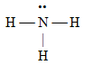 D) 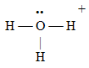
B) 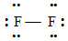 E) 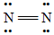
C) 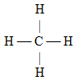
Ans: E Category: Medium Section: 9.6

31. What is the formal charge on the oxygen atom in N₂O (the atomic order is N–N–O)?
A) 0 B) +1 C) –1 D) –2 E) +2
Ans: C Category: Difficult Section: 9.7

32. Which of the following substances will display an incomplete octet in its Lewis structure?
A) CO₂ B) Cl₂ C) ICl D) NO E) SO₂
Ans: D Category: Medium Section: 9.9

33. Which of the elements listed below is most likely to exhibit an expanded octet in its compounds?
A) O B) S C) Na D) C E) N
Ans: B Category: Easy Section: 9.9

34. Which one of the following compounds does not follow the octet rule?
A) NF₃ B) CF₄ C) PF₅ D) AsH₃ E) HCl
Ans: C Category: Easy Section: 9.9

35. Which one of the following compounds does not follow the octet rule?
A) NF₃ B) CO₂ C) CF₄ D) Br₂ E) NO
Ans: E Category: Medium Section: 9.9

36. Which response includes all the molecules below that do not follow the octet rule?
(1) H₂S (2) BCl₃ (3) PH₃ (4) SF₄
A) (2) and (4) B) (2) and (3) C) (1) and (2) D) (3) and (4) E) (1) and (4)
Ans: A Category: Medium Section: 9.9

37. Which one of the following molecules has an atom with an incomplete octet?
A) NF₃ B) H₂O C) AsCl₃ D) GeH₄ E) BF₃
Ans: E Category: Medium Section: 9.9

38. Which one of the following molecules has an atom with an expanded octet?
A) HCl B) AsCl₅ C) ICl D) NCl₃ E) Cl₂
Ans: B Category: Medium Section: 9.9

39. Which molecule has a Lewis structure that does not obey the octet rule?
A) N₂O B) CS₂ C) PH₃ D) CCl₄ E) NO₂
Ans: E Category: Medium Section: 9.9

40. Write the Lewis dot symbol for the chloride ion.
Ans: 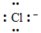
Category: Medium

41. Write the Lewis dot symbol for the sulfide ion.
Ans: 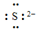
Category: Medium

42. Write a Lewis structure for OF₂.
Ans: 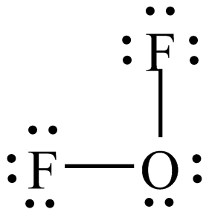
Category: Medium Section: 9.6

43. Write a Lewis structure for the nitrate ion, NO₃–, showing all non-zero formal charges.
Ans: 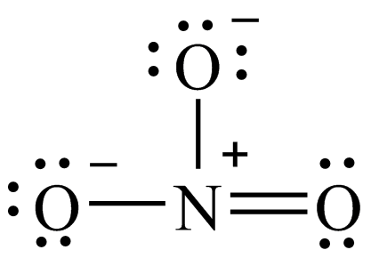
Category: Medium Section: 9.7

44. Write a Lewis structure for SO₃ that obeys the octet rule, showing all non-zero formal charges, and give the total number of resonance structures for SO₃ that obey the octet rule.
Ans: 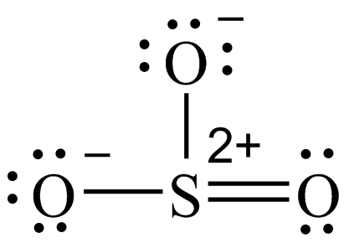
Total number of resonance structures of this type (that obey the octet rule) = 3.
Category: Medium Section: 9.8

45. Write a Lewis structure for SO₃ that expands the octet to minimize formal charge and if necessary places negative formal charges on the most electronegative atom(s).
Ans: 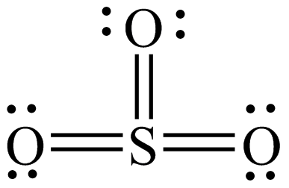
Category: Medium Section: 9.9

46. Write the Lewis structure of boron trifluoride.
Ans: 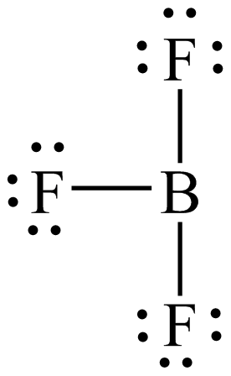
Category: Medium Section: 9.6

47. Write the Lewis structure of ammonia (nitrogen trihydride).
Ans: 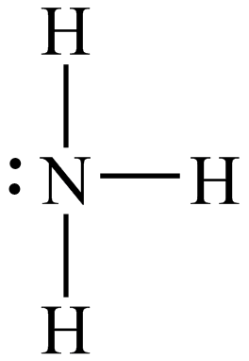
Category: Medium Section: 9.6

48. Which of the following solids would have the highest melting point?
A) NaF B) NaCl C) NaBr D) NaI
Ans: A Category: Medium Section: 9.3

49. Which of the following solids would have the highest melting point?
A) NaI B) NaF C) MgO D) MgCl₂ E) KF
Ans: C Category: Medium Section: 9.3

50. Which of the following solids would have the lowest melting point?
A) KI B) KBr C) KCl D) KF
Ans: A Category: Medium Section: 9.3

Chapter 10: (2 points each)

1. Give the number of lone pairs around the central atom and the molecular geometry of SCl₂.
A) 0 lone pairs, linear D) 3 lone pairs, bent
B) 1 lone pair, bent E) 3 lone pairs, linear
C) 2 lone pairs, bent
Ans: C Category: Medium Section: 10.1

2. Give the number of lone pairs around the central atom and the molecular geometry of XeF₂.
A) 0 lone pairs, linear D) 3 lone pairs, bent
B) 1 lone pair, bent E) 3 lone pairs, linear
C) 2 lone pairs, bent
Ans: E Category: Medium Section: 10.1

3. Give the number of lone pairs around the central atom and the molecular geometry of XeF₄.
A) 0 lone pairs, tetrahedral
B) 1 lone pair, distorted tetrahedron (seesaw)
C) 1 lone pair, square pyramidal
D) 1 lone pair, tetrahedral
E) 2 lone pairs, square planar
Ans: E Category: Medium Section: 10.1

4. Give the number of lone pairs around the central atom and the molecular geometry of IF₅.
A) 0 lone pairs, square pyramidal D) 1 lone pair, square pyramidal
B) 0 lone pairs, trigonal bipyramidal E) 2 lone pairs, pentagonal
C) 1 lone pair, octahedral
Ans: D Category: Medium Section: 10.1

5. The geometry of the SF₄ molecule is
A) tetrahedral. D) square planar.
B) trigonal pyramidal. E) distorted tetrahedron (seesaw).
C) trigonal planar.
Ans: E Category: Medium Section: 10.1

6. Use VSEPR theory to predict the geometry of the PCl₃ molecule.
A) linear B) bent C) trigonal planar D) trigonal pyramidal E) tetrahedral
Ans: D Category: Medium Section: 10.1

7. The geometry of the CS₂ molecule is best described as
A) linear. B) trigonal planar. C) tetrahedral. D) bent. E) trigonal pyramidal.
Ans: A Category: Medium Section: 10.1

8. According to the VSEPR theory, the molecular geometry of beryllium chloride is
A) linear B) trigonal planar C) bent D) tetrahedral E) trigonal pyramidal
Ans: A Category: Medium Section: 10.1

9. According to the VSEPR theory, the molecular geometry of SiCl₄ is
A) linear B) trigonal planar C) bent D) tetrahedral E) trigonal pyramidal
Ans: D Category: Medium Section: 10.1

10. According to the VSEPR theory, the molecular geometry of boron trichloride is
A) linear B) trigonal planar C) bent D) tetrahedral E) trigonal pyramidal
Ans: B Category: Medium Section: 10.1

11. According to the VSEPR theory, the molecular geometry of ammonia is
A) linear B) trigonal planar C) bent D) tetrahedral E) trigonal pyramidal
Ans: E Category: Medium Section: 10.1

12. According to the VSEPR theory, which one of the following species should be linear?
A) H₂S B) HCN C) BF₃ D) H₂CO E) SO₂
Ans: B Category: Medium Section: 10.1

13. According to VSEPR theory, which one of the following molecules should have a geometry that is trigonal bipyramidal?
A) SF₄ B) XeF₄ C) NF₃ D) SF₆ E) PF₅
Ans: E Category: Medium Section: 10.1

14. According to VSEPR theory, which one of the following molecules should be nonlinear?
A) CO₂ B) C₂H₂ C) SO₂ D) BeCl₂ E) KrF₂
Ans: C Category: Medium Section: 10.1

15. Which one of the following molecules has tetrahedral geometry?
A) XeF₄ B) BF₃ C) AsF₅ D) CF₄ E) NH₃
Ans: D Category: Medium Section: 10.1

16. According to VSEPR theory, which one of the following molecules has tetrahedral geometry?
A) NH₃ B) CCl₄ C) CO₂ D) SF₄ E) PCl₅
Ans: B Category: Medium Section: 10.1

17. The F – S – F bond angles in SF₆ are
A) 90° and 180° B) 109.5° C) 120° D) 180° E) 90° and 120°
Ans: A Category: Medium Section: 10.1

18. Which one of the following molecules is nonpolar?
A) NH₃ B) OF₂ C) CH₃Cl D) H₂O E) BeCl₂
Ans: E Category: Medium Section: 10.2

19. Complete this sentence: The PCl₅ molecule has
A) nonpolar bonds, and is a nonpolar molecule.
B) nonpolar bonds, but is a polar molecule.
C) polar bonds, and is a polar molecule.
D) polar bonds, but is a nonpolar molecule.
Ans: D Category: Medium Section: 10.2

20. Which one of the following molecules has a non-zero dipole moment?
A) BeCl₂ B) Br₂ C) BF₃ D) IBr E) CO₂
Ans: D Category: Medium Section: 10.2

21. Which one of the following molecules has a zero dipole moment?
A) CO B) CH₂Cl₂ C) SO₃ D) SO₂ E) NH₃
Ans: C Category: Medium Section: 10.2

22. Which one of the following molecules is polar?
A) PBr₅ B) CCl₄ C) BrF₅ D) XeF₂ E) XeF₄
Ans: C Category: Medium Section: 10.2

23. Predict the geometry and polarity of the CS₂ molecule.
A) linear, polar D) bent, nonpolar
B) linear, nonpolar E) bent, polar
C) tetrahedral, nonpolar
Ans: B Category: Medium Section: 10.2

24. Which of the following species has the largest dipole moment (i.e., is the most polar)?
A) CH₄ B) CH₃Br C) CH₃Cl D) CH₃F E) CH₃I
Ans: D Category: Medium Section: 10.2

25. The number of pi bonds in the molecule below is
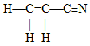
A) 1 B) 2 C) 3 D) 5 E) 9
Ans: C Category: Medium Section: 10.5

26. The number of pi bonds in the molecule below is
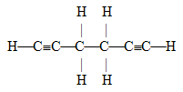
A) 2 B) 4 C) 6 D) 10 E) 15
Ans: B Category: Medium Section: 10.5

27. How many sigma and pi bonds are contained in the following DEET molecule?
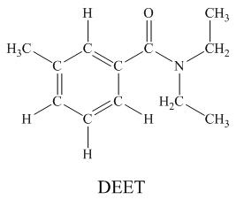
Ans: 31 sigma bonds and 4 pi bonds (18 sigma, 4 pi)
Category: Medium Section: 10.5

28. How many sigma bonds and pi bonds are contained in a ibuprofen molecule?

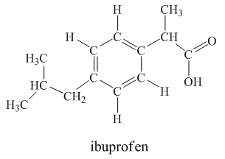
Ans: 33 sigma bonds and 4 pi bonds (19 sigma, 4 pi)
Category: Medium Section: 10.5

29. Pi bonds are covalent bonds in which the electron density is concentrated above and below a plane containing the nuclei of the bonding atoms.
Ans: True Category: Easy Section: 10.5

30. A bonding molecular orbital is of lower energy (more stable) than the atomic orbitals from which it was formed.
Ans: True Category: Medium Section: 10.6

Chapter 11: (2 points each)

1. Which one of the following substances is expected to have the highest boiling point?
A) Br₂ B) Cl₂ C) F₂ D) I₂
Ans: D Category: Easy Section: 11.2

2. Which one of the following substances is expected to have the lowest melting point?
A) BrI B) CsI C) LiI D) NaI E) RbI
Ans: A Category: Easy Section: 11.2

3. Which one of the following substances is expected to have the highest boiling point?
A) HBr B) HCl C) HF D) HI
Ans: C Category: Easy Section: 11.2

4. Helium atoms do not combine to form He₂ molecules, yet He atoms do attract one another weakly through
A) dipole-dipole forces. D) dipole-induced dipole forces.
B) ion-dipole forces. E) hydrogen bonding.
C) dispersion forces.
Ans: C Category: Medium Section: 11.2

5. The molecular property related to the ease with which the electron density in a neutral atom or molecule can be distorted is called
A) a dipole moment. D) surface tension.
B) polarizability. E) a van der Waals force.
C) a dispersion force.
Ans: B Category: Easy Section: 11.2

6. Which of the following substances should have the highest boiling point?
A) CH₄ B) Cl₂ C) Kr D) CH₃Cl E) N₂
Ans: D Category: Medium Section: 11.2

7. Which of the following substances should have the lowest boiling point?
A) CBr₄ B) CBr₃F C) CBr₂F₂ D) CBrF₃ E) CF₄
Ans: E Category: Medium Section: 11.2

8. Which of the following liquids would have the highest viscosity at 25°C?
A) CH₃OCH₃ B) CH₂Cl₂ C) C₂H₅OH D) CH₃Br E) HOCH₂CH₂OH
Ans: E Category: Medium Section: 11.3

9. Which of the following would be expected to have the highest vapor pressure at room temperature?
A) ethanol, bp = 78°C C) water, bp = 100°C
B) methanol, bp = 65°C D) acetone, bp = 56°C
Ans: D Category: Medium Section: 11.8

10. Which of the following would be expected to have the lowest vapor pressure at room temperature?
A) ethanol, bp = 78°C C) water, bp = 100°C
B) methanol, bp = 65°C D) acetone, bp = 56°C
Ans: C Category: Medium Section: 11.8

11. Given the following liquids and their boiling points, which has the highest vapor pressure at its normal boiling point?
A) ethanol, bp = 78°C
B) methanol, bp = 65°C
C) water, bp = 100°C
D) benzene, bp = 80°C
E) The vapor pressure of each of the liquids at its normal boiling point would be the same.
Ans: E Category: Medium Section: 11.8

12. Which of the responses includes all of the following that can form hydrogen bonds with water molecules?
(1) Na⁺ (2) CH₃COOH (3) C₂H₆ (4) CH₃NH₂
A) (1) and (2) B) (1) and (3) C) (2) and (3) D) (2) and (4) E) (3) and (4)
Ans: D Category: Medium Section: 11.2

13. Which of the following atoms does not participate in hydrogen bonding?
A) S B) O C) F D) N
Ans: A Category: Easy Section: 11.2

14. Which of the following is not true with regard to water?
A) Water has a high heat capacity.
B) Water has an unusually high boiling point.
C) Water can form hydrogen bonds.
D) Ice is more dense than liquid water.
E) Water is a polar molecule.
Ans: D Category: Medium Section: 11.3

15. Which property of water allows a razor blade to float on it without sinking?
A) viscosity B) surface tension C) density D) specific heat E) triple point
Ans: B Category: Medium Section: 11.3

16. Butter melts over a range of temperature, rather than with a sharp melting point. Butter is classified as a/an
A) metallic crystal. D) amorphous solid.
B) covalent solid. E) ionic crystal.
C) molecular crystal.
Ans: D Category: Medium Section: 11.7

17. The number of atoms in a body-centered cubic unit cell is
A) 1 B) 2 C) 3 D) 4 E) 8
Ans: B Category: Medium Section: 11.4

18. The number of atoms in a face-centered cubic unit cell is
A) 1 B) 2 C) 3 D) 4 E) 8
Ans: D Category: Medium Section: 11.4

19. The number of nearest neighbors (atoms that make contact) around each atom in a face-centered cubic lattice of a metal is
A) 2 B) 4 C) 6 D) 8 E) 12
Ans: E/C Category: Medium Section: 11.4

20. Potassium crystallizes in a body-centered cubic lattice. How many atoms are there per unit cell?
A) 1 B) 2 C) 4 D) 6 E) 8
Ans: B Category: Medium Section: 11.4

21. A liquid boils when its
A) vapor pressure is exactly 1 atmosphere.
B) vapor pressure is equal to, or greater than, the external pressure pushing on it.
C) temperature is equal to 273 K (standard temperature).
D) temperature is greater than room temperature.
Ans: B Category: Medium Section: 11.8

22. The heat capacity of liquid water is 4.18 J/g·°C and the heat of vaporization is 40.7 kJ/mol. How many kilojoules of heat must be provided to convert 1.00 g of liquid water at 67°C into 1.00 g of steam at 100°C?
A) 22.7 kJ B) 40.8 kJ C) 2.2 kJ D) 2,400 J E) 40.8 J
Ans: D Category: Medium Section: 11.8

23. Use the graph of vapor pressure to determine the normal boiling point of CHCl₃.
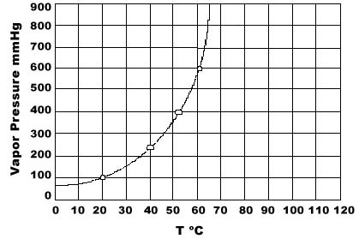
A) 19°C B) 52°C C) 60°C D) 64°C E) 70°C
Ans: D Category: Medium Section: 11.8

24. Which of the following is not an endothermic process?
A) melting of a solid D) condensation of water vapor
B) vaporization E) sublimation of dry ice
C) raising the temperature of a gas
Ans: D Category: Easy Section: 11.8

25. Acetic acid has a heat of fusion of 10.8 kJ/mol and a heat of vaporization of 24.3 kJ/mol. What is the expected value for the heat of sublimation of acetic acid?
A) 35.1 kJ/mol
B) –13.5 kJ/mol
C) +13.5 kJ/mol
D) –35.1 kJ/mol
E) Not enough information is given to answer the question.
Ans: A Category: Medium Section: 11.8

26. Use the graph of vapor pressure to determine the normal boiling point of O₂.
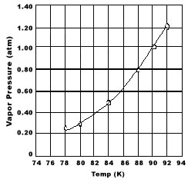
A) 92 K
B) 90 K
C) 88 K
D) 84 K
E) O₂ doesn't boil because it is always a gas.
Ans: B Category: Medium Section: 11.8

27. Calculate the amount of heat that must be absorbed by 10.0 g of ice at –20°C to convert it to liquid water at 60.0°C. Given: specific heat (ice) = 2.1 J/g·°C; specific heat (water) = 4.18 J/g·°C; ΔH_{fus} = 6.0 kJ/mol.
A) 420 J B) 2,900 J C) 6,261 J D) 63 kJ E) 7.5 J
Ans: C Category: Medium Section: 11.8

28. Calculate the amount of heat needed to melt 2.00 kg of iron at its melting point (1,809 K), given that ΔH_{fus} = 13.80 kJ/mol.
A) 494 kJ B) 27,600 kJ C) 27.6 kJ D) 27,600 J E) 25,000 kJ
Ans: A Category: Medium Section: 11.8

29. How much energy (heat) is required to convert 52.0 g of ice at –10.0°C to steam at 100°C?
specific heat of ice: | 2.09 J/g·°C | ΔH_{fus} = 6.02 kJ/mol
specific heat of water: | 4.18 J/g·°C | ΔH_{vap} = 40.7 kJ/mol
specific heat of steam: | 1.84 J/g·°C

A) 2,570 kJ B) 1,086 kJ C) 157.8 kJ D) 40.2 kJ E) 22,957 kJ
Ans: C Category: Medium Section: 11.8

30. The vapor pressure of a liquid in a closed container depends upon
A) the amount of liquid. D) the temperature.
B) the surface area of the liquid. E) None of the above.
C) the volume of the container.
Ans: D Category: Medium Section: 11.8

31. Indicate all the types of intermolecular forces of attraction in SO₂(l).
Ans: dipole-dipole and dispersion
Category: Medium Section: 11.2

32. Indicate all the types of intermolecular forces of attraction in C₂H₆(g).
Ans: dispersion
Category: Medium Section: 11.2

33. Indicate all the types of intermolecular forces of attraction in SF₆(g).
Ans: dispersion
Category: Medium Section: 11.2

34. Indicate all the types of intermolecular forces of attraction in CF₄(g).
Ans: dispersion
Category: Medium Section: 11.2

35. Indicate all the types of intermolecular forces of attraction in HCl(g).
Ans: dipole-dipole and dispersion
Category: Medium Section: 11.2

36. Of the given pair of compounds, which would have the higher boiling point?
C₃H₈ or CH₃OCH₃
Ans: CH₃OCH₃
Category: Medium Section: 11.2

37. Of the given pair of compounds, which would have the higher boiling point?
CCl₄ or CH₄
Ans: CCl₄
Category: Medium Section: 11.2

38. Of the given pair of compounds, which would have the higher boiling point?
CH₃Cl or CH₄
Ans: CH₃Cl
Category: Medium Section: 11.2

39. Of the given pair of compounds, which would have the higher boiling point?
NH₃ or CH₄
Ans: NH₃
Category: Medium Section: 11.2

40. Methane has a heat of fusion of 0.84 kJ/mol and a heat of vaporization of 9.2 kJ/mol. Estimate the value for the heat of sublimation.
Ans: 10.04 kJ/mol
Category: Medium Section: 11.8

41. What phase exists at the point labeled a?
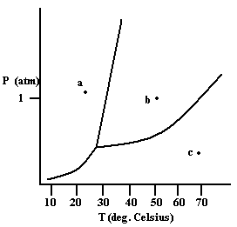
Ans: solid
Category: Medium Section: 11.9

42. What phase exists at the point labeled b?
Ans: liquid
Category: Medium Section: 11.9

43. What phase exists at the point labeled c?
Ans: gas
Category: Medium Section: 11.9

44. Suppose the atoms in a two-dimensional crystal have the following arrangement:
On the drawing above, sketch the unit cell of this crystal.
Ans:
Category: Medium Section: 11.4

45. Suppose the atoms in a two-dimensional crystal have the following arrangement:
How many atoms are in one unit cell?
Ans: one (each corner of unit cell has one-fourth of an atom)
Category: Medium Section: 11.4

46. How much enthalpy is necessary to heat 10.0 g of solid benzene (C₆H₆) at 0.0°C to benzene vapor at 100°C?
Data for Benzene
melting point | 5.5°C
boiling point | 80.1°C
specific heat of solid benzene | 1.52 J/g·°C
specific heat of liquid benzene | 1.73 J/g·°C
specific heat of benzene vapor | 1.06 J/g·°C
ΔH_{fus} | 9.9 kJ/mol
ΔH_{vap} | 30.8 kJ/mol

Ans: 6.9 kJ
Category: Medium Section: 11.8

47. Ethanol (C₂H₅ – OH) will have a greater viscosity than ethylene glycol (HO – CH₂CH₂ – OH) at the same temperature.
Ans: False Category: Medium Section: 11.3

48. The shape of the water-to-glass meniscus results from the strong adhesive forces between glass and water.
Ans: True Category: Medium Section: 11.3

49. The fact that the density of ice is less than the density of liquid water is due to the formation of hydrogen bonds.
Ans: True Category: Medium Section: 11.3

50. The freezing point of a liquid does not change as the atmospheric pressure changes.
Ans: False Category: Medium Section: 11.9

