New Faculty: How to Retrieve User ID and Password
- Goto www.hccs.edu.
- Click information for……
- Click Faculty.
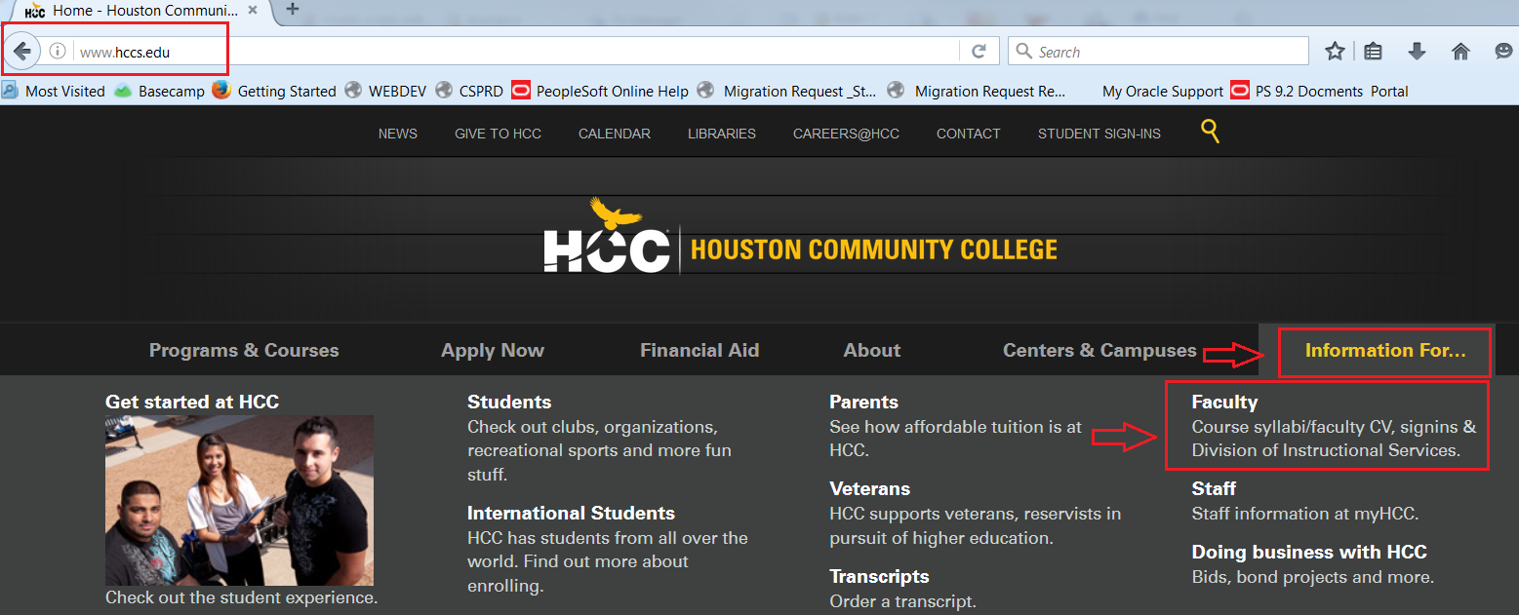

- On the Faculty landing page click Activate your Account.
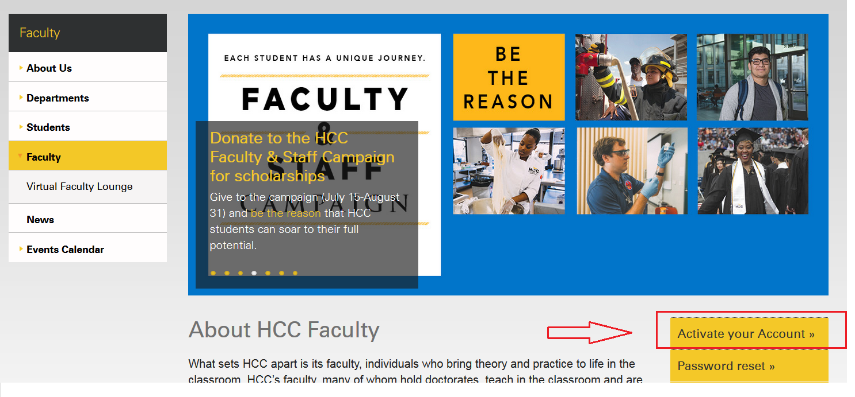
- Enter required information, and then click Next to setup challenge questions and retrieve userid and password.
