UPSWING, formerly ASKONLNE
This is offered by HCCS, for free, to all students, in not just English and writing, but every other subject area. This online tutoring helps students improve their writing.
Sign in to Upswing with your login information. You will see Profile Info.
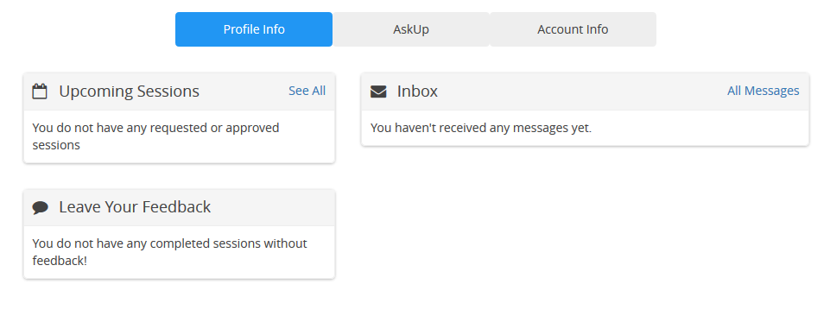
Click AskUp. This is where you will submit your assignment.
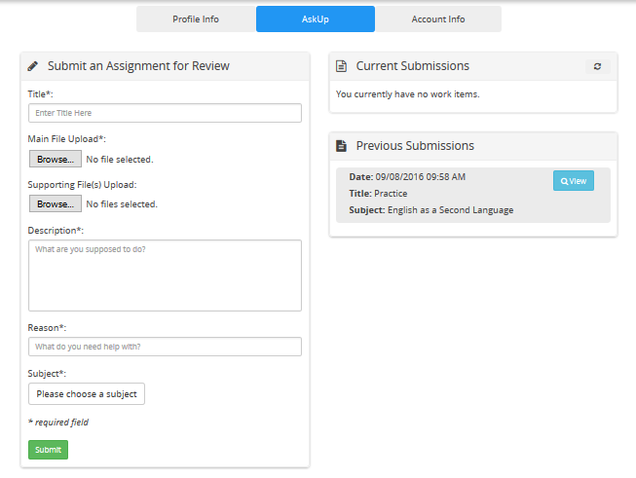

NOTE: Copy and paste the information into the required boxes in Upswing.
Change this each time you are asked to submit your work to help you.
Title Box: Narrative Essay, Draft 1
Main File Upload: Browse and upload your paper in .doc, .docx. or .rtf
Support Files Upload: (Probably not necessary)
Description: (ESOL0354/Smith) This is my paragraph/essay/journal about my topic __________________________________ (and any details about the assignment that the tutor needs to know to help you better.) I need feedback please, especially in grammar and organization. Thanks for your help.
Reason: Some examples of what to ask help for:
grammar
organization
punctuation, capitalization, and spelling
thesis statement, topic sentences, supporting sentences and conclusion; are they clear enough, or how can I improve them?
Subject: English as a Second Language
Submit
Often, it may take 18-72 hours to see the revisions, so plan accordingly. The tutor cannot correct everything, but will highlight where you are making common mistakes.
Notification
You should receive an email that your post is ready for review. Go to your inbox.

